Mating-induced patterns of spermathecal fluid protein expression in two eusocial insect species, Lasius niger and Apis mellifera
Alison McAfee^{1,2}*, Félicien Delgueldre³, Shelley E. Hoover⁴, Serge Aron^{3‡}, and Leonard J. Foster^{1‡}*
- Department of Biochemistry and Molecular Biology, Michael Smith Laboratories, University of British Columbia, Vancouver, British Columbia, Canada
- Department of Applied Ecology, North Carolina State University, Raleigh, North Carolina, USA
- Department of Evolutionary Biology & Ecology, Université Libre de Bruxelles, Brussels, Belgium
- Department of Biological Sciences, University of Lethbridge, Lethbridge, Alberta, Canada
‡These authors contributed equally
Corresponding authors:
alison.n.mcafee@gmail.com (AM)
foster@msl.ubc.ca (LJF)

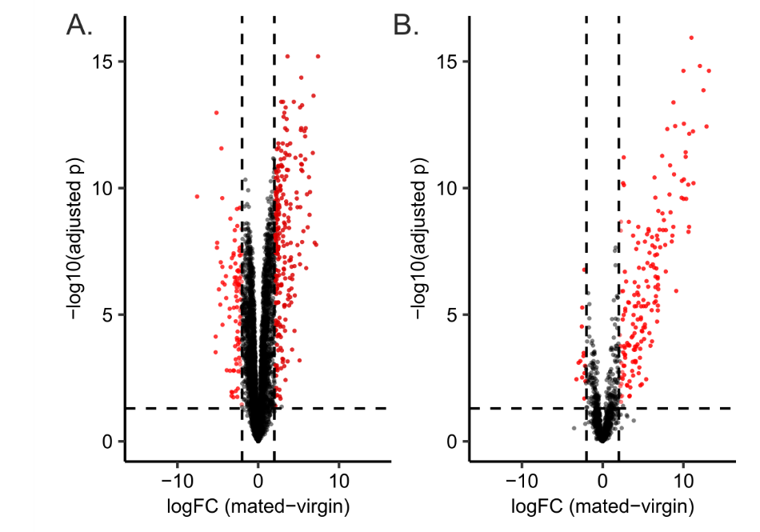
Figure S1. Comparison of A. mellifera proteomic data structure with and without sperm depletion by centrifugation. A) Proteomic data of spermathecal fluid with sperm depletion (this paper). B) Proteomic data of spermathecal fluid without sperm depletion (McAfee et al.⁶⁴). Without centrifugation, the volcano plot is highly skewed toward highly abundant proteins in the mated queen samples (originating from the sperm cells).

