Supplementary information
Balancing productivity and sustainability: Cattle farming, energy intensity, and environmental degradation in Latin America
Mejía, Daniela¹; Junca Paredes, John Jairo^{2;} Burkart, Stefan²*
¹ Universidad EAFIT, Medellín, Colombia
² International Center for Tropical Agriculture (CIAT), Cali, Colombia
* Correspondence:
Stefan Burkart
s.burkart@cgiar.org
Supplementary Table S1. Results of the Granger causality tests
Grangertest (d2_ener~d2_produc, order=5)  Granger Causality Test  Model 1: d2_ener ~ Lags(d2_ener, 1:5) + Lags(d2_produc, 1:5)  Model 2: d2_ener ~ Lags(d2_ener, 1:5)  Res.Df Df F Pr(>F)  1 1  2 6 -5 344.86 0.04086 *  # Cattle production Granger-causes agricultural energy use with a lag of five periods | Grangertest (d2_produc~d2_ener, order=5)  Granger Causality Test  Model 1: d2_produc ~ Lags(d2_produc, 1:5) + Lags(d2_ener, 1:5)  Model 2: d2_produc ~ Lags(d2_produc, 1:5)  Res.Df Df F Pr(>F)  1 1  2 6 -5 24.608 0.1518  # Energy use never Granger-causes cattle production
Grangertest (d2_emissi~d2_ener, order=4)  Granger causality test  Model 1: d2_emissi ~ Lags(d2_emissi, 1:4) + Lags(d2_ener, 1:4)  Model 2: d2_emissi ~ Lags(d2_emissi, 1:4)  Res.Df Df F Pr(>F)  1 4  2 8 -4 7.6178 0.03727 *  # Energy use Granger-causes cattle emissions with a lag of four periods | Grangertest (d2_ener~d2_emissi, order=4)  Granger Causality Test  Model 1: d2_ener ~ Lags(d2_ener, 1:4) + Lags(d2_emissi, 1:4)  Model 2: d2_ener ~ Lags(d2_ener, 1:4)  Res.Df Df F Pr(>F)  1 4  2 8 -4 1.3318 0.394  # Cattle emissions never Granger-cause energy use
Note: This table presents the econometric results of the hypothesis tests regarding Granger causality among the variables of interest. Source: Own elaboration.
Supplementary Table S2. Results of tests for the optimal lag order of the VAR model
AIC (n)  2 | HQ(n)  2 | SC (n)  2 | FPE (n)  1
Results of the hypothesis test to identify the optimal lag order for running the VAR model indicate that the appropriate order is 2. Source: Own elaboration.
Supplementary Table S3. Results of specification tests under the stability condition
Roots of the characteristic polynomial:
0.8264 0.8264 0.6166 0.3288 0.3288 0.2021
Fitted plot and correlogram of Gross Production Value (cattle) residuals.
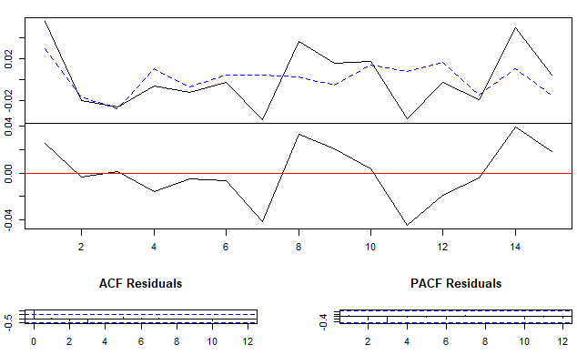

Fitted plot and correlogram of Energy intensity in agriculture residuals.
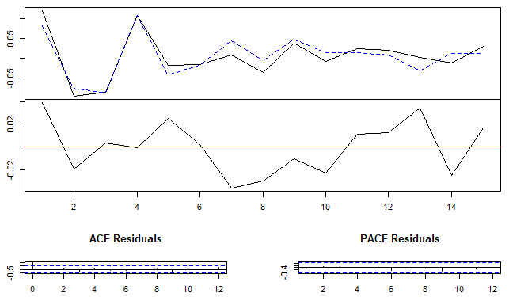
Fitted plot and correlogram of CO2eq emissions residuals.
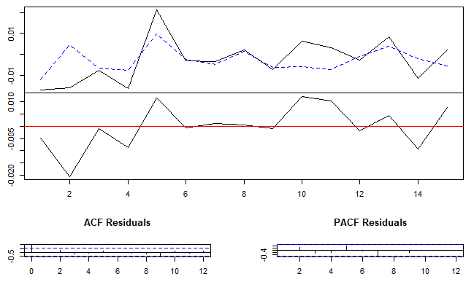
Note: The results of the characteristic polynomial roots and correlogram plots of the variables of interest are presented to assess stationarity. Source: Own elaboration.
Supplementary Table S4. Results of the serial autocorrelation test of the residuals
H0: The residuals are not autocorrelated >.05 accept H0
H1: The residuals are autocorrelated <.05 accept H1
Portmanteau Test (asymptotic)
data: Residuals of VAR object var1
Chi-squared = 10.635, df = 0, p-value < 2.2e-16
Note: This table presents the results of the hypothesis test for detecting serial autocorrelation in the residuals. Source: Own elaboration.
Supplementary Table S5. Results of the normality test of the residuals
H0: The residuals are normally distributed >0.05 accept H0
H1: The residuals are not normally distributed <0.05 accept H1
$Skewness
Skewness only (multivariate)
data: Residuals of VAR object var1
Chi-squared = 0.90919, df = 3, p-value = 0.8232
$Kurtosis
Kurtosis only (multivariate)
data: Residuals of VAR object var1
Chi-squared = 0.93233, df = 3, p-value = 0.8176
Note: This table presents the results of the hypothesis test for the normality of the model's residuals. Source: Own elaboration.
Supplementary Table S6. Results of the test for homoscedasticity of the residual variance
H0: The variance of the residuals is constant >0.05 accept H0
H1: The variance of the residuals is not constant <0.05 accept H1
ARCH (multivariate)
data: Residuals of VAR object var1
Chi-squared = 78, df = 72, p-value = 0.2939
Note: This table presents the results of the hypothesis test for homoscedasticity of the residual variance of the model. Source: Own elaboration.
Supplementary Table S7. Results of unit root tests for the Panel VAR model
intensity_UR  Levin-Lin-Chu Unit-Root Test (ex. var.: Individual Intercepts)  data: intensity_UR  z = -3.2559, p-value = 0.0005652  alternative hypothesis: stationarity  intensity_UR  Maddala-Wu Unit-Root Test (ex. var.: Individual Intercepts)  data: intensity_UR  chisq = 62.231, df = 24, p-value = 3.072e-05  alternative hypothesis: stationarity  intensity_UR  Im-Pesaran-Shin Unit-Root Test (ex. var.: Individual Intercepts)  data: intensity_UR  Wtbar = -2.914, p-value = 0.001784  alternative hypothesis: stationarity | emissions_UR  Levin-Lin-Chu Unit-Root Test (ex. var.: Individual Intercepts)  data: emissions_UR  z = 0.31504, p-value = 0.6236  alternative hypothesis: stationarity  emissions_UR  Maddala-Wu Unit-Root Test (ex. var.: Individual Intercepts)  data: emissions_UR  chisq = 38.217, df = 24, p-value = 0.03294  alternative hypothesis: stationarity  emissions_UR  Im-Pesaran-Shin Unit-Root Test (ex. var.: Individual Intercepts)  data: emissions_UR  Wtbar = 0.99442, p-value = 0.84  alternative hypothesis: stationarity | production_UR  Levin-Lin-Chu Unit-Root Test (ex. var.: Individual Intercepts)  data: production_UR  z = -4.4817, p-value = 3.703e-06  alternative hypothesis: stationarity  production_UR  Maddala-Wu Unit-Root Test (ex. var.: Individual Intercepts)  data: production_UR  chisq = 24.563, df = 24, p-value = 0.4298  alternative hypothesis: stationarity  production_UR  Im-Pesaran-Shin Unit-Root Test (ex. var.: Individual Intercepts)  data: production_UR  Wtbar = -0.1704, p-value = 0.4323  alternative hypothesis: stationarity
Note: This table presents the results of the hypothesis test for unit root tests in the Panel VAR model. Source: Own elaboration
Supplementary Table S8. Results of the unit root tests for the Panel VAR model (in first differences)
dif1_intensity  Levin-Lin-Chu Unit-Root Test (ex. var.: Individual Intercepts)  data: dif1_intensity  z = -9.7439, p-value < 2.2e-16  alternative hypothesis: stationarity | dif1_emissions  Levin-Lin-Chu Unit-Root Test (ex. var.: Individual Intercepts)  data: dif1_emissions  z = -12.708, p-value < 2.2e-16  alternative hypothesis: stationarity | dif1_production  Levin-Lin-Chu Unit-Root Test (ex. var.: Individual Intercepts)  data: dif1_production  z = -7.6963, p-value = 7.002e-15  alternative hypothesis: stationarity
Note: This table presents the results of the hypothesis test for unit root tests in the Panel VAR model using first differences. Source: Own elaboration.
Supplementary Table S9. Results of the PANELVAR model
PANELVAR_5 <- pvargmm (dependent_vars = c("energy_intensity_agri", "CO2eq", "Gross_Produ_cattle"),
lags = 1,
transformation = "fod",
data = BD_PRUEBA,
panel_identifier = c("area","year"),
steps = c("twostep"),
system_instruments = TRUE,
system_constant = TRUE,
pca_instruments = TRUE,
pca_eigenvalue = 1,
max_instr_dependent_vars = 60,
max_instr_predet_vars = 60,
min_instr_dependent_vars = 2L,
min_instr_predet_vars = 1L,
collapse = TRUE,
tol = 1e-09)

---------------------------------------------------
Dynamic Panel VAR estimation, two-step GMM
---------------------------------------------------
Transformation: Forward orthogonal deviations
Group variable: area
Time variable: year
Number of observations = 204
Number of groups = 12
Obs per group: min = 17
avg = 17
max = 17
Number of instruments = 24

====================================================================================
energy_intensity_agri CO2eq Gross_Produ_cattle
--------------------------------------------------------------------------------------------
lag1_ energy_intensity_agri 0.9972 *** 0.2634 0.5589
(0.1994) (0.1366) (0.3215)
lag1_CO2eq 0.6937 2.1914 *** 3.2029 *
(0.5588) (0.5454) (1.4090)
lag1_Gross_Produ_cattle 0.0886 -0.3490 * 0.1307
(0.1647) (0.1636) (0.3163)
const -8.1573 * -5.7381 -17.0194 *
(4.0616) (2.9896) (8.5484)
====================================================================================
*** p < 0.001; ** p < 0.01; * p < 0.05

---------------------------------------------------
Instruments for equation
Standard

GMM-type
Dependent vars: L (2, 17)
Collapse = TRUE
---------------------------------------------------

Hansen test of overid. restrictions: chi2(12) = 0.83 Prob > chi2 = 1
(Robust, but weakened by many instruments.)
Note: This table presents the modeling specifications for the PANELVAR model. Source: Own elaboration.

