Extended Data

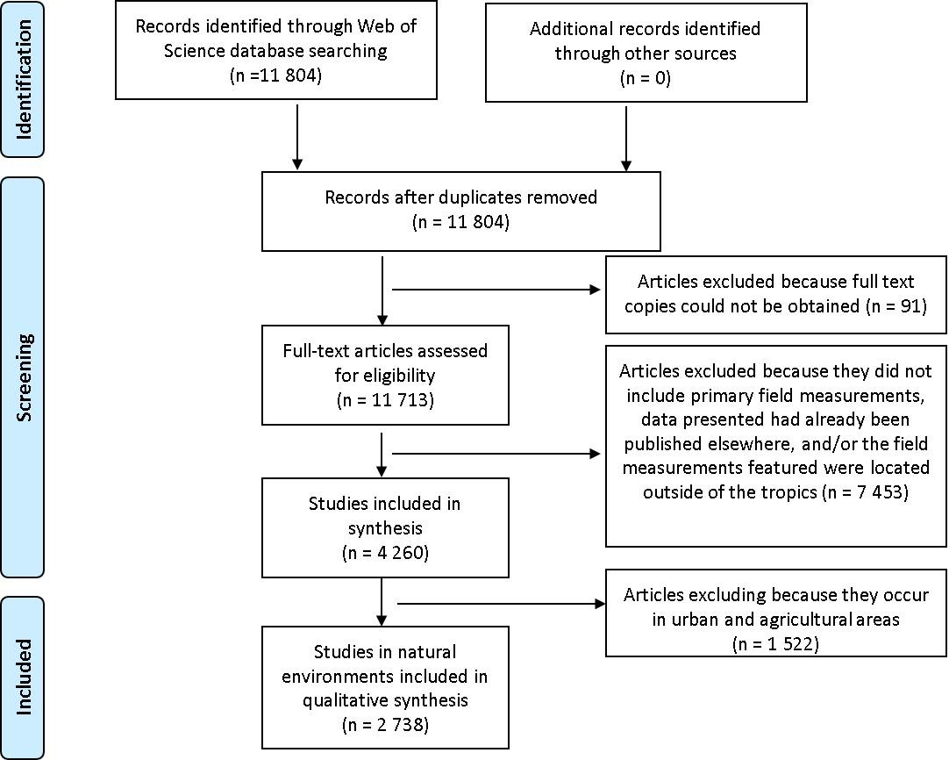
Extended Data Fig. S1. Flow diagram describing key steps in the literature review.

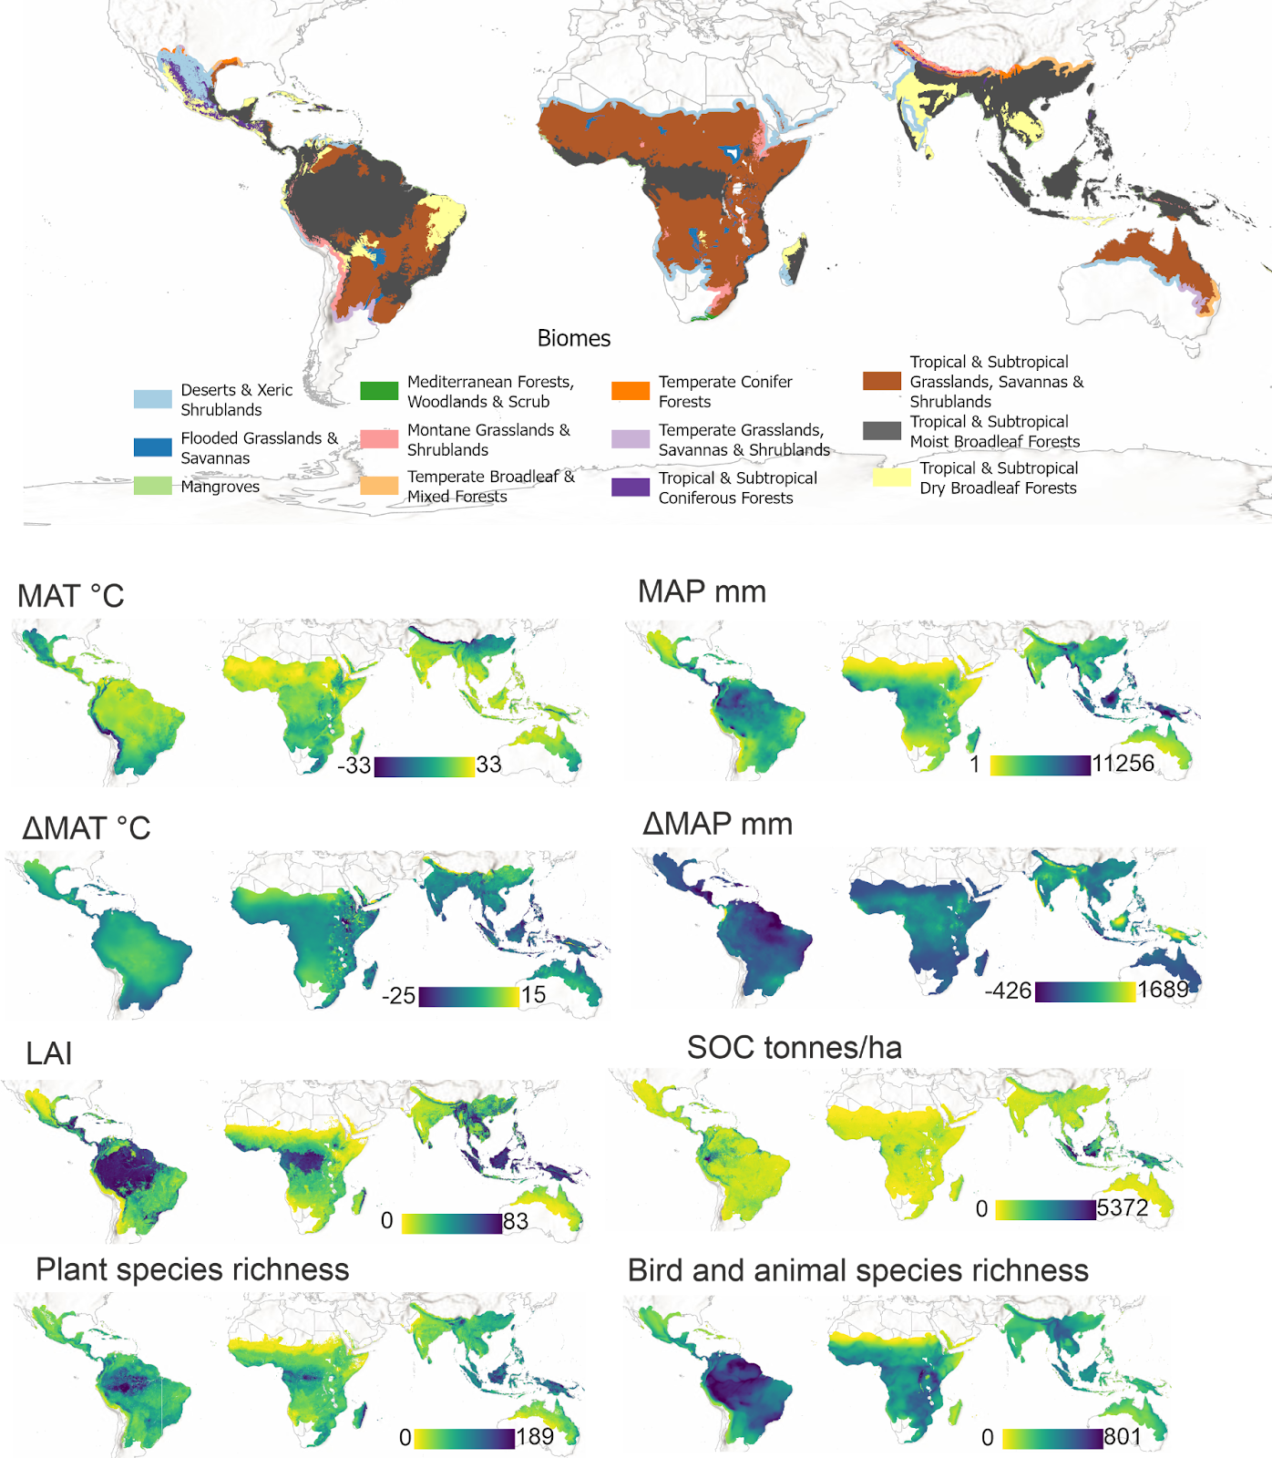
Extended Data Fig. S2. The tropical biomes²⁷ and environmental conditions used in the study¹⁰⁻¹⁴. Note that in most layers, the minimum and maximum values can be extremely low or high, but these extremes are not widespread across the area. Background maps from ESRI and Natural Earth.

Ecoregion | Credit | Link
Guinean mangroves | Julien Saison | https://commons.wikimedia.org/wiki/File:Cueilleuse_traditionnelle_d%27Hu%C3%AEtres_de_mangrove,_delta_du_Sine_Saloum,_femme_du_village_de_Soucouta,_S%C3%A9n%C3%A9gal.jpg
Ethiopian montane moorlands | Nina R | https://commons.wikimedia.org/wiki/File:Bale_Mountains_National_Park_(49849653091).jpg
Southeast Tibet shrublands and meadows | NoGhost | https://commons.wikimedia.org/wiki/File:Southeast_Tibet_meadows.jpg
Marianas tropical dry forests | CT Snow | https://commons.wikimedia.org/wiki/File:Rota_Island_in_the_Commonwealth_of_Northern_Mariana_Islands.jpg
Purus-Madeira moist forests | Erick Caldas Xavier | https://commons.wikimedia.org/wiki/File:Floresta_Nacional_do_Iquiri_Erick_Caldas_Xavier_(6).jpg
Borneo lowland rain forests | Mike Prince | https://commons.wikimedia.org/wiki/File:Dipterocarp_Forest_at_Danum_Valley_(13997709808).jpg
Uatumã-Trombetas moist forests | Ministério da Ciência, Tecnologia e Inovação | https://commons.wikimedia.org/wiki/File:A_(12)_(20932801935).jpg
Puerto Rican moist forests | Alessandro Cai | https://commons.wikimedia.org/wiki/File:Rain_Forest_of_El_Yunque,_Puerto_Rico.jpg
Jian Nan subtropical evergreen forests | SuTa-mei | https://commons.wikimedia.org/wiki/File:A_forest_scene_of_Xibin_town,Youxi_county.JPG
Isthmian-Atlantic moist forests | MongeNajera | https://commons.wikimedia.org/wiki/File:Braulio_Carrillo_National_Park_2.jpg
Extended Data Table S1. Details of photographs used in Figure 3. The photographs were modified from the originals. Use of these photographs does not constitute endorsement by the licensor.

