Supporting Information

Amorphous MoO₃ memristor: The role of stoichiometry on synaptic plasticity

Gion Kalemai^{1,2}, Konstantinos Aidinis^{3,4}, Michael-Alexandros Kourtis⁵, Dimitris Davazoglou¹, Anastasia Soultati^{1,*}
¹Institute of Nanoscience and Nanotechnology (INN), National Center for Scientific
Research Demokritos, 15341 Agia Paraskevi, Athens, Greece
²Department of Physics, University of Patras, 26504 Patra, Rio, Greece
³Department of Electrical and Computer Engineering, Ajman University, P.O. Box 346, Ajman, United Arab Emirates
⁴Center of Medical and Bio-Allied Health Sciences Research, Ajman, United Arab Emirates
⁵Institute of Informatics & Telecommunications, National Center for Scientific Research Demokritos, 15341 Agia Paraskevi, Athens, Greece

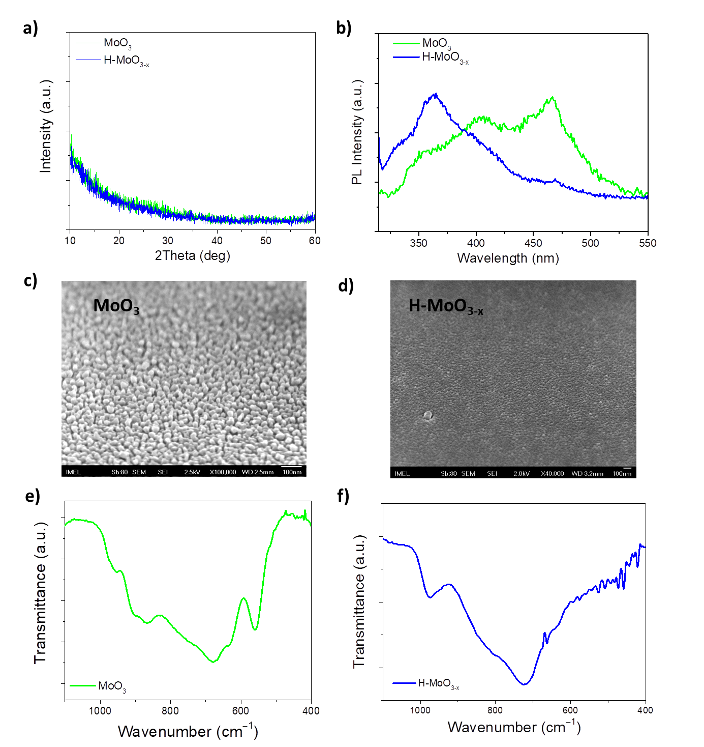
Figure S1: a) XRD patterns and b) PL spectra of fully-stoichiometric (MoO₃) and hydrogenated sub-stoichiometric (H-MoO_{3-x}) films. Top-view SEM images of c) MoO₃ and d) H-MoO_{3-x} films. FTIR transmittance spectra of e) MoO₃ and f) H-MoO_{3-x} films.

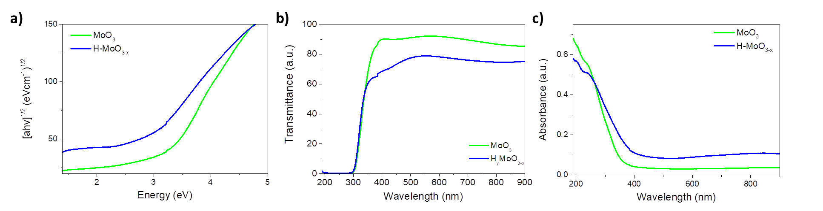
Figure S2: a) Tauc plots, b) transmittance, and c) absorption spectra of MoO₃ and H-MoO_{3-x} films.

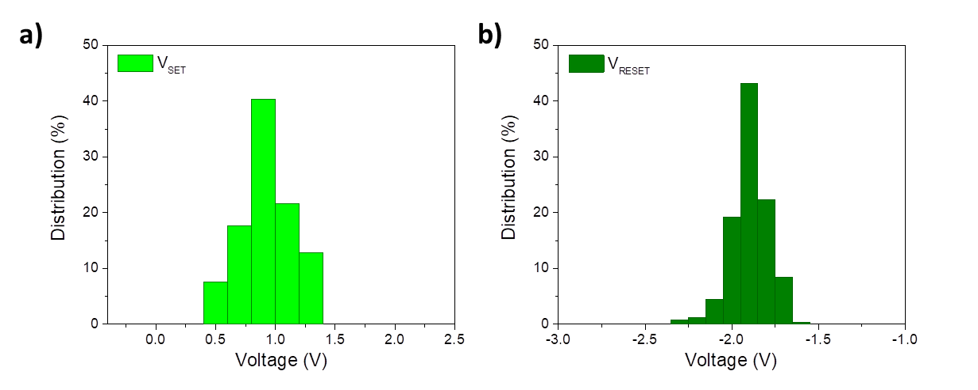
Figure S3: The distribution of SET and RESET voltages of MoO₃-based memristor during 250 cycles.

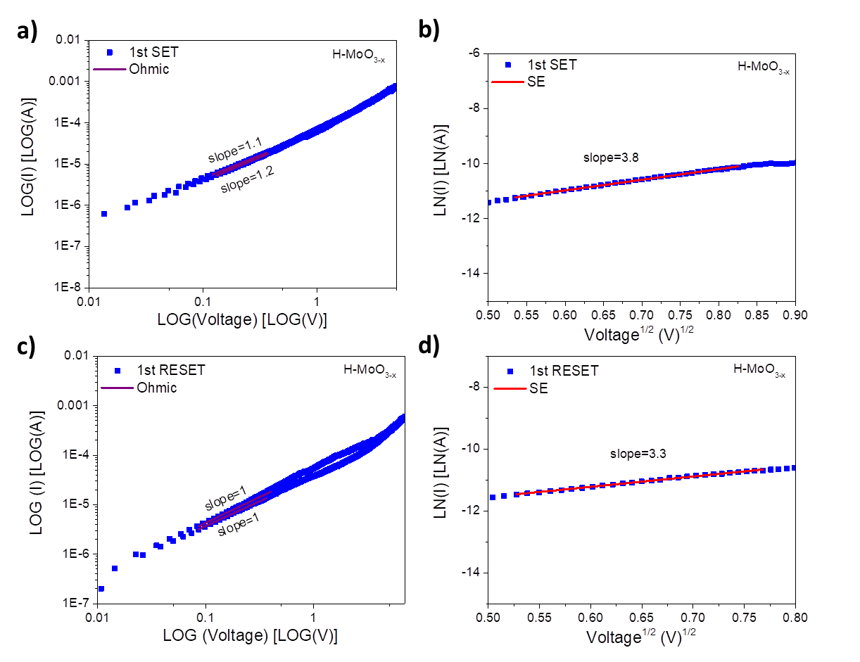
Figure S4: I-V curve analysis for conductive mechanism of the H-MoO₃-based device during a) and b) SET and c) and d) RESET operation.

