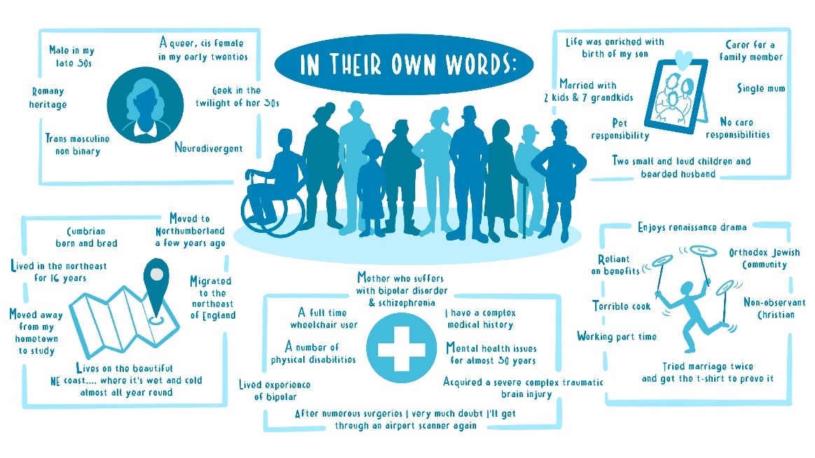
Figure 2.Illustration showing some of the information shared by Expert by lived Experience in their pen-portraits.

