Supplementary Materials

Empirical laws calibration
The first thing we set up is the conversion law from PGV to intensity because the intensity scale in Japan is completely different from the one used in the rest of the world. The relation used in QuakeUp used to convert the PGV in intensity was the following¹
$$I_{JMA}=2.68+1.72⋅\log_{10}{PGV}$$
Equation S 1

Where $I_{JMA}$ is the intensity on the JMA scale and $PGV$ is the peak ground velocity recorded at the station or predicted by the GMPE. The laws that correlate the magnitude to P-wave parameters (see Equations 4 in the main text) and the laws correlating the PGV to the same P-wave parameters (see Equations 3 in the main text) have been interpolated using local earthquake data. In particular, we used three earthquakes of magnitude from 4.2, 5.0 and 6.6. The resulting laws to predict the magnitude are the following
$$M_{w}^{a}=1.25+1.08⋅\log_{10}{P_{a}}+2.01⋅\log_{10}{R} SE=0.4$$
$$M_{w}^{v}=3.48+0.98⋅\log_{10}{P_{v}}+1.69⋅\log_{10}{R} SE=0.4$$
$$M_{w}^{d}=4.91+0.80⋅\log_{10}{P_{d}}+1.16⋅\log_{10}{R} SE=0.4$$
Equation S 2

Here the moment magnitude $M_{w}$ is calculated as a function of the logarithm of the hypocentral distance $R$ and the logarithm of the peak amplitude in acceleration, velocity and displacement on the P-waves ($P_{a}, P_{v}$ and $P_{d}$ respectively). $SE$ is the standard error on the laws calculated with a minimum square method. The P-wave parameters are measured using a three seconds time-window on manually picked accelerometric waveforms. The parameters in velocity and displacement were obtained performing single and double integration respectively. Before each integration, the traces were filtered with a fourth order high-pass Butterworth filter with a corner frequency of $2×{10}^{-4} Hz$. To plot equation S2, in figure S1, we used $R=30km$ as a representative distance, since this value constitutes the mean of the distance between the stations and the hypocentre.

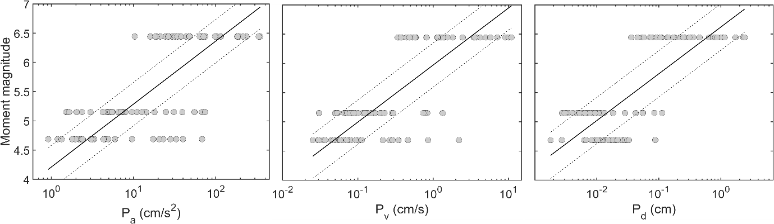
The laws correlating the $PGV$ and the P-wave amplitudes were also interpolated using the same traces as in the previous case. We report them here
Figure S 1. The grey dots represent the data used to calibrate the coefficients of the Magnitude versus $P_{x}$ laws (black solid lines). The black dashed lines represent the standard errors on the laws
$$\log_{10}{PGV_{a}}=-1.16+1.05⋅\log_{10}{P_{a}} SE=0.3$$
$$\log_{10}{PGV_{v}}=0.59+1.02⋅\log_{10}{P_{v}} SE=0.3$$
$$\log_{10}{PGV_{d}}=1.28+0.85⋅\log_{10}{P_{d}} SE=0.3$$
Equation S 3

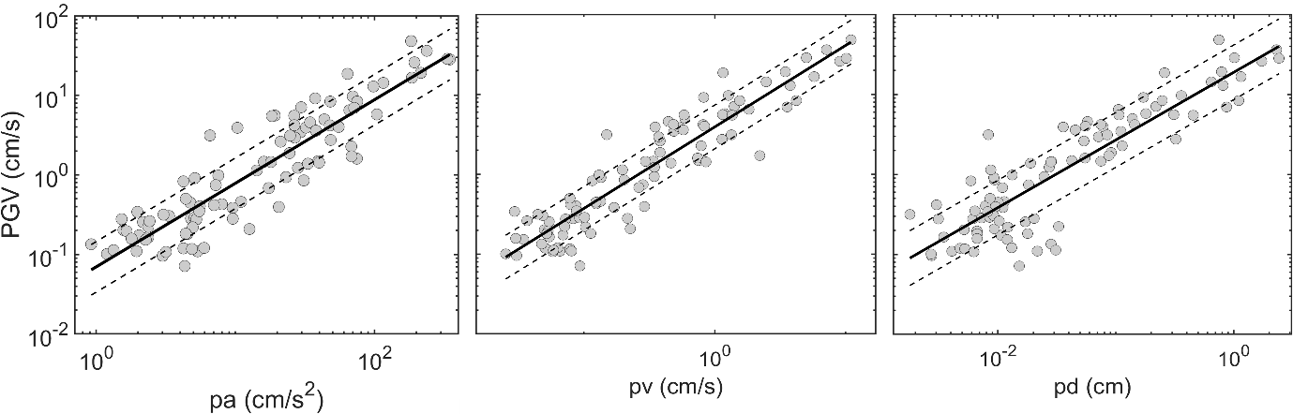
The P-wave parameters were measured in the same way as we showed above. The calibrated laws are shown in figure S2.
Figure S 2. Figure showing the data (grey dots) from the three events used to calibrate equations 3.9 (black solid lines) and their uncertainties (black dashed lines).
The epicentral locations, the magnitude and the origin time of the events used in the calibration are reported in Table S1. All of them were recorded by the accelerometric network in Tottori prefecture. In table S1 the moment magnitude and the JMA magnitude are reported. This is because, to calibrate the laws, we used the moment magnitude ($M_{w}$), but the JMA bulletin reported the events with its own magnitude scale.

Origin Time (UTC) | Latitude (deg) | Longitude (deg) | Depth (km) | $$M_{JMA}$$ | $$M_{w}$$
2016/10/21 03:12:23.02 | 35.3807 | 133.8548 | 10.26 | 4.2 | 4.1
2016/10/21 05:07:22.57 | 35.3805 | 133.8562 | 10.61 | 6.6 | 6.2
2016/10/21 05:53:17.57 | 35.3613 | 133.8678 | 8.94 | 5.0 | 4.7
Table S1. The events listed in this table were used to calibrate equation 3.8 and 3.9. Here we report the origin time, the location and the magnitude of each event.

References
[1] S. Midorikawa, “Correlation of new JMA instrumental seismic intensity with former JMA seismic intensity and ground motion parameters.,” J. Inst. Soc. Safety Sci., pp. 51–56, 1999

