Supplementary Tables and Figures
Table S1. Clinical characteristics of atherosclerosis patients.
Patient # | 5 | 18 | 19 | 26 | 28 | 32 | 33 | 38 | 42 | 44 | 51 | 62 | 66 | 68 | 72 | 79 | 89
Age (years) | 72 | 82 | 65 | 65 | 76 |  | 67 | 74 | 72 | 69 | 75 | 78 | 69 | 76 | 70 | 68 | 64
Sex | M | F | F | F | F | M | M | F | F | F | M | F | F | M | M | F | F
BMI (kg/m2) |  | 19 | 31 | 19 | 22 |  | 36 | 22 |  |  | 28 | 25 | 27 |  | 32 |  | 25
Smoking* | 2 | 0 | 2 | 1 | 2 | 1 | 2 | 2 | 1 | 1 | 2 | 2 | 2 | 2 | 2 | 1 | 1
ApoE genotype | 34 | 34 | 33 | 33 | 33 | 34 | 33 | 33 | 24 | 33 |  | 34 | 44 | 34 | 33 | 23 | 24
Hypertension | Yes | Yes | Yes | Yes | No | Yes | Yes | No | Yes | Yes | Yes | Yes | Yes | Yes | Yes | Yes | Yes
Dyslipidemia | Yes | No | Yes | Yes | Yes |  | Yes | No | Yes | Yes | Yes | Yes | Yes | Yes | Yes | Yes | Yes
Diabetes Mellitus I or II | Yes | No | No | Yes | No | Yes | No | No | No | Yes | Yes | No | No | No | Yes | Yes | No
Renal insufficiency/ failure | Yes | No | No | No | No | No | No | No | No | No | No | No | No | No | Yes | Yes | No
Hemoglobin (g/l) | 79 | 130 | 134 | 134 | 126 | 138 | 139 | 142 | 127 | 120 | 123 | 129 | 142 | 131 | 122 | 119
Total leukocyte count (10E9/l) | 5.5 | 9.4 | 6.3 | 10.0 | 10.2 | 7.1 | 9.6 | 6.3 | 6.7 | 7.5 | 10.9 | 8.1 | 6.6 | 7.4 | 6.6 | 10.6
Thrombocytes (10E9/l) | 253 | 198 | 275 | 269 | 315 | 338 | 282 | 296 | 266 | 202 | 296 | 252 | 185 | 283 | 233 | 318
LDL-cholesterol (mmol/l) | 1.60 | 2.00 | 1.60 | 1.90 | 3.30 |  | 2.90 | 3.10 | 4.40 | 2.10 | 1.70 | 2.50 | 2.60 | 2.30 | 2.00 | 2.50 | 3.00
Triglycerides (mmol/l) | 1.28 | 0.98 | 0.71 | 1.55 | 1.32 |  | 1.69 | 0.75 | 1.36 | 1.34 | 1.06 | 1.05 | 1.73 | 1.50 | 2.90 | 1.12 | 2.08
HDL-cholesterol (mmol/l) | 0.68 | 2.03 | 2.27 | 1.37 | 1.86 |  | 0.96 | 1.25 | 1.61 | 1.29 | 0.81 | 1.05 | 1.09 | 1.57 | 0.85 | 1.21 | 1.40
Total cholesterol (mmol/l) | 2.80 | 4.50 | 4.50 | 4.10 | 5.90 |  | 4.30 | 4.50 | 6.60 | 4.00 | 2.90 | 4.10 | 4.30 | 4.50 | 3.60 | 4.10 | 5.80
High sensitivity CRP (g/l) | 4.92 | 1.31 | 3.36 | 1.13 | 4.28 |  | 1.84 | 1.03 | 0.75 | 1.29 | 4.03 | 2.28 | 2.29 | 0.55 | 1.38 | 4.06 | 0.52
Alat (U/l) | 7 | 21 | 5 | 26 | 5 |  | 8 | 8 | 10 | 9 | 12 | 8 | 10 | 11 | 15 | 5 | 5
Asat (U/l) | 16 | 30 | 24 | 47 | 17 |  | 23 | 23 | 23 | 12 | 34 | 23 | 29 | 22 | 28 | 19 | 25
Afos (U/l) | 123 | 90 | 98 | 74 | 46 |  | 54 | 80 | 62 | 40 | 97 | 41 | 48 | 57 | 57 | 51 | 68
Na (mmol/l) | 136 | 143 | 135 | 141 | 141 | 141 | 141 | 140 | 136 | 139 | 138 | 140 | 142 | 142 | 142 | 142
K (mmol/l) | 4.20 | 3.60 | 3.60 | 3.90 | 3.80 | 3,6 | 4.40 | 4.40 | 4.70 | 4.60 | 4.40 | 3.70 | 4.00 | 3.70 | 4.40 | 4.20
Creatinine (mmol/l) | 183 | 126 | 116 | 63 | 74 | 65 | 92 | 52 | 72 | 61 | 126 | 120 | 71 | 90 | 117 | 71
GFR (ml/min /1.73 m2) | 31 | 34 | 43 | 89 | 68 | >83 | 74 | 81 | 72 | 88 | 48 | 38 | 75 | 71 | 54 | 76
* 0=never smoker, 1=current smoker, 2=ex-smoker.
Table S2. Separate excel file

Table S3. Plaque proteome analysis reveals proteins enriched in samples from atherosclerosis patients with high versus low CFH-HDL levels. Canonical pathways associated with differentially expressed proteins in peripheral artery plaques from patients with high versus low CFH-HDL levels (n=6).
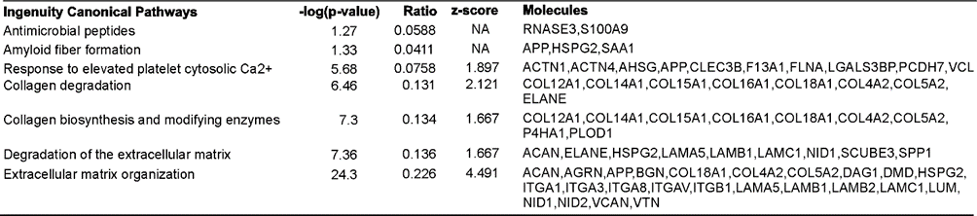

Table S4. Correlations between clinical parameters, MDA-HDL, CFH-HDL and perlecan levels in atherosclerosis patients.
Correlations | MDA-HDL |  |  |  |  |  |  |  |  |  | CFH-HDL
 | r | p |  | r |  | p |  |  | n |  | r |  | p | n
Measurements | Spearman |  |  | Pearson |  |  |  |  |  |  | Spearman
Thrombocytes (10E9/l) |  |  |  | 0.258 |  | 0.334 |  |  | 16 |  | -0.489 |  | 0.055 | 16
Triglycerides (mmol/l) | -0.497 | 0.05 |  |  |  |  |  |  | 16 |  | 0.328 |  | 0.198 | 16
Creatinine (mmol/l) | 0.212 | 0.430 |  |  |  |  |  |  | 16 |  | 0.128 |  | 0.636 | 16
GFR¹ (mL/min/1.73 m2) |  |  |  | -0.172 |  | 0.523 |  |  | 16 |  | -0.21 |  | 0.94 | 16
MDA-HDL (A450 nm) |  |  |  |  |  |  |  |  |  |  | -0.762 |  | <0.001 | 17
CFH-HDL (mg/ml) | -0.762 | <0.001 |  |  |  |  |  |  | 17 |  |  |  |  | 17
Serum perlecan (pg/ml) |  |  |  | 0.236 |  | 0.314 |  |  | 17 |  | 0.065 |  | 0.812 | 17
Correlations | Serum perlecan
 | r | p | r |  |  | p |  |  |  | n
Measurements | Spearman |  | Pearson
Thrombocytes (10E9/l) |  |  | -0.31 |  |  | 0.863 |  |  |  | 33
Triglycerides (mmol/l) | 0.128 | 0.477 |  |  |  |  |  |  |  | 33
Creatinine (mmol/l) | 0.576 | <0.011 |  |  |  |  |  |  |  | 33
GFR¹ (ml/min/1.73 m2) |  |  | -0.546 |  |  | <0.001 |  |  |  | 16
MDA-HDL (A450 nm) |  |  | 0.236 |  |  | 0.314 |  |  |  | 17
CFH-HDL (mg/ml) | 0.065 | 0.812 | -0.105 |  |  | 0.687 |  |  |  | 17
Serum perlecan (pg/ml)
¹ GFR (= glomerular filtration rate) was calculated using the Chronic Kidney Disease
Epidemiology Collaboration (CKD-EPI) equation.
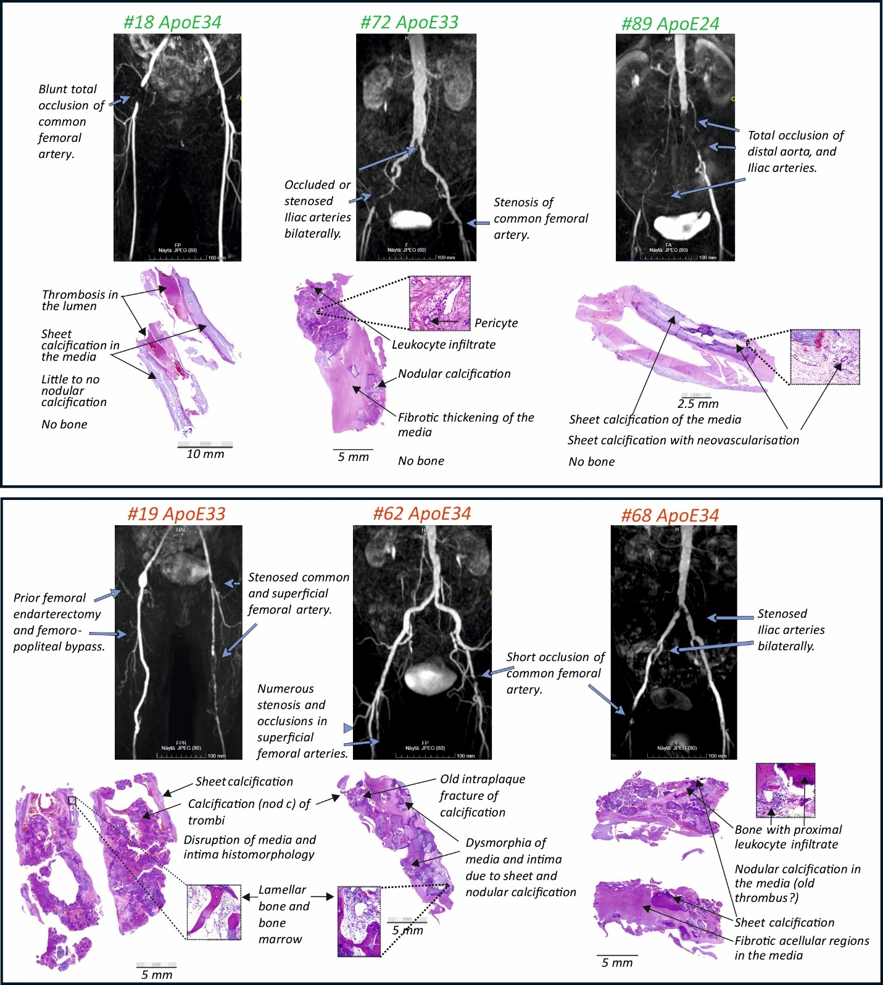
Figure S1. Magnetic resonance angiograms (MRA) of the arteries, and plaque histology of six PAD patients. MRA of the arteries in the operation area and H&E-stained paraffin sections of the plaques from patients with high (top) and low CFH-HDL levels (bottom). In MRA images, the flowing lumen of the artery is visible using contrast. Patients with high CFH-HDL levels exhibited varied calcification patterns. The patients on the left and right side have total occlusions of various lengths in arteries that do not otherwise show extensive blockage to flow that would indicate universal atherosclerosis. The middle patient shows extensive atherosclerosis. The patients (bottom panel) with low CFH-HDL levels show extensive atherosclerotic changes in the arteries and exhibited all three calcification patterns (sheet, nodular, and bone).

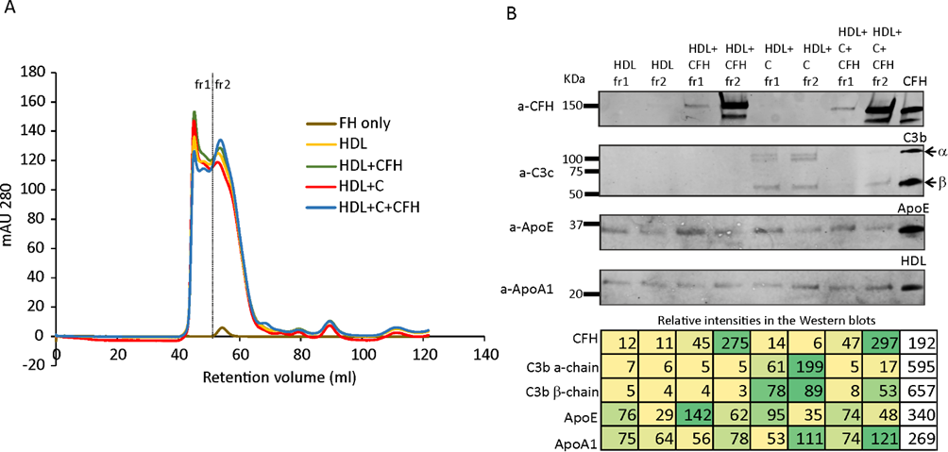
Figure S2. Preparation of HDL-2 fraction. A) HDL-2 particles ¹ (2.8 mg/ml) were incubated with 1) Ca²⁺/Mg²⁺-free Dulbecco's phosphate‐buffered saline (D‐PBS), 2) CFH (Cat#A137, Complement technology, 0.3 μM), 3) C3 (Cat#A113, Complement technology, 0.3 μM), CFB (Cat#A136, Complement technology, 0.3 μM), and CFD (Cat#A135, Complement technology, 0.03 μM), and 4) CFH together with complement components C3 (0.3 μM), CFB (0.3 μM) and CFD (0.03 μM) in D‐PBS. After incubation at 37°C for 60 min, samples were subjected to size-exclusion chromatography using Superdex 200 10/300 GL column (Global Life Sciences Solutions LLC, Marlborough, MA, USA) at a flow rate 0.5 ml/min in PBS. Peak fractions were collected and pooled (dashed line) based on the presence of CFH and ApoE, which was determined using dot blot analysis. Fraction 1 contained HDL-associated CFH, while fraction 2 contained free CFH. The combined fractions were stored at -80°C until further analysis. The protein concentrations were measured with the bicinchoninic acid assay (BCA) (Pierce Biotechnology, Rockford, Il, US) according to the manufacturer’s instructions. The results were expressed as the protein weight (μg). (dashed line). B) HDL (12 µg), FH (25ng) and ApoE (500 ng) were mixed with sample buffer and reducing agent (Cat. No. B0007 and Cat. No. B0009, Life Technologies) and incubated at 70 °C for 10 minutes. The samples were loaded onto Mini-PROTEAN TGX Stain-free precast gels (Cat.no. 4568094, Bio-Rad) and run in Tris/Glycine/SDS buffer (Bio-Rad Laboratories, Hercules, CA, USA) at 165V for 50 minutes along with a protein standard (Cat. No. 161-0375, Bio-Rad Laboratories). The gel was imaged using GelDoc Bio-Rad camera, blotted using iBlot Transfer System and iBlot 2 NC Regular Stacks (Cat. No. IB23001, Invitrogen), blocked with 3% milk-PBS, and incubated with goat anti-factor H (Cat. No. 341276, Merck Millipore) and rabbit anti-ApoE (kind gift from Dr. Matti Jauhiainen) antibodies in 0.3% milk-PBS. Next, the membrane was incubated with IRDye 800CW-conjugated anti-goat IgG (Cat. No.926-32214, LI-COR) and IRDye680nm-conjugated anti-rabbit IgG (Cat. No. 926-68073) and imaged using an Odyssey Clx Scanner (LI-COR). CFH is present on HDL fractions incubated with CFH. C3b is present in infractions incubated with Complement without CFH while it is absent on HDL sample incubated with complement components and CFH indicating inhibition of C3b deposition by CFH (competition of FB binding to C3b). Relative intensities in the Western blots are normalized against the average intensities of all the bands in each blot.

Figure S3. H&E and immunohistochemistry analysis of peripheral artery atherosclerotic plaques from patients with high (green) and low (red) CFH-HDL levels. Cryosections (10 μm) of femoral plaques were cut using a cryostat (Leica Microsystems), mounted on Superfrost microscope slides, and stored at -70°C until analysis at the Finnish Centre for Laboratory Animal Pathology (University of Helsinki). The sections were positioned to highlight the thickest areas and structural characteristics of the plaques. Additionally, they were strategically oriented perpendicular to the plaque to provide a clearer view of the vascular wall’s structure and integrity. The sections were stained using a standard H&E protocol. For immunofluorescence staining the sections were air-dryed, rehydrated and washed for 5 minutes with both PBS and PBS-T (0.05% Tween-20). The sections were preheated (92°C) in 10 mM sodium citrate buffer (pH 6.0) for 45 min, followed by cooling at room temperature for 45 min. The slides were washed three times for 5 min with PBS containing 0.05% Tween-20 (PBST; Sigma-Aldrich) and blocked with 5% BSA in PBST. Primary antibodies were applied overnight at room temperature in 3% BSA in PBST: rabbit anti-apoE (dilution 1:400), goat anti-factor H (dilution 1:400), and mouse anti-C5b9 (aE11, dilution 1:200, Cat.N. HM2167, Hycult). Following three 5 min washes in PBST, sections were incubated for 2h at room temperature with (1:500 dilution in 3% BSA in PBST): Alexa Fluor 488 (donkey anti-goat 488 Invitrogen Cat. No. A11055), Alexa Fluor 594 (donkey anti-rabbit 594, Cat. No. A21207, Invitrogen), and Alexa Fluor 647 (donkey anti-mouse IgG, Cat. No. A31571, Invitrogen). After washing, sections were mounted in Vectashield with DAPI (Cat. No. H1200, Vector Laboratories Ltd.). Negative controls were processed in parallel without primary antibody incubation. The sections were scanned under 20x magnification using a Zeiss Axio Imager 1 microscope and analyzed with Zen software (Carl Zeiss AG). Imaging was carried out at the Biomedicum Imaging Unit, University of Helsinki, supported by Helsinki Institute of Life Science (HiLIFE) and Biocenter Finland. Post-processing was done with CorelDRAW® 2023 program, where the eraser tool was used to remove background outside the tissue sections. The legend shows the distribution and colocalization of ApoE, CFH, and C5b-9 in the tissue. Controls are stained with the secondary antibodies only.

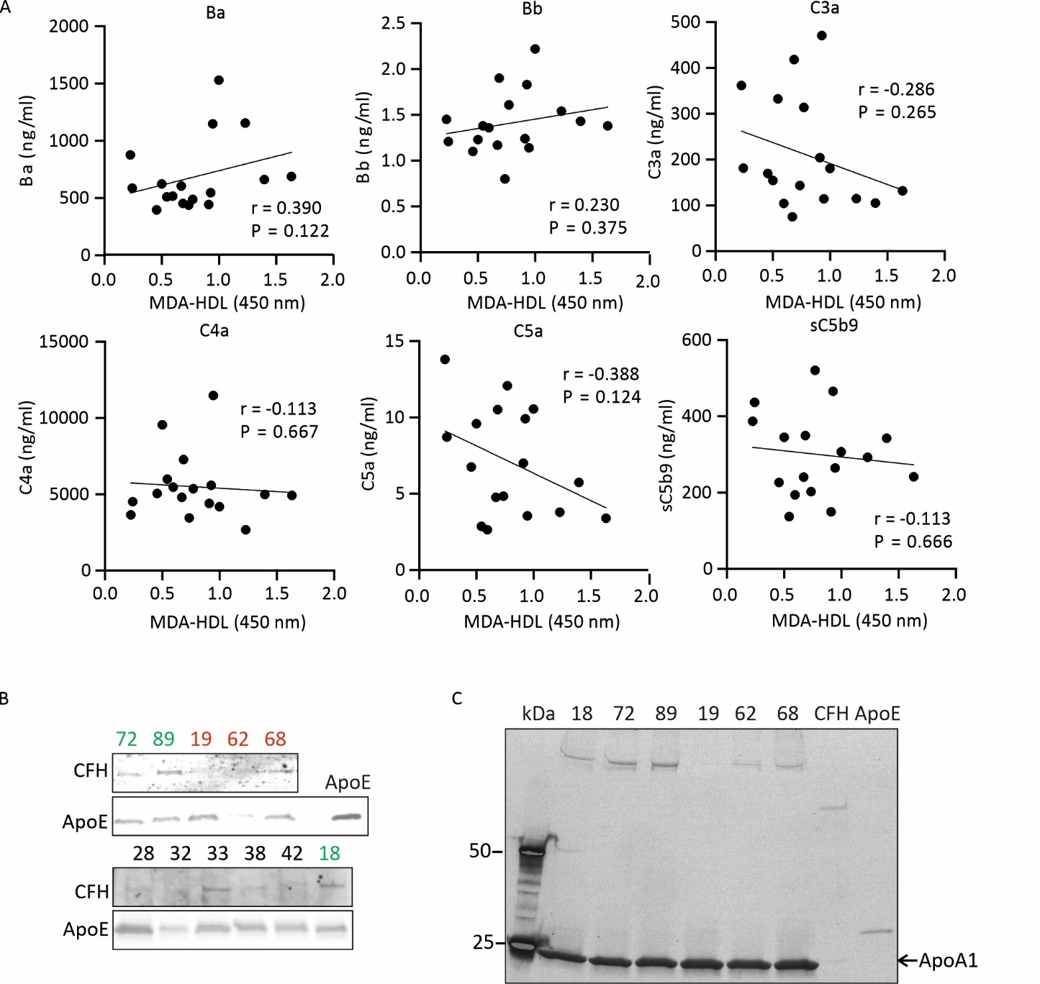
Figure S4. Correlation between serum complement activation markers and MDA-HDL levels in atherosclerosis patients. A. MDA-HDL (malondialdehyde-modified high-density lipoprotein) levels did not correlate with plasma Ba, Bb, C3a, C4a, C5a or C5b9 levels. MDA-HDL concentrations were measured from serum samples using a commercial Oxidized HDL Assay Kit (MDA-HDL, Human; Cat. No. ab242308, Abcam). Complement activation markers were determined from EDTA-plasma samples (diluted 1:50 or 1:100) using A900 MicroVue Complement Multiplex (Quidel) - Panel 1 (Ba, Bb, C3a, C4a, C5a, sC5b-9). The plate was scanned with a Q-view Image PRO scanner and analyzed using Q-View software (Quansys Biosciences). Spearman (for non-normally distributed parameters) or Pearson’s (for normally distributed parameters) correlation coefficient (r) and p-values are indicated for each complement marker and MDA-HDL. B. ApoE and CFH proteins are present in HDL particles isolated from PAD patients. The presence of CFH, C3b, ApoE and ApoA1 were detected on the isolated HDLs by Western blotting (Fig. S1). The pooled SEC fractions were run under reducing conditions on Mini-PROTEAN TGX Stain-Free precast gels (4-20%) at 120 V for 60 min and imaged with GelDoc Bio-Rad camera. CFH, ApoE, ApoAI, and C3 were detected using the following antibodies: goat anti-Factor H, rabbit anti-ApoE (Cat. No. ab183597 (EPR19392), Abcam) and rabbit anti-ApoAI (Cat. No. ab64308, Abcam). C. ApoA1, the major HDL-associated protein, is present in HDL isolated from the plasma of PAD patients. The ApoE sample (rightmost well) was used to confirm the specificity of the ApoA1 antibody.
Figure S5. H&E-stained cryosections of peripheral artery atherosclerotic plaques from patients with high CFH-HDL levels (green: 18, 72, 89) and low CFH-HDL levels (red: 19, 32, 68) showing morphological structures. Scale bars: 500 µm (same for all sections). For clarity, the grey background outside the stained tissue was removed using the 'erase' tool, without modifying the tissue itself.

