Supplemental figures
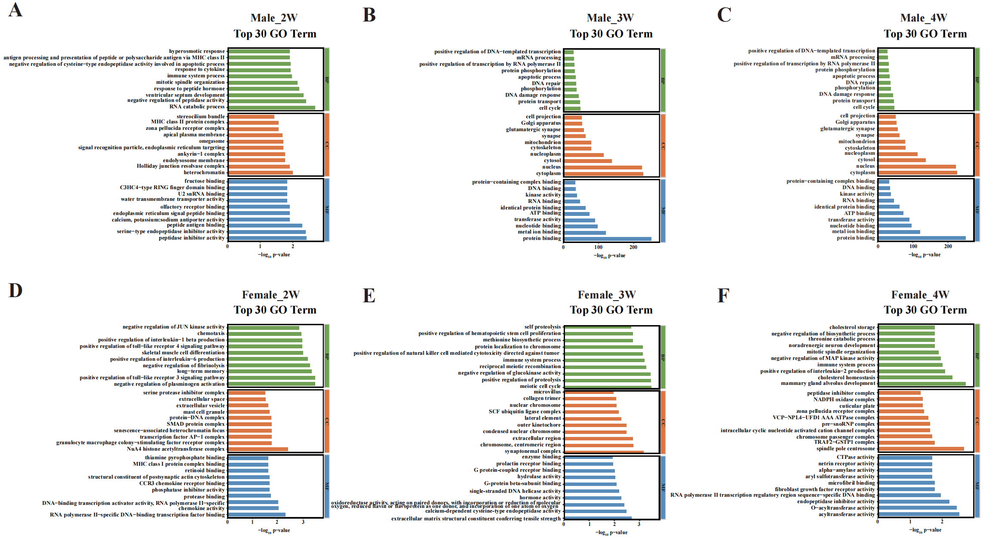
Fig. 1. GO enrichment analysis of DEGs in male and female mice after SI
(A-C) GO enrichment analysis of DEGs in male mice at 2, 3, and 4 weeks of isolation, highlighting the top 30 significantly enriched terms across three categories: BP, CC, and MF.
(D-F) GO enrichment analysis of DEGs in female mice at 2, 3, and 4 weeks of isolation, highlighting the top 30 significantly enriched terms across BP, CC, and MF.
BP: biological Process; CC: cellular components;MF: molecular functions.

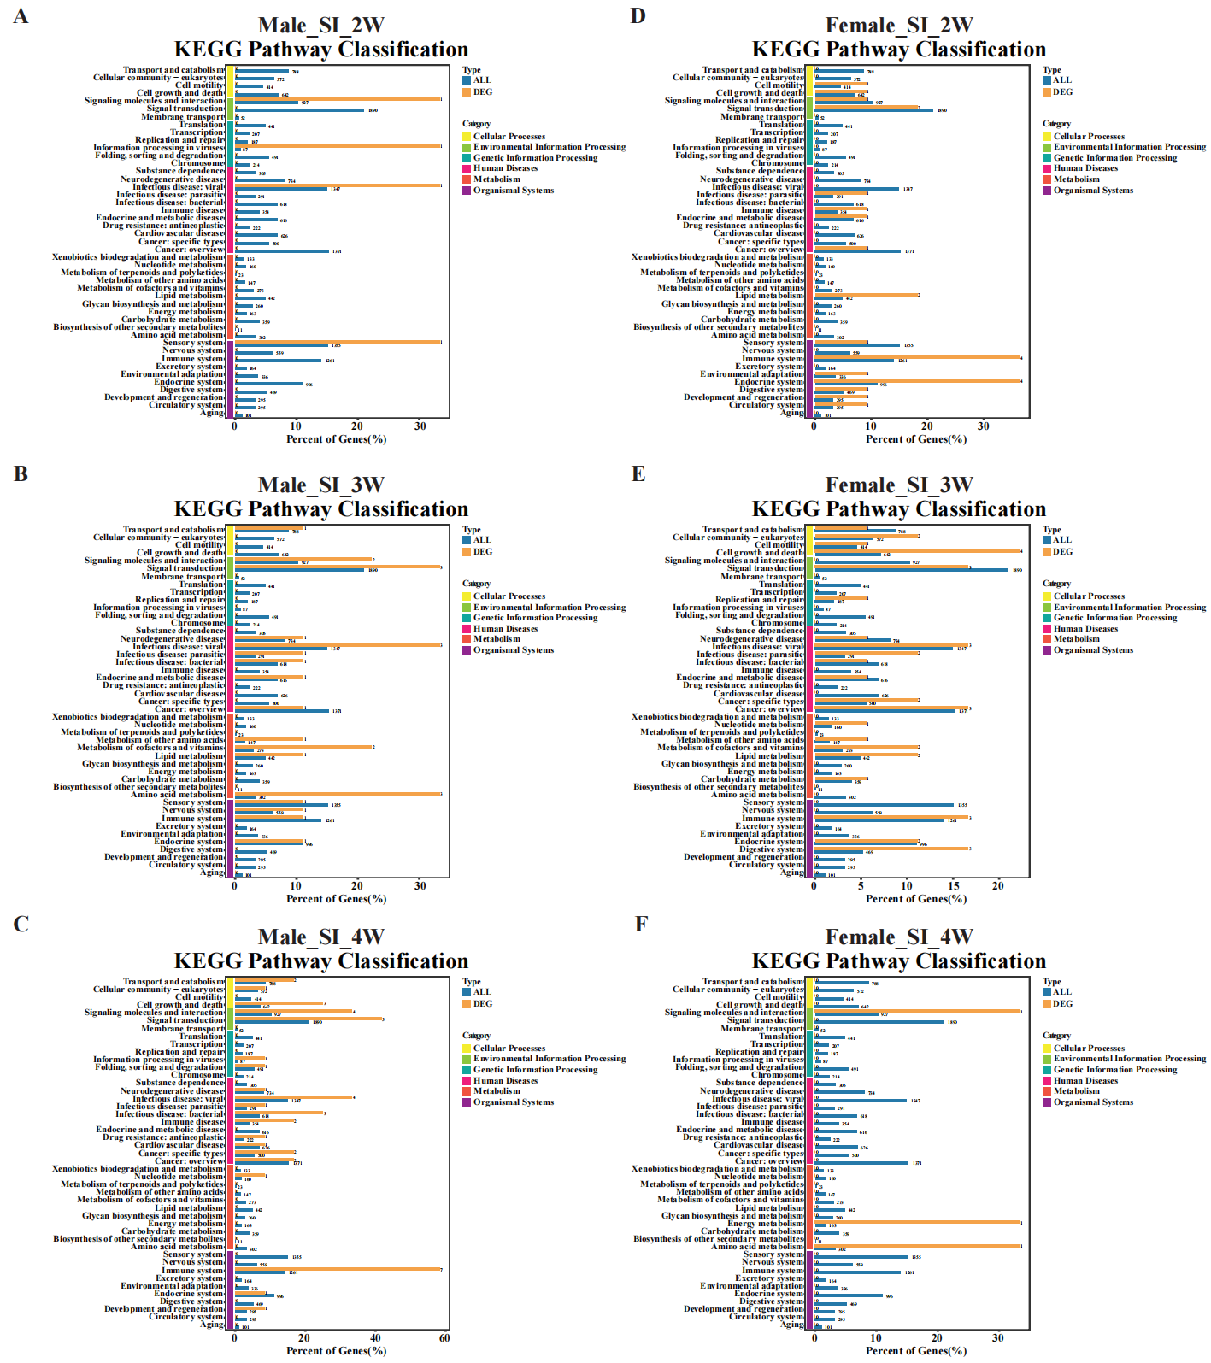
Fig. 2. KEGG pathway classification of key DEGs in male and female mice after SI
(A-C) KEGG pathway classification of key DEGs in male mice at 2, 3, and 4 weeks of isolation.
(D-F) KEGG pathway classification of key DEGs in female mice at 2, 3, and 4 weeks of isolation.

