SUPPLEMENTARY DATA
Cytotoxicity, Anti-microbial Activity, and Biochemical Alterations in Olive (Olea europaea L.) Extracts from Different Distances to the Yatağan Thermal Power Plant, Türkiye
Esra GÜRBÜZ^{1,2}, Emre AKSOY³, Aytül SANDALLI⁴, Funda BİLGİLİ TETİKOĞLU^{1,2}, Enes ŞEKER¹, Naciye Nisa KIRAN¹, Sinan TETİKOĞLU^{1,2}, Hacer MURATOĞLU¹, Muhammed Fatih KAYA³, Emine AKYÜZ TURUMTAY^{5,6,7}, Selcen ÇELİK UZUNER^{1,*}
¹ Department of Molecular Biology and Genetics, Faculty of Science, Karadeniz Technical University, 61080, Trabzon, Türkiye
² Graduate School of Natural and Applied Science, Karadeniz Technical University, 61080, Trabzon, Türkiye
³ Department of Biological Sciences, Faculty of Arts and Science, Middle East Technical University, 06100, Ankara, Türkiye
⁴ Department of Biology, Faculty of Science, Karadeniz Technical University, 61080, Trabzon, Türkiye
⁵ Department of Chemistry, Faculty of Science and Art, Recep Tayyip Erdogan University, 53100, Rize, Türkiye
⁶Joint Bioenergy Institute (JBEI), 5885 Hollis Street, Emeryville, CA 94608, USA
⁷ Biological Systems & Engineering Division, Lawrence Berkeley National Laboratory, Berkeley, CA 94720, USA
*Correspondence, selcencelik83@yahoo.com

SUPPLEMENTARY TABLES
Supplementary Table S1. Dry weights (DW) of leaves and fruits collected from the closest and farthest from the power plant. Mean ± SEM (n=5).

 | Location
 | Şahinler Village (closest) | Deştin Village (farthest)
Leaf DW (g) | 0.48 ± 0.03 | 0.60 ± 0.03 *
Fruit DW (g) | 0.69 ± 0.04 | 0.81 ± 0.03 *
* Indicates a statistically significant difference between the groups according to Student’s t-test (p < 0.05).

Supplementary Table 2. Calibration and validation parameters of HPLC-DAD method
λ (nm) | # | Compounds |  | Mean RT | RSD% of RT | RSD% of area | slope | intercept | R² | LOD (µg.mL⁻¹) | LOQ (µg.mL⁻¹)
280 | 1 | Gallic acid |  | 5.70 | 0.20 | 1.44 | 2.37 | -1.33 | 0.998 | 0.01 | 0.04
254 | 2 | Protocatechuic acid |  | 10.42 | 0.60 | 2.08 | 2.84 | -1.04 | 1.000 | 0.06 | 0.18
254 | 3 | p-OH benzoic acid |  | 18.40 | 0.21 | 0.54 | 5.39 | 0.19 | 1.000 | 0.02 | 0.07
315 | 4 | Chlorogenic acid |  | 22.29 | 0.22 | 1.25 | 1.76 | -0.11 | 1.000 | 0.05 | 0.14
254 | 5 | Vanillic acid |  | 22.51 | 0.06 | 2.59 | 2.55 | -0.95 | 0.999 | 0.07 | 0.20
315 | 6 | Caffeic acid |  | 23.66 | 0.13 | 0.19 | 2.96 | 1.05 | 0.999 | 0.01 | 0.02
280 | 7 | Syringic acid |  | 24.02 | 0.24 | 0.88 | 1.98 | -0.06 | 1.000 | 0.03 | 0.10
280 | 8 | Vanillin |  | 25.12 | 0.16 | 1.16 | 4.27 | -1.97 | 0.999 | 0.04 | 0.11
280 | 9 | Epicatechin |  | 25.48 | 0.25 | 1.23 | 0.38 | 0.04 | 0.995 | 0.04 | 0.13
315 | 10 | p-Coumaric acid |  | 28.07 | 0.20 | 0.17 | 4.73 | 0.06 | 1.000 | 0.01 | 0.02
315 | 11 | Ferulic acid |  | 30.39 | 0.44 | 1.56 | 4.13 | -0.81 | 0.999 | 0.05 | 0.16
254 | 12 | Rutin |  | 32.77 | 0.28 | 0.96 | 1.28 | -0.04 | 1.000 | 0.04 | 0.11
254 | 13 | Luteolin-7-glycoside |  | 33.12 | 0.50 | 0.94 | 1.88 | -0.92 | 0.999 | 0.03 | 0.08
280 | 14 | Naringin |  | 34.34 | 0.27 | 2.10 | 1.07 | -0.11 | 1.000 | 0.05 | 0.16
280 | 15 | Hesperidin |  | 34.87 | 0.45 | 3.54 | 0.86 | 0.16 | 0.998 | 0.17 | 0.51
315 | 16 | Apigenin-7-glucoside |  | 35.78 | 0.24 | 1.92 | 0.79 | -0.07 | 0.999 | 0.07 | 0.21
315 | 17 | Rosmarinic acid |  | 36.16 | 0.45 | 1.97 | 1.52 | -0.44 | 1.000 | 0.06 | 0.17
370 | 18 | Fisetin |  | 37.91 | 0.42 | 2.35 | 3.31 | -1.48 | 0.999 | 0.07 | 0.20
280 | 19 | Eriodictyol |  | 40.06 | 0.19 | 1.89 | 1.86 | 0.07 | 0.999 | 0.07 | 0.20
254 | 20 | Luteolin |  | 42.52 | 0.33 | 1.12 | 2.41 | -0.11 | 1.000 | 0.04 | 0.11
370 | 21 | Quercetin |  | 42.86 | 0.15 | 1.75 | 2.55 | -0.64 | 1.000 | 0.06 | 0.18
280 | 22 | Naringenin |  | 43.94 | 0.34 | 2.54 | 1.68 | 0.67 | 0.999 | 0.11 | 0.32
280 | 23 | Hesperetin |  | 45.60 | 0.35 | 2.85 | 1.71 | 0.69 | 0.999 | 0.12 | 0.36
315 | 24 | Apigenin |  | 46.89 | 0.15 | 1.92 | 1.59 | -0.04 | 0.998 | 0.07 | 0.22
370 | 25 | Kaempferol |  | 47.87 | 0.29 | 3.56 | 2.18 | 0.53 | 1.000 | 0.14 | 0.42

Supplementary Table S3. Chemical composition of the fruit (F) extracts from different locations (T, M, D) by HPLC-DAD analysis. T: Şahinler (Closest to the TPP); M: Yatağan Center (Midway to the TPP); D: Deştin (Fartherst from the TPP).
 |  |  | mg std/100g extract
# | RT | Compounds | TF | MF | DF
1 | 5.32 | Protocatechuic acid D. | 12.79 | ND | ND
2 | 7.65 | Oleuropein aglycone D1 | ND | 13.42 | ND
3 | 9.96 | Gallic acid D3 | 18.72 | ND | ND
4 | 10.29 | Protocatechuic acid | ND | ND | 8.09
5 | 11.43 | Oleocanthal D1 | ND | 11.02 | ND
6 | 21.20 | Nüzhenide 11-methyl oleoside D1 | ND | 25.45 | 76.54
7 | 21.50 | Nüzhenide 11-methyl oleoside D2 | ND | 14.11 | 40.00
8 | 21.86 | Oleuropein aglycone D1 | ND | ND | 24.33
9 | 22.17 | Nüzhenide 11-methyl oleoside D3 | 41.54 | 43.09 | 141.94
10 | 22.23 | Nüzhenide 11-methyl oleoside D4 | 148.37 | 273.51 | 716.83
11 | 25.59 | Nüzhenide 11-methyl oleoside D6 | ND | 16.77 | 32.58
12 | 26.19 | Oleocanthal D2 | ND | 8.91 | 26.22
13 | 26.66 | Nüzhenide 11-methyl oleoside D7 | ND | 16.14 | 45.42
14 | 28.02 | p-Coumaric acid | ND | 4.62 | 6.96
15 | 29.04 | Nüzhenide 11-methyl oleoside D8 | ND | 14.69 | 16.26
16 | 29.50 | Oleuropein aglycone D2 | ND | 17.65 | 55.54
17 | 29.78 | Oleuropein aglycone D3 | ND | 11.59 | ND
18 | 30.09 | Oleuropein aglycone D4 | ND | 26.53 | 108.41
19 | 30.81 | Oleocanthal D2 | ND | ND | 30.77
20 | 31.28 | Oleuropein aglycone D5 | 18.85 | ND | ND
21 | 31.55 | Protocatechuic acid D. | ND | ND | 13.84
22 | 31.83 | Nüzhenide 11-methyl oleoside D9 | ND | 14.74 | 42.05
23 | 32.30 | Rosmarinic acid D1 | 13.95 | 86.85 | 224.09
24 | 32.78 | Naringin D1 | ND | ND | 231.00
25 | 32.96 | Oleuropein aglycone D6 | 236.79 | 74.60 | 119.12
26 | 33.33 | Luteolin-7-glycoside | 12.01 | 120.29 | 275.36
27 | 34.84 | p-Coumaric acid D1 | ND | 7.47 | 32.01
28 | 36.11 | Oleuropein aglycone D7 | 48.49 | 309.02 | 842.88
29 | 37.09 | Rosmarinic acid D2 | ND | 49.50 | ND
30 | 37.31 | p-Coumaric acid D2 | ND | ND | 64.82
31 | 39.03 | Nüzhenide 11-methyl oleoside D10 | 124.62 | 34.76 | ND
32 | 39.24 | Oleuropein aglycone D9 | ND | 41.75 | 130.19
33 | 40.42 | Oleuropein aglycone D10 | ND | 6.77 | 23.25
34 | 40.91 | p-Coumaric acid-D6 | ND | 3.23 | 20.06
35 | 41.62 | p-Coumaric acid-D7 | ND | 0.42 | ND
36 | 42.57 | Apigenin D. | 2,63 | ND | ND
37 | 46.81 | Apigenin | 1.53 | ND | ND
ND, not detected
Supplementary Table S4. Chemical composition of the leaf (L) extracts from different locations (T, M, D) by HPLC-DAD analysis. T: Şahinler (Closest to the TPP); M: Yatağan Center (Midway to the TPP); D: Deştin (Fartherst from the TPP).
 |  |  | mg std/100g extract
# | RT | Compounds | TL | ML | DL
1 | 4.26 | Gallic acid D1 | 357.86 | ND | ND
2 | 9.21 | Gallic acid D2 | 53.88 | 30.68 | ND
3 | 11.60 | Oleocanthal D1 | ND | 58.03 | ND
4 | 18.01 | p-OH benzoic acid | 41.19 | ND | ND
5 | 22.13 | Chlorogenic acid | ND | ND | 31.92
6 | 22.22 | Nüzhenide 11-methyl oleoside D3 | ND | 21.23 | ND
7 | 22.64 | Chlorogenic acid D1 | ND | ND | 8.01
8 | 22.96 | Nüzhenide 11-methyl oleoside D5 | ND | 51.82 | ND
9 | 23.65 | p-Coumaric acid D1 | 8.18 | 29.74 | 40.06
10 | 24.63 | Chlorogenic acid D2 | 17.30 | 44.83 | 108.90
11 | 26.21 | Oleocanthal D2 | ND | 25.35 | ND
12 | 26.76 | Caffeic acid D1 | ND | ND | 2.87
13 | 27.26 | Apigenin gylcoside D1 | 61.48 | 60.38 | ND
14 | 28.01 | p-Coumaric acid | 29.40 | 11.78 | ND
15 | 29.49 | Oleuropein aglycone D2 | ND | 64.81 | ND
16 | 30.43 | Ferulic acid | 32.87 | ND | ND
17 | 31.08 | Ferulic acid D1 | 12.07 | ND | ND
18 | 32.29 | Rosmarinic acid D1 | 53.32 | 305.34 | ND
19 | 33.30 | Luteolin-7-glycoside | 161.01 | 210.90 | 632.39
20 | 34.60 | p-Coumaric acid D2 | ND | 52.48 | ND
21 | 34.69 | Apigenin gylcoside D2 | 91.73 | ND | ND
22 | 35.04 | Apigenin gylcoside D3 | 37.04 | ND | ND
23 | 35.35 | Apigenin gylcoside D4 | 107.62 | ND | ND
24 | 35.90 | Apigenin-7-glucoside | 348.98 | 449.51 | 954.79
25 | 36.15 | Oleuropein aglycone D7 | ND | 622.76 | 1284.09
26 | 36.50 | Luteolin glycoside D1 | 24.65 | ND | ND
27 | 37.38 | Luteolin glycoside D2 | 11.59 | ND | ND
28 | 38.14 | Luteolin glycoside D3 | 14.78 | ND | ND
29 | 38.15 | Oleuropein aglycone D8 |  | 50.29 | ND
30 | 40.11 | p-Coumaric acid D5 | ND | 16.09 | ND
31 | 42.10 | Caffeic acid D2 | ND | 32.97 | ND
32 | 42.48 | Luteolin | ND | 49.75 | 100.15
33 | 42.74 | Quercetin | 42.70 | 14.66 | ND
34 | 43.90 | Vanillic acid D1 | 26.04 | ND | ND
35 | 45.48 | Luteolin D. | ND | ND | 30.58
36 | 46.57 | Hesperetin D1 | ND | 32.52 | ND
37 | 46.70 | Apigenin | 184.91 | ND | ND
38 | 47.18 | Hesperetin D2 | 10.86 | 28.30 | ND
39 | 47.99 | Luteolin D. | 28.91 | ND | ND
40 | 48.65 | Kaempferol D. | ND | 6.94 | ND
41 | 49.64 | Oleuropein aglycone D11 | ND | ND | 176.1192
ND, not detected
Supplementary Table S5. The differences in the content of fruits and leaves by locations (OFE; O. europea fruit extracts, OLE; O. europea leaf extracts) The numbers indicate the compound numbers in Suppl Tables S2-S3.
Color Code | Location | Compound
Color Code | Location | OFE | OLE
 | Only found in the extracts collected from near the Thermal Station | - protocatechuic acid D  - gallic acid D.  - oleuropein aglycone D5  - apigenin D.  - apigenin (1,3,20,36,37) | - Gallic acid D1  - p-OH benzoic acid  - ferulic acid  - ferulic acid D1  - Apigenin gylcoside D2  - Apigenin gylcoside D3  - Apigenin gylcoside D4  - luteolin glycoside D1  - luteolin glycoside D2  - luteolin glycoside D3  - vanillic acid D1  - apigenin  - luteolin D.  (1,4,16,17,21,22,23,26,27,28,34,37,39)
 | Found in both mid and far locations but the highest amount in the farthest location from the thermal station | - Nüzhenide 11-methyl oleoside D6  - oleocanthal D2  - Nüzhenide 11-methyl oleoside D7  - p-coumaric acid  - Nüzhenide 11-methyl oleoside D8  - oleuropein aglycone D2  - oleuropein aglycone D4  (11,12,13,14,15,16,18,32,33,34) | - oleuropein aglycone D7  - luteolin  (25,32)
 | Found in all locations but the highest amount in the location far from the thermal station | - Nüzhenide 11-methyl oleoside D3  - Nüzhenide 11-methyl oleoside D4  - rosmarinic acid D1  - luteolin-7-glicoside  - oleuropein aglycone D7 (9,10,23,26,28) | - p-coumaric acid D1  - chlorogenic acid D2  - luteolin-7-glycoside  - apigenin-7-glucoside  (9,10,19,24)
 | Only in the location far from Thermal Station | - protocatechuic acid  - oleocanthal D2  - protocatechuic acid D.  - P-coumaric acid D2  - Naringin D1 (4,19, 21,30) | - chlorogenic acid  - chlorogenic acid D1  - caffeic acid D1  - luteolin D.  - oleuropein aglycone D11 (5,7,12,35,41)

Supplementary Table S6. Statistical comparison of cell viability in each cell detected by MTT cytotoxicity test
Cell | ARPE-19 |  | MCF10A |  | BEAS-2B |  | HUVEC
Parameter (Single or more) | p values |  | p values |  | p values |  | p values
Parameter (Single or more) | Fruit | Leaf | Fruit | Leaf | Fruit | Leaf | Fruit | Leaf
Dose | 0.000 | 0.000 | 0.000 | 0.000 | 0.000 | 0.012 | 0.000 | 0.000
Location | 0.000 | 0.001 | 0.003 | 0.002 | NS | 0.000 | 0.000 | 0.000
Incubation | 0.000 | 0.000 | 0.006 | NS | 0.000 | 0.000 | 0.000 | NS
Dose and location | NS | NS | NS | 0.007 | 0.000 | 0.000 | 0.039 | 0.016
Dose and incubation | 0.003 | 0.000 | NS | 0.050 | 0.000 | 0.000 | 0.000 | NS
Location and incubation | NS | NS | 0.001 | NS | 0.008 | NS | NS | 0.003
Dose, Location, and incubation | NS | NS | NS | NS | 0.000 | 0.005 | NS | NS
NS; not significant. p values ≤0.05 are considered significant

Supplementary Table S7. Cell viability comparisons between the cells treated with 100µg/mL or 500µg/mL leaf or fruit extracts for 48h collected from the closest location to the thermal station
Cell 1 | Cell 2 | Leaf extract |  | Fruit extract
Cell 1 | Cell 2 | 100µg/mL 48h | 500µg/mL 48h | 100µg/mL 48h | 500µg/mL 48h
ARPE19 | BEAS-2B | 0.003 | NS | NS | 0.000
ARPE19 | HUVEC | NS | NS | NS | 0.000
ARPE19 | MCF10A | NS | NS | 0.011 | 0.007
BEAS-2B | ARPE19 | 0.003 | NS | NS | 0.000
BEAS-2B | HUVEC | 0.001 | NS | NS | 0.027
BEAS-2B | MCF10A | 0.001 | NS | NS | 0.000
HUVEC | ARPE19 | NS | NS | NS | 0.000
HUVEC | BEAS-2B | 0.001 | NS | NS | 0.027
HUVEC | MCF10A | NS | NS | NS | 0.005
MCF10A | ARPE19 | NS | NS | 0.011 | 0.007
MCF10A | BEAS-2B | 0.001 | NS | NS | 0.000
MCF10A | HUVEC | NS | NS | NS | 0.005
NS; not significant. p values ≤0.05 are considered significant

Supplementary Table S8. Antimicrobial and antifungal activities of extracts on bacteria and fungi.
Microorganism | Extracts |  |  |  |  |  | Antibiotics
Microorganism | ML | MF | TL | TF | DL | DF | Ampicillin | Kanamycin
B. subtilis | N.E. | N.E. | N.E. | N.E. | N.E. | N.E. | 0.781 | -
E. faecalis | N.E. | N.E. | N.E. | N.E. | N.E. | N.E. | 0.195 | -
S. aureus | 13.75 | N.E. | 12.5 | 20 | 12.5 | 30 | 0.39 | -
P. aeruginosa | N.E. | N.E. | N.E. | N.E. | N.E. | N.E. | 12.5 | -
Y. pseudotuberculosis | N.E. | N.E. | N.E. | N.E. | N.E. | N.E. | 3.125 | -
E. coli | N.E. | N.E. | N.E. | N.E. | N.E. | N.E. | 25 | -
C. albicans | N.E. | N.E. | N.E. | N.E. | N.E. | N.E. | - | 25
MIC values are shown as mg/ml. N.E (no effect); MIC values of some extracts could not be determined
ML; middle-leaf, MF; middle fruit, TL; thermal-leaf, TF; thermal fruit, DL; Destin village-leaf, DF; Destin village-fruit

SUPPLEMENTARY FIGURES
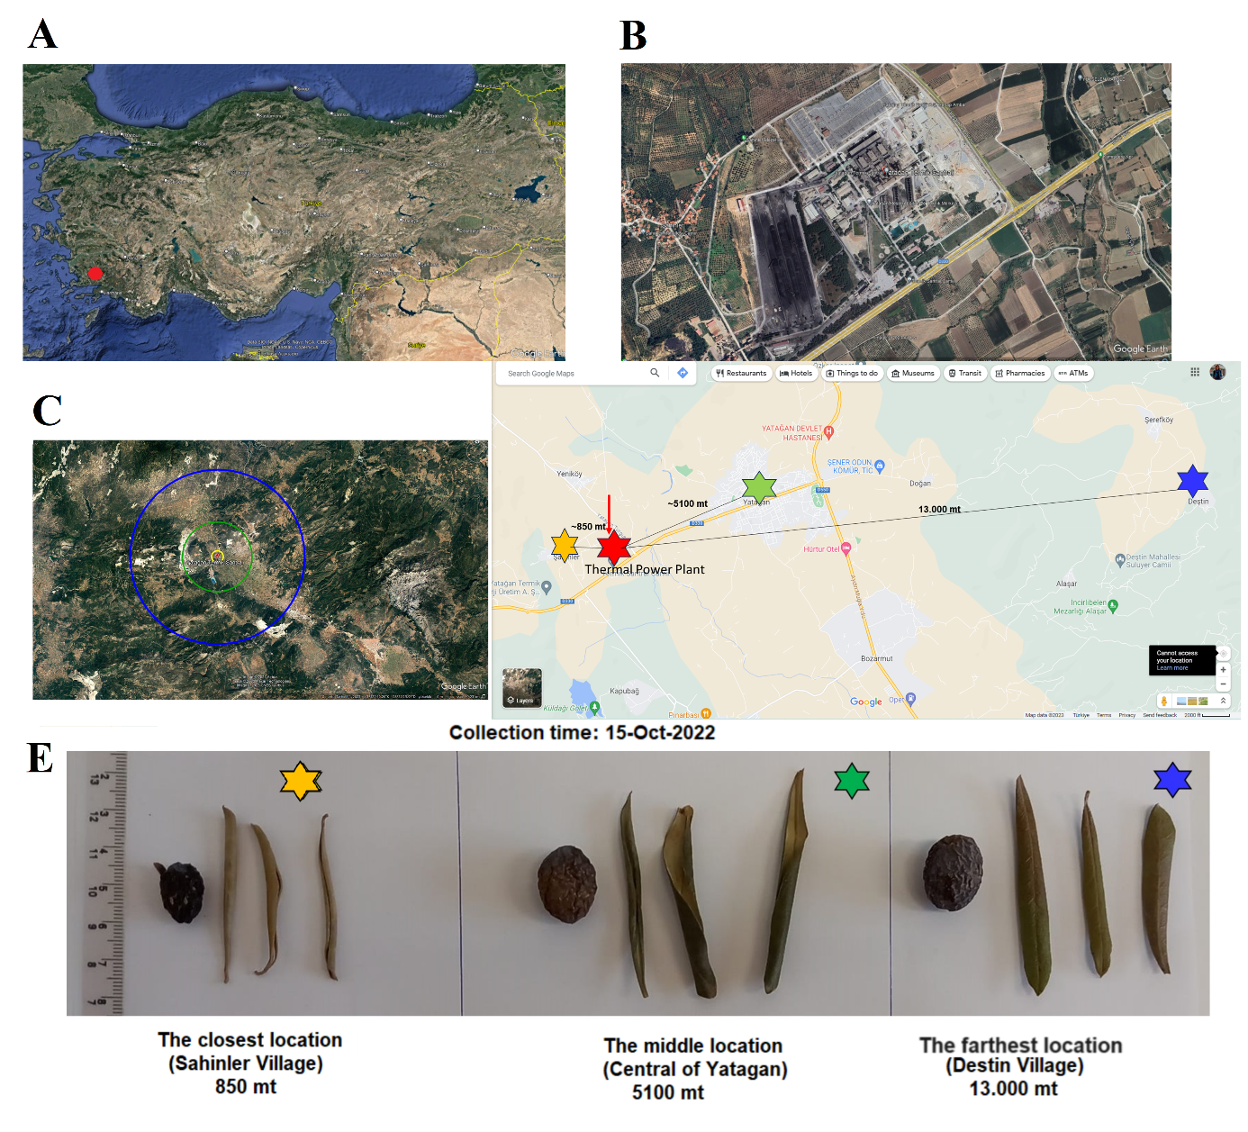
Supplementary Figure S1. Sample collection locations and morphophysiological properties. The location of Muğla province (A), a close view of the thermal power station (B), circles indicating the diameter of collection areas (yellow, green, and blue stars) with different distances from the power plant (red) (C), the distances from the power plant (red star) by calculation of direct lines (D), and representative morphological profiles of olive fruits and leaves from different locations, after drying (E). Bar: 1 cm.

Supplementary Figure S2. Samples of extraction obtained from olive fruit and leaf (O. europaea) collected from three distances from the TPP.
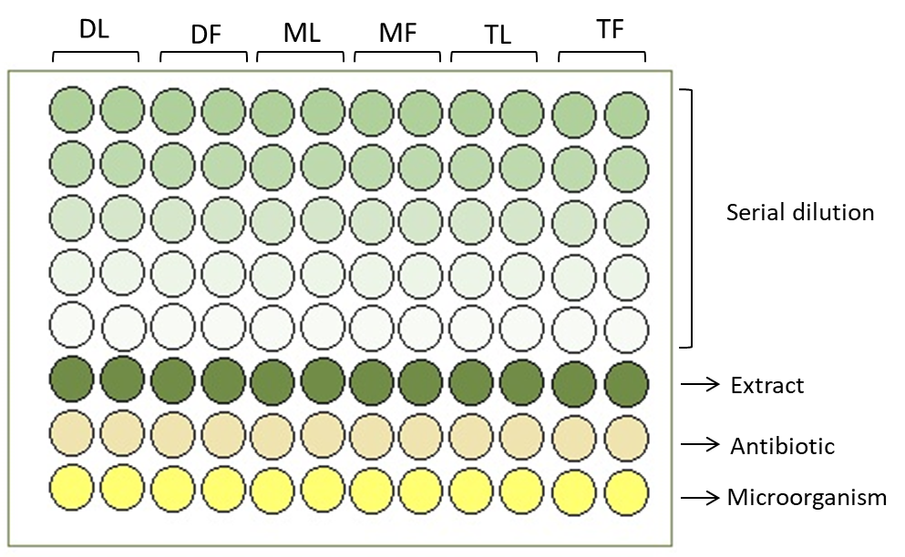
Supplementary Figure S3. Representative microplate design for anti-microbial experiments. DL; Destin village-leaf, DF; Destin village-fruit, ML; middle-leaf, MF; middle fruit, TL; thermal-leaf, TF; thermal fruit

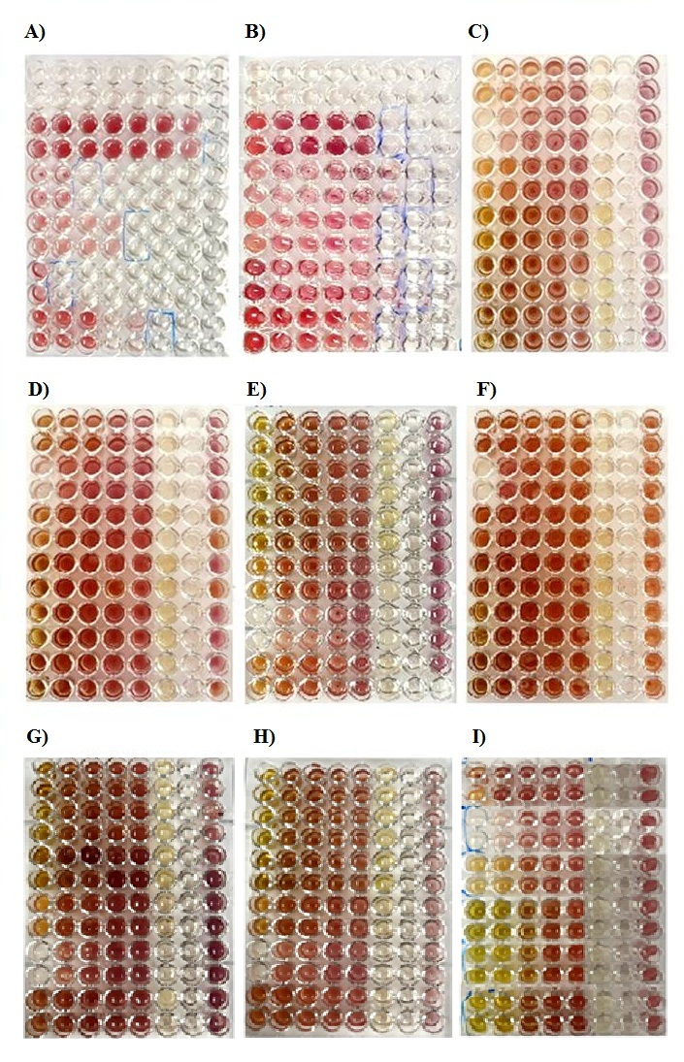
Supplementary Figure S4. INT colorimetric assay. MIC doses of A) Ampicillin antibiotic (50 mg/ml) in all bacteria, B) DMSO (%100) in all bacteria, C) extracts against B. subtilis, D) extracts against Candida albicans, E) extracts against E. Coli, F) extracts against E. feacalis, G) extracts against P. aeroginosa, H) extracts against Y. pseudotuberculosis, I) extracts against S. aereus.
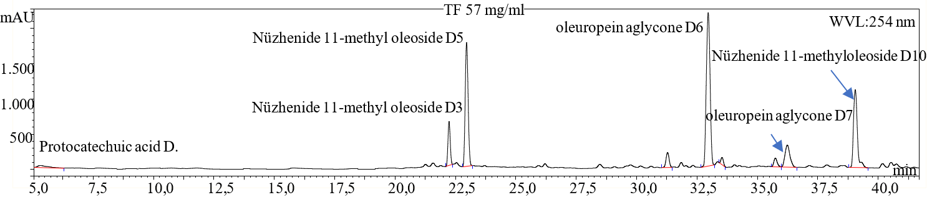
Supplementary Figure S5. HPLC-DAD chromatogram of TF extract at 254 nm.
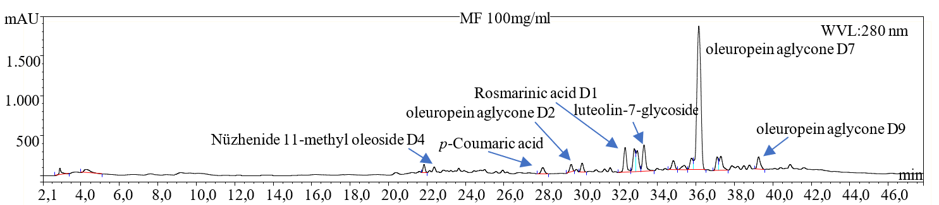
Supplementary Figure S6. HPLC-DAD chromatogram of MF extract at 280 nm.
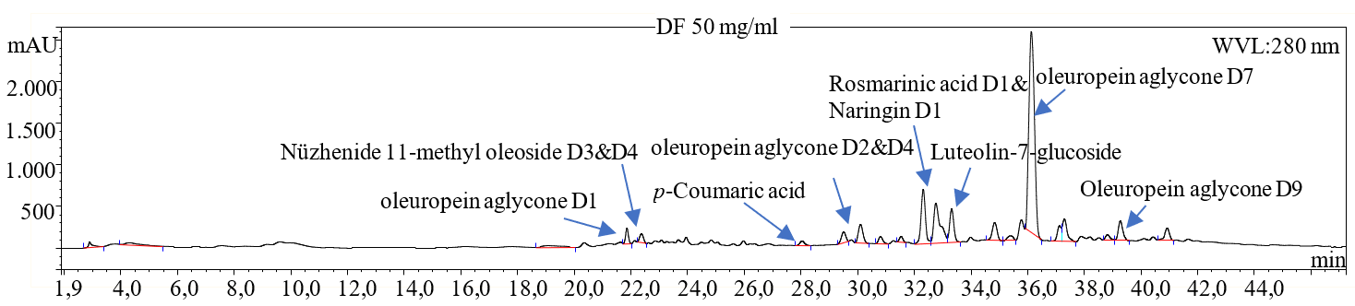
Supplementary Figure S7. HPLC-DAD chromatogram of DF extract at 280 nm.
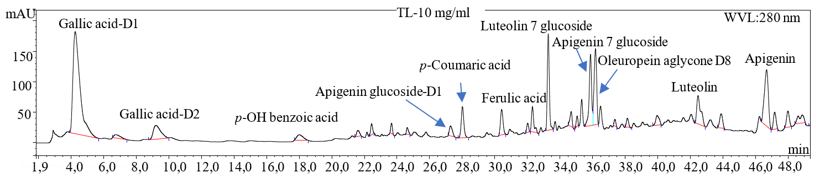
Supplementary Figure S8. HPLC-DAD chromatogram of TL extract at 280 nm.
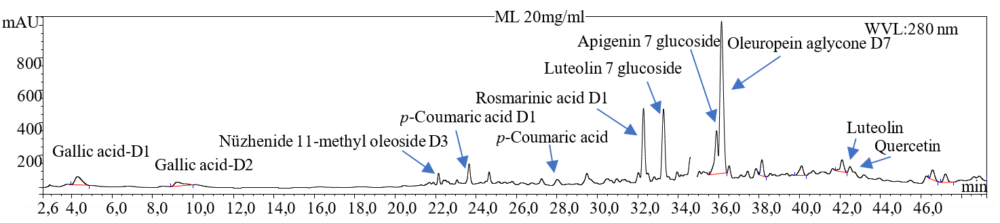
Supplementary Figure S9. HPLC-DAD chromatogram of ML extract at 280 nm.
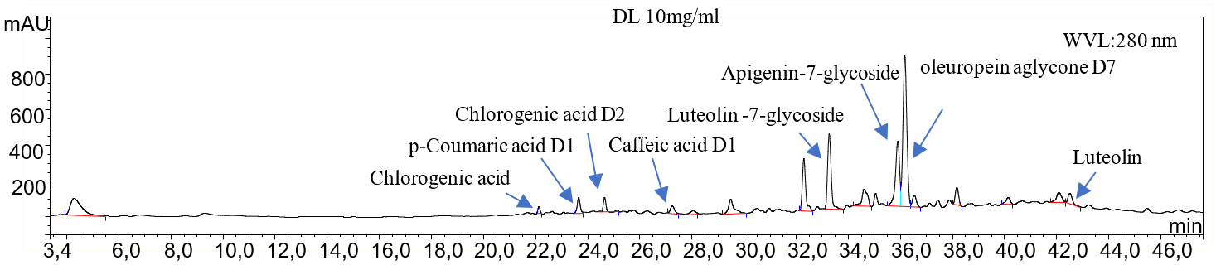
Supplementary Figure S10. HPLC-DAD chromatogram of DL extract at 280 nm.

References

Cecchi, Lorenzo, Giulia Ghizzani, Maria Bellumori, Carmen Lammi, Bruno Zanoni, and Nadia Mulinacci. 2023. “Virgin Olive Oil By-Product Valorization: An Insight into the Phenolic Composition of Olive Seed Extracts from Three Cultivars as Sources of Bioactive Molecules.” Molecules 2023, Vol. 28, Page 2776 28 (6). Multidisciplinary Digital Publishing Institute: 2776. doi:10.3390/MOLECULES28062776.
Demir, Elif Ayazoglu, A. Colak, S. Celik Uzuner, and O. Bekircan. 2021. “Cytotoxic Effect of a 3-(4-Chlorophenyl)-5-(4-Methoxybenzyl)-4H-1,2,4-Triazole Derivative Compound in Human Melanoma Cells.” International Journal of Biology and Chemistry 14 (1). al-Farabi Kazakh National University: 139–148. doi:10.26577/IJBCH.2021.V14.I1.015.
Kuete, Victor, Rémy BetrandTeponno, Armelle T. Mbaveng, Léon A. Tapondjou, Jacobus J.M. Meyer, Luciano Barboni, and Namrita Lall. 2012. “Antibacterial Activities of the Extracts, Fractions and Compounds from Dioscorea Bulbifera.” BMC Complementary and Alternative Medicine 12 (November). BMC Complement Altern Med. doi:10.1186/1472-6882-12-228.
Kumar, Priti, Arvindhan Nagarajan, and Pradeep D. Uchil. 2018. “Analysis of Cell Viability by the MTT Assay.” Cold Spring Harbor Protocols 2018 (6). Cold Spring Harbor Laboratory Press: pdb.prot095505. doi:10.1101/PDB.PROT095505.
Spagnuolo, Carmela, Stefania Moccia, Idolo Tedesco, Giuseppina Crescente, Maria Grazia Volpe, Maria Russo, and Gian Luigi Russo. 2023. “Phenolic Extract from Extra Virgin Olive Oil Induces Different Anti-Proliferative Pathways in Human Bladder Cancer Cell Lines.” Nutrients 15 (1). MDPI. doi:10.3390/NU15010182/S1.

