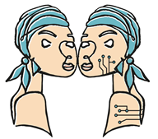



DATA MANAGEMENT PLAN versión 1.0

PROYECTO DE MEDICINA PERSONALIZADA DE PRECISIÓN
PMP22/00032

HIGH DEFINITION MEDICINE (HDM)
Establecimiento de una cohorte de pacientes con cáncer avanzado para seguimiento prospectivo de alta resolución

COORDINATING INVESTIGATORS:
Miguel Quintela Fandiño. CNIO – Centro Nacional de Investigaciones Oncológicas
Ramon Colomer Bosch – Hospital Universitario de la Princesa

DATA MANAGEMENT PLAN (DMP)
This document represents the 1st version of the High Definition Medicine (HDM) Data Management Plan (DMP). The aim of this document is to describe the data management life cycle for all data sets that will be collected, processed, or generated by the HDM project.

0. Project name
“Integrating longitudinal patient-generated data and multi-omic profiling for comprehensive precision oncology in women's cancer” High Definition Medicine (HDM)

1. Description of the data
1.1 Type of study

This project requires a prospective observational study with longitudinal deep patient sampling and profiling and data science, oriented to refine our current understanding of cancer processes and outcomes, with the aims of improving our current predictive capacity in Oncology and achieve better treatment efficacy outcomes (RR, PFS, OS).

The working plan includes a longitudinal data collection of the 300 patients and samples at the 9 clinical sites of the consortium:

Ramon Colomer Bosch – Hospital Universitario de la Princesa
Begoña Bermejo (Hospital Clínico Universitario de Valencia)
Sonia Pernas Simón (ICO Bellvitge)
Juan Antonio Guerra (Hospital de Fuenlabrada)
Josefa Terrasa Pons (Hospital Son Espases)
Ruth Vera (Complejo Hospitalario de Navarra)
David Vicente Vaz (Hospital Virgen de la Macarena)
Santiago González (Hospital San Pedro de Alcántara)
Rosario García Campelo (Hospital Universitario A Coruña)

Coordinating Institution:
Miguel Quintela Fandiño. CNIO – Centro Nacional de Investigaciones Oncológicas

Data management and Analysis:
Antonio Artés (Universidad Carlos III)
Alfonso Rodríguez Patón (Universidad Politécnica de Madrid)

1.2 Types of data

We propose two approaches: 1) incorporating automated, remote, passive patient-generate data gathering to the current factors that are considered for clinical decisions; and 2) extend data gathering beyond genomics.

We plan to lead the transition from current precision oncology to Patient-Led Precision Oncology (PLPO), a new approach than instead of studying univariate relationships with clinical outcomes, considers the whole Patient Data Universe (PDU)
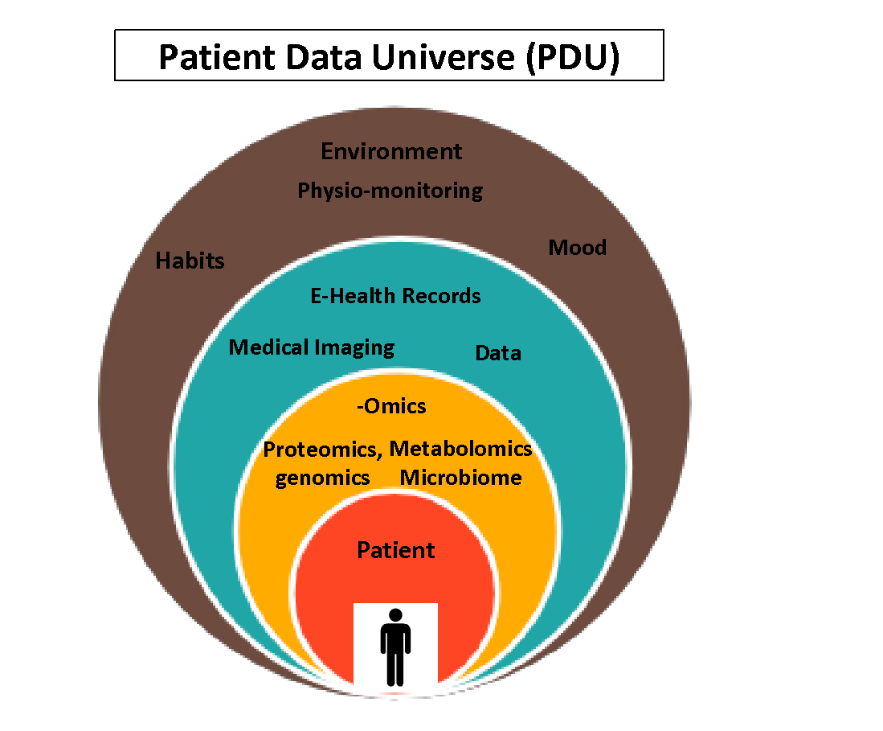

The PLPO study will combine the interdisciplinary expertise of clinical oncology, translational oncology, wearable monitoring devices data capture, App design, and data science and artificial intelligence to conduct this prospective study.

We will capture data from and monitor the following spheres:
-Continuous physiological monitoring and patient-reported outcomes that include qualitative and quantitative data through different questionnaires.

-Digital footprint: that includes qualitative and quantitative data about patient features as social interactions, habits, and physical localization.

- Multi-Omics: plasma metabolomics and proteomics, blood and tumor whole exome sequencing, whole blood DNA methylation and gut microbiome. This will include patient´s samples: tissue samples, blood samples and stool samples.

-Electronic Health Records (EHR) and medical imaging tests: the medical records include administrative and demographic data, qualitative and quantitative data about the disease, physical stage and other diseases, and lab parameters and image test.

-Physical activity, sleep, physiologic parameters: these parameters will be passively collected
with a combination of a wearable monitoring device (Garmin vivosmart 4) and a smartphone app, which is a type 1 medical device.

1.3 Format and scale of the data

Daily summaries are generated with important variables extracted from passive and active data, the defined variables are:
- Sleep: minutes slept per day, phases, quality.
- Heartbeat.
- Activity: steps.
- Mobility: number of hours away from home.
- Mobile phone usage: total usage time, screen unlocks.
- Oxygen saturation.
- Emotions (intensity/valence coordinates)

Omics data:
- Gut microbiome: data will be collected twice per subject (at 0 and 3 months). The data consists of DNA sequences (shotgun metagenomics) in plain text (FASTA format). The estimated size per subject is 4Gb.
- Blood metabolome: data will be collected twice per subject (at 0 and 3 months). The data consists of abundance tables in plain text format (csv). The estimated size per subject is <1Gb.
- Tumor genome: data will be generated once per subject using basal samples. The data consists of DNA sequences (whole exome sequencing) in plain text (FASTA format). The estimated size per subject is 20Gb.
- Blood proteome: data will be collected twice per subject (at 0 and 3 months). The data consists of abundance tables in plain text format (csv). The estimated size per subject is <1Gb.
- Germline genome: data will be generated once per subject using basal samples. The data consists of signal intensities in IDAT format. The estimated size per subject is <1Gb.
- Whole blood DNA methylation: data will be generated three times per subject (at 0, 3 and 6 months). The data consists of signal intensities in IDAT format. The estimated size per subject is <1Gb.

Data at rest at CNIO facilities:
- The data collected and available at CNIO is available as a shared folder or NFS export only available to the right set of users, with the right level of privileges on each piece of data (RBAC).
- The login and authorization are centrally managed on CNIO’s Identity Provider, based on LDAP, kerberized and highly available.
- CNIO replicates the information to a second location, and backups it with an Enterprise level solution that allows different levels of backup (immutable, full and incremental mainly), and with different retention types.
- As part of the Security Program that is in place, the Centre has anti-Ransomware solutions that are directly related with the storage available for this project.
- The Foundation uses Endpoint Advanced Protection in all computers, Antivirus solutions and Next-Gen Firewalls deployed in different layers.
- Remote access to CNIO is only allowed through MFA, with restrictions at timing and access level.
- IT department routinely checks the level of access for the different groups and/or ACLs. The right to add/modify/delete accesses/authorizations comes from the Project Leader, that communicates any change needed to the IT team.

2. Data collection / generation / reuse
2.1 Will the project reuse data?
Yes ☐ No ☒

New data / data management

This project requires a prospective study with longitudinal deep patient sampling and profiling and data science, oriented to refine our current understanding of cancer processes and outcomes.

The protocol and the informed consent are approved by the Ethics Committee and by the management of each participating center.

The participating hospital staff are trained during the initiation visits and there will be a close monitoring of the data by the coordinating institution staff.

The proposed project will involve human participants and will acquire biological samples (blood, cells, plasma, fecal matter and paraffin embedded tumor), clinical and genomic data from 300 patients with mama, colon or lung cancer. It will utilize samples collected from patients who have provided informed consent. The lab team will not have access to the samples’ identifiers linked to the patients.

2.2 Methodologies for data collection / generation

Data will be collected at any of the 9 participating hospitals and principal investigators will identify and invite the patients to participate in the study.

Written informed consent must be obtained from the patient before a patient is included in the study or before any study-specific procedure is performed, in accordance with ICH E6R2 guidelines.

Data collection will be performed according to the approved protocol of the study.

The data will include the above-mentioned spheres:

- A Wearable physiologic monitoring device and the eB2 App will collect the continuous physiological monitoring and patient-reported outcomes, combined with active engagement of the patient in reporting mood, well-being or functional status as well as filling-in different questionnaires.

The data collected by the app can be categorized into passive and active data. Passive data, primarily gathered through a Garmin Vivosmart 4 wearable, enables continuous patient monitoring by collecting information on sleep, physical activity, heart rate, and oxygen saturation. On the other hand, active data includes filling in questionnaires, mood reporting and nutrition reporting.

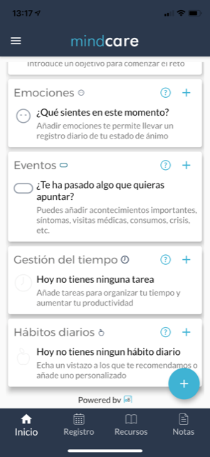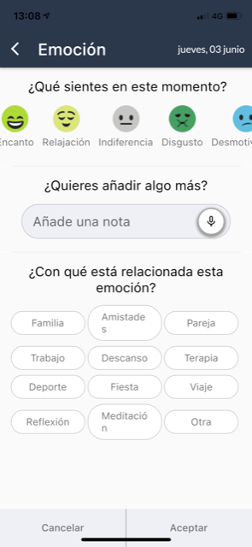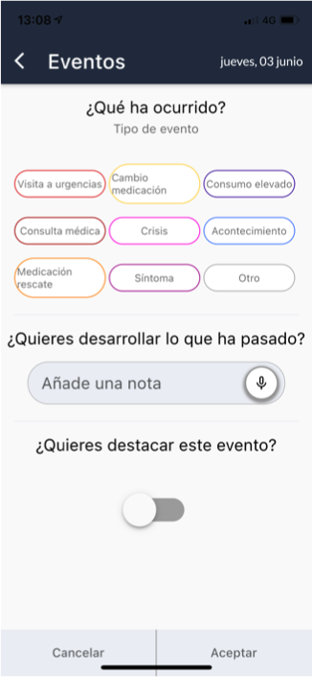

The penetrance of smartphones and different Apps allows accessing to other patient features. Social interactions, habits, and physical localization can be monitored with simple Apps.

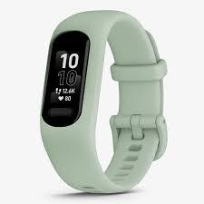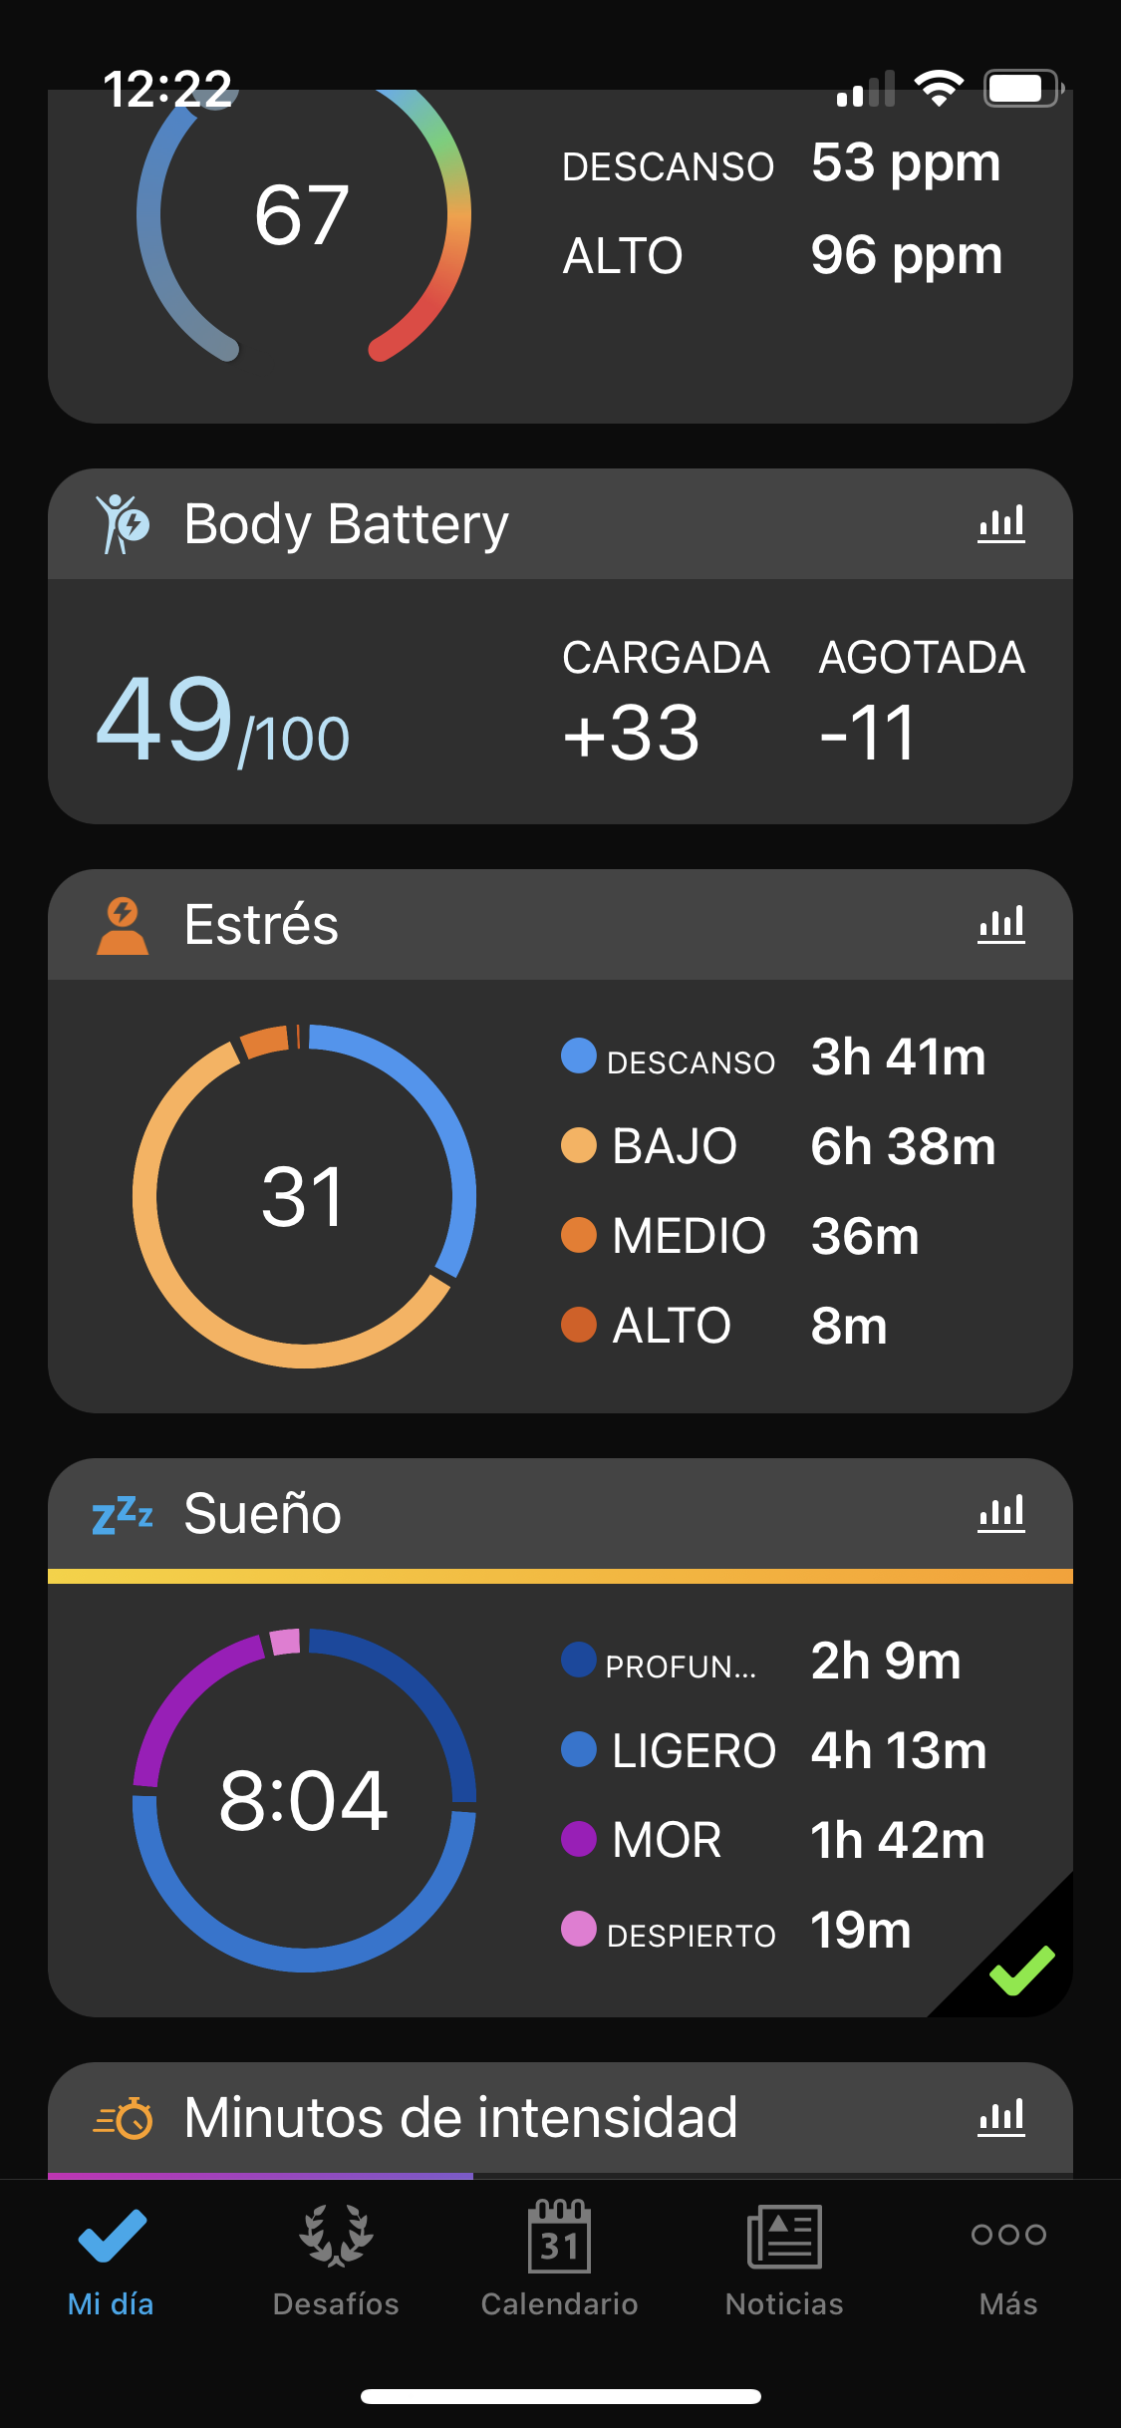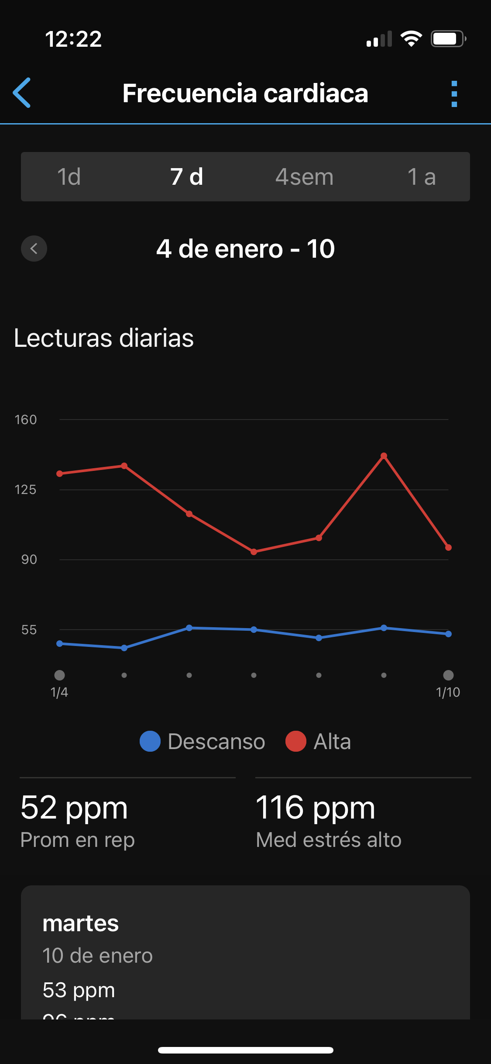

-Multi -Omics: currently, the evolution of -omics, allows a robust, inexpensive, deep and broad assessment of several potential source layers beyond genomics: plasma metabolomics and proteomics, tumor and germline genomics, whole blood DNA methylation and microbiome.
The patient´s samples are collected at each participating site following the protocol schedule. The sample management at sites is performed following the Study Sample Management Plan what includes all the information about the pre-processing of each sample and the archive and shipping information. The shipment and the final processing for analysis is performed at the coordinating institution.

-Electronic Health Records (EHR) and medical imaging tests will be collected at each participating site according to the data and schedule of the approved study protocol. The information will be completed at the electronic Case Report Form (e-CRF) accessible at each participating site. This e-CRF is in compliance of the 21 CFR11 (FDA) and all information is coded and anonymized to each patient in compliance with the ICH Good Clinical Practice.
The investigators at each site will complete the requested data for each patient at the e-CRF, according to the parameters and visits described at the study protocol.

2.3 Data quality and standards
The consistency and quality of data will be controlled by the investigator at each site and supervised by the staff of the coordinating institution.

The information from the EHR will be enter by the data managers of each site to the e-CRF. The study coordinator of the coordinating institution has e-access to the database of each patient and site, and will confirm the validation of data. There an automated validation process at the e-CRF where it raises queries in case of inconsistencies or incomplete data. The Study coordinator may also create manual queries that the data entries and investigators of each site should answer and solve. The last revision will happen when the database of each patient should be locked down by the data management and statistician staff.

The Wearable device and the eB2 App are supervised by the staff of eB2 corporation and the Universidad Carlos III. The site investigators have access to the dashboard of the applications and may follow up the registration of data, completion of questionnaires by the patients and registration of activity by the wearable device. They will review, and train the patient if needed, at every patient visit.

The data is continuously collected from the eB2 mobile device app, employing mechanisms to ensure uninterrupted data gathering. Additionally, there are methods in place to address missing data to guarantee data accuracy and maintain data quality.

Only researchers authorized by the Principal Investigator have access to the data available in the panel, for which they are provided with authenticated user credentials to ensure data security. Furthermore, in the eB2 system, no personal patient data is stored, and to protect patient anonymity, a numerical code is assigned to each patient, this code is the only way to identify patients, it is in the data collection notebook, which can only be accessed by the authorized personnel.

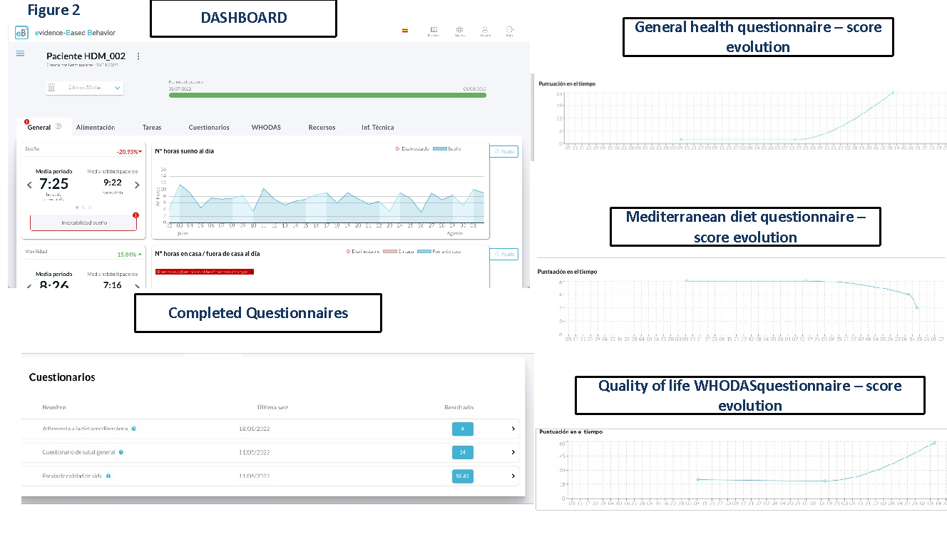
The study coordinators of the coordinating institution may review the completion of all this data and request for action to the responsible investigator on a specific case.

The patient samples are collected by the study nurses at each site. Each sample has to be labelled and coded with the unique identification number of the patient and pre-processing, storage and shipping will be performed following the instructions from the Study Sample Management Plan. The quality control of the samples is performed at the Coordinating Institution by the lab staff. Any deviation on the procedure of collection and pre-processing will be informed to the site staff to correct for the following samples and updated the Study Sample Management Plan, if needed.

3. Data management, documentation and curation
3.1 Managing, storing and curating data.

The e-CRF system, developed by ShareCRF, is certified annually with ISO 9001 and ISO 27001 for information security. Data will be stored at Amazon Web Services (AWS) hosting infrastructure that is compliant with SOC 1, SOC2, ISO 27001, with measures over physical access and authorization, protection against natural disasters, malicious attacks, accidents, environmental hazards, etc.

All records are stored in two different geographical locations. The data can be recreated from the backup. Data created after the last backup is usually lost. ShareCRF provides Data Backup, Data Recovery and Disaster Recovery.

ShareCRF supports user/password credentials. Each user has a unique user/password credentials. Each credential has access to the clinical studies which has been invited by the Study Administrator and with profiles selected by Study Administrator. The right access is defined in the profiles section of the study.

The eB2 MindCare App is a Class I Medical Device, which implies the compliance with safety and privacy protocols. Daily backups of all the information are conducted, and there exists an automated system for storing all data in non-relational databases.

Samples will be collected from each hospital by sanitary personal under regulated sanitary standards. After, samples are processed following instruction describes in the technical document of this project "Manual de laboratorio para el manejo de muestras biológicas, proyecto High Definition Medicine". All biological samples will be transport to Central laboratory (CNIO) under appropriate conditions in order to preserve their integrity.

Samples will be registered at electronic databases where kind of sample, number of patient and collection date will be annotated.

Blood, cells, plasma and fecal samples will be stored in tubes identified with alphanumeric codes, in minus 80 freezer or in nitrogen tanks which are located in CNIO. The sample names are written at the top and at the side label of each tube and it should match with the sample information form.

Each tube is sealed with parafilm before packaging. Cotton or absorbent papers can be used to prevent tubes from moving inside the container. Samples are shipped in dry ice under company instructions. Only skilled personnel from Breast Cancer Unit can access to the frozen samples. Maintenance and quality control of freezers and nitrogen tank are under CNIO supervision.

The samples are completely spent after analysis. QC reports are issued before the analysis with concentration and quality data. Raw data may be downloaded up to one month after their analysis. Then, the raw data will not be available anymore.

3.2 Metadata standards and data documentation

The e-CRF metadata includes questionnaires and masterfiles (IDC questionnaire (clinical data), ISP questionnaire (follow-up data), PQ questionnaire (morphological data), PG_Codebook_PQ and Patient’s registration SOP.

The data will be managed in accordance with the FAIR principles. Specifically, to make the data Findable, all the repositories will be detailed and linked in the project’s publications and website. We will use repositories which guarantee that the data is publicly Accessible (e.g. GEO, EMBL’s MGnify). All the data will be available either in plain-text formats or accessible through processable through open-source tools [1] (microarray data), making it highly Interoperable. We will provide accompanying metadata to make the data Reusable while maintaining the patients’ anonymity.

4. Data security and confidentiality of potentially disclosive information
4.1 Formal information/data security standards

The e-CRF system, developed by ShareCRF, is certified annually with ISO 9001 and ISO 27001 for information security. Certificates are available at https://www.sharecrf.com/es/calidad

4.2 Main risks to data security

ShareCRF implement all the necessary measures to ensure privacy and security over the information stored and transmitted by ShareCRF, as well as the requirements for each feature added to the system. Security is applied in both the cloud environment with the infrastructure for the platform, and on-premises, where all employees are subject to strict policies regarding their equipment (full disk encryption, strong passwords, non-admin privileges and prohibition from installing unauthorized software).

A Disaster Recovery Plan is maintained and tested periodically for different areas (disasters covering API servers, databases, regional infrastructure impact, backup, recovery, etc.).
At the e-CRF, all communications between users and servers are encrypted using HTTPSprotocol, segregation of network groups for the different components of the infrastructure, firewall and DDoS shield.

The access to the e-CRF system is by user/password credentials: Password encrypted on users database; Automatic user lockout when the password is incorrect several times in a row;
User password selection is limited to high-level password security; User access permissions are configurable at the study level.

Any security incident is reported, addressed and traced in the e-CRF system, following the corresponding procedure for classification, resolution and documentation. Knowledge gained from analyzing and resolving the incidents is documented to reduce the probability or impact of future incidents. all information is classified and protected regarding its value, sensitivity and privacy.

Only individuals authorized by the Principal Investigator have access to the data, for which they are provided with authenticated user credentials. Authorized clinical personnel can access the panel for data monitoring and questionnaire/scale completion if required. Additionally, data downloads on demand are facilitated, and these are sent to the Principal Investigator.

5. Principal Investigator, their telephone & email contact details
Dr. Miguel Quintela Fandiño
Head of the Breast Cancer Unit
CNIO - Spanish National Cancer Research Center
Melchor Fernandez Almagro, 3
Madrid, 28029, Spain
e-mail: mquintela@cnio.es
Phone: +34 917 328 000
Signature and date:

