Supplementary Information

Supplementary Fig. 1| Experimental Method. (a) The in situ electrically biased TEM holder. (b) The schematic diagram of the in situ electrical measurement and micromorphology characterization system. (c) The experimental process for tracking deformation behaviors.
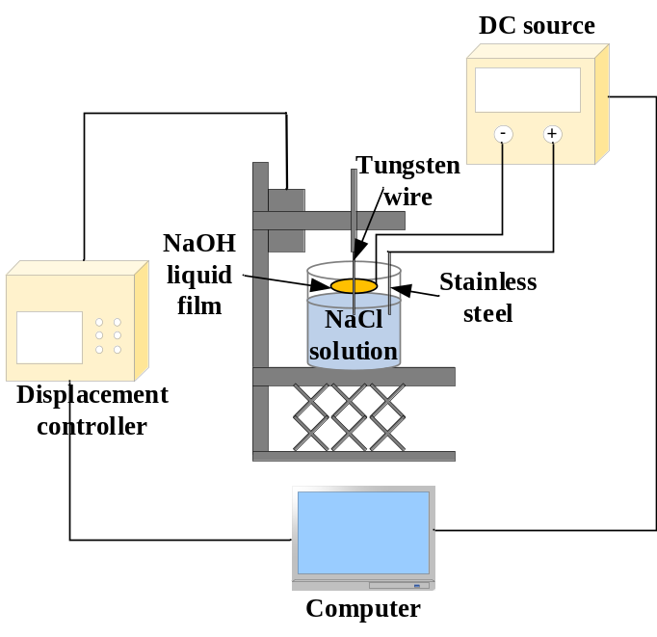
Supplementary Fig. 2| The schematic diagram of double-electrolyte electrochemical etching method.
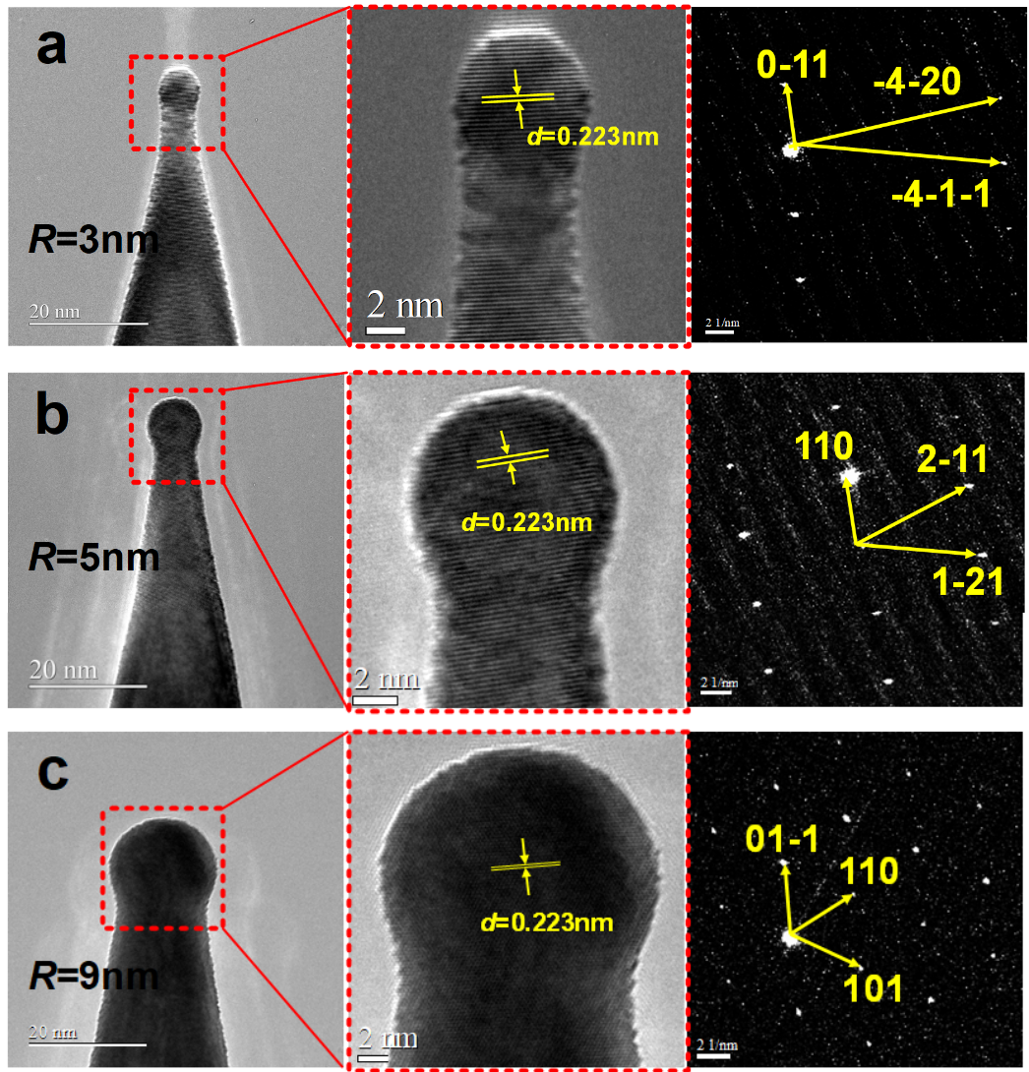
Supplementary Fig. 3| The TEM images of the initial tungsten nanotips with different apex radii (R = 3 nm, 5 nm and 9 nm) and the corresponding selected area electron diffraction (SAED) results. (a) R = 3 nm. (b) R = 5 nm. (c) R = 9 nm.

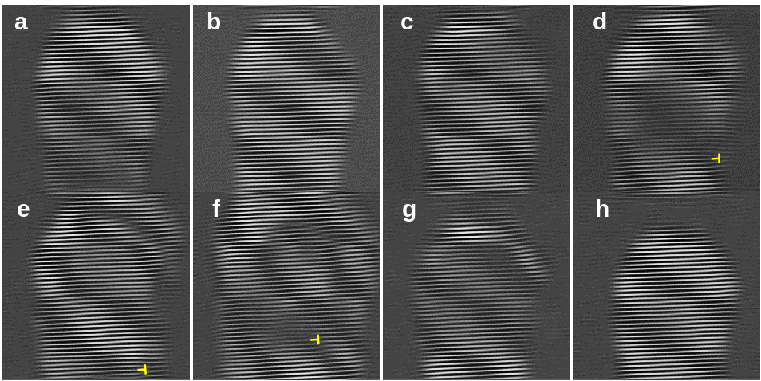
Supplementary Fig. 4| The corresponding Fourier-filtered images (to Fig. 1) of a <110>-oriented tungsten nanotip with an apex radius of 3 nm depict the evolution of dislocations, with the edge dislocations of different polarities marked by magenta and yellow ‘⊥’ symbols, respectively.

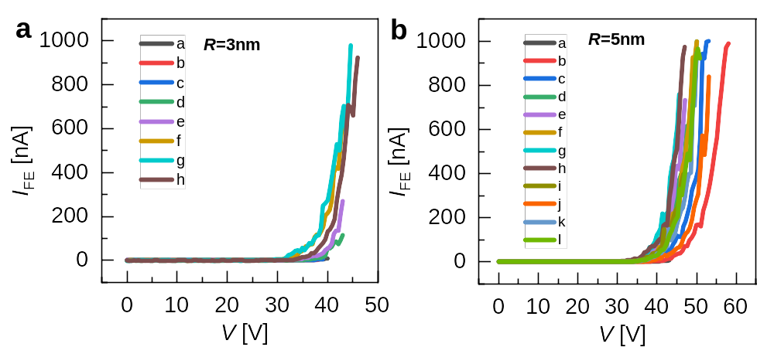
Supplementary Fig. 5| Field emission I-V curves of tungsten nanotips. (a) R = 3 nm. (b) R = 5 nm.

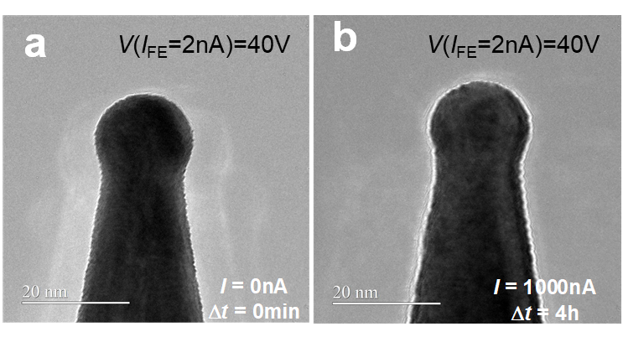
Supplementary Fig. 6| The deformation behaviors of tungsten nanotip with an apex radius of 9 nm. (a) The initial TEM image of tungsten nanotip. (b) The TEM image of this tungsten nanotip after field emission treatment with I_{FE} = 1000 nA and ∆t = 4 h.

Supplementary Note 1: The maxwell stress induced by electric fields
The most significant effect of an external electric field on a metal surface is that it exerts an a tensile stress to the material surface, i.e. the Maxwell stress $σ$
$$σ=\frac{ε_{0}}{2}F^{2}$$
Where $F$ is the electric field strength at a surface point and $ε_{0}$ is the vacuum permittivity. The Supplementary Fig. 7 shows the relationship between the Maxwell stress $σ$ and the electric fields. The field enhacenment factor is defined as $γ=F_{max}/F_{avg}$, where $F_{avg}=V/d$ is applied electric field, $F_{max}$ is the maximum electric field. Based on the electric field distribution simulated using ED-MD-PIC simulations, $γ$ is about 3.73 for a 3 nm tip at 15 nm gap, and $γ$ is about 2.88 for a 5 nm tip at 15 nm gap. Thus, the maximum electric fields $F_{max}$ in our experiments are near 10 V/nm, corresponding to a Maxwell stress $σ$ of less than 0.5 GPa. This value is significantly lower than the yield strength of tungsten along the <110> direction, which is 19.2 GPa³⁹. Therefore, the deformation cannot be attributed to the plastic deformation induced by the applied electric fields.
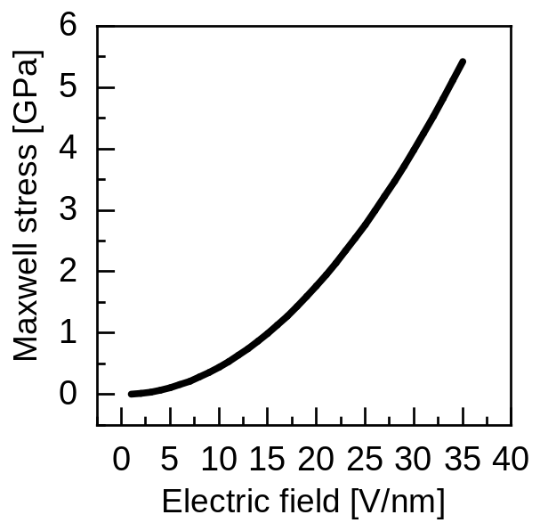
Supplementary Fig. 7| Maxwell stress induced by different electric field strengths.

Supplementary Note 2: The thermal effects by field emission
To determine the temperature of the nanotips during field emission and assess whether thermal effects significantly influence their deformation behaviors, we simulated the temperature distribution for all three nanotips under a field emission current of 1000 nA. The simulated results, including field emission current, maximum electron and phonon temperature, electric field distribution, as well as electron and phonon temperature distribution, are shown in Supplementary Fig. 8, Supplementary Fig. 9 and Supplementary Fig. 10, respectively. When the electron and phonon temperatures stabilize and converge, this temperature can be considered the steady-state value. The simulations reveal that for all three nanotips, both electron and phonon temperatures remain around 300 K, indicating that the field emission current of about 1000 nA in the experiments does not cause a significant temperature rise.

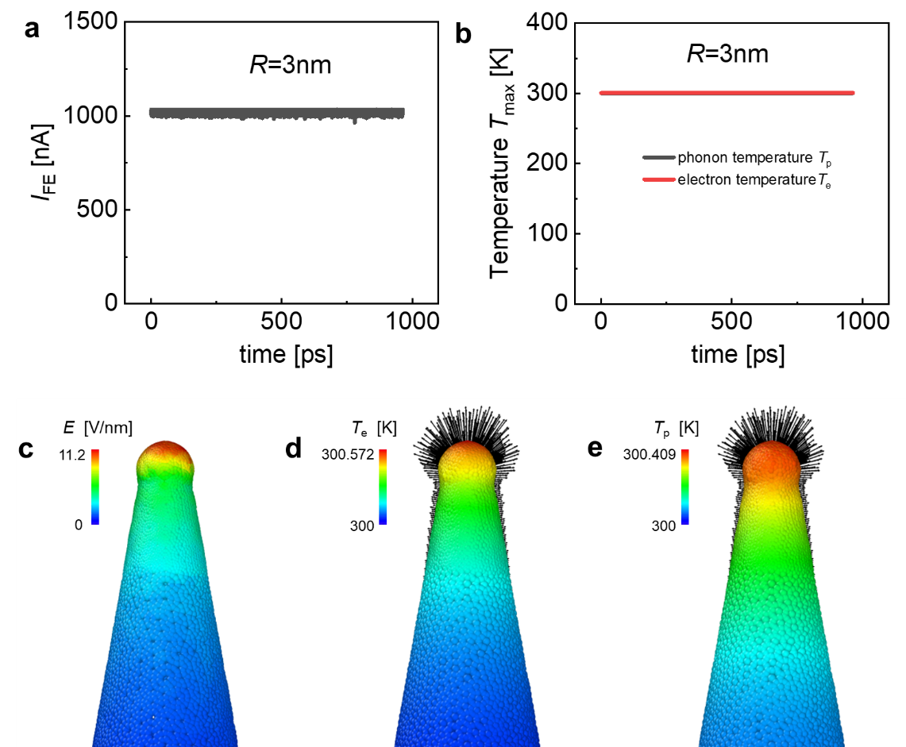
Supplementary Fig. 8| Thermal effects of a tungsten nanotip with an apex radius of 3 nm during field emission treatment. (a) Field emission current. (b) Maximum electron temperature and phonon temperature under field emission. (c) The electric field distribution. (d) The electron temperature distribution and the electric field lines. (e) The phonon temperature distribution and the electric field lines.

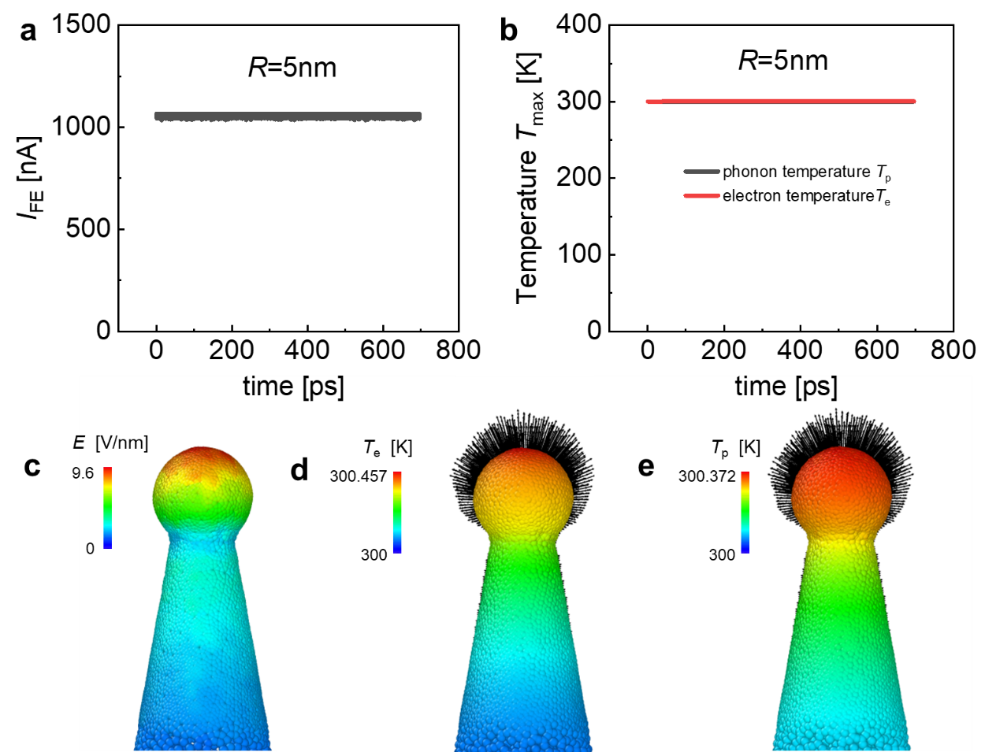
Supplementary Fig. 9| Thermal effects of a tungsten nanotip with an apex radius of 5 nm during field emission treatment. (a) Field emission current. (b) Maximum electron temperature and phonon temperature under field emission. (c) The electric field distribution. (d) The electron temperature distribution and the electric field lines. (e) The phonon temperature distribution and the electric field lines.

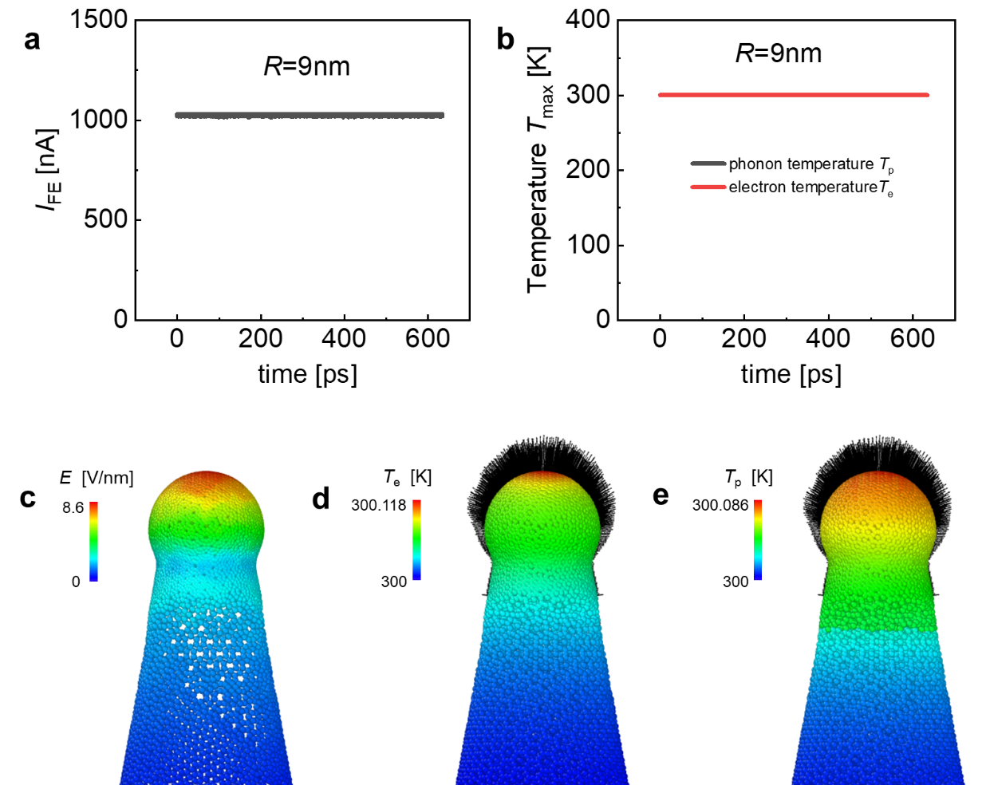
Supplementary Fig. 10| Thermal effects of a tungsten nanotip with an apex radius of 9 nm during field emission treatment. (a) Field emission current. (b) Maximum electron temperature and phonon temperature under field emission. (c) The electric field distribution. (d) The electron temperature distribution and the electric field lines. (e) The phonon temperature distribution and the electric field lines.

Supplementary Note 3: The electric field effects for the deformation behaviors of tungsten nanotips
To decouple the electric field effects from field emission, we conducted the reverse polarity experiments on tungsten nanotips with radii of 2 nm and 5 nm. The corresponding TEM images and SAED results are shown in Supplementary Fig. 11a and Supplementary Fig. 12a, which reveal a surface devoid of contaminants, a round and smooth apex, a neatly arranged lattice with few internal defects and a <110> crystallographic direction aligned with the emitter axis. The field emission I-V curves and the reverse polarity I-V curves are shown in Supplementary Fig. 11b and Supplementary Fig. 12b. It can be seen that the current during reverse polarity measurements is approximately 4 nA under the same electric field distribution, which is significantly lower than 1000 nA observed during field emission measurements, indicating successful decoupling of electric field effects from field emission. The representative voltage and current curves during reverse polarity treatment periods are shown in Supplementary Fig. 11c and Supplementary Fig. 12c.
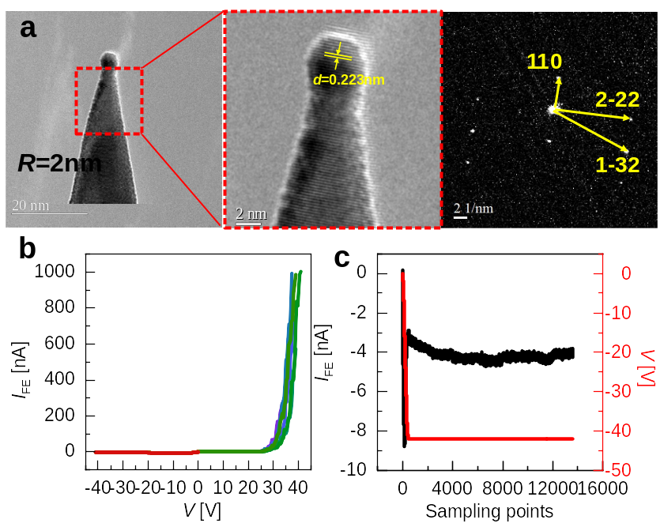
Supplementary Fig. 11| Reverse polarity experiment of a tungsten nanotip with an apex radius of 2 nm. (a) The TEM images of this tungsten nanotip and the corresponding selected area electron diffraction (SAED) result. (b) I-V curves for field emission characteristics (tungsten nanotip as cathode) and reverse polarity (tungsten nanotip as anode). (c) Representative voltage and current curves during reverse polarity treatment periods.

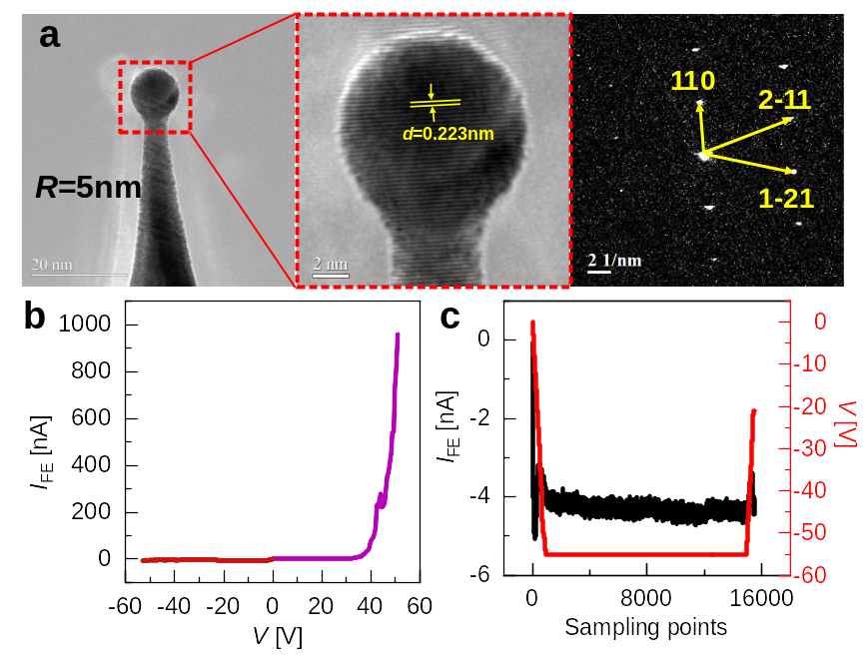
Supplementary Fig. 12| Reverse polarity experiment of a tungsten nanotip with an apex radius of 5 nm. (a) The TEM images of this tungsten nanotip and the corresponding selected area electron diffraction (SAED) result. (b) I-V curves for field emission characteristics (tungsten nanotip as cathode) and reverse polarity (tungsten nanotip as anode). (c) Representative voltage and current curves during reverse polarity treatment periods.

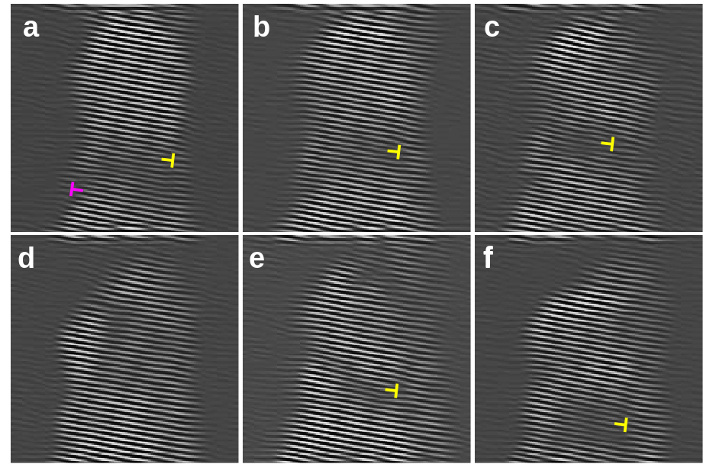
Supplementary Fig. 13| The corresponding Fourier-filtered images (to Fig. 3) of a <110>-oriented tungsten nanotip with an apex radius of 2 nm depict the evolution of dislocations, with the edge dislocations of different polarities marked by magenta and yellow ‘⊥’ symbols, respectively.

