Supplementary Data
Prioritization of candidate causal genes in GWAS signals of asthma in UK Biobank

Kim Valette¹, Zhonglin Li¹, Valentin Bon-Baret¹, Arnaud Chignon¹, Jean-Christophe Bérubé¹, Aida Eslami¹, Jennifer Lamothe¹, Nathalie Gaudreault¹, Philippe Joubert¹, Ma’en Obeidat², Maarten van den Berge³, Wim Timens⁴, Don D. Sin², David Nickle⁵, Ke Hao⁶, Catherine Labbé¹, Krystelle Godbout¹, Andréanne Côté¹, Michel Laviolette¹, Louis-Philippe Boulet¹, Patrick Mathieu¹, Sébastien Thériault^{1,7}, Yohan Bossé^{1,8}
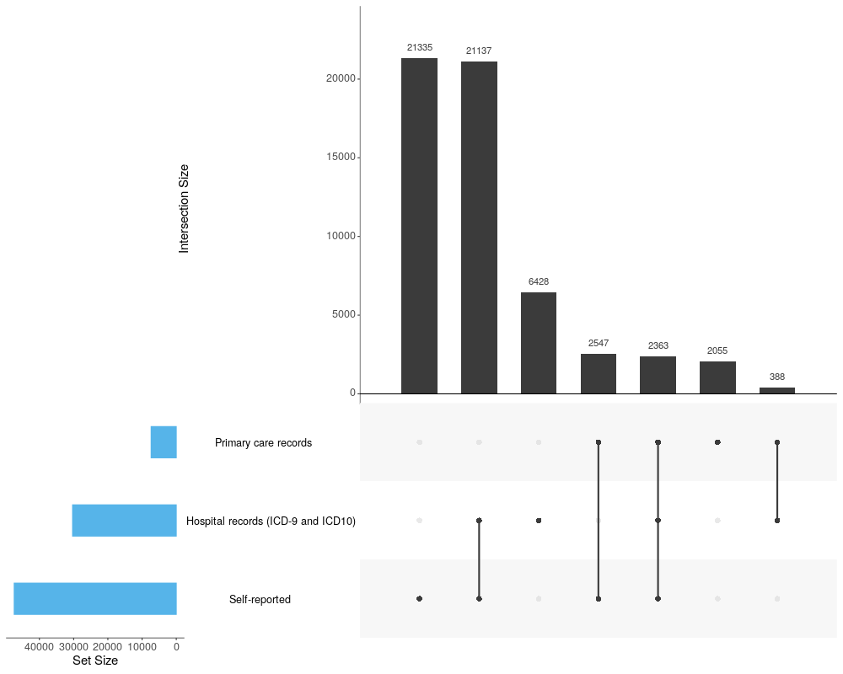
Supplementary Figure 1. UpSet plot showing the data sources to define asthma status in UK Biobank. A total of 56,167 asthma cases were identified. Affected individuals had one or more diagnosis of asthma based on self-reported questionnaires, hospital records (ICD-9 and ICD-10), and primary care records.

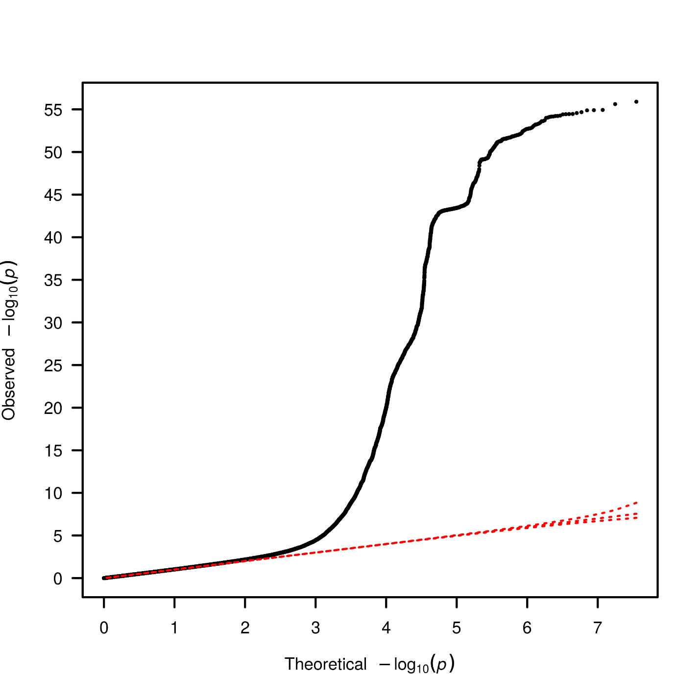
Supplementary Figure 2. Quantile-quantile plot of test statistics generated by the GWAS in UK Biobank including 56,167 asthma cases and 352,255 controls. Genomic inflation factor λ=1.029.

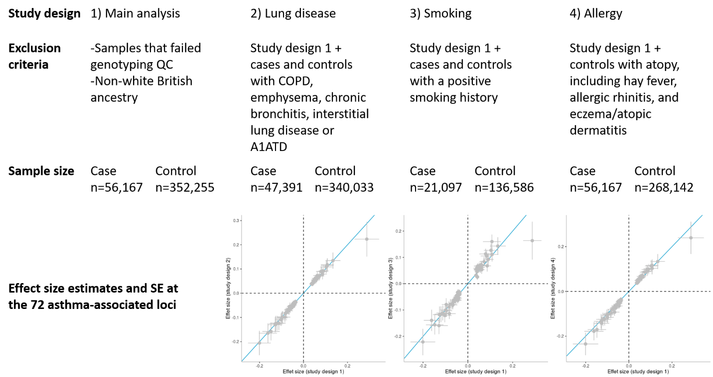
Supplementary Figure 3. Results of sensitivity analysis evaluating the potential confounder effects of other lung diseases, smoking and allergy. The three scatter plots compared the effect size estimates and SE of the main study design (x axis) with the three alternative study designs (y axis). The identity line is shown in blue. The single and most extreme outlier in the upper right corner of scatter plots consists of the sentinel variant on 1q21.3.
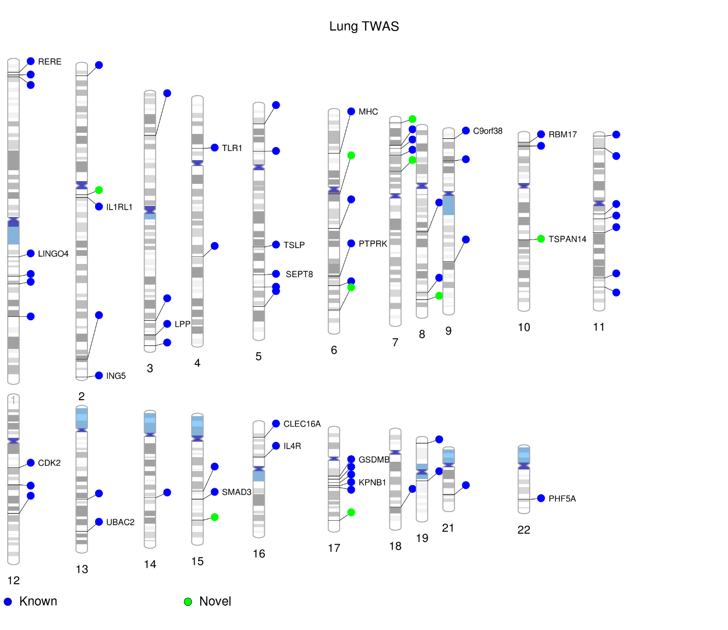
Supplementary Figure 4. The top lung TWAS genes identified per asthma-associated loci. Previously known and new asthma loci are illustrated in blue and green, respectively.

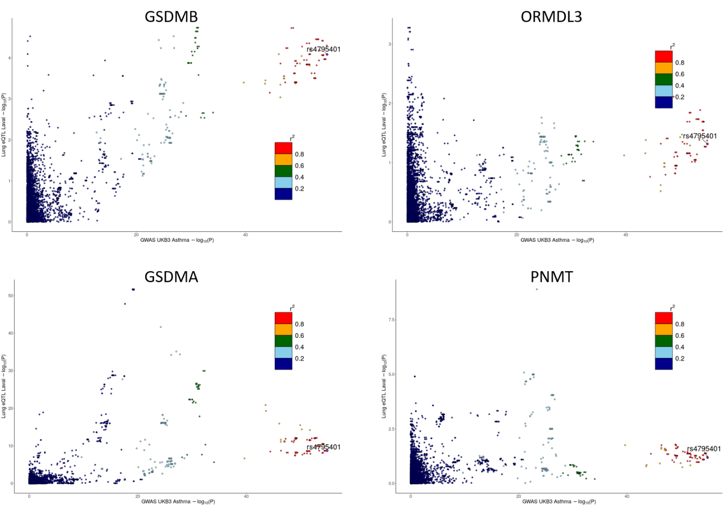
Supplementary Figure 5. LocusCompare plots for four significant TWAS genes on chromosome 17q12-q21. Association signals for SNPs within 50 Kb up and downstream of target genes are illustrated for GSDMB, ORMDL3, GSDMA, and PNMT.

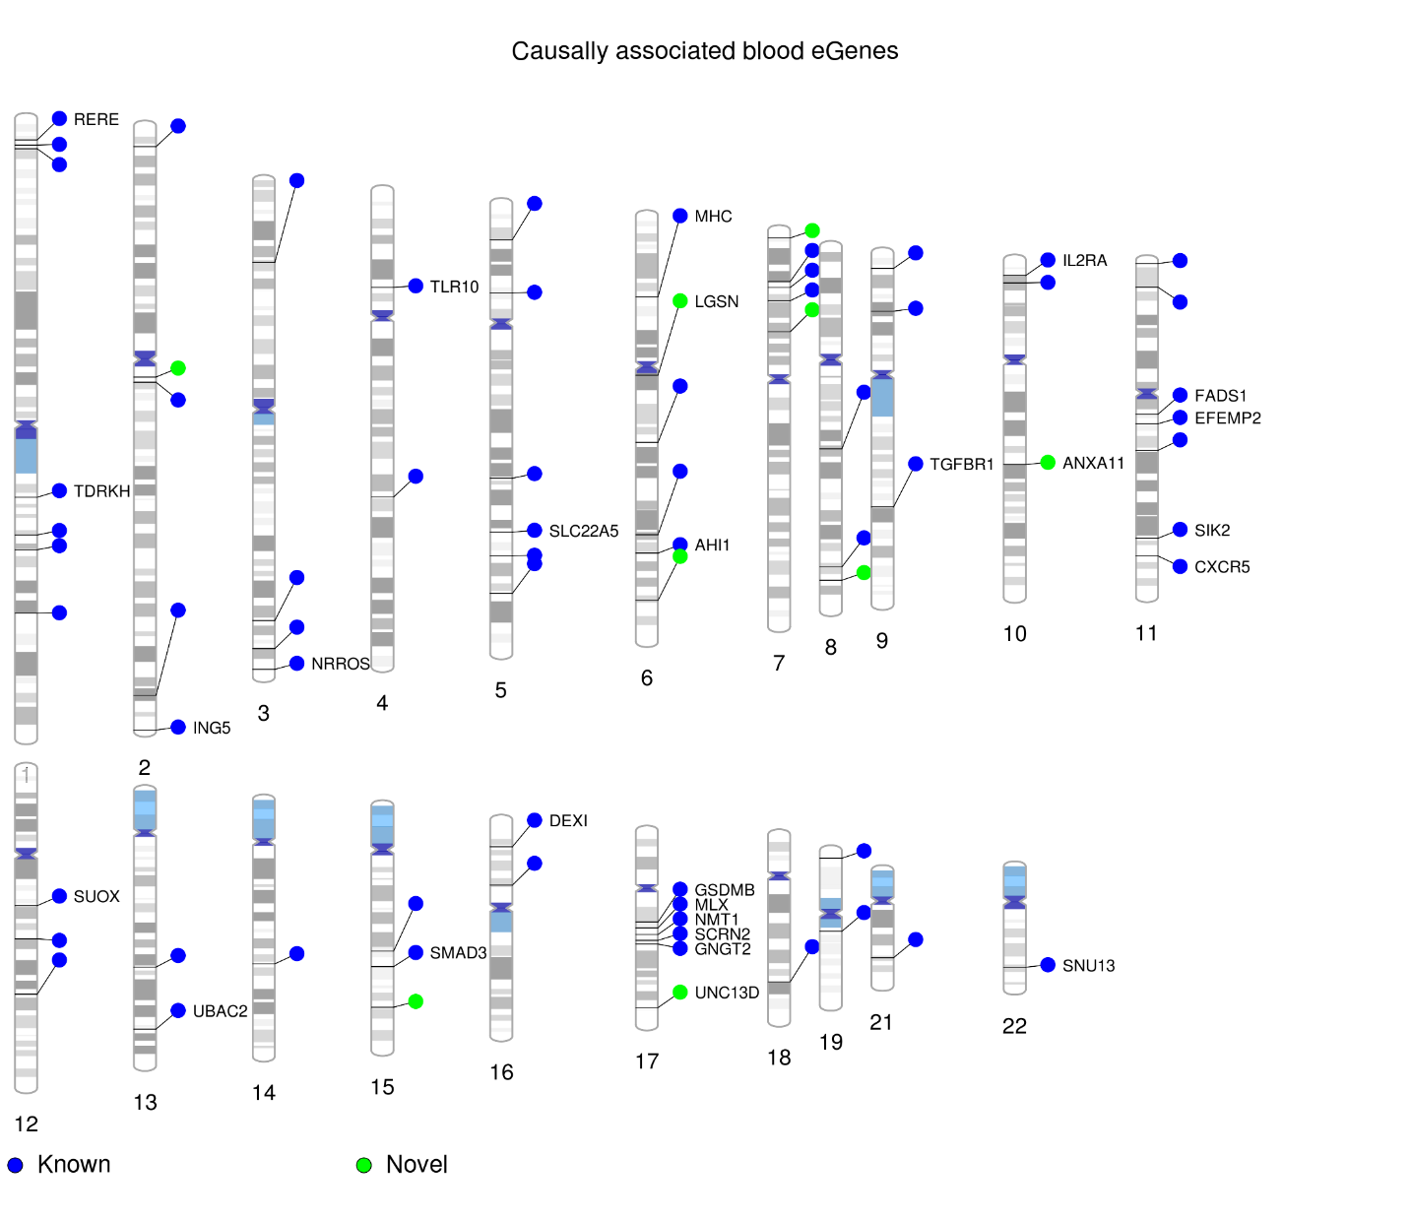
Supplementary Figure 6. The top causally associated blood eGene identified per asthma-associated loci. Previously known and new asthma loci are illustrated in blue and green, respectively.

