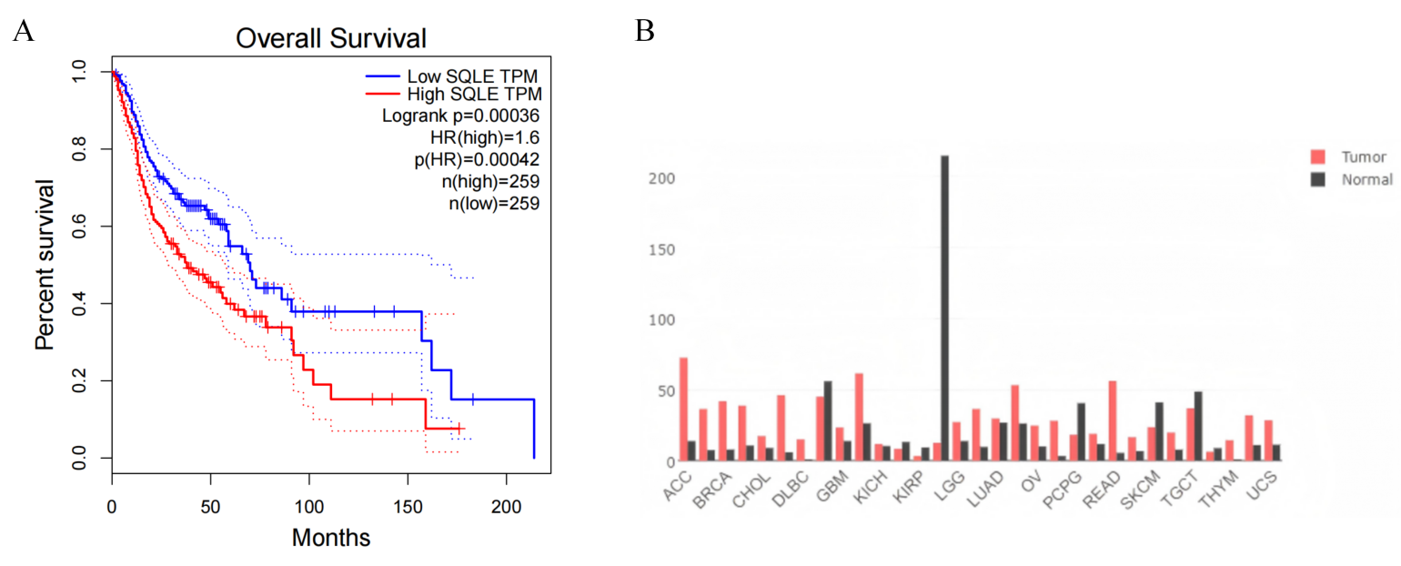
Fig. S2 A Survival analysis levels of SQLE predicted from GEPIA database. B The pan-cancer analysis of SQLE by GEPIA database.

