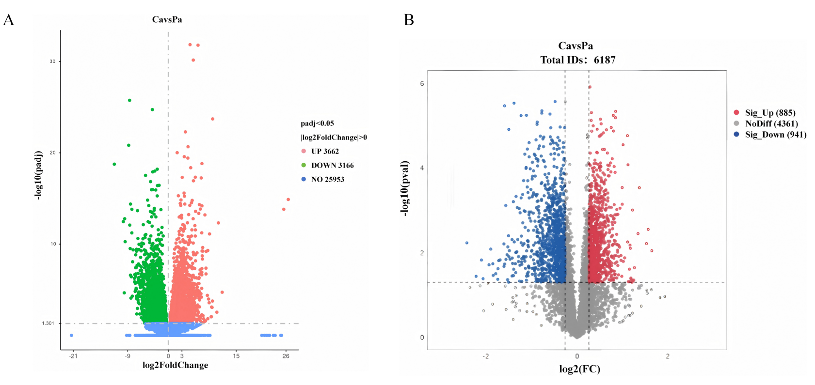
Fig. S1 A Proteomic volcano plot of differentially expressed proteins. B Transcriptomic volcano plot of differentially expressed genes.

