Supporting data file
Quinoline-6-Carboxylic Acid Derivatives: A New Class of Potent Ectonucleotidase Inhibitors
Aqsa Ishaq^{1,2}, Ismat Nawaz¹, Javeria Qadir¹, Salman Alrokayan³, Tajamul Hussain^{3,4*}, Nicolly Espindola Gelsleichter^{5,6}, Julie Pelletier⁶, Jean Sévigny^{5,6}, Muhammad Muhammad⁷, Qing Huang^{7,8}, Jamshed Iqbal^{1,2}*
¹Centre for Advanced Drug Research, COMSATS University Islamabad, Abbottabad Campus, Abbottabad 22060, Pakistan.
²Department of Chemistry, COMSATS University Islamabad, Abbottabad Campus, Abbottabad, 22060, Pakistan
³Research Chair for Biomedical Application of Nanomaterials, Biochemistry Department, College of Science, King Saud University, Riyadh 11451, Saudi Arabia
⁴Center of Excellence in Biotechnology Research, King Saud University, Riyadh 11451, Saudi Arabia
⁵Département de microbiologie-infectiologie et d’immunologie, centres PROTEO et ARThrite, Faculté de Médecine, Université Laval, Quebec city, QC G1V 0A6, Canada.
⁶Axe Maladies infectieuses et immunitaires, Centre de recherche du CHU de Québec – Université Laval, Quebec city, QC G1V 4G2, Canada.
⁷CAS Key Laboratory of Ion-Beam Bioengineering, Institute of Intelligent Machines, Hefei Institutes of Physical Science, Chinese Academy of Sciences, Hefei, China
⁸Science Island Branch of Graduate School, University of Science and Technology of China, Hefei, China

Corresponding author.
Jamshed Iqbal Email: drjamshed@cuiatd.edu.pk
Tajamul Hussain Email: thussain@ksu.edu.sa

Table of Contents
S.No | Description | Page.No
1- | Table SI: Results of biological activities of quinoline-6-carboxylic acid derivatives (4a-4l),  - h-NTPDase1 and h-NTPDase2  - h-NTPDase3 and h-NTPDase8  - h-e5′NT and h-NPP1
2- | Figure S1 to S24 : NMR spectra’s (presenting 1H NMR and 13C NMR) of Quinoline-6-Carboxylic Acid Derivatives (4a-4l)

Table SI: Results of biological activities of quinoline-6-carboxylic acid derivatives (4a-4l),
- h-NTPDase1 and h-NTPDase2

S.No | Comp.  Code | h-NTPDase1 |  | h-NTPDase2
S.No | Comp.  Code | Graph | IC_{50 ±} SEM (µM) / % inhibition | Graph | IC_{50 ±} SEM (µM) / % inhibition
1 | 4a | - | 37.02% | - | 23.30%
2 | 4b | 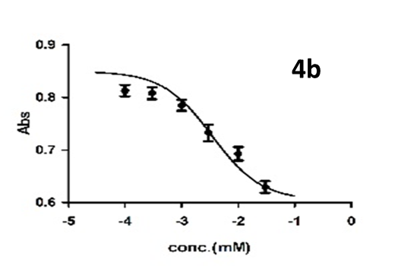 | 3.46±0.49 | - | 26.18%
3 | 4c | 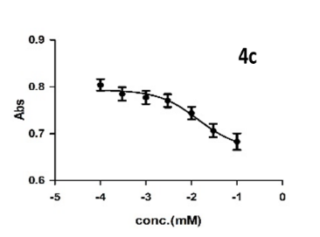 | 6.13±0.64 | 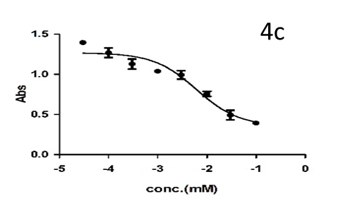 | 6.39±1.07
4 | 4d | 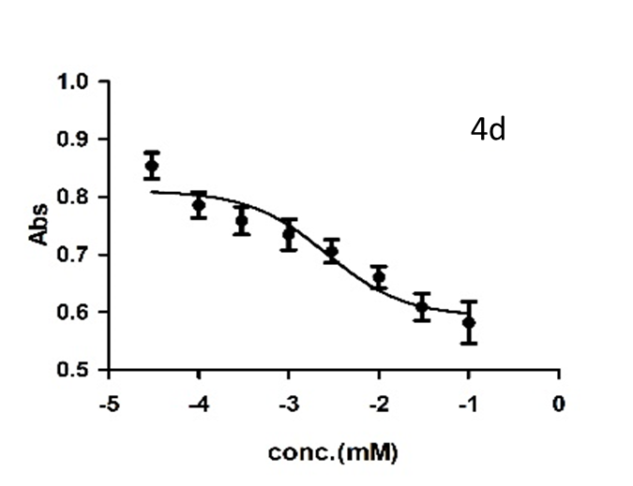 | 0.28±0.03 | 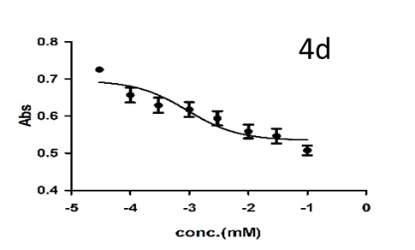 | 0.92±0.17
5 | 4e |  | 32.56% | - | 36.36%
6 | 4f | - | 44.06% | - | 35.41%
7 | 4g | 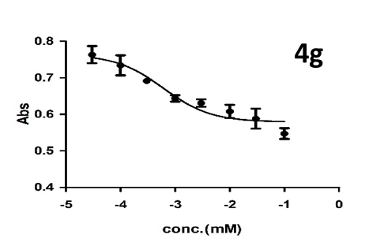 | 0.61±0.09 | - | 33.91%
8 | 4h | - | 18.45% | - | 28.29%
9 | 4i | - | 19.48% | - | 39.64%
10 | 4j | - | 33.06% | - | 26.20%
11 | 4k | - | 33.79% | - | 18.56%
12 | 4l | - | 32.37% | - | 41.16%

- h-NTPDase3 and h-NTPDase8
S.No | Comp.  Code | h-NTPDase3 |  | h-NTPDase8
S.No | Comp.  Code | Graph | IC_{50 ±} SEM (µM) / % inhibition | Graph | IC_{50 ±} SEM (µM) / % inhibition
1 | 4a | - | 30.60% | - | 39.64%
2 | 4b | 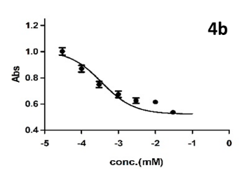 | 0.35±0.17 | 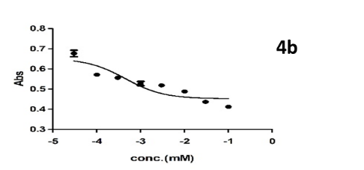 | 0.44±0.08
3 | 4c | 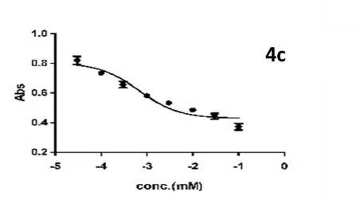 | 0.67±0.27 | 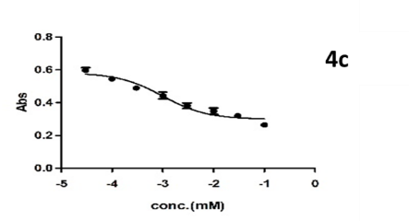 | 0.99±0.13
4 | 4d | 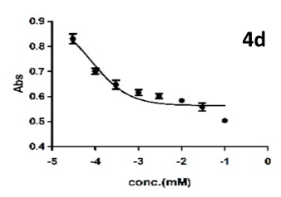 | 0.82±0.07 | - | 33.02%
5 | 4e |  | 40.21% | - | 39.46%
6 | 4f | 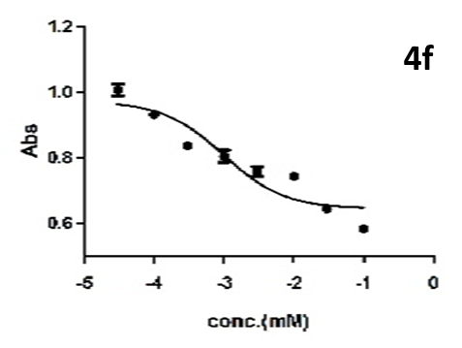 | 0.99±0.29 | - | 39.91%
7 | 4g | 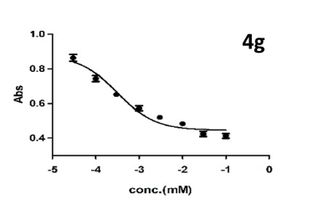 | 0.32±0.05 | - | 20.35%
8 | 4h | 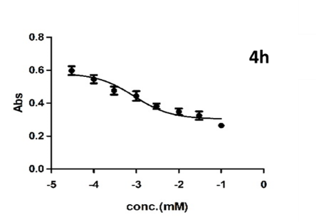 | 0.88±0.29 | 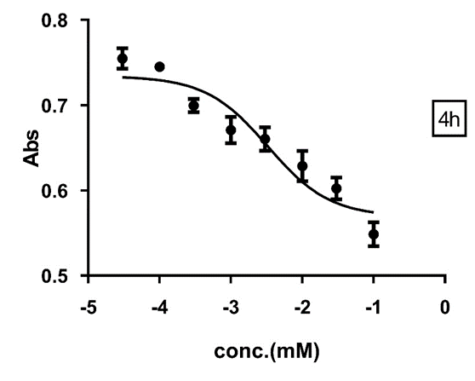 | 3.29±0.36
9 | 4i | - | 25.08% | - | 29.82%
10 | 4j | - | 35.64% | - | 28.64%
11 | 4k | - | 38.45% | - | 27.02%
12 | 4l | - | 36.14% | - | 26.12%

- h-e5′NT and h-NPP1

S.No | Comp.  Code | h-e5’NT |  | h-NPP1
S.No | Comp.  Code | Graph | IC_{50 ±} SEM (µM) / % inhibition | Graph | IC_{50 ±} SEM (µM) / % inhibition
1 | 4a | 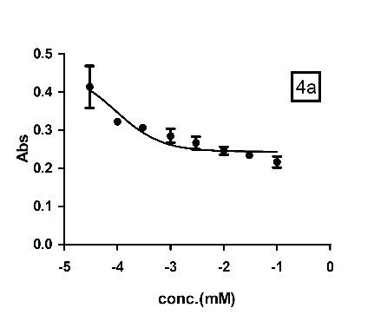 | 0.092±0.02 | 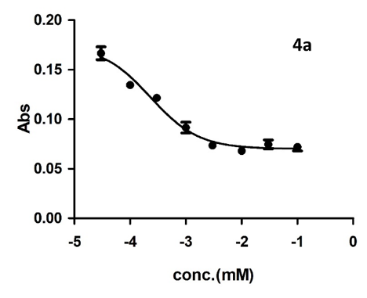 | 0.23±0.02
2 | 4b | - | 37% | - | 44.80%
3 | 4c | 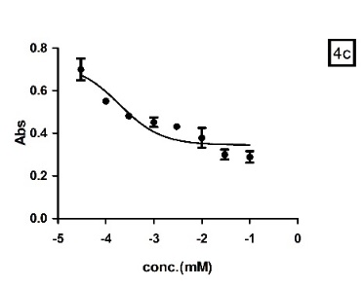 | 0.19±0.01 | - | 45.25%
4 | 4d | - | 35.64% | 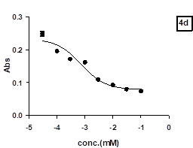 | 0.73±0.09
5 | 4e | 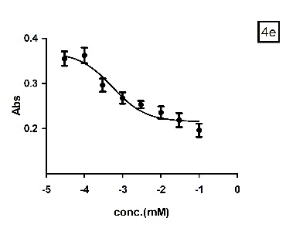 | 0.54±0.09 | - | 34.62%
6 | 4f | - | 48.49% | 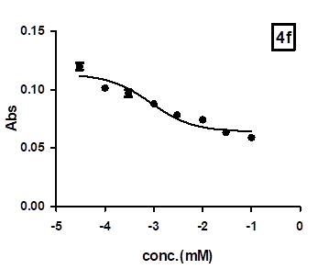 | 0.87±0.11
7 | 4g | 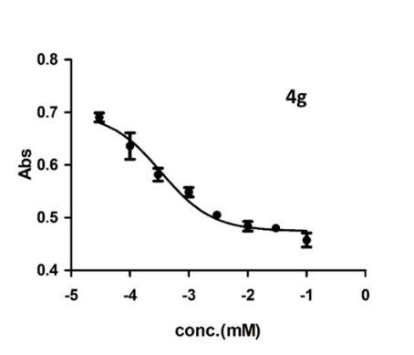 | 0.34±0.07 | - | 43.67%
8 | 4h | 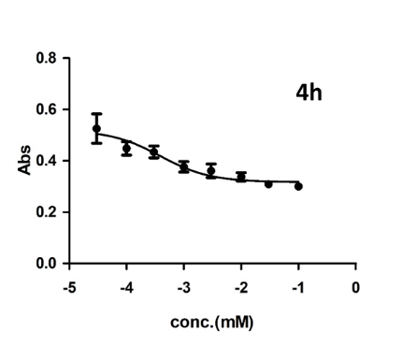 | 0.39±0.1 | - | 33.94%
9 | 4i | 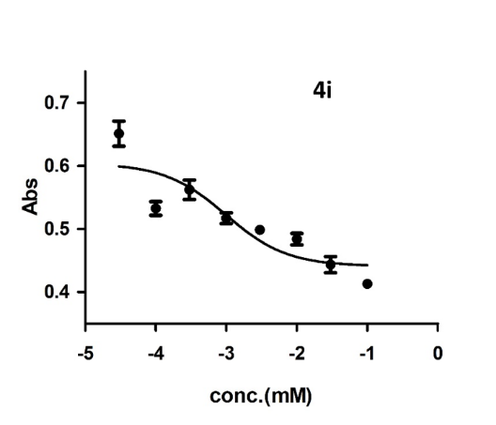 | 0.99±0.13 | - | 29.19.42%
10 | 4j | 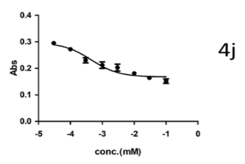 | 0.44±0.07 | 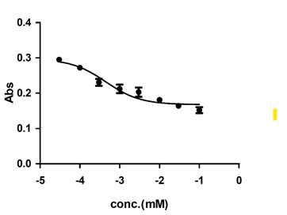  4j | 13.5±1.24
11 | 4k | - | 28.43% | 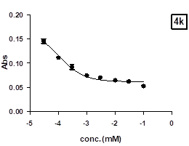 | 0.11±0.02
12 | 4l | 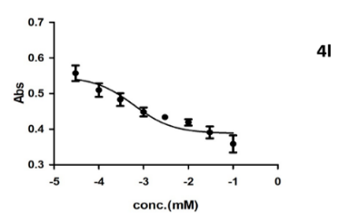 | 0.47±0.26 | - | 29.42%

NMR spectra’s (presenting ¹H NMR and ¹³C NMR) of Quinoline-6-Carboxylic Acid Derivatives (4a-4l)

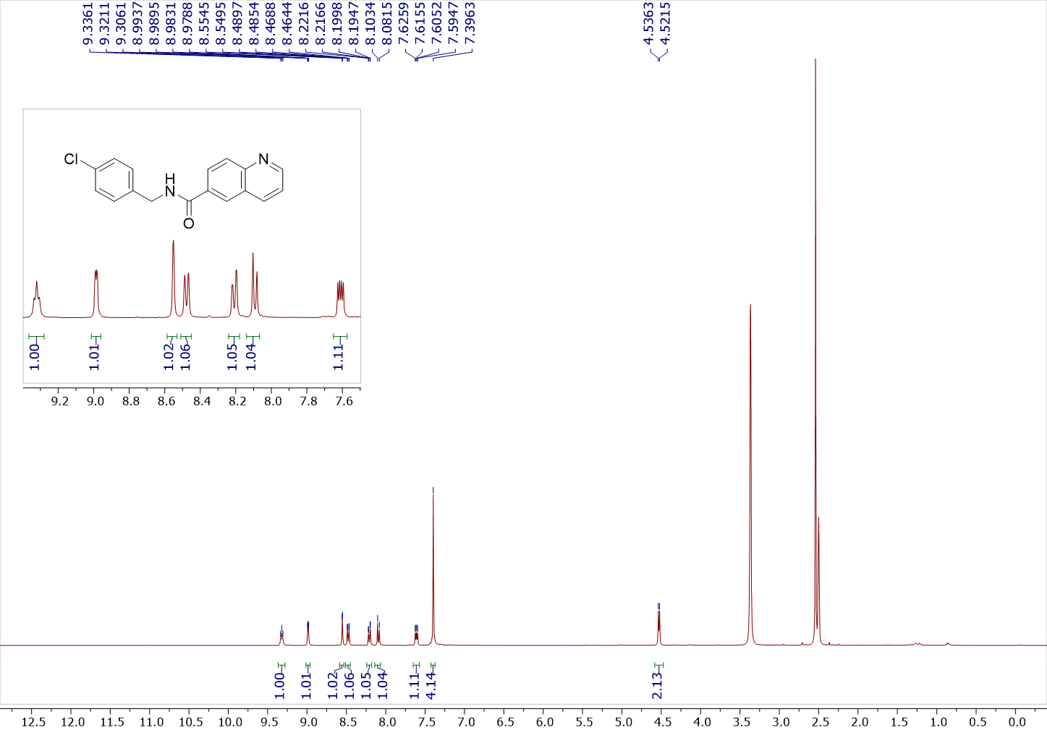
Figure S1: ¹H spectrum of N-(4-chlorobenzyl)quinoline-6-carboxamide in DMSO-d6 (4a)
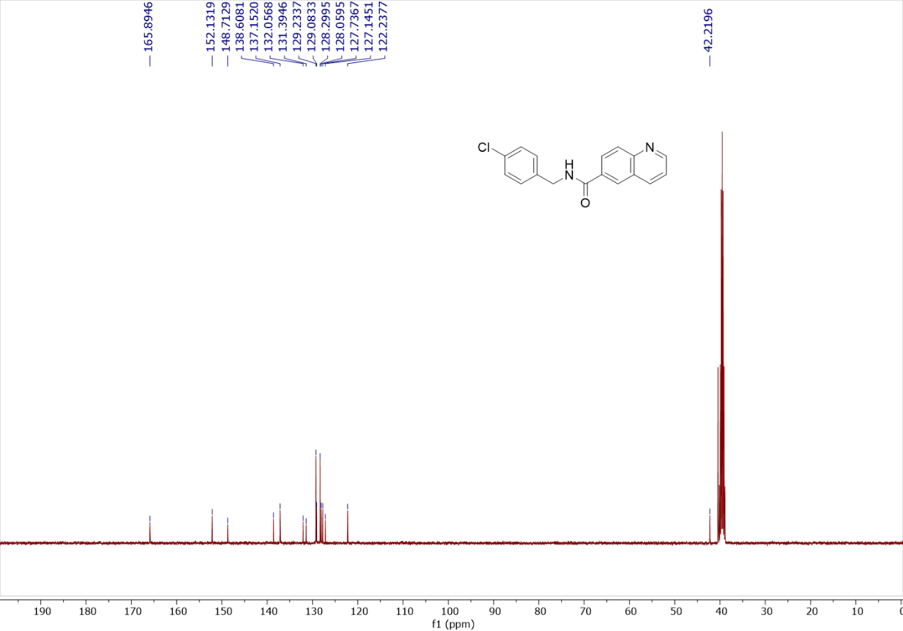
Figure S2: ¹³C{¹H} spectrum of N-(4-chlorobenzyl)quinoline-6-carboxamide in DMSO-d6 (4a)
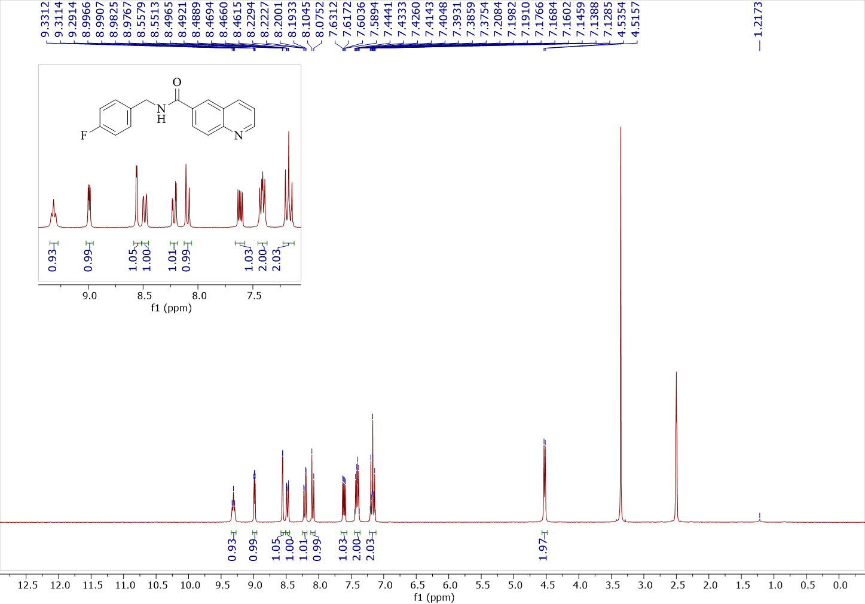
Figure S3: ¹H spectrum of N-(4-fluorobenzyl)quinoline-6-carboxamide in DMSO-d6 (4b)
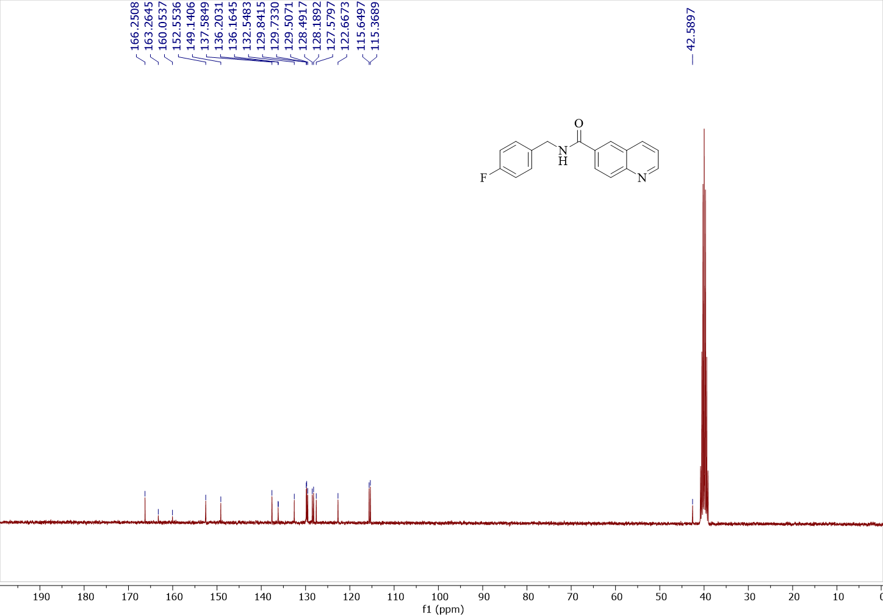
Figure S4: ¹³C{¹H} spectrum of N-(4-fluorobenzyl)quinoline-6-carboxamide in DMSO-d6 (4b)
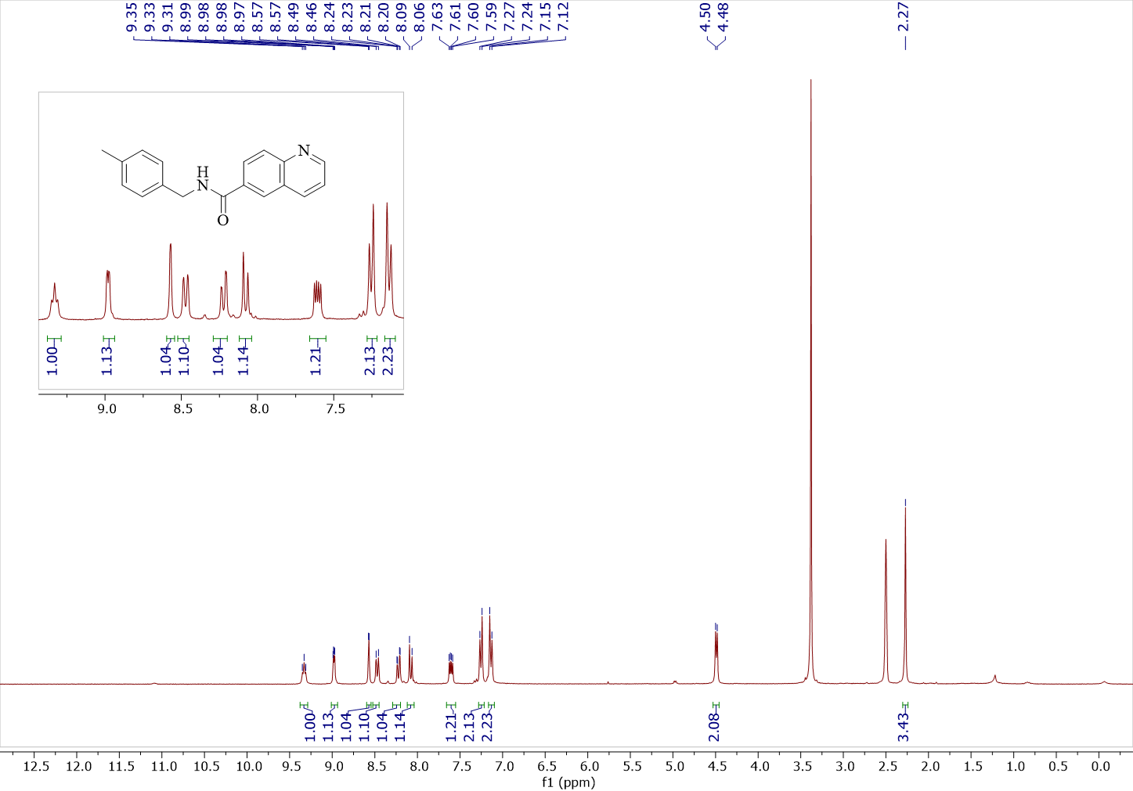
Figure S5: ¹H spectrum of N-(4-methylbenzyl)quinoline-6-carboxamide in DMSO-d6 (4c)
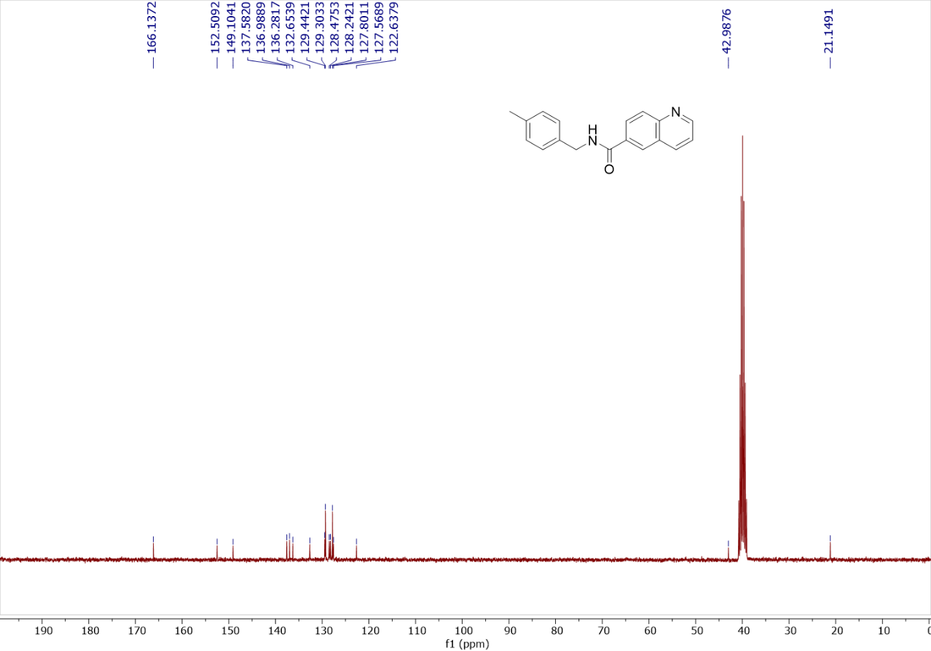
Figure S6: ¹³C{¹H} spectrum of N-(4-methylbenzyl)quinoline-6-carboxamide in DMSO-d6 (4c)
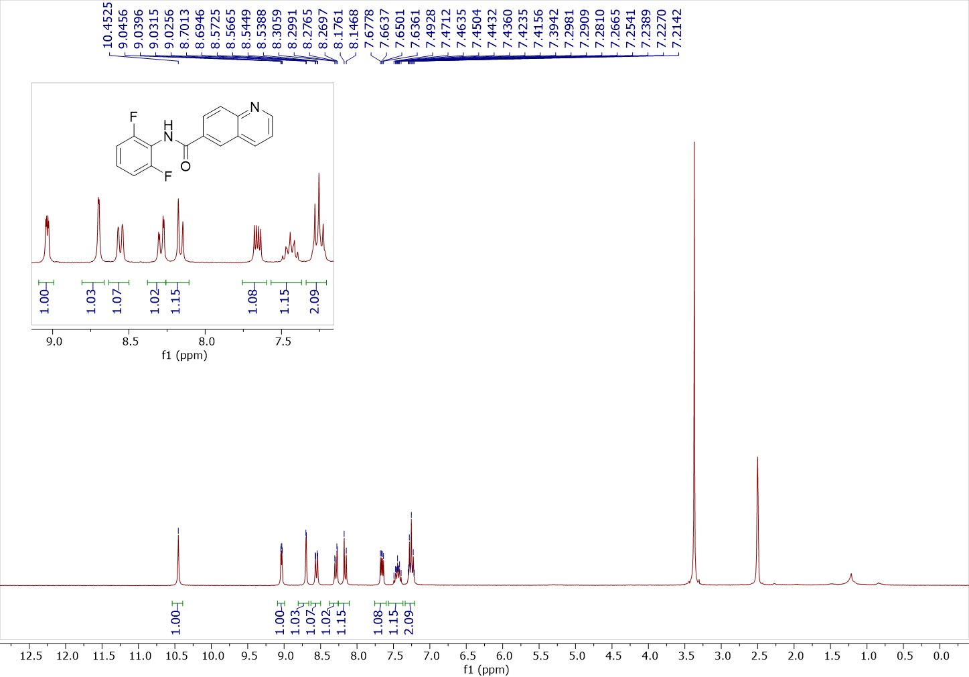
Figure S7: ¹H spectrum of N-(2,6-difluorophenyl)quinoline-6-carboxamide in DMSO-d6 (4d)
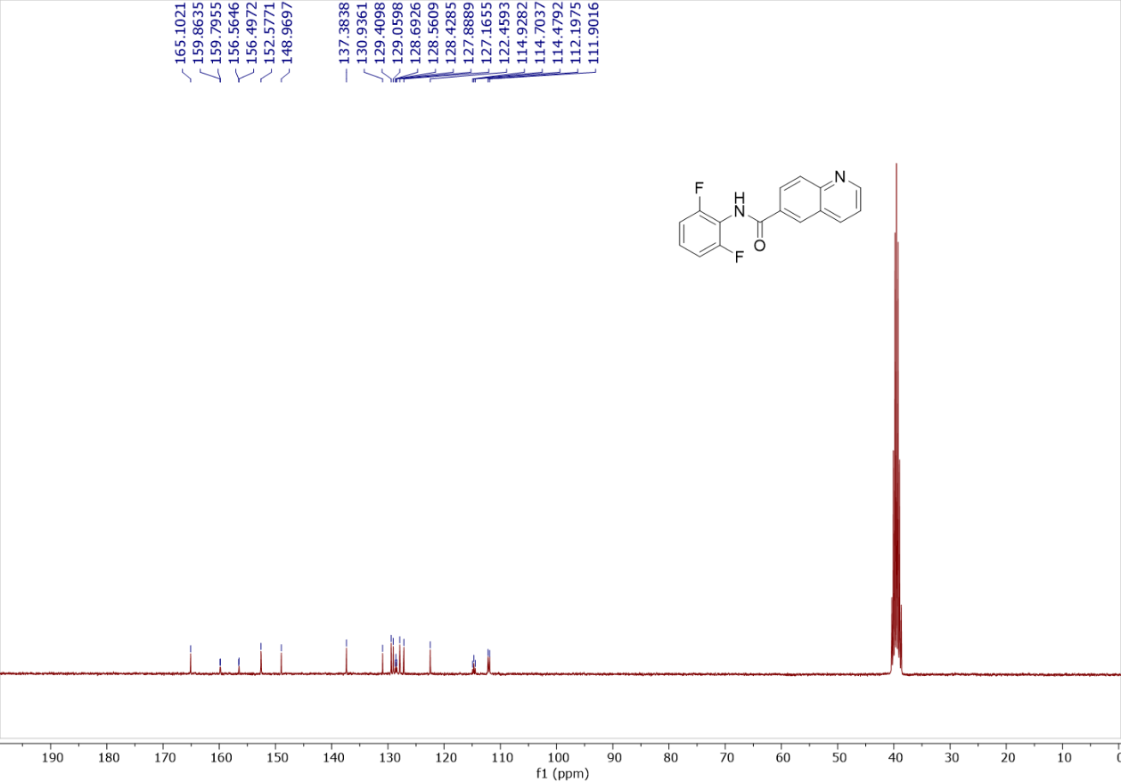
Figure S8: ¹³C{¹H} spectrum of N-(2,6-difluorophenyl)quinoline-6-carboxamide in DMSO-d6 (4d)
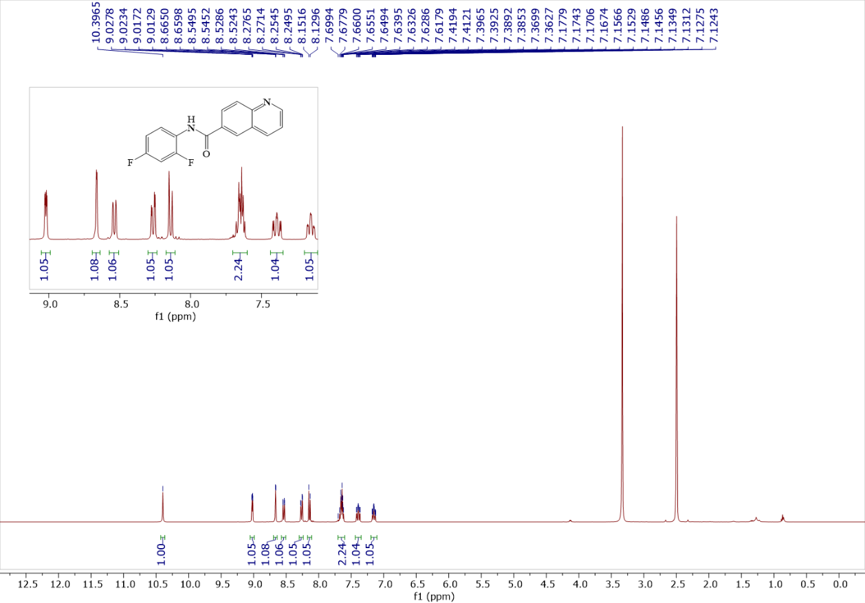
Figure S9: ¹H spectrum of N-(2,4-difluorophenyl)quinoline-6-carboxamide in DMSO-d6 (4e)
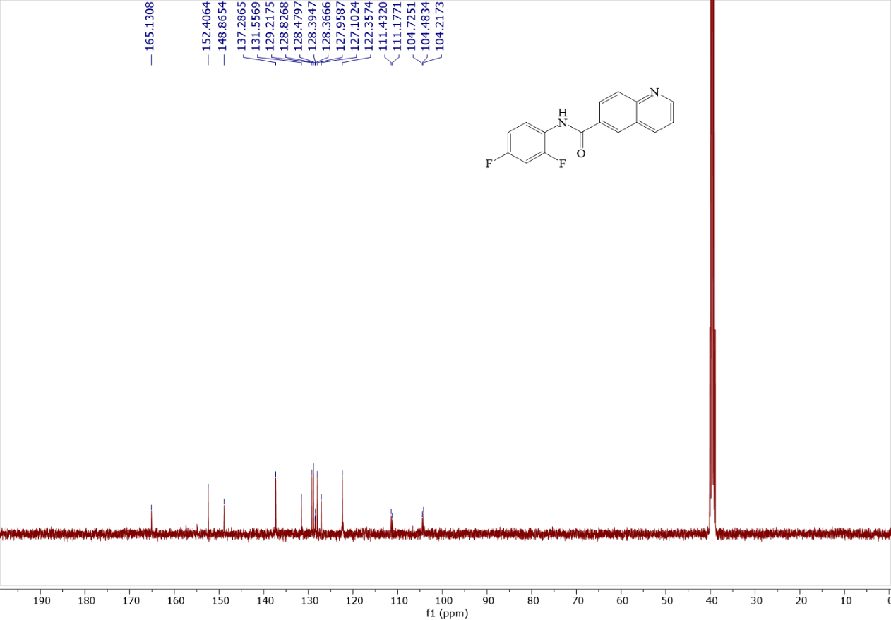
Figure S10: ¹³C{¹H} spectrum of N-(2,4-difluorophenyl)quinoline-6-carboxamide in DMSO-d6 (4e)
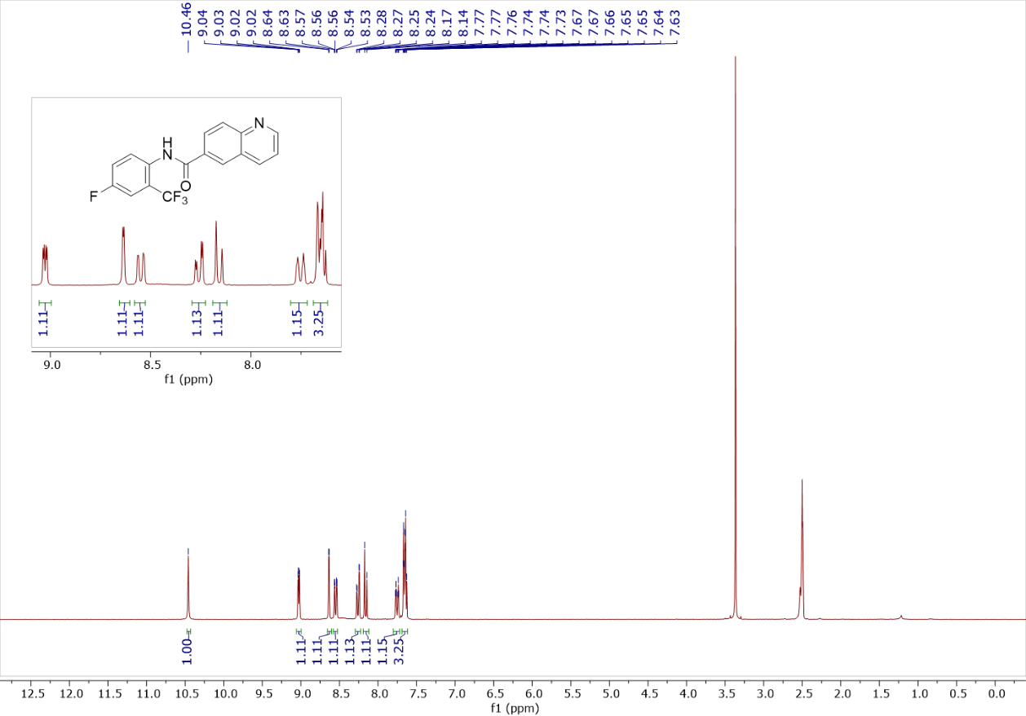
Figure S11: ¹H spectrum of N-(4-fluoro-2-(trifluoromethyl)phenyl)quinoline-6-carboxamide in DMSO-d6 (4f)

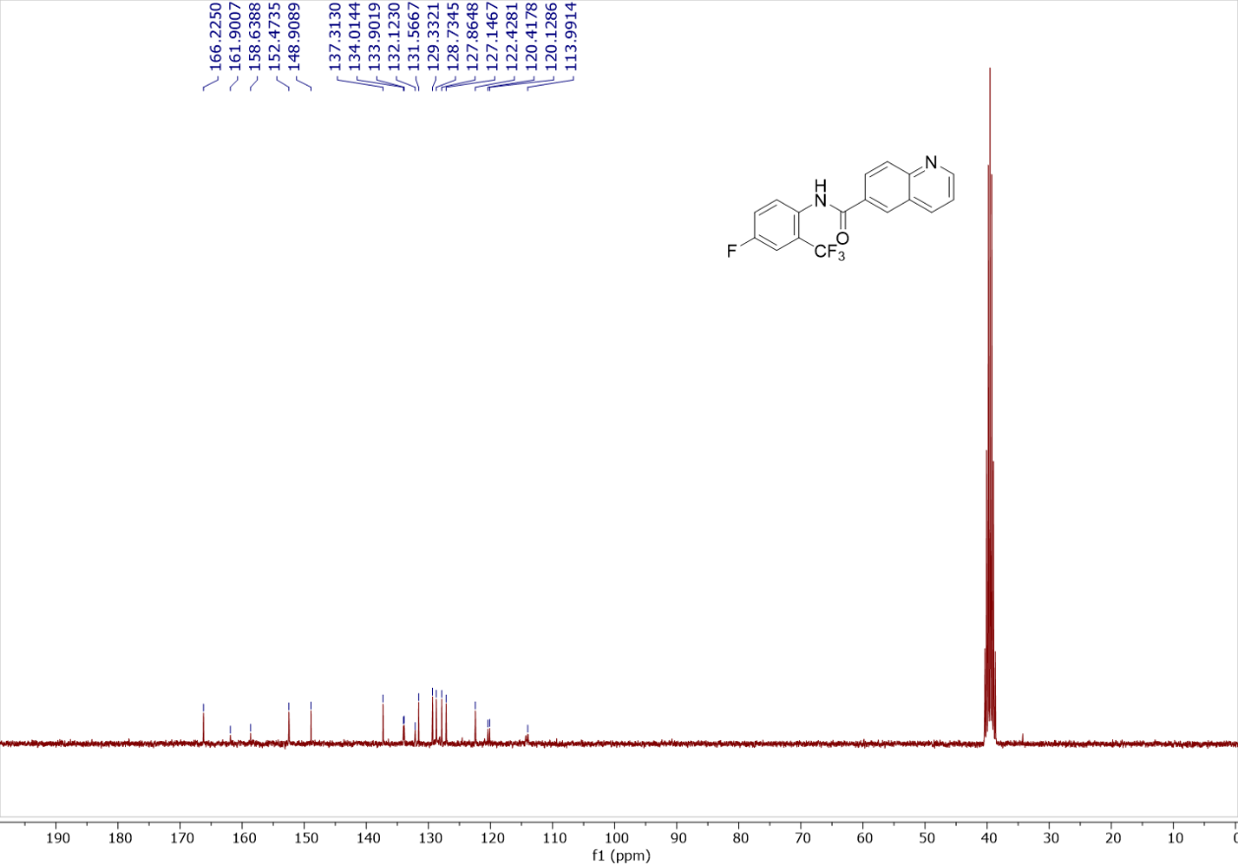
Figure S12: ¹³C{¹H} spectrum of N-(4-fluoro-2-(trifluoromethyl)phenyl)quinoline-6-carboxamidein DMSO-d6 (4f)

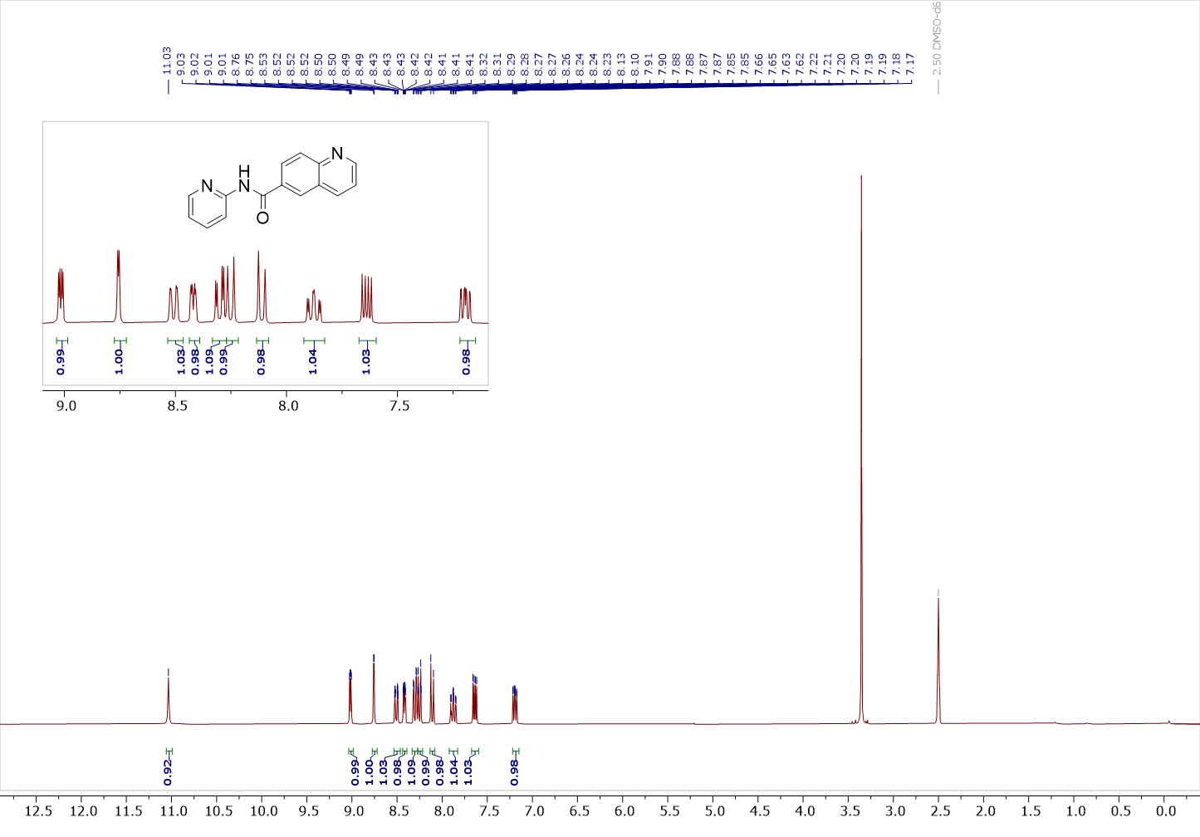
Figure S13: ¹H spectrum of N-(pyridin-2-yl)quinoline-6-carboxamide in DMSO-d6 (4g)
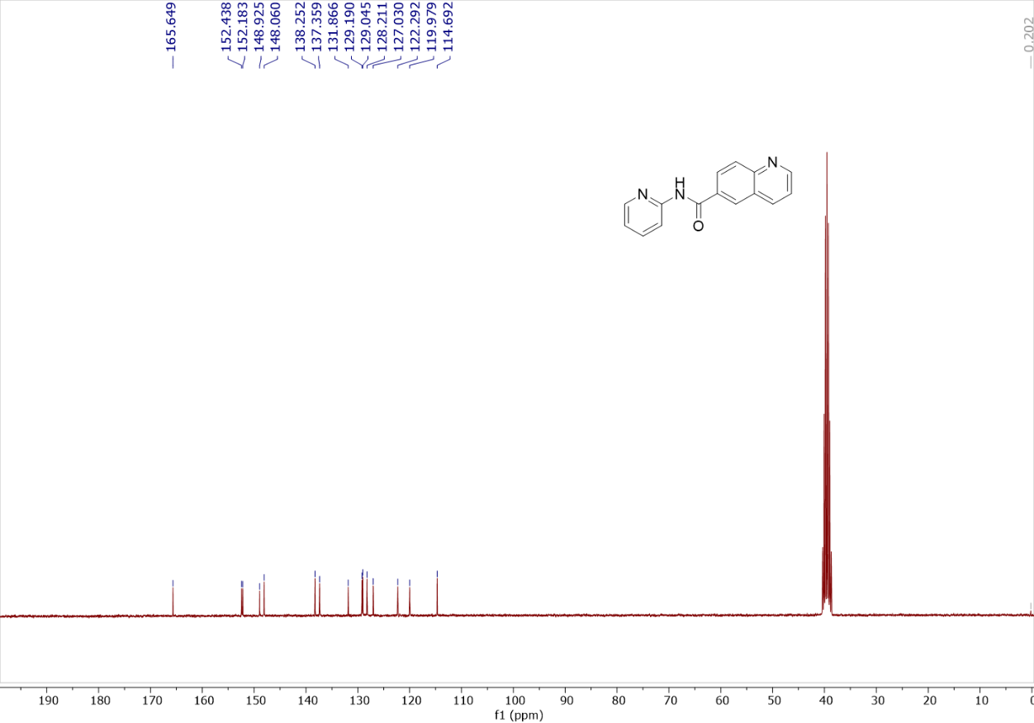
Figure S14: ¹³C{¹H} spectrum of N-(pyridin-2-yl)quinoline-6-carboxamide in DMSO-d6 (4g)
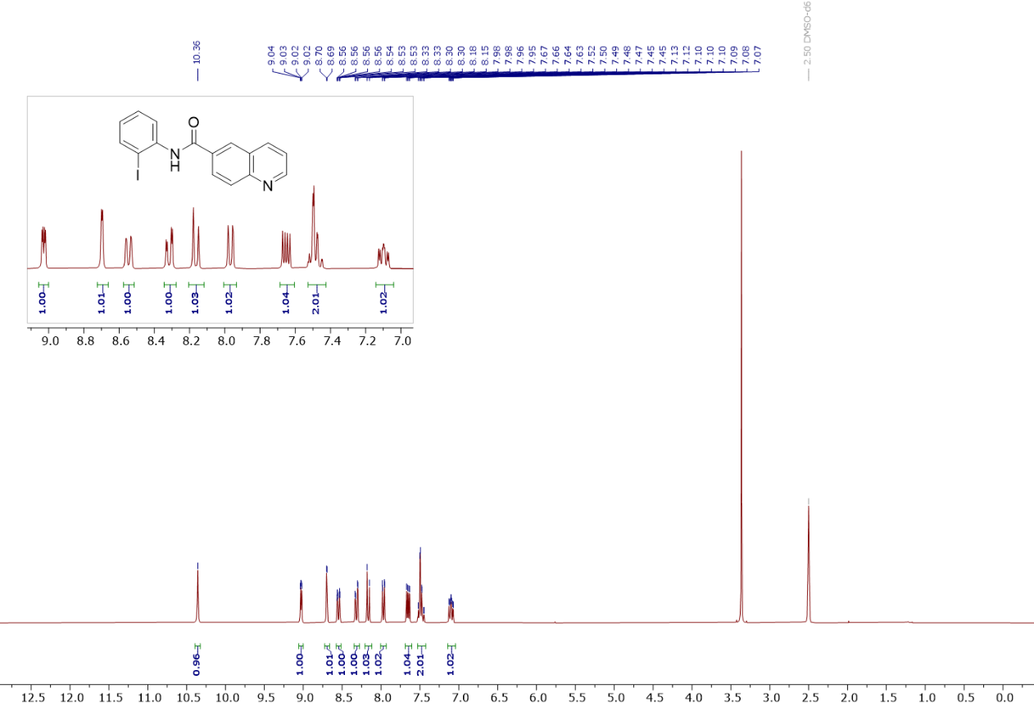
Figure S15: ¹H spectrum of N-(2-iodophenyl)quinoline-6-carboxamide in DMSO-d6 (4h)
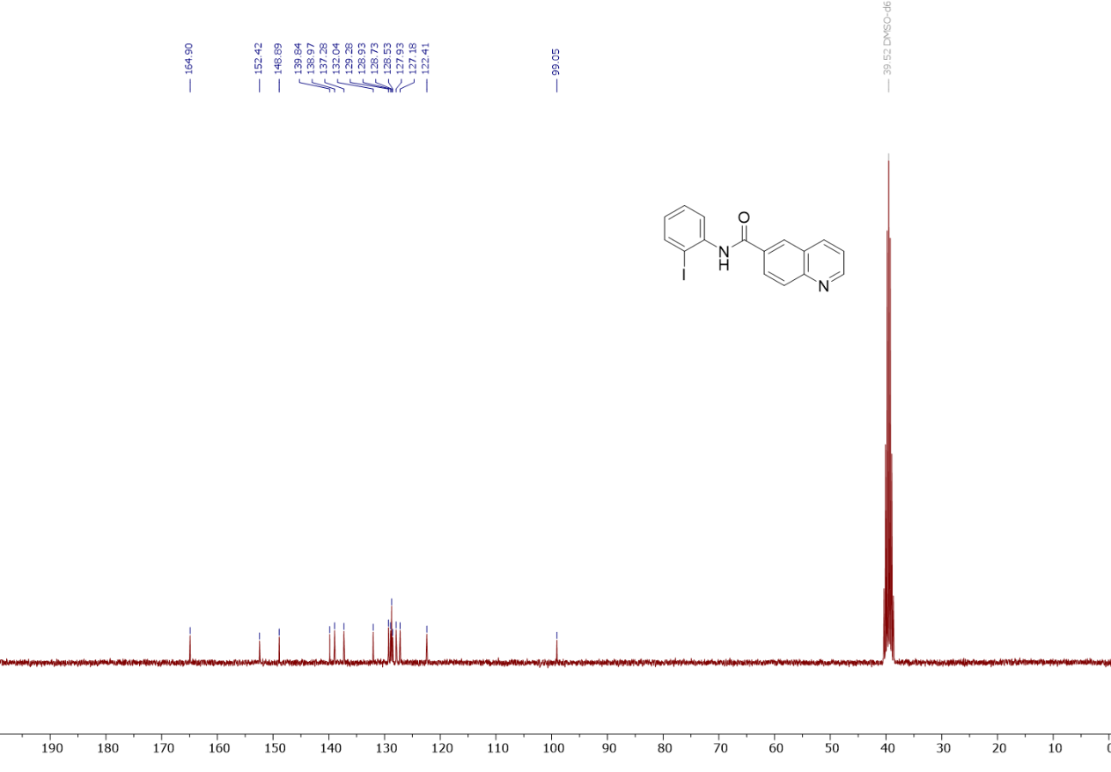
Figure S16: ¹³C{¹H} spectrum of N-(2-iodophenyl)quinoline-6-carboxamide in DMSO-d6 (4h)^{(a)}

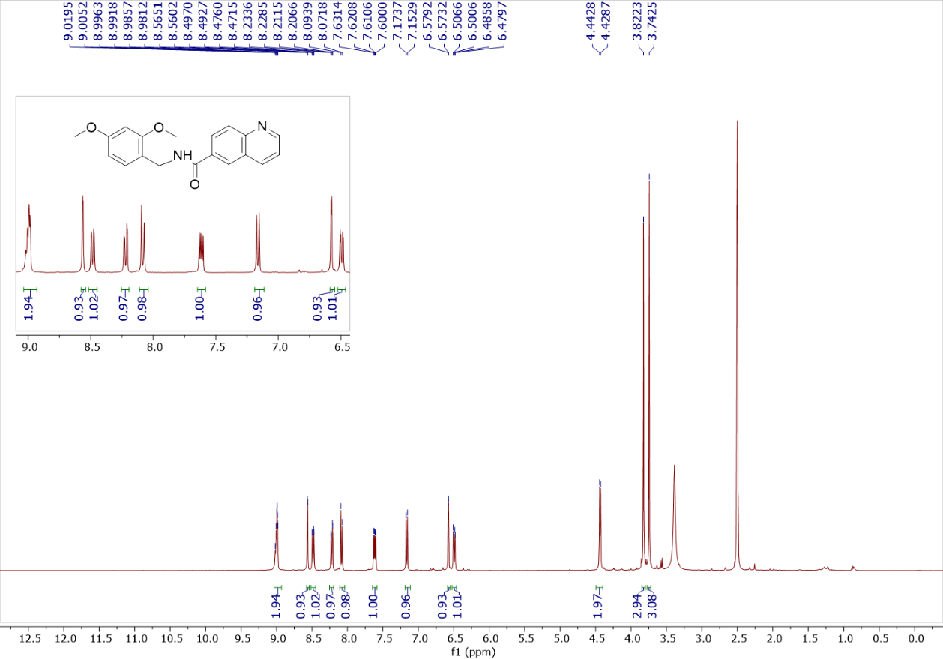

Figure S17: ¹H spectrum of N-(2,4-dimethoxybenzyl)quinoline-6-carboxamide in DMSO-d6 (4i)

.

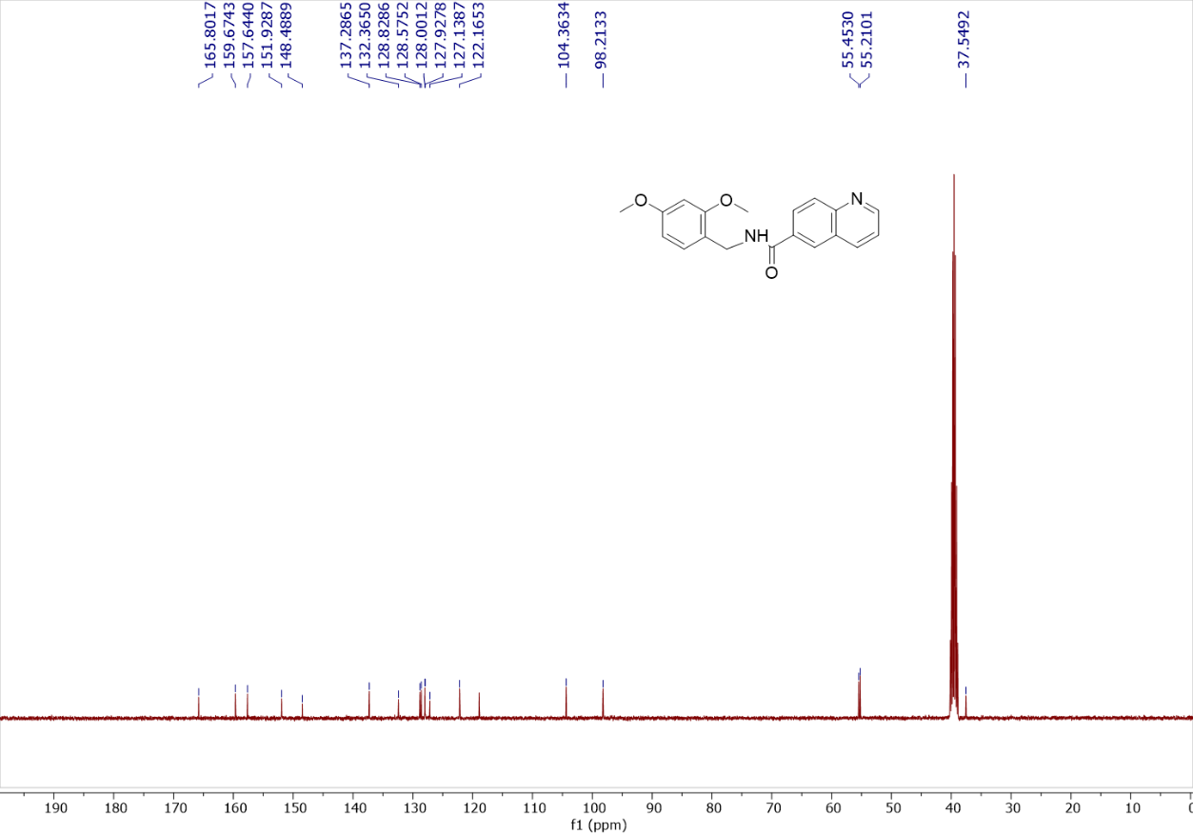
Figure S18: ¹³C{¹H} spectrum of N-(2,4-dimethoxybenzyl)quinoline-6-carboxamide in DMSO-d6 (4i)

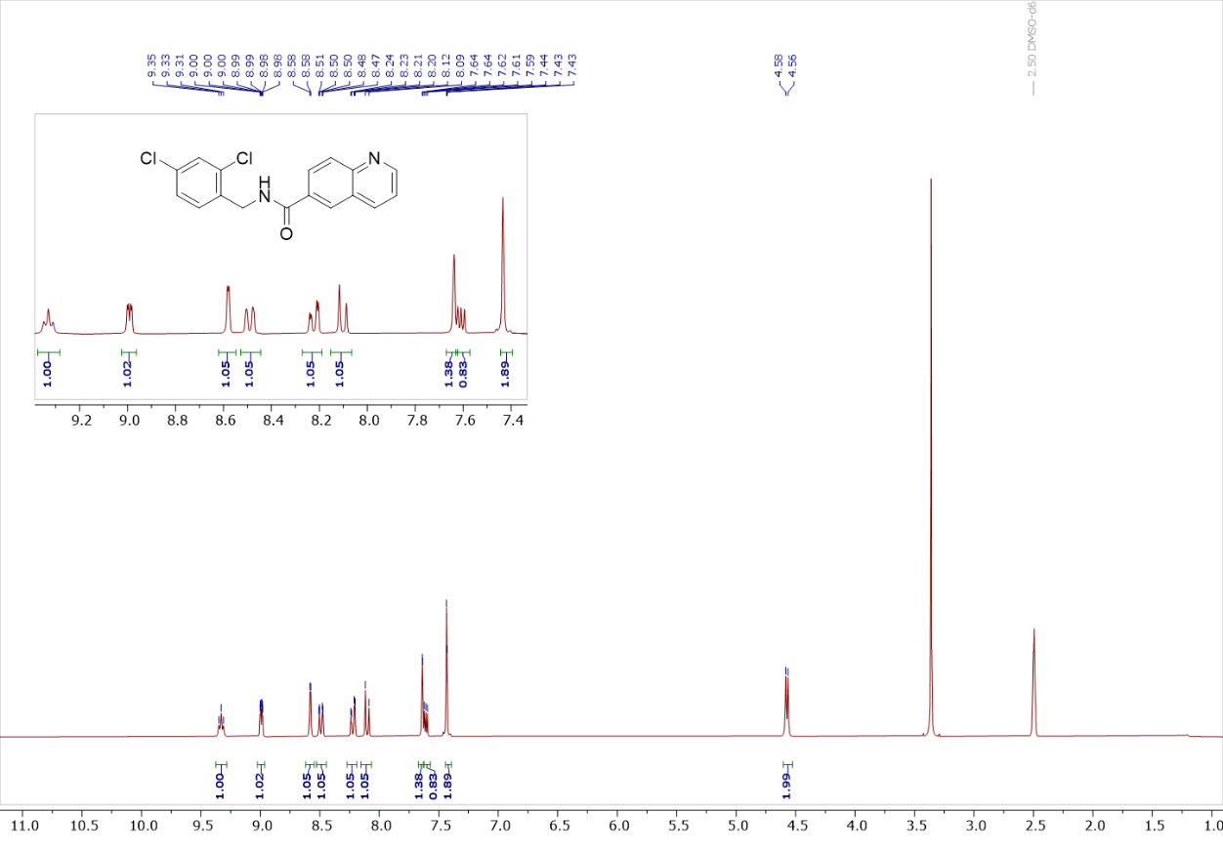
Figure S19: ¹H spectrum of N-(2,4-dichlorophenyl)quinoline-6-carboxamide in DMSO-d6 (4j)

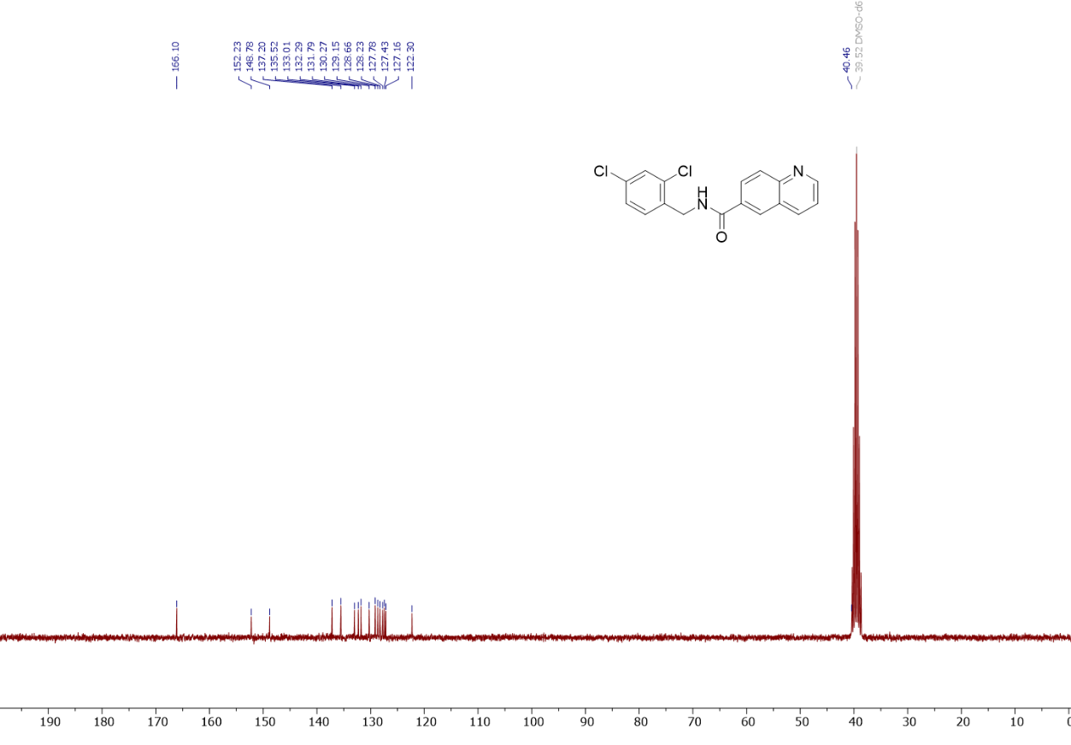
Figure S20: ¹³C{¹H} spectrum of N-(2,4-dichlorophenyl)quinoline-6-carboxamide in DMSO-d6 (4j)

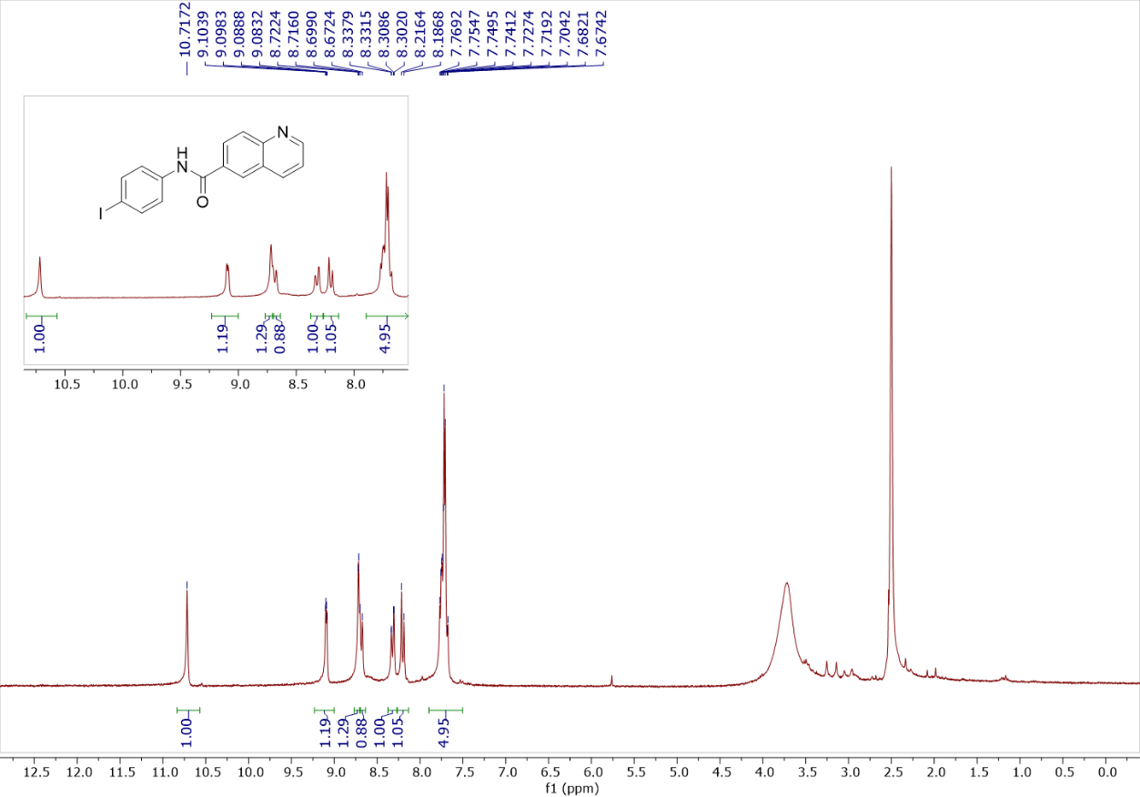
Figure S21: ¹H spectrum of N-(4-iodophenyl)quinoline-6-carboxamide in DMSO-d6 (4k)
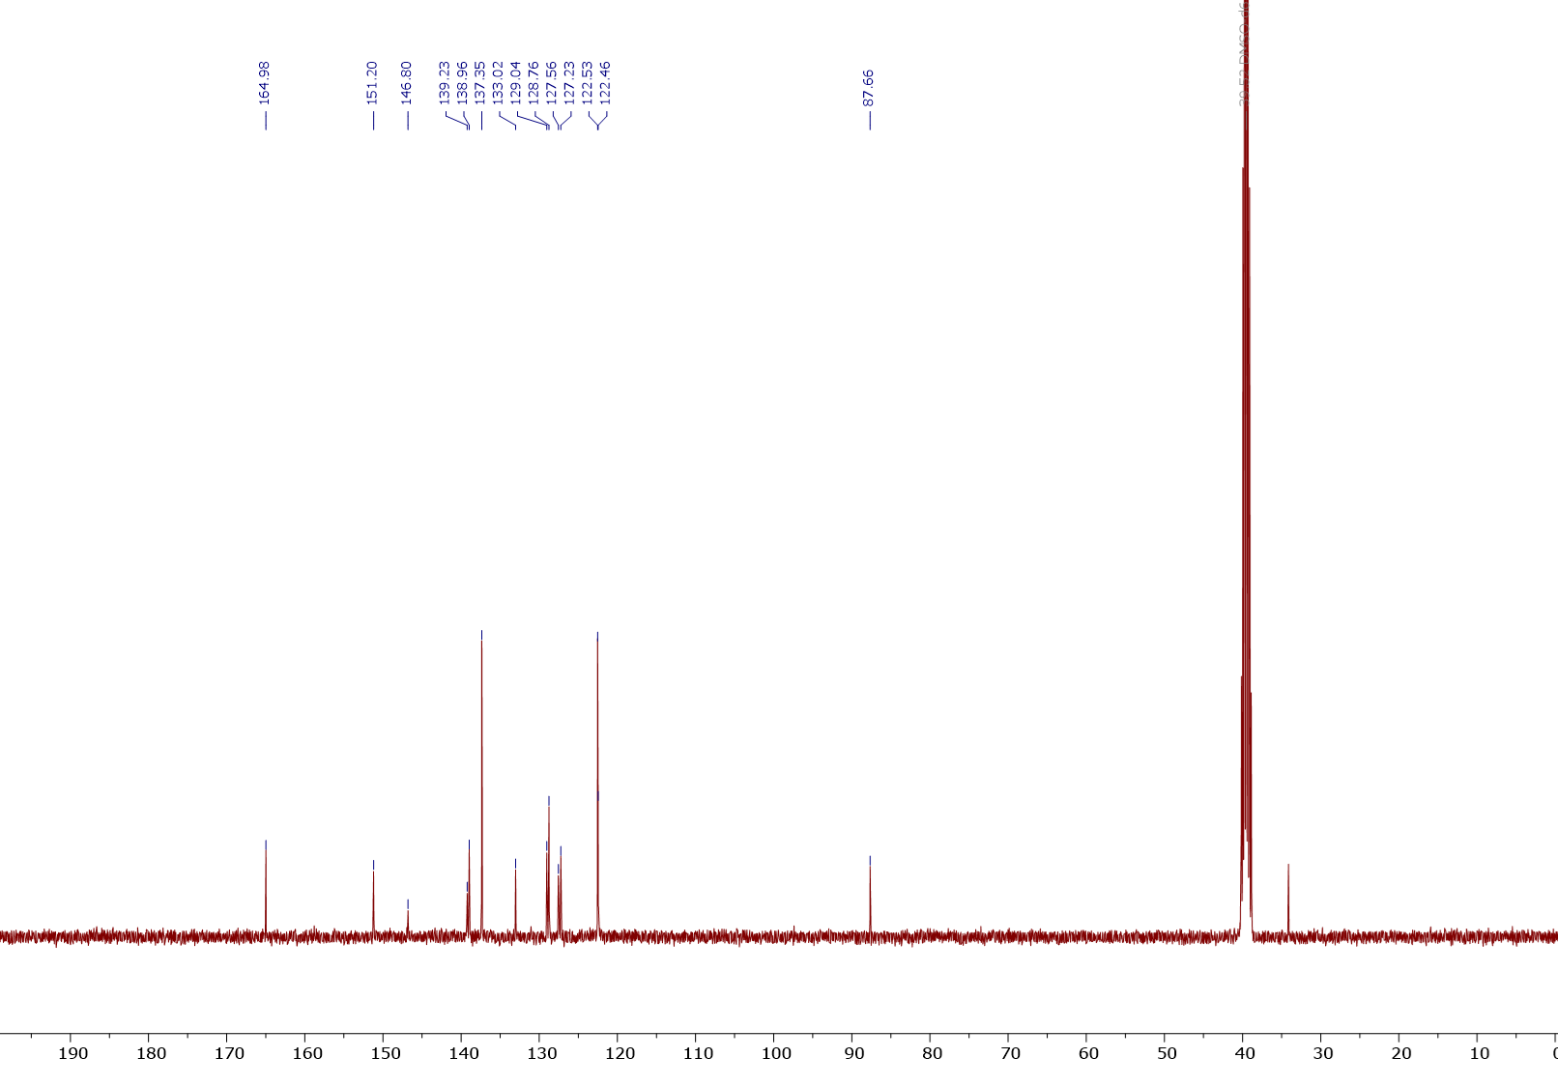
Figure S22: ¹³C{¹H} spectrum of N-(4-iodophenyl)quinoline-6-carboxamide in DMSO-d6 (4k)
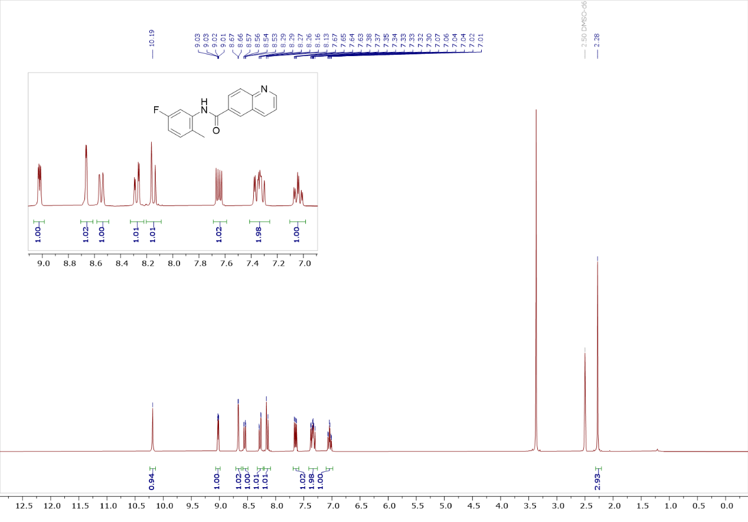
Figure S23: ¹H spectrum of N-(5-fluoro-2-methylphenyl)quinoline-6-carboxamide in DMSO-d6 (4l)

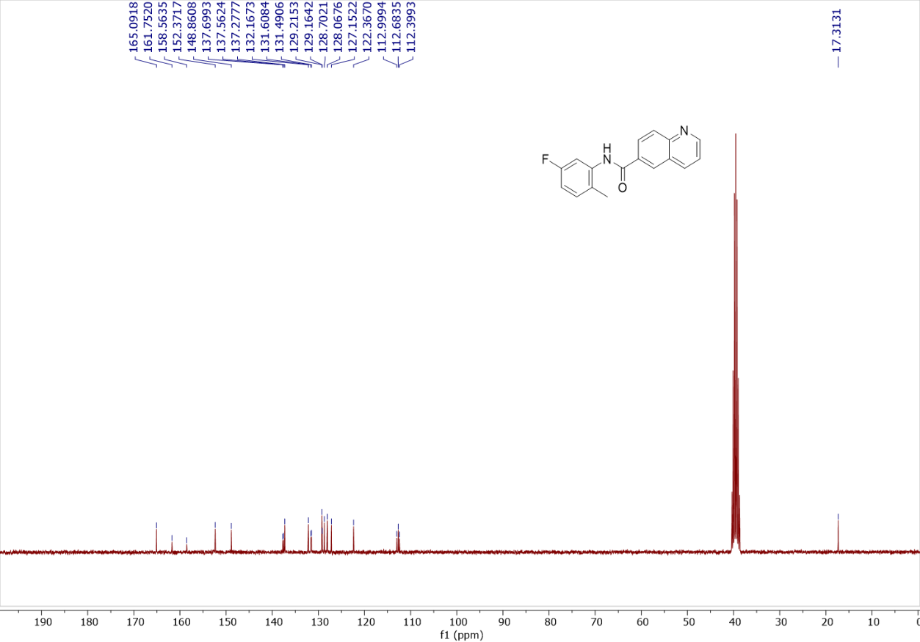
Figure S24: ¹³C{¹H} spectrum of N-(5-fluoro-2-methylphenyl)quinoline-6-carboxamide in DMSO-d6 (4l)

