Search Strategy Details

Table S1. Search terms with “germline variants“.

Number of search term | Terms used
1 | “Breast cancer recurrence” AND “germline variants”
2 | “Breast cancer metastasis” AND “germline variants”
3 | “Breast cancer prognosis” AND “germline variants”
4 | “Breast cancer” AND “relapse free survival” AND “germline variants”
5 | “Breast cancer” AND “recurrence free survival” AND “germline variants”
6 | “Breast cancer” AND “disease free survival” AND “germline variants”
7 | “Breast cancer” AND “distant metastasis free survival” AND “germline variants”
8 | “Breast cancer” AND “progression free survival” AND “germline variants”
9 | “Breast cancer” AND “event free survival” AND “germline variants”
10 | “Breast cancer” AND “overall survival” AND “germline variants”

Table S2. Search terms with “germline polymorphisms“.

Number of search term | Terms used
1 | “Breast cancer recurrence” AND “germline polymorphisms”
2 | “Breast cancer metastasis” AND “germline polymorphisms”
3 | “Breast cancer prognosis” AND “germline polymorphisms”
4 | “Breast cancer” AND “relapse free survival” AND “germline polymorphisms”
5 | “Breast cancer” AND “recurrence free survival” AND “germline polymorphisms”
6 | “Breast cancer” AND “disease free survival” AND “germline polymorphisms”
7 | “Breast cancer” AND “distant metastasis free survival” AND “germline polymorphisms”
8 | “Breast cancer” AND “progression free survival” AND “germline polymorphisms”
9 | “Breast cancer” AND “event free survival” AND “germline polymorphisms”
10 | “Breast cancer” AND “overall survival” AND “germline polymorphisms”

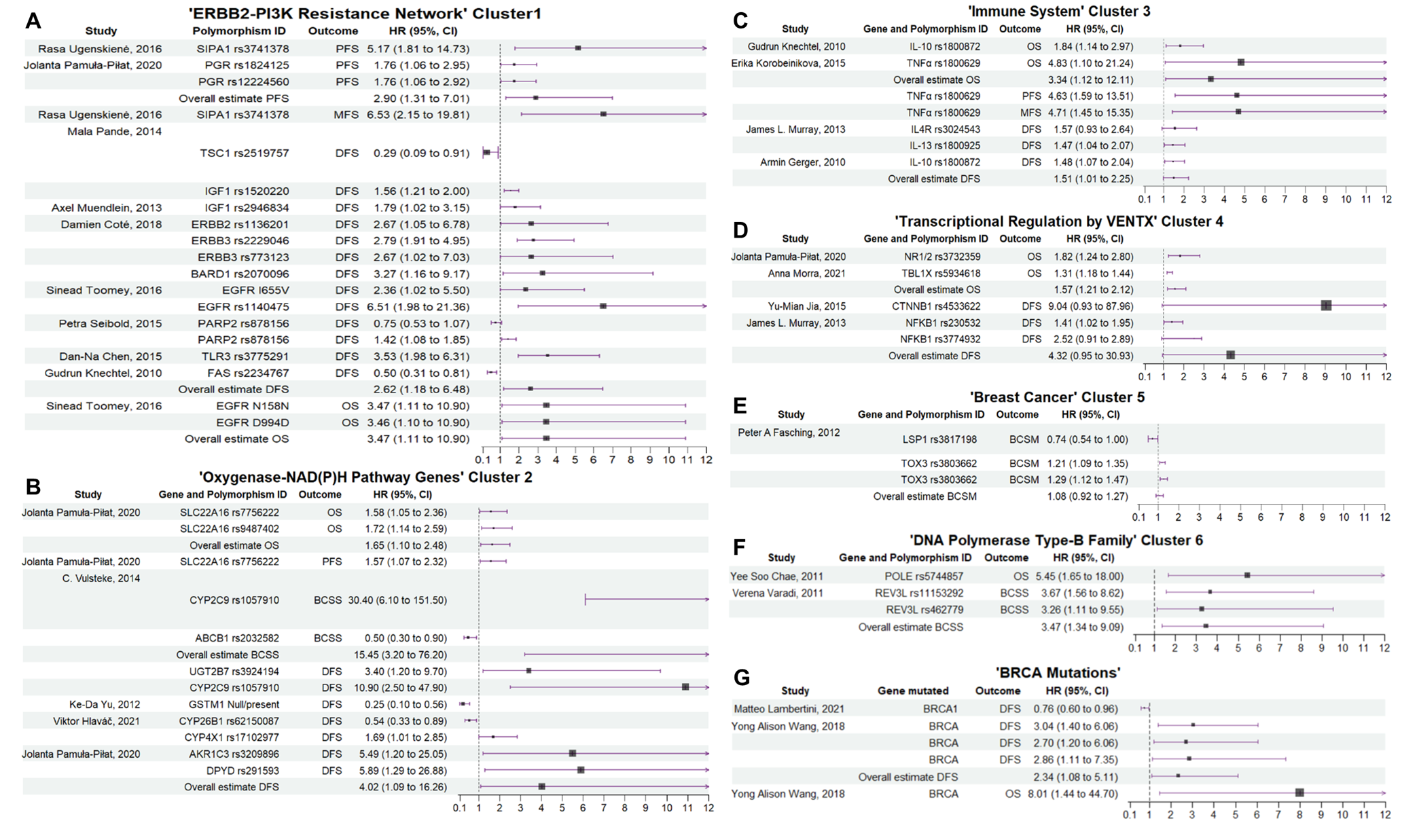
Figure S1. Forest plots of clusters 1 to 6 and BRCA mutations. Overall estimates were calculated when two or more estimates were reported for each outcome and are presented at the end of the list. For visual consistency, confidence intervals (CIs) exceeding 12 were capped at that value and indicated with an arrow at the line´s end. The width of each estimate´s square reflects the corresponding Standard Error (SE). During the meta-analysis, cluster 3 was modified, ADPQ and LEPR were removed and TNFα was added to group the genes involved in immune system.

