Halophytes have different ecophysiological and fungal root colonization traits in two saline soil conditions

Jesús Adrián Barajas González, Rogelio Carrillo-González, Jesús Eulises Corona Sánchez, Yersain Ely Keller de la Rosa, Ma. del Carmen Ángeles González-Chávez*

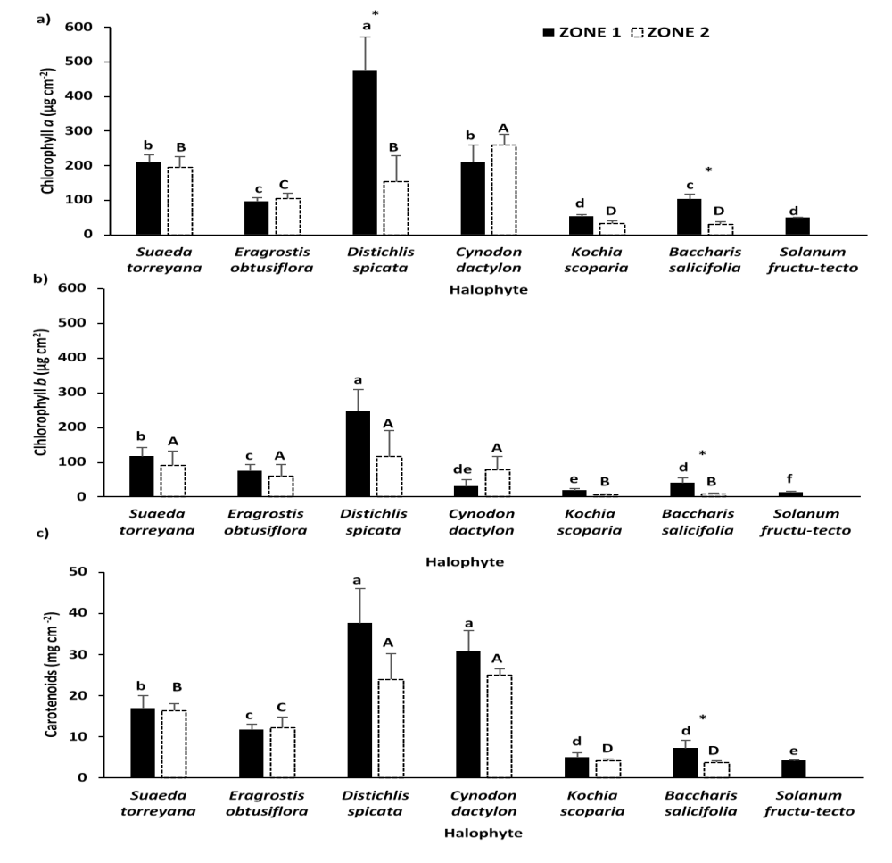
Fig. S2 Photosynthetic pigments in halophytes established in two zones with different soil electrical conductivity. a) Chlorophyll a, b) chlorophyll b, and c) carotenoids. Averages and standard deviation, n=8. Identical lower letters show no statistical difference in the pigment concentration between plants from Zone 1. Identical capital letters show no statistical difference in these variables between plants from Zone 2. Asterisk (*) denotes statistical differences when comparing the same plant between zones. In all cases, Tukey (α=0.05)

