Halophytes have different ecophysiological and fungal root colonization traits in two saline soil conditions
Jesús Adrián Barajas González, Rogelio Carrillo-González, Jesús Eulises Corona Sánchez, Yersain Ely Keller de la Rosa, Ma. del Carmen Ángeles González-Chávez*
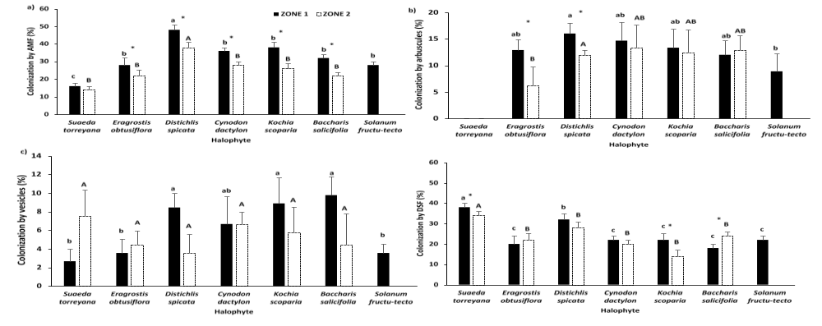

Fig. S5 Endorhizal root colonization and glomalin concentration in halophytes established in two zones with different soil electrical conductivity. a) Colonization by arbuscular mycorrhizal fungi (AMF), b) colonization by arbuscules, c) colonization by vesicles, and d) colonization by dark septate fungi (DSF). Similar lower letters show no statistical difference in these variables between plants from Zone 1. Identical capital letters show no statistical difference in these variables between plants from Zone 2. Asterisk (*) denotes statistical differences when comparing the same plant between zones. In all cases, Tukey (α=0.05)

