Halophytes have different ecophysiological and fungal root colonization traits in two saline soil conditions
Jesús Adrián Barajas González, Rogelio Carrillo-González, Jesús Eulises Corona Sánchez, Yersain Ely Keller de la Rosa, Ma. del Carmen Ángeles González-Chávez*
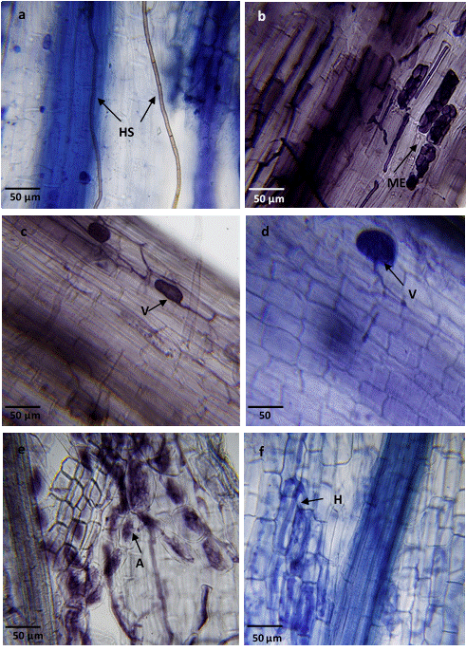

Fig. S4 Endorhizal root colonization in halophytes. (a) S. torreyana (Zone 1), (b) S. torreyana (Zone 2), (c) D. spicata (Zone 1), (d) D. spicata (Zone 2), (e) C. dactylon (Zone 1), and (f) C. dactylon (Zone 2). Structures of arbuscular mycorrhizal fungi = arbuscules (A), vesicles (V), and hyphae (H). Structures of dark septate fungi = microsclerotium (ME) and dark septate hyphae (HS)

