Supplementary Material: A techno-economic analysis and life cycle assessment of woody biochar as an additive for orphan well plugging
Brooke Ballengerª, Kerry Miller^{b}, Thomas Borch^{b,c}, Jason C. Quinn^{a*}
ªDepartment of Mechanical Engineering, Colorado State University, 711 Oval Drive, Fort Collins, CO 80521, United States
^{b}Department of Chemistry, Colorado State University, 711 Oval Drive, Fort Collins, CO 80521, United States
^{c}Department of Soil & Crop Sciences, Colorado State University, 711 Oval Drive, Fort Collins, CO 80521, United States
*Corresponding author, Email: jason.quinn@colostate.edu

Method S1 Cement mixing protocol. Class G cement was donated by A Plus Wells (Greely, CO), and a polycarboxylate (PCE) superplasticizer (item #97190) was donated by Fritz-Pak Corporation (Mesquite, TX). All mixes were mixed using industrial supply water. Ratios of water, cement, biochar, and plasticizer used in each test can be found in . Eight 2”x 4” cylinders were poured for each test using Forney PVC cement molds (LA-0211-24) with caps. Biochar and dry cement were mixed for 1 minute dry before adding water. After water was added and mixture was completely wet, superplasticizer was added during mixing. Combined materials were mixed at high speed for 5 minutes before pouring into molds. Each mold was tamped 30 times after filling halfway, then 30 more times after filling completely. The molds were then capped and left in a heat and humidity-controlled room until demolding (Pecha, 2022). Demolding was accomplished by puncturing the bottom of the mold with a nail, then adding compressed air until the cement cylinder was released
Method S2 Compressive strength. Compressive strength was measured using a Forney F-1500KN-VFD Automatic Compression Test Machine, which records stress applied to a sample every ~0.3 seconds until failure (pressure loss >100 PSI in one 0.3 second interval with no recovered pressure), or the sample is compressed enough that the machine no longer registers its presence. Compressive strength was measured every 1, 4, 7, and 28 days after each test started. It should be noted that only stress was measured, and no strain data was collected; therefore, Young’s Modulus could not be calculated
Method S3 Cement slurry viscosity: Viscosity was measured using the Zahn cup method (ASTM D 4212, D 816, D 1084). After the cement was fully mixed, the no. 3 Zahn cup (3.86mm) was fully submerged in the mixture and allowed to drain. The time from the start of draining to the breakup in the fluid stream was recorded and viscosity was calculated in centistokes (Bhattad, 2023) . The correct mass of superplasticizer needed to compensate biochar addition was elucidated by comparing the viscosity the control mix (no biochar), and PCE was added to biochar mixtures until similar viscosities were achieved (Pecha, 2022)

Table S1 Well plugging assumptions and parameters used in techno-economic analysis
Parameter | Value | References
Well Type | Conventional Vertical | (CO DNR, 2024)
Measured Well Depth | 2074 m | (COGIS, 2024)
Well Diameter | 23 cm (0 – 442 m depth)  13 cm (442 m – 2074 m depth) | (COGIS, 2024)
Plugs Used | 6 | (COGIS, 2024)
Cement Used | 11.6 tonnes (271 sacks) | (COGIS, 2024; WAC, 2024)
Labor | 4 workers | (Kaiser and Dodson, 2007)
Well Plugging Timeline | 4 days | (ND DMR, 2024)
Service Equipment | Bulk truck, triplex truck, workover rig | (COGIS, 2024; Hawthorn et al., 2022)
Procedures Performed | Pressure test, wireline, squeezing, well plug placement, spacer placement, cut & cap | (COGIS, 2024; Hawthorn et al., 2022)
Transport | 185 km (roundtrip) | (COGIS, 2024)
Biochar Purchase Price (No Credits) | $58-$348/tonne, (Avg - $209/ tonne) | (Puro.earth, 2024; Oregon Biochar Solutions, 2024; Go Biochar, 2024; Blue Sky Biochar, 2024; Airterra, 2024; Biochar Now, 2023)

Table S2 Relevant properties of pyrolysis, biomass, and biochar for the various thermochemical conversion methods
Method | Operating Temperature | C_{org} Content | Biochar Yield | Energy Used | References
Injection Auger | 500°C | 80% | 24% | Electricity Natural Gas | (Brassard et al., 2018; Bruckman et al., 2016; Kim et al., 2011; Hansson et al., 2020; Tisserant and Cherubini, 2019; Hassan et al., 2020)
Rotary Kiln | 500°C | 80% | 38% | Electricity Natural Gas | (Khodaei et al., 2024; Chireshe et al., 2020; Gwenzi et al., 2015; Nan et al., 2020; Panwar et al., 2019)
Batch Reactor | 500°C | 76% | 27% | Electricity Natural Gas | (Kizza et al., 2019; Morin et al., 2016; Mohabeer et al., 2020; Aguda, 2017; Lian et al., 2014, Bartoli et al., 2020; Dissanayake et al., 2020; Mohammadi et al., 2020)
Portable Retort | 550-600°C | 88% | 16.5% | Diesel  Propane | (Gaspard, 2024)
Mobile Carbonizer | 680-750°C | 89% | 17% | Diesel  Propane | (Puemmann et al., 2020; COGA, 2024)

Table S3 Slurry mix ratios
Biochar-Cement Mixture | Cement (g) | Water (mL) | Biochar (g) | PCE (g) | Mass Ratio (cement:water:biochar:PCE)
Control | 2380 | 1047.2 | 0 | 0 | 1:0.44:0:0
1% | 2380 | 1047.2 | 23.8 | 0 | 1:0.44:0.01:0
3% 3x | 2380 | 1047.2 | 71.4 | 24ª | 1:0.44:0.03:0.01
3%H₂O | 2380 | 1285.2 | 71.4 | 8 | 1:0.54:0.03:0.003
3% | 2380 | 1047.2 | 71.4 | 8 | 1:0.44:0.03:0.003
5% | 2380 | 1047.2 | 119 | 32ª | 1:0.44:0.05:0.0134
10% | 2380 | 1047.2 | 238 | 46.6ª | 1:0.44
ªIndicates addition of excess PCE

Table S4 Slurry viscosity. Testing did not continue with the 10% mix due to very high viscosity. The 3%3x mixture represents the lowest possible viscosity a 3% biochar mix can achieve while adding only excess PCE and no extra water
Mixture | Control | 1% | 3% | 3%3x | 3%H₂O | 5% | 10%
Kinematic Viscosity (cSts) | 72.31  +/- 0.48 | 95.82  +/- 0.42 | 286.65  +/- 0.33 | 122.89 +/- 0.39 | 71.64  +/- 0.27 | 336.26  +/- 0.67 | Infinite/does not flow
Dynamic Viscosity (cP) | 135.69  +/- 2.82 | 181.84  +/- 3.16 | 542.44  +/- 2.06 | 231.03 +/- 13.78 | 135.12 +/- 6.05 | 632.16  +/- 2.67 | Infinite/does not flow
Comparison | Maple syrup | Tomato juice | Apple sauce | Maple syrup | Maple syrup | Castor oil or glycerin | Silly Putty

Figure S1 Average compressive of the cement mixtures with different weight % biochar added in. n=2-4 cylinders broken each time point. The 5% mix did not show a clear point of failure, and the value shown represents the point of plastic failure instead

Figure S2 Average compressive strength of cement mixes with controlled viscosity. The control, 3%3x, and 3% H₂O samples all have similar viscosity, with ‘3%3x’ controlled by excess PCE, and the ‘3%H₂O’ mix controlled by excess water. The ‘3%’ mix has a slightly higher viscosity and was designed to optimize performance over viscosity. The ‘3%3x’ mixture did not show a clear point of failure, and the value shown represents the point of plastic failure instead. n=2-4 cylinders broken each time point

A
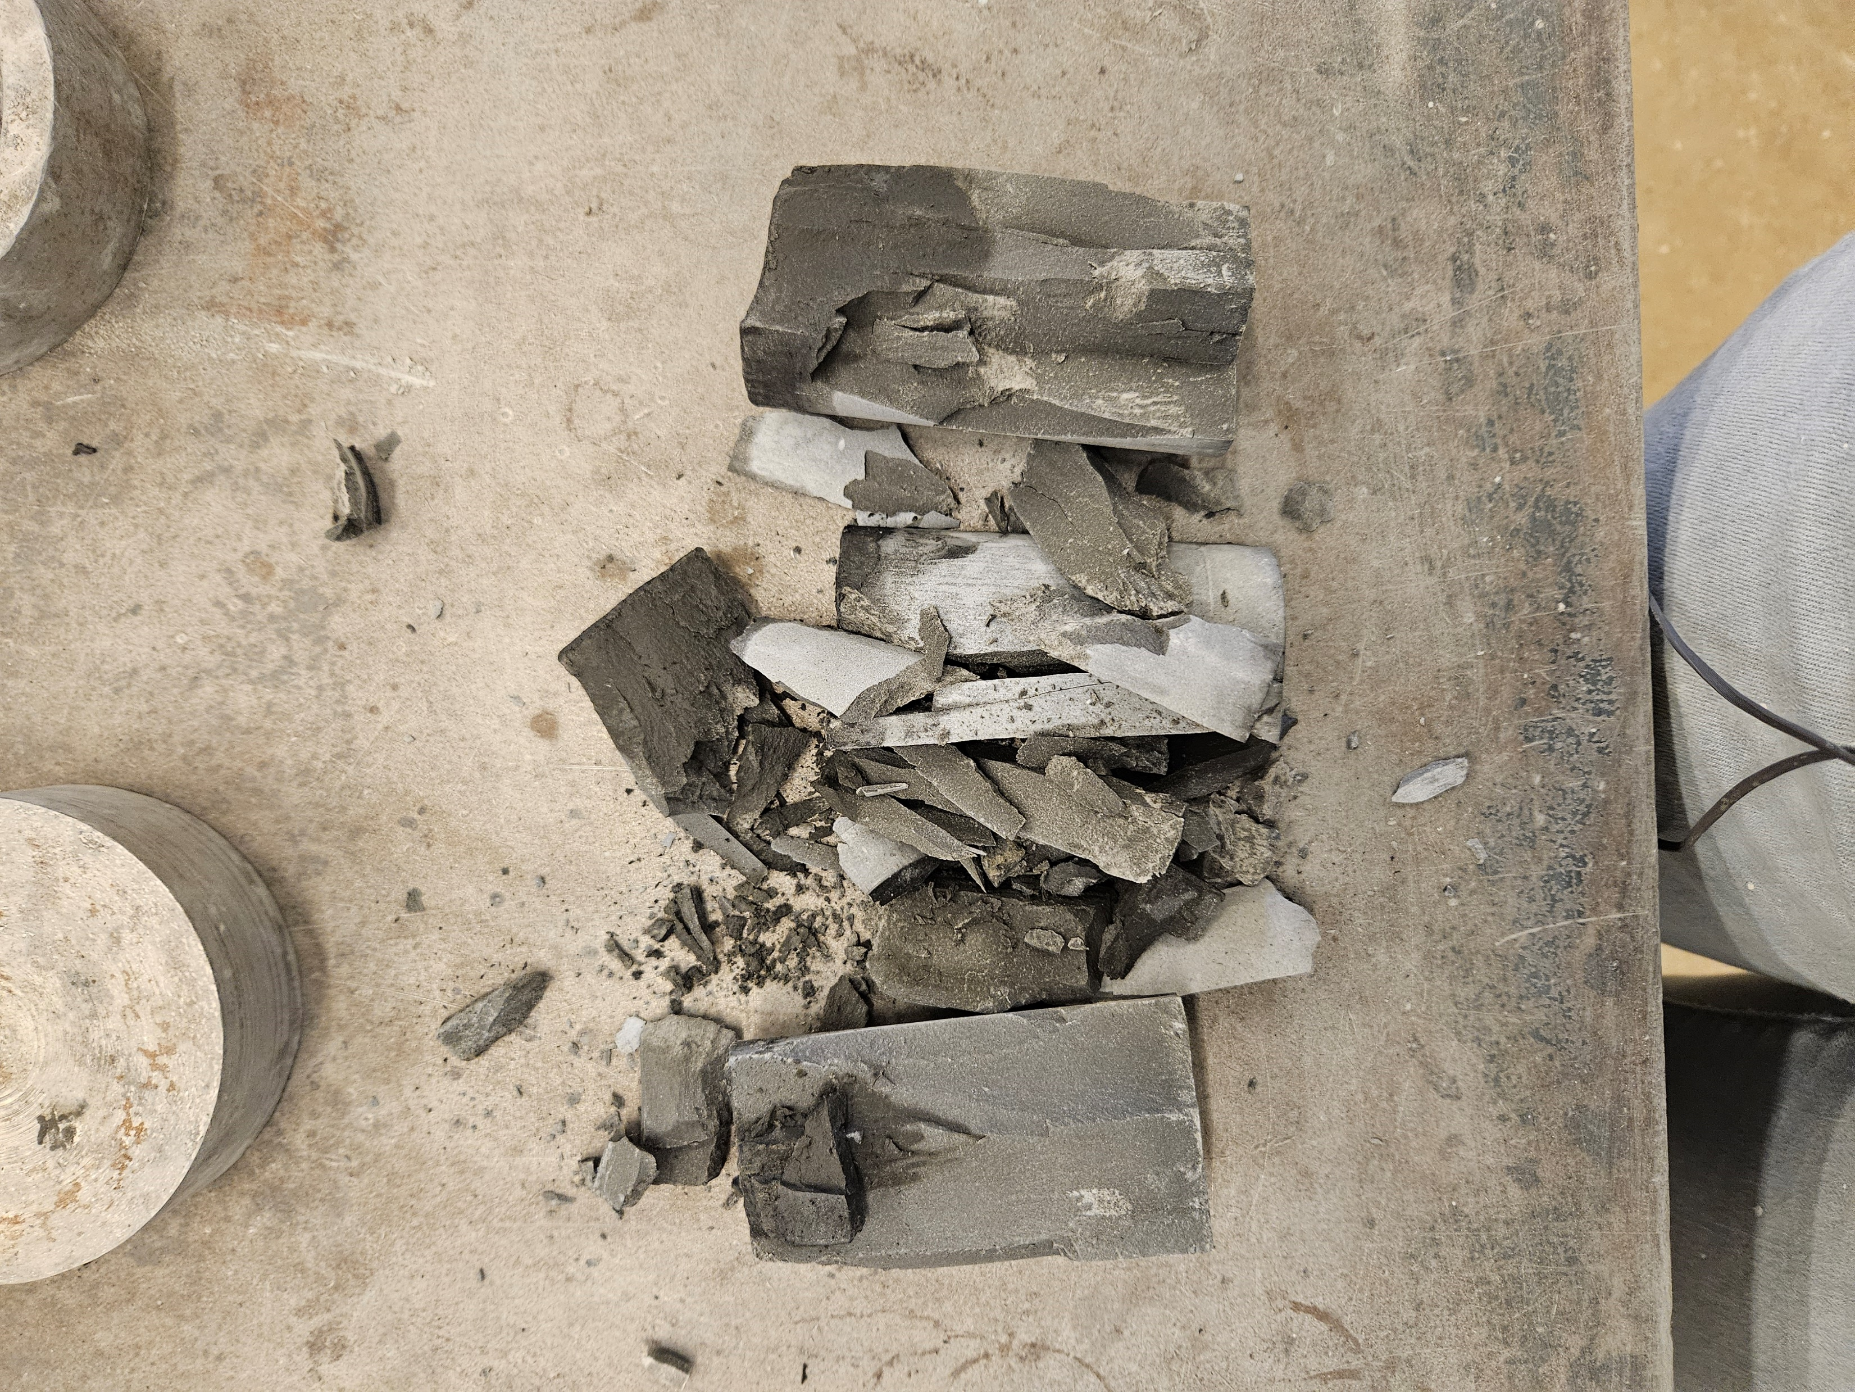

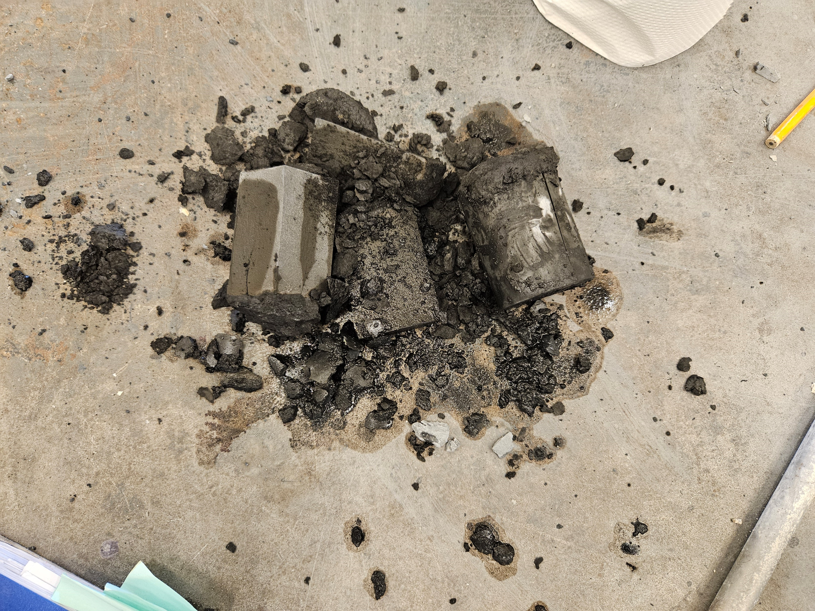
B

Figure S3 Stress at break vs. point of plastic deformation. In samples with a linear applied stress/time plot like the 3% biochar curve shown, there is a clear point of elastic failure, which is automatically recorded by the Automatic Compression Test Machine (shown in point A), and is the value recorded as the ‘stress at break’ used in further calculations. These samples result in longitudinal fractures and insignificant change to the length of the cement cylinder (shown in top image). Samples with excess PCE (5%, 3%3x) tended to show plastic failure (shown in point B), and dramatic deformation of the cylinder was observed (bottom image). These samples did not show a clear point of failure, and the Automatic Compression Test Machine stopped when the cylinder compressed so small that the machine could no longer register its presence. For this reason, the value recorded for future calculations was the plastic failure point shown in point B

References
Aguda, R., 2017. Preparation and Characterization of Modified Biomass as Functional Carbon-based Materials. Ph.D. Dissertation, North Carolina State University, Raleigh, North Carolina.
AirTerra, 2024. About AirTerra. https://www.airterra.ca/about-airterra/ (accessed 21 May 2024).
Bartoli, M., Giorcelli, M., Jagdale, P., Rovere, M., Tagliaferro, A., 2020. A review of non-soil biochar applications. Materials, 13(2), 261. https://doi.org/10.3390/ma13020261.
Bhattad, A., Review on viscosity measurement: devices, methods and models. Journal of Thermal Analysis and Calorimetry, 2023. 148(14): p. 6527-6543. DOI:10.1007/s10973-023-12214-0
Blue Sky Biochar, 2024. Product Collections. https://blueskybiochar.com/collections/all (accessed 21 May 2024).
Brassard, P., Godbout, S., Pelletier, F., Raghavan, V., Palacios, J.H., 2018. Pyrolysis of switchgrass in an auger reactor for biochar production: A greenhouse gas and energy impacts assessment. Biomass and Bioenergy, 116, 99–105. https://doi.org/10.1016/j.biombioe.2018.06.007.
Bruckman, V.J., Apaydin Varol, E., Uzun, B.B., Liu, J., 2016. Biochar: A regional supply chain approach in view of climate change mitigation. Cambridge University Press.
Chireshe, F., Collard, F.-X., Görgens, J.F., 2020. Production of low oxygen bio-oil via catalytic pyrolysis of forest residues in a kilogram-scale rotary kiln reactor. Journal of Cleaner Production, 260, 120987. https://doi.org/10.1016/j.jclepro.2020.120987.
Colorado Department of Natural Resources (CO DNR), 2024. Communication.
Colorado Oil and Gas Association (COGA), 2024. Additional Resources. https://www.coga.org/additionalresources.html (accessed 5 Feb 2024).
Colorado Oil and Gas Information System (COGIS), 2024. COGIS Data. https://ecmc.state.co.us/data.html#/cogis (accessed 21 May 2024).
Dissanayake, P.D., You, S., Igalavithana, A.D., Xia, Y., Bhatnagar, A., Gupta, S., Kua, H.W., Kim, S., Kwon, J.-H., Tsang, D.C.W., Ok, Y.S., 2020. Biochar-based adsorbents for carbon dioxide capture: A critical review. Renewable and Sustainable Energy Reviews, 119, 109582. https://doi.org/10.1016/j.rser.2019.109582.
Biochar Now, 2023. Personal communication.
Go Biochar, 2024. Products. https://gobiochar.com/shop/ (accessed 21 May 2024).
Gwenzi, W., Chaukura, N., Mukome, F.N.D., Machado, S., Nyamasoka, B., 2015. Biochar production and applications in sub-Saharan Africa: Opportunities, constraints, risks, and uncertainties. Journal of Environmental Management, 150, 250–261. https://doi.org/10.1016/j.jenvman.2014.11.027.
Hansson, A., Haikola, S., Fridahl, M., Albrectsen, A., Lundmark, T., 2021. Biochar as multi-purpose sustainable technology: Experiences from projects in Tanzania. Environment, Development and Sustainability, 23, 5182–5214. https://doi.org/10.1007/s10668-020-00809-8.
Hassan, M., Liu, Y., Naidu, R., Parikh, S.J., Du, J., Qi, F., Willett, I.R., 2020. Influences of feedstock sources and pyrolysis temperature on the properties of biochar and functionality as adsorbents: A meta-analysis. Science of the Total Environment, 744, 140714. https://doi.org/10.1016/j.scitotenv.2020.140714.
Hawthorn, A., Steinsiek, R., Rahman, S., 2022. Casing and cement evaluation on drillpipe: New tool acquires well integrity data in parallel with existing drillpipe deployed operations from drilling to plug and abandonment. Offshore Technology Conference Asia. https://doi.org/10.4043/31502-MS.
Kaiser, M.J., Dodson, R., 2007. Cost of plug and abandonment operations in the Gulf of Mexico. Marine Technology Society Journal, 41(2), 12–22. https://doi.org/10.4031/002533207787442204.
Khodaei, H., Álvarez-Bermúdez, C., Chapela, S., Olson, C., MacKenzie, M.D., Gómez, M.A., Porteiro, J., 2024. Eulerian CFD simulation of biomass thermal conversion in an indirect slow pyrolysis rotary kiln unit to produce biochar from recycled waste wood. Energy, 288, 129895. https://doi.org/10.1016/j.energy.2023.129895.
Kim, P., Johnson, A., Edmunds, C.W., Labbé, N., Hatfield, K., Vasudevan, S., Rials, T.G., 2011. Surface functionality and carbon structures in lignocellulosic-derived biochars produced by fast pyrolysis. Energy & Fuels, 25(10), 4693–4703. https://doi.org/10.1021/ef200915s
Kizza, R., Banadda, N., Kabenge, I., Seay, J., Willet, S., Kiggundu, N., Zziwa, A., 2019. Pyrolysis of wood residues in a cylindrical batch reactor: Effect of operating parameters on the quality and yield of products. Journal of Sustainable Development, 12(5), 112. https://doi.org/10.5539/jsd.v12n5p112.
Lian, F., Sun, B., Song, Z., Zhu, L., Qi, X., Xing, B., 2014. Physicochemical properties of herb-residue biochar and its sorption to ionizable antibiotic sulfamethoxazole. Chemical Engineering Journal, 248, 128–134. https://doi.org/10.1016/j.cej.2014.03.021.
Mohabeer, C., Boukaous, N., Maarawi, A., Abdelouahed, L., Meniai, A.-H., Chikhi, M., Taouk, B., 2020. Pyrolysis of beech wood in a continuous drop tube reactor in comparison to a batch reactor. Advances in Science, Technology and Engineering Systems Journal, 5(2), 441–451. https://doi.org/10.25046/aj050257.
Mohammadi, A., Khoshnevisan, B., Venkatesh, G., Eskandari, S., 2020. A critical review on advancement and challenges of biochar application in paddy fields: Environmental and life cycle cost analysis. Processes, 8(10), 1275. https://doi.org/10.3390/pr8101275.
Morin, M., Pécate, S., Hemati, M., Kara, Y., 2016. Pyrolysis of biomass in a batch fluidized bed reactor: Effect of the pyrolysis conditions and the nature of the biomass on the physicochemical properties and the reactivity of char. Journal of Analytical and Applied Pyrolysis, 122, 511–523. https://doi.org/10.1016/j.jaap.2016.10.002.
Nan, Q., Wang, C., Yi, Q., Zhang, L., Ping, F., Thies, J.E., Wu, W., 2020. Biochar amendment pyrolysed with rice straw increases rice production and mitigates methane emission over successive three years. Waste Management, 118, 1–8. https://doi.org/10.1016/j.wasman.2020.08.013.
North Dakota Department of Mineral Resources (ND DMR), 2024. Well Plugging. https://www.dmr.nd.gov/dmr/oilgas/well-plugging (accessed 21 May 2024).
Panwar, N.L., Pawar, A., Salvi, B.L., 2019. Comprehensive Review on Production and Utilization of Biochar. SN Applied Sciences, 1(2), 168.
Pecha, M.B., Tunstall, L.E., Hylton, J., 2022. Cementitious biochar compositions and methods of making the same. U.S. Patent Application 17/698,569. https://patents.google.com/patent/US20220294666A1 (accessed 21 May 2024).
Puettmann, M., Sahoo, K., Wilson, K., Oneil, E., 2020. Life cycle assessment of biochar produced from forest residues using portable systems. Journal of Cleaner Production, 250, 119564. https://doi.org/10.1016/j.jclepro.2019.119564.
Puro.earth, 2024. CORC CO₂ Removal Certificate Supplier Listings. https://carbon.puro.earth/CORC-co2-removal-certificate/supplier-listings (accessed 21 May 2024).
Rogue Biochar, 2024. Pricing. Oregon Biochar Solutions. https://www.chardirect.com/rogue-biochar-pricing (accessed 21 May 2024).
Tisserant, A., Cherubini, F., 2019. Potentials, Limitations, Co-Benefits, and Trade-Offs of Biochar Applications to Soils for Climate Change Mitigation. Land, 8(12), 179. https://doi.org/10.3390/land8120179
Washington Administrative Code (WAC), 2024. Well Plugging Requirements. WAC 173-160-420. https://app.leg.wa.gov/wac/default.aspx?cite=173-160-420 (accessed 21 May 2022)

