Electrochemical reduction of CO₂ on CoNi nanoparticles supported on different carbon matrixes
Jhon Faber Zapata Cardona^{1,2 #}, Julieta Carballo³, Gonzalo Montiel⁴, Mariano M. Bruno², Federico A. Viva^{1,2}

SI-Figure 1. Cyclic voltammetry of standard solution for the possible CO₂ electroreduction products in 0.1 M KHCO₃ saturated with CO₂. The ring electrode (Pt) was swept between 0.0V and 1.0 V vs SHE at a rotation rate of 900 rmp and a sweep speed of 50 mV s⁻¹.
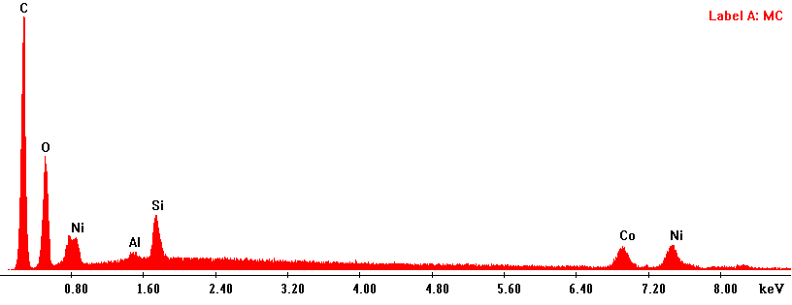
SI-Figure 2. EDX spectra of Co-Ni catalyst on mesoporous carbon.
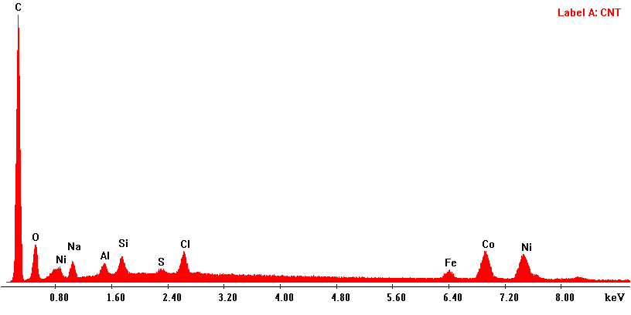
SI-Figure 3. EDX spectra of Co-Ni catalyst on carbon nanotubes.

.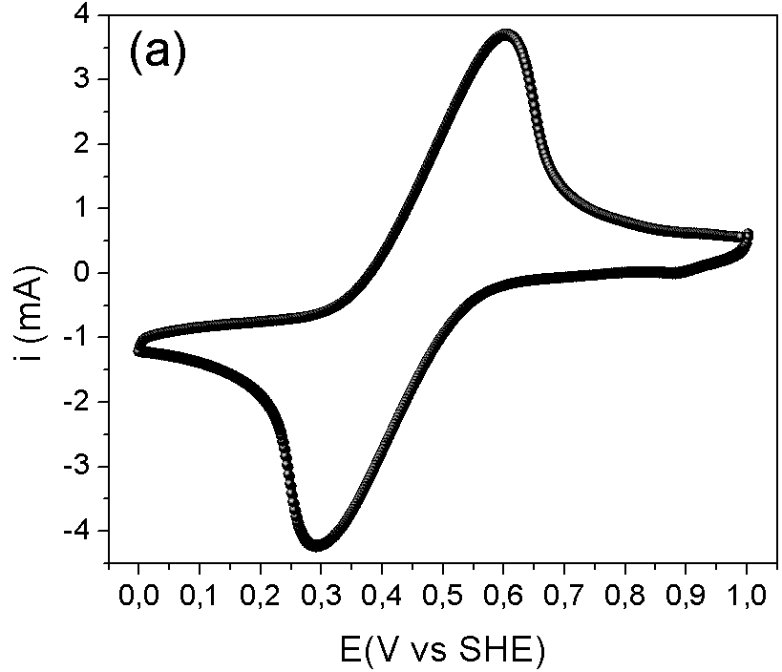 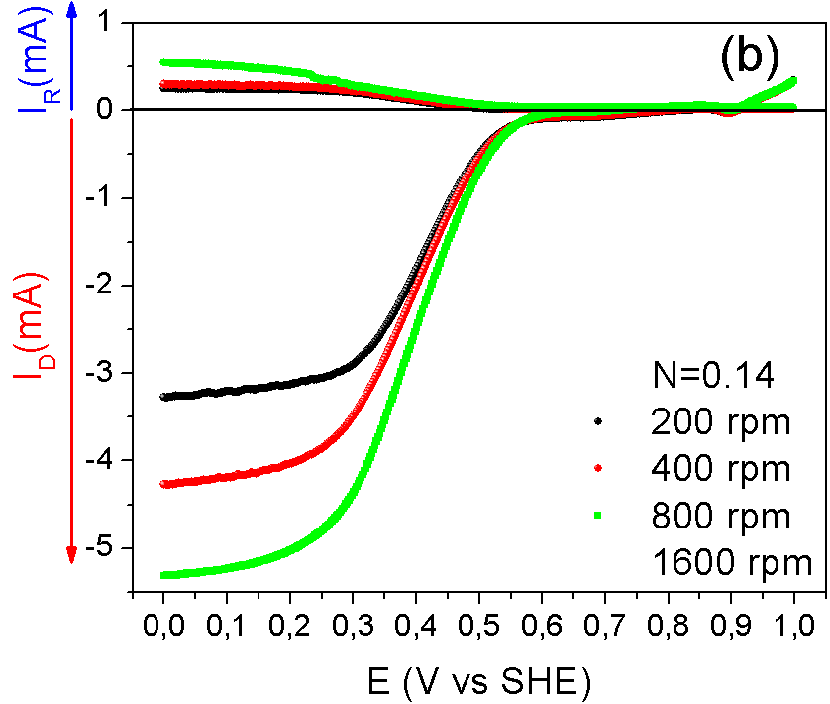
SI-Figure 4. a) Cyclic voltammogram of the ferro/ferri couple in CoNi/MC at a potential between 0 and 1 V vs SHE a 50 mVs⁻¹. b) Linear voltammetry on the disk and the ring at different speeds of rotation.

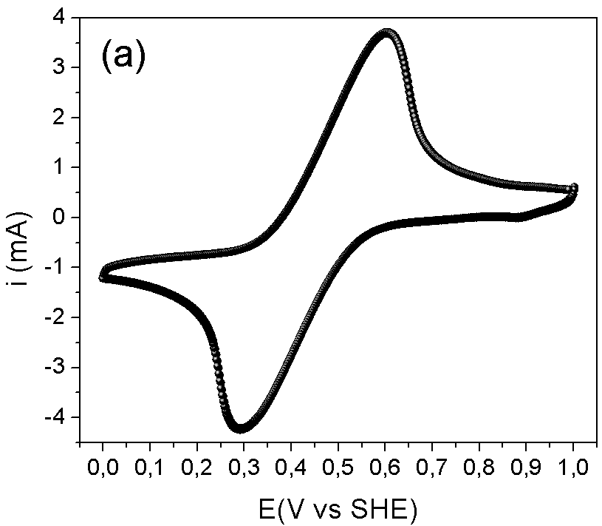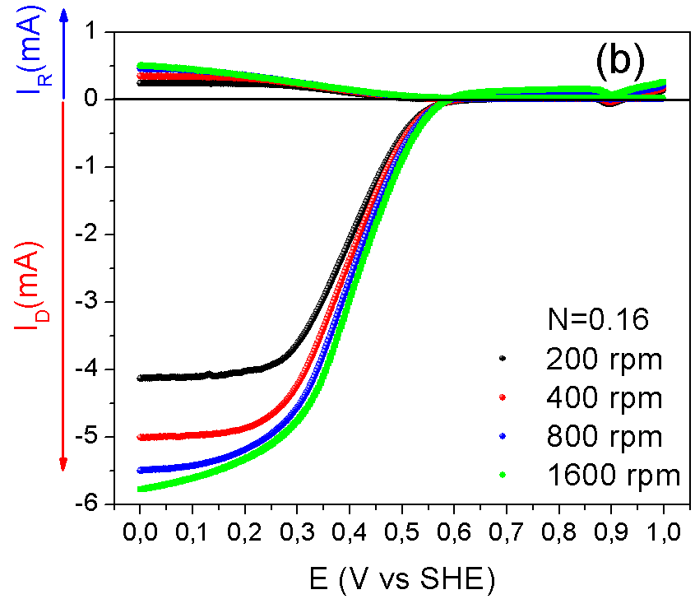
SI-Figure 5. a) Cyclic voltammogram of the ferro/ferri couple in CoNi/CNT at a potential between 0 and 1 V vs SHE a 50 mVs⁻¹ b) Linear voltammetry on the disk and the ring at different speeds of rotation.

