Tuning the In Vivo Photosynthetic Activity of Cyanobacteria’s Phycobilisome complex: A Spectroscopic Approach
Swapna Kalkar¹, Jeffrey C. Ayerh¹, Daniel Herr^{1*}, Tetyana Ignatova^{1*}
¹ University of North Carolina at Greensboro, Department of Nanoscience, Greensboro, NC, USA
*Corresponding authors:
Daniel Herr ( 0000-0001-7659-0869 ) djherr@uncg.edu
Tetyana Ignatova ( 0000-0003-3859-6367 ) t_ignato@uncg.edu

This document contains additional Figures and Tables to support information presented in main paper.

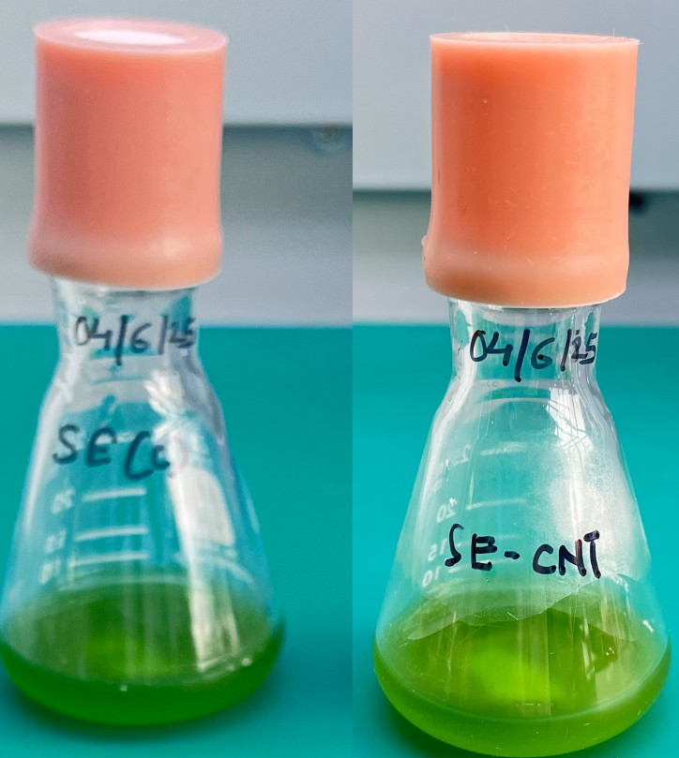
Figure 1:The standard growth of the bacteria for in vivo studies without any stress environment
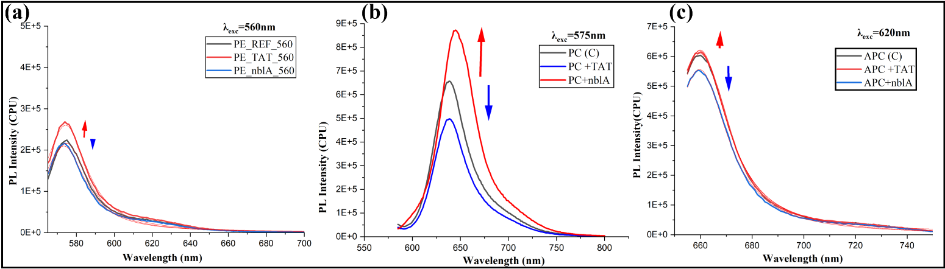
Figure 2: Spectra showing significant intensity change in commercial pigment’s fluorescence at (a)PE (λexc=560nm), (b)PC (λexc=575nm), and (c)APC (λexc=620nm) wavelengths when treated with only TAT and nblA peptide
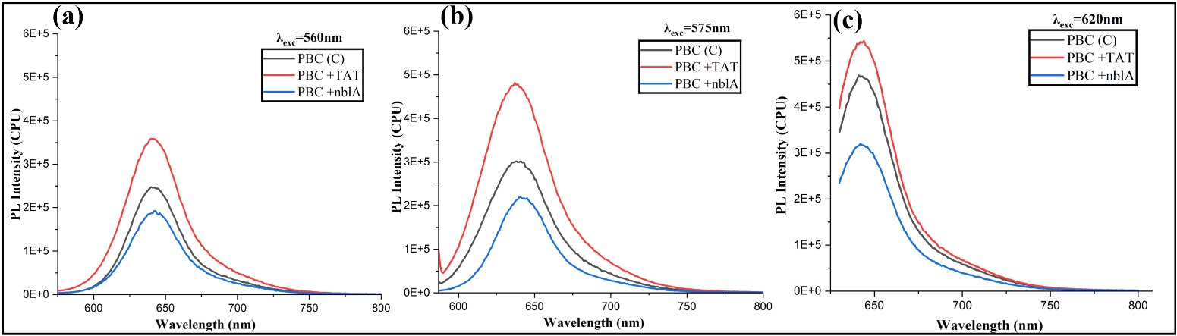
Figure 3:Spectra showing significant intensity change in PBC pigment’s photoluminescence at (a)PE (λexc=560nm), (b)PC (λexc=575nm), and (c)APC (λexc=620nm) wavelengths when treated with only TAT and nblA peptide
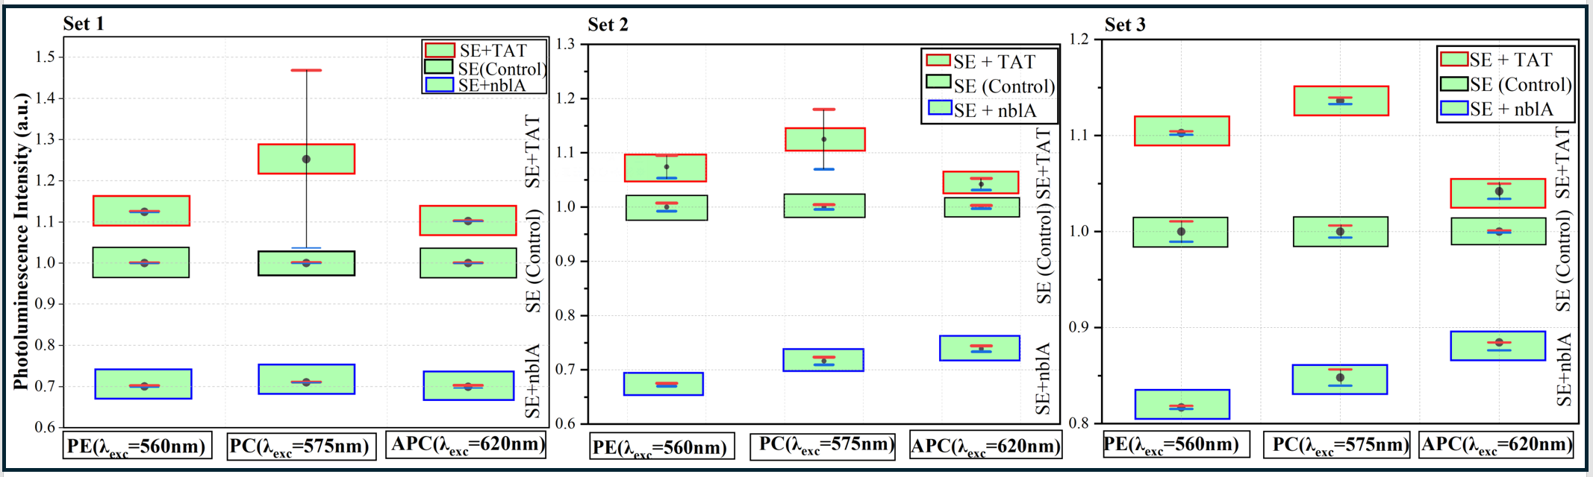
Figure 4: Comparison between 3 sets of in vivo studies showing degree of PL enhancement or quenching by interaction of CNT-TAT and CNT-nblA.
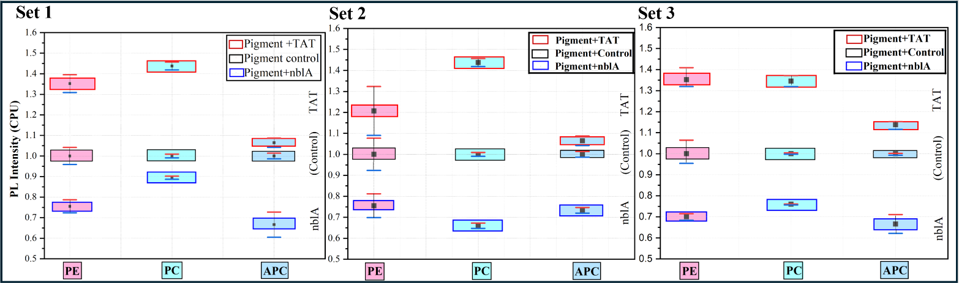
Figure 5: Comparison between 3 sets of in commercial pigments studies showing degree of PL enhancement or quenching by interaction of CNT-TAT and CNT-nblA
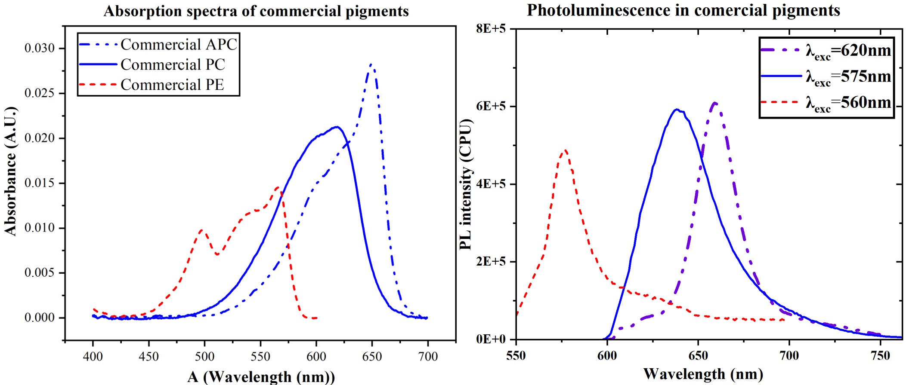
Figure 6:Absorption and photoluminescence of commercial pigments for calculation of quantum yield of reference pigments
Quantum yields of (Rhodamine 6G as a reference (Φ=95%)):
${\text{Φ}}_{PE}=0.81(81\%)$,
${\text{Φ}}_{PC}=0.61(61\%)$, and
${\text{Φ}}_{APC}=0.58 (58\%),$ respectively.
We confirmed reported values
Table 1: Summary of two-tailed p-values, based on two sample t-tests, that compare the observed in vivo PL of a given CNT-TAT and CNT-nblA hybrids with that for the pigment with only CNT, TAT or nblA.
For PE pigment:
Nanomaterial/peptide | CNT | TAT | nblA
PE+CNT-TAT | 0.001 | 0.001 | -
PE+CNT- nblA | 0.062 | - | 0.000

For PC pigment:
Nanomaterial/peptide | CNT | TAT | nblA
PC+CNT-TAT | 6.17E-06 | 0.000 | -
PC+CNT- nblA | 1.42E-05 | - | 5.73E-07

For APC pigment:
Nanomaterial/peptide | CNT | TAT | nblA
PC+CNT-TAT | 5.94E-03 | 3.29E-03 | -
PC+CNT- nblA | 6.36E-05 | - | 1.18E-03

