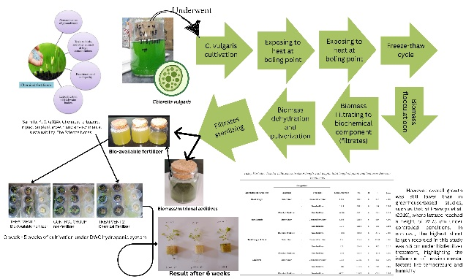
IX. APPENDIX
Illustration 1
Graphical abstract of the research study titled “Bio-available Fertilizer for Hydroponic Lettuce (Lactuca sativa L. var. longifolia) from byproducts of Chlorella vulgaris”.
TABLE 7
Seasonal Suitability for Lettuce Cultivation in the Philippines with Supporting Literature
Season | Months | Suitability for lettuce cultivation | Supporting literature
Cold dry season | November to February | Ideal | In the study conducted by Gonzaga, et al. (2017) based upon the statistical result, it indicates that lettuce plants thrive in cooler temperatures prevalent during this season leading to better yield and growth.
Hot dry Season | March to May | Moderate to difficult | While the cold dry season is suitable for cultivating lettuce plants, the research study conducted by Gonzaga, et al. (2017) also shows that the high temperature during the hot dry season can cause bolting to lettuce plants; only controlled environments such as greenhouse or shade neat can mitigate these physiological stresses.
Rainy season | June to October | Not Ideal | The rainy season is not the ideal season to cultivate a lettuce plant according to Gonzaga, et al. (2017) excessive rainfall can cause a fungal disease and root rot in lettuce plants.
This table 16 shows when the most suitable season is to cultivate a lettuce plant to perform rapid growth and yield cultivation in the Philippines.

