Additional files
Additional file 1
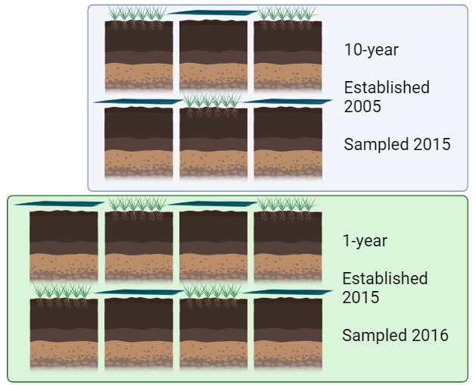
Schematic and aerial photograph showing the experimental layout within the sampling field. Plots with grass in each of the age classes are “grassland” or “vegetated” plots, and samples without plants are “bare” or “unvegetated” or “plant-excluded” plots. The shape above each bare plot represents the permeable fabric kept over the bare plots to prevent desiccation and colonisation effects.

Additional file 2
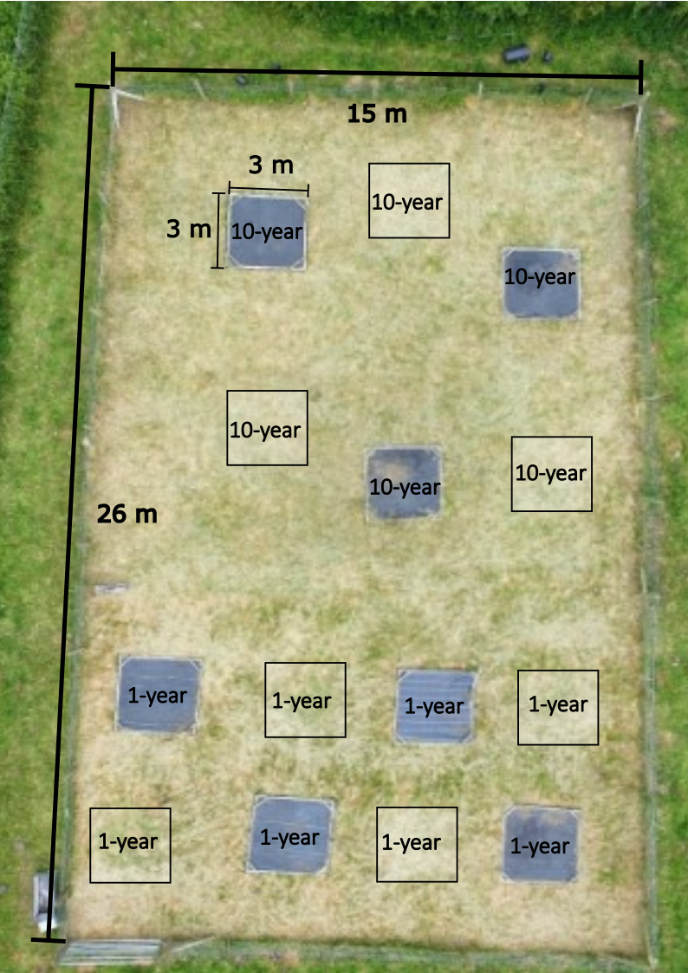
Aerial photograph of the experiment after annual mowing. The bare plots under black sheeting are clearly visible. Plots are marked by their age category. The experimental treatments consisted of plant-excluded (bare) soil, and annually mown grasslands which had been established with these treatments for differing lengths of time. The treatments had sample sizes: 10-year bare N=3, 1-year bare N=4, 1-year grassland N=4, 10-year grassland N=3.
Additional file 3
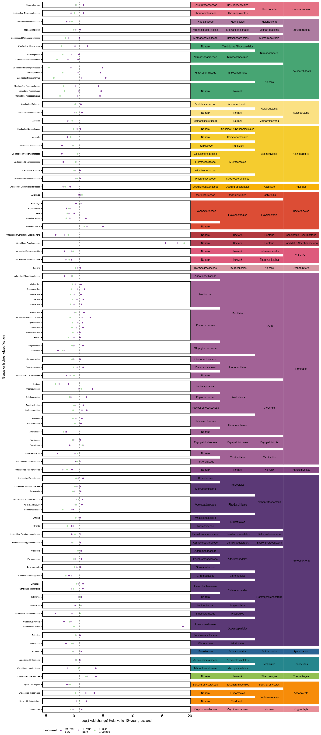
Changes in relative abundances of the species (grouped phylogenetically) which showed a significant log₂ fold change relative to in 10-year grassland, according to GLMs. The experimental treatments consisted of plant-excluded (bare) soil, and annually mown grasslands which had been established with these treatments for differing lengths of time. The treatments had sample sizes: 10-year bare N=3, 1-year bare N=4, 1-year grassland N=4, 10-year grassland N=3.
Additional file 4
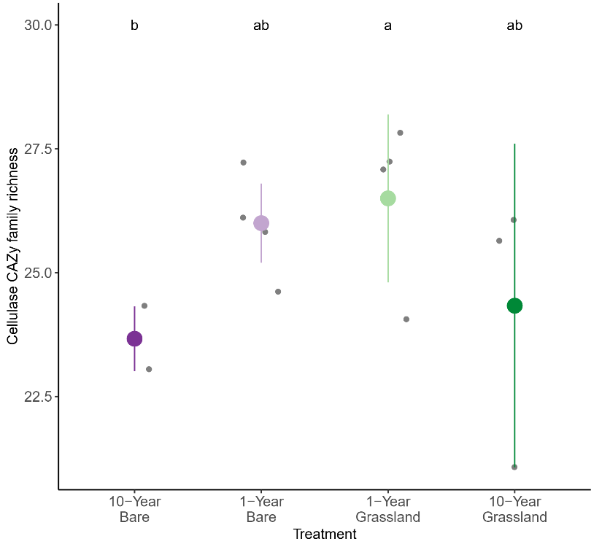
Richness of cellulase CAZy families in each treatment. Letters above the data represent significance groupings determined by a Dunn’s test, where groups which share a letter were not significantly different. The experimental treatments consisted of plant-excluded (bare) soil, and annually mown grasslands which had been established with these treatments for differing lengths of time. The treatments had sample sizes: 10-year bare N=3, 1-year bare N=4, 1-year grassland N=4, 10-year grassland N=3. Errorbars represent Gaussian 95% confidence intervals.

Additional file 5
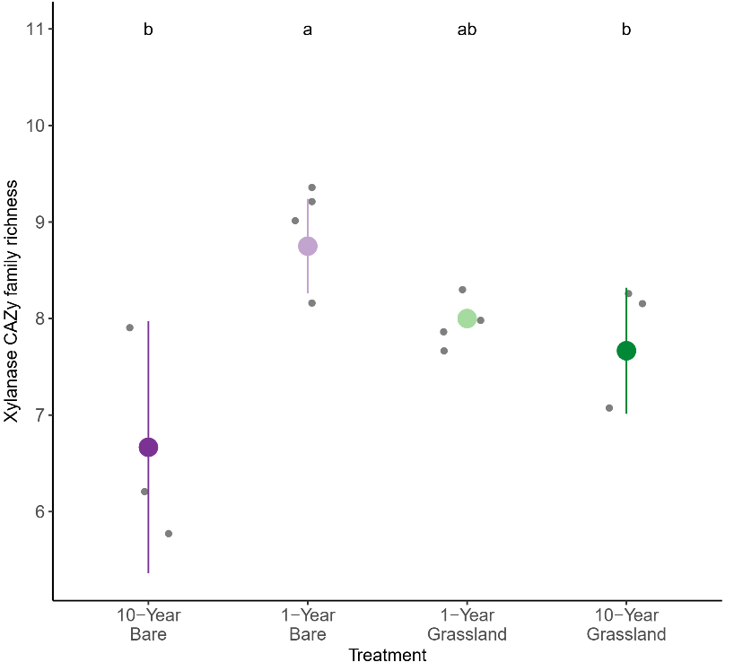
Richness of xylanase CAZy families in each treatment. Letters above the data represent significance groupings determined by a Dunn’s test, where groups which share a letter were not significantly different. The experimental treatments consisted of plant-excluded (bare) soil, and annually mown grasslands which had been established with these treatments for differing lengths of time. The treatments had sample sizes: 10-year bare N=3, 1-year bare N=4, 1-year grassland N=4, 10-year grassland N=3. Errorbars represent Gaussian 95% confidence intervals.

Additional file 6
https://github.com/fidlerdb/Plant_exclusion_experiment_lignocellulase_genes/tree/main/Supplementary_figures/Species_changes_2022-05-10_supplementary.pdf
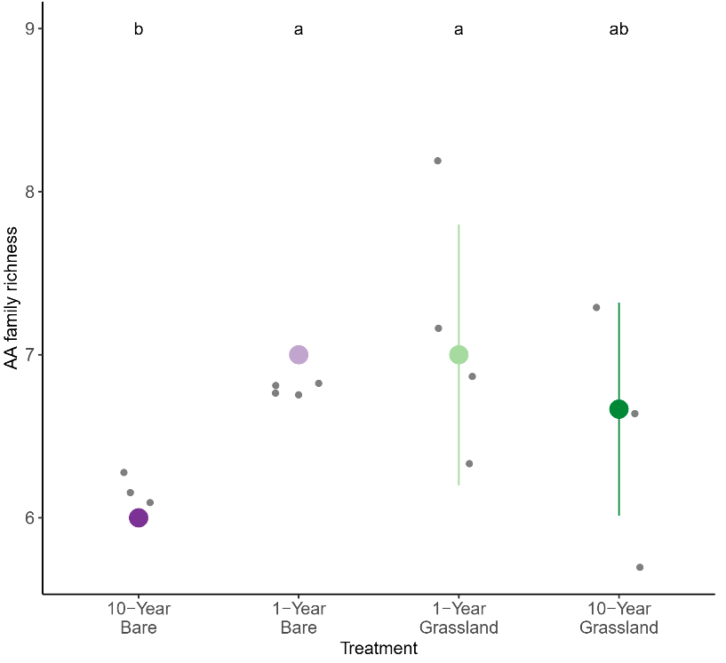
Richness of AA CAZy families in each treatment. Letters above the data represent significance groupings determined by a Dunn’s test, where groups which share a letter were not significantly different. The experimental treatments consisted of plant-excluded (bare) soil, and annually mown grasslands which had been established with these treatments for differing lengths of time. The treatments had sample sizes: 10-year bare N=3, 1-year bare N=4, 1-year grassland N=4, 10-year grassland N=3. Errorbars represent Gaussian 95% confidence intervals.

Additional file 7
Relative abundances of indicator lignocellulase gene families of contigs generated from metagenomic sequencing in this study that could be taxonomically assigned. The experimental treatments consisted of plant-excluded (bare) soil, and annually mown grasslands which had been established with these treatments for differing lengths of time. The treatments had sample sizes: 10-year bare N=3, 1-year bare N=4, 1-year grassland N=4, 10-year grassland N=3.

