Table 1 Goodness-of-Fit results for the confirmatory Factor Analysis.
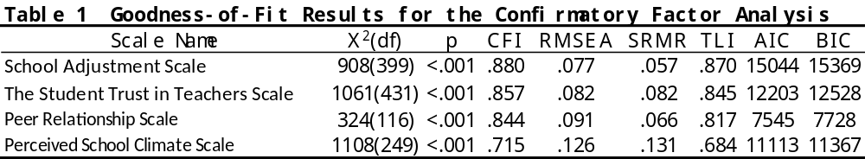

Table 2 Results of Exploratory Factor Analysis for All Items of the Chinese Version of the "School Adjustment Scale"
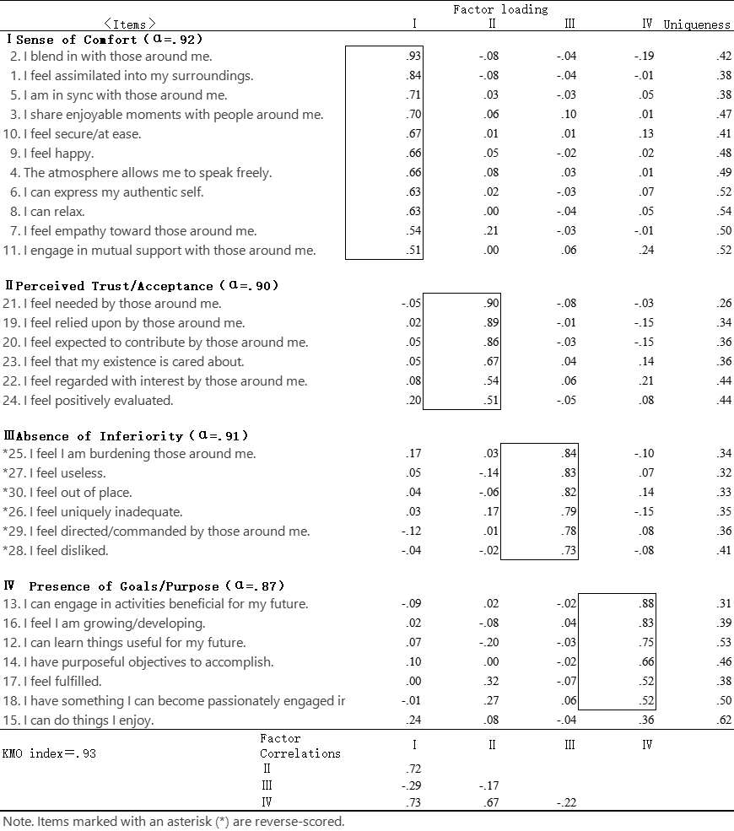
Table 3 Results of Exploratory Factor Analysis for the Chinese Version of the "Students' Trust in Teachers Scale"
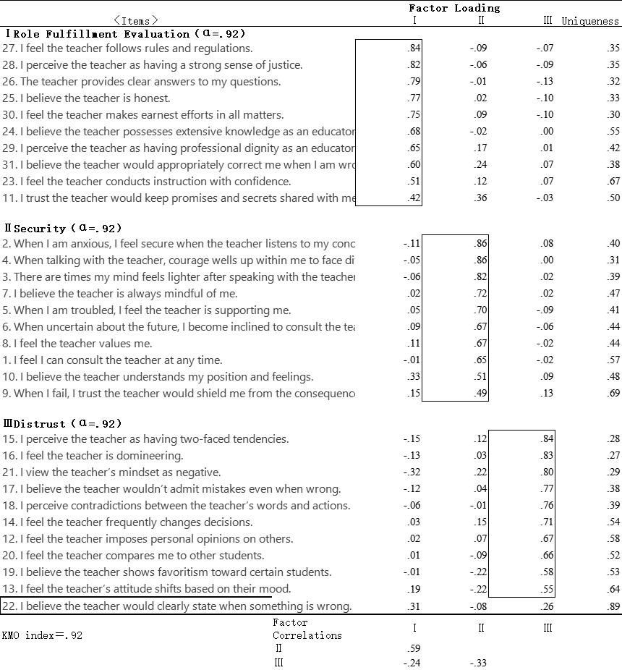

Table 4 Results of Exploratory Factor Analysis for the Chinese Version of the Peer Friendship Scale
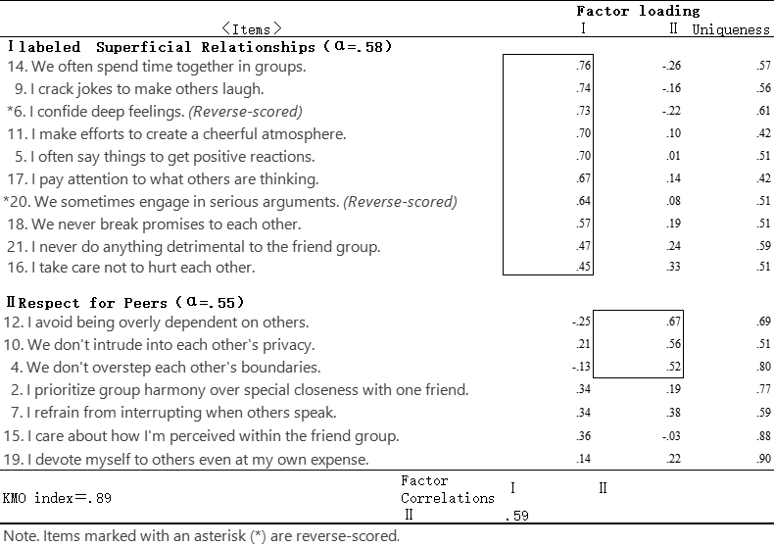

Table 5 Results of Exploratory Factor Analysis for the Chinese Version of the "Perceived School Climate Scale"
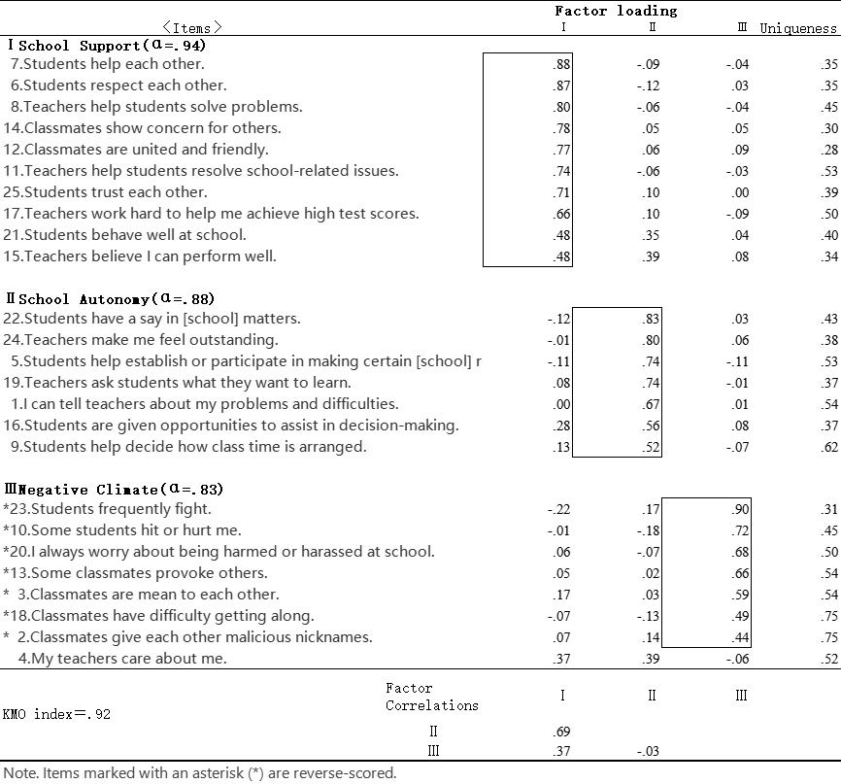

Table 6 Results of Independent Samples t-tests for Sex Differences Across Factors
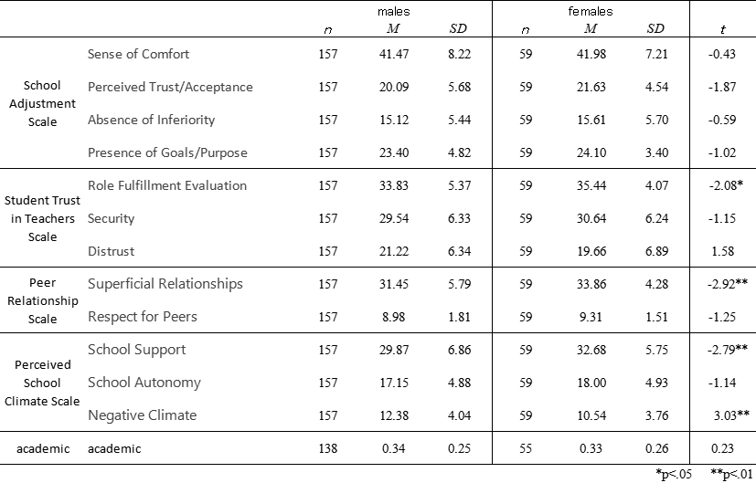
Table 7 Results of Independent Samples t-tests for School Level Differences on the Perceived School Climate Scale
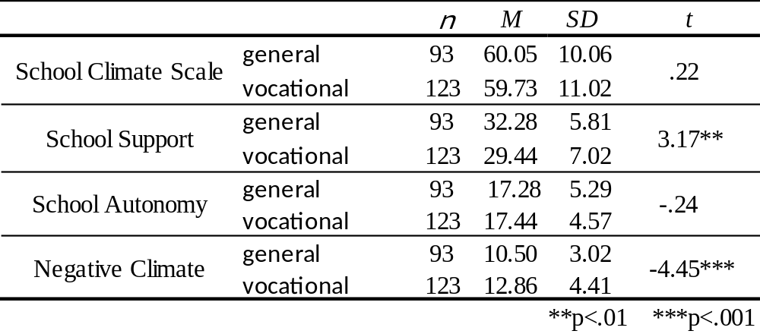
**p<.01 ***p<.001

**p<.01 ***p<.001

Table 8 Correlation Matrix for All Measurement Scales
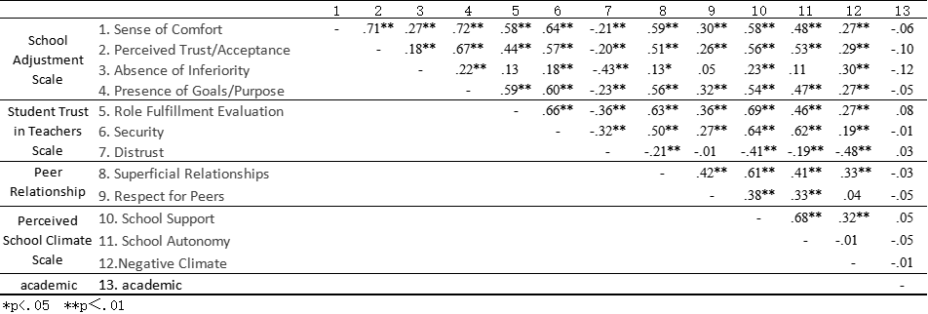

Table 9 Results of Multiple Regression Analysis with School Climate Predicting School Adaptation
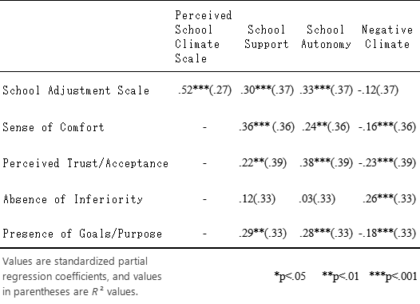

Table 10 Multiple Regression Analysis of Teacher and Peer Relationships Predicting School Adaptation in Academic High Schools
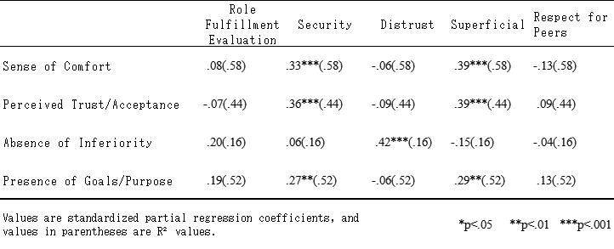

Table 11 Multiple Regression Analysis of Teacher and Peer Relationships Predicting School Adaptation in Vocational High Schools
