Appendix
Appendix A
Items and Initial EFA Factor Loadings for the Family Distancing Measure
Item | Factor Loadings
Item | Distancing actions | Rumination | Emotional Disconnect
- Do you frequently attempt to hide significant life details or information from certain household members? | .508 | .223 | .109
- Do you frequently avoid face-to-face contact with certain household members? | .916 | -.070 | .044
- Do you try your hardest to avoid answering messages or calls from certain household members? | .589 | .194 | .141
- Do you try to maintain significant physical distance between yourself and certain household members whenever possible? | .936 | .053 | -.071
- Do you avoid contact with certain household members during special occasions, such as holidays? | .757 | -.013 | .150
- Do you often refuse to do what is expected of you by certain household members? | .406 | .214 | .053
- Do you feel recurring anger, frustration, or resentment towards a certain household member? | .342 | .601 | -.018
- Do you often catch yourself thinking negative thoughts about a certain family member? | -.039 | 1.001 | .028
- Are there any household members who you don't care about anymore? | -.012 | .010 | 1.004
- Are there any relationships with household members that you no longer feel a desire to maintain? | .376 | .214 | .545
- Have you ever taken legal steps to distance yourself from certain household members? | – | – | –
Note: italicized items were removed from the measure due to poor theoretical and statistical alignment with the overall construct. All final items were collapsed to one scale.

Appendix B
Correlations, Means, and Standard Deviations across Differentiation of Self, Family Distancing, and Social Supports
 | 1. | 2. | 3. | 4. | 5. | 6.
1. Emotional Cutoff | --
2. Emotional Reactivity | .41*** | --
3. I-position | .39*** | .73*** | --
4. Fusion with Others | .37*** | .82*** | .62*** | --
5. Distancing | -.38*** | -.29** | -.17 | -.18 | --
6. Social Supports | .40*** | .29** | .35*** | .14 | -.39*** | --
Mean | 4.21 | 3.07 | 3.76 | 3.53 | 1.76 | 3.83
SD | 1.17 | 1.04 | 0.92 | 1.12 | 0.78 | 0.74
Note: * = p < .05; ** = p < .01; *** = p < .001

Appendix C
Moderation and Simple Slopes of Social Supports on Family Distancing and Emotional Cutoff for Participants Currently Attending College (n = 89)
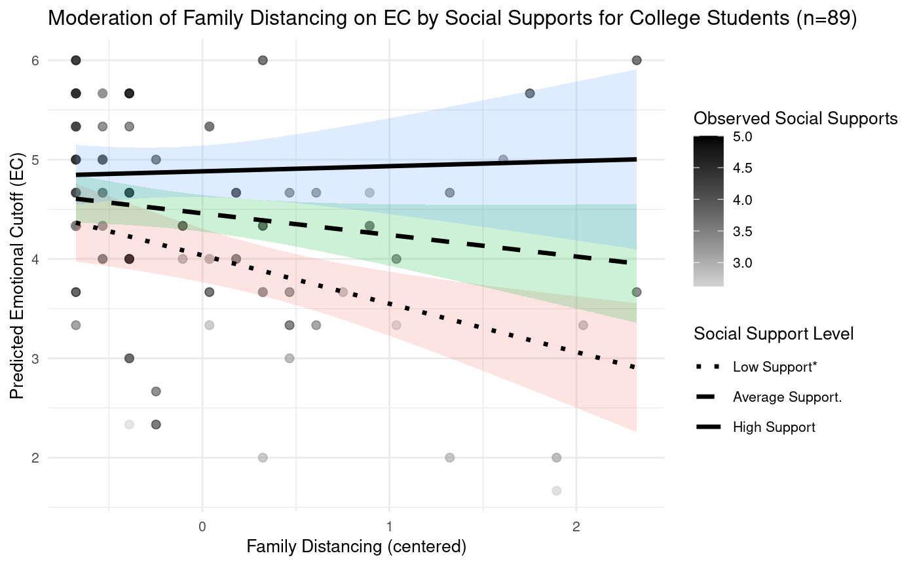
Note: . = p < .1; * = p < .05

Appendix D
Moderation and Simple Slopes of Social Supports on Family Distancing and Emotional Cutoff for Participants Not Currently in College (n = 33)
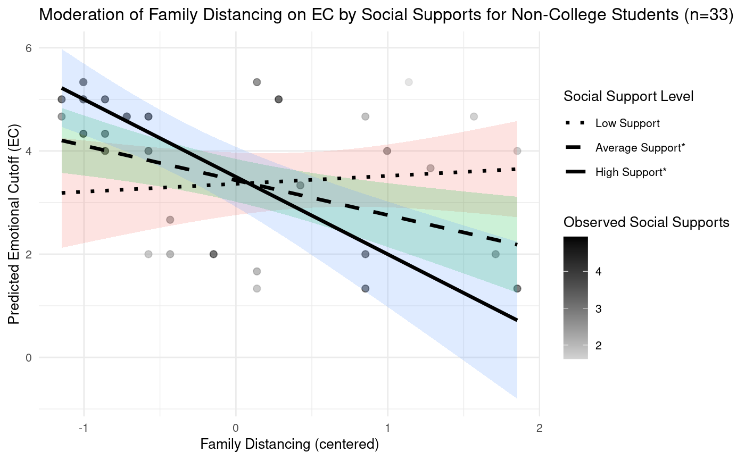
Note: * = p < .05

