
Patient Name and Case #

O
NCOLOGY

S
ECTION

Patient

Update

Form

Date:

Phone

number

you

can

be

reached

at:

Time

you

will

be

available

at

that

phone

number:

Discharge

hours

are

assigned according to all patient needs

between 4
-
5
pm

Please complete the following form as accurately as possible.
This information is important in helping us make the best treatment decision for your pet.
1. Have you noted any signs of tumor growth since your last | 2. Describe your pet’s activity level since your
appointment? | last appointment:
 No |  Normal
 Yes (Please characterize): |  Increased  - Mildly decreased  - Moderately decreased
 Unsure |  Severely decreased
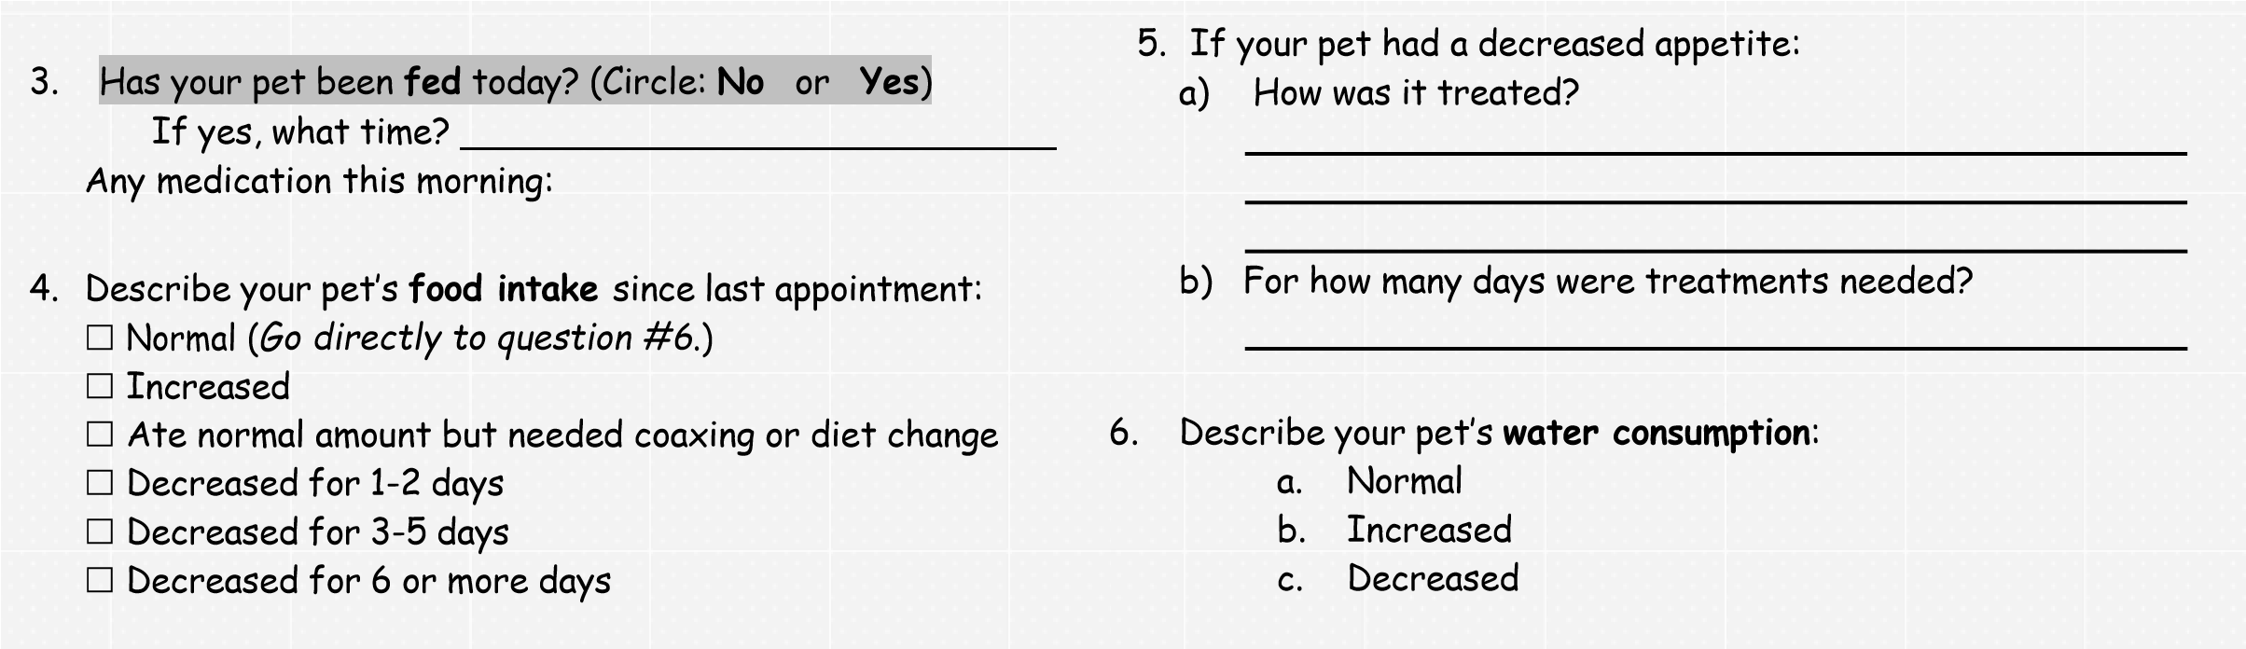
7. Did your pet have any vomiting since last appointment?  - No (Go directly to question #13.)  - Yes  Unsure  9. If your pet was vomiting, how many times did s/he vomit?   1-2 times  3-5 times  6+ times  11. If your pet was vomiting, how many days did it last?  - 1 day  - 2-4 days  - 5 or more days | 8. If your pet was vomiting, how soon after the last appointment did it begin?   Hours  1 day  2-3 days  4+ days  10. If your pet vomited more than 1 time, were the vomit events:  - Less than or equal to 15 minutes apart  - More than 15 minutes apart  12. If your pet had any vomiting:  - How was it treated?  - For how many days were treatments needed?
13. Describe your pet’s stools since last appointment:  - Normal/ formed (Go directly to question #17)  - Soft  - Diarrhea | 14. If your pet had any diarrhea, how many times per day did it occur?   Once  Twice  3-6 per day  7+ per day


15.

If

your

pet

had

any

diarrhea,

how

soon

after

the

last

16.

If

your

pet

had

any

diarrhea:

appointment

did

it

begin?

a.

How

was

it

treated?



Hours



1

day



2
-
3

days

b.

For

how

many

days
were

treatments

needed?



4

or

more

days

17. Describe your pet’s urination frequency: 18. Was your pet straining to urinate?
- Unchanged (please answer Questions 18-20)  No
- Increased up to 2x’s normal  Yes
- Increased more than 2x’s normal  Unsure
- Hourly
19. Was your pet leaking urine since last appointment? 20. Did you notice any blood in your pet’s urine?
 No  Yes  Unsure  No  Yes  Unsure

21.

Did

you

observe

any

coughing

or

difficulty

breathing

since

last

appointment?

(
Circle
:

No

or

Yes
)

If

yes,

please

characterize:

22.

Did

your

pet

show

any

signs
of

being

in

pain

since

last

appointment?



No



Mild

pain,

not

interfering

with

daily

activity



Moderate

pain,

interfering

with

daily

activity



Severe

pain,

severely

affecting

daily

activity



Disabling

pain



Unsure

23. What is your pet’s current diet and how much a day are they eating (ex: can/ cup)? Please include treats and supplements (ex herbs, vitamins). If you have already listed this previously please include just changes that have been made.

_____________________________________________________________________________________________________

24. List medications your pet is receiving. Please be sure to list any preventative medications that your pet receives (ex: heartworm).
Medication & Amount (milligrams or number of pills) | How Frequently? | Refill Needed?


25
a.

Do

you

have

anti
-
nausea

medication

at

home

for

your

pet?

26
a.

Do

you

have

anti
-
diarrheal

medication

at

home

for

your

pet?

b.

Do

you

know

what

and

how

much?

b.

Do

you

know

what

and

how

much?

27

Do

you

give

us

permission

to

sedate

your

pet

today

if

28.

Do

you give

us

permission

to

do

additional

blood
work

if

needed? Circle: Yes or No indicated? Circle: Yes or No

The above information is true and accurate.
Signed:____________________________________________ Date:

