Supplementary Materials
Demographic and Imaging Parameters in the Normal Diagnosis Group
Variable | Mean±SD
Female Sex, N (%) | 18 (40.91%)
Age, years | 35±15.9
BMI, kg/m² | 25.24 ± 4.27
Heart Rate, bmp | 72.07 ± 10.27
LVEF, % | 63.1±6.3
EDVI, ml/m² | 70.1±13.6
ESVI, ml/m² | 26.0±7.2
SVI, ml/m² | 44.0±8.5
T_{1-BN}, ms | 1563.07 ± 83.76
T_{1-BP}, ms | 282.89 ± 68.19
T_{1-MN}, ms | 1009.11 ± 33.07
T_{1-MP}, ms | 436.84 ± 70.40
Hct_{measured}, % | 42.9±4.3
Hct_{reported}, % | 41.5±4.2
ECV_{measured}, % | 24.9±2.8
ECV_{reported}, % | 25.5±2.7
Abbreviations: BMI, body-mass index; Bmp, beats per minute; CI, cardiac index; ECV, extracellular volume; EDVI, end-diastolic volume index; ESVI, end-systolic volume index; Hct, hematocrit; LVEF, left ventricular ejection fraction; SVI, stroke volume index; T_{1-BN}, native T1 blood; T_{1-BP}, post-contrast T1 blood; T_{1-MN}, native T1 myocard; T_{1-MP}, post-contrast T1 myocard

A freely accessible online calculator for synthetic ECV estimation based on the proposed model is available at https://syntheticecvcalculator.shinyapps.io/syntheticecvapp or by scanning the QR code below.


Graphical Abstract

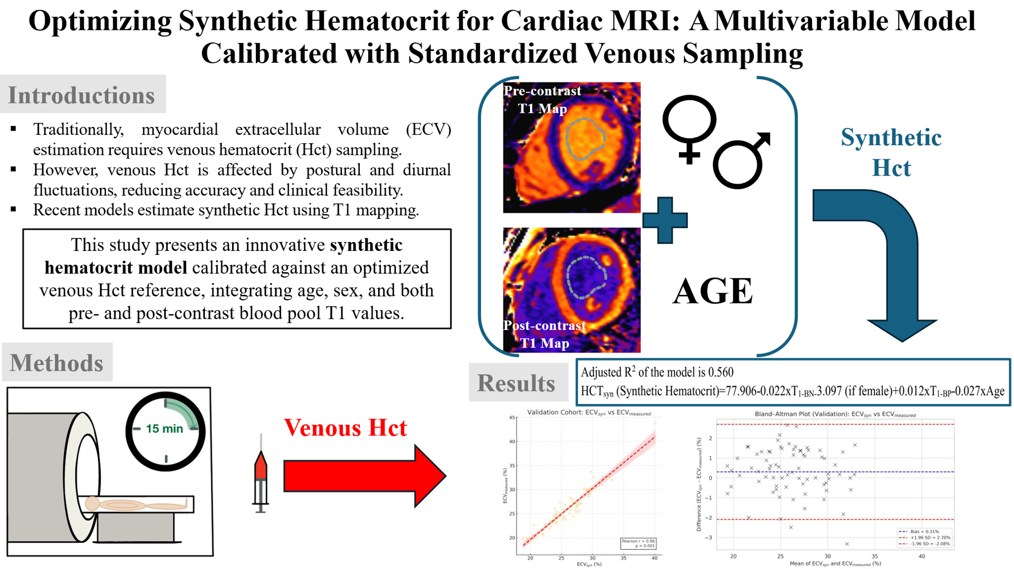

Abstract: The synthetic Hct model combining sex, age, and pre-/post-contrast blood T1, calibrated using venous Hct under postural standardization, enables accurate, sampling-free ECV quantification.

