Additional file 3: Overview and outcomes of secondary scenarios
Manuscript: Guiding the willingness to pay for repurposed tiratricol in the treatment of Allan-Herndon-Dudley syndrome using a cost-based-plus pricing framework

In addition to the four primary analyses, which consider the contributions of public and charitable funding in the repurposing of tiratricol for AHDS, two additional scenarios have been conducted that assume a higher profit margin, with variations in the number of eligible patients (Scenarios 1e–1f). While the royalties paid to former owners are not directly related to the development process, it is important to recognize their potential impact on the pricing strategy. Since a percentage of net sales must be paid to former owners, this can lead to an increased profit margin applied by the company. Additionally, two more scenarios were analysed—also varying in patient numbers—that assume a fully private-investment development model (Scenarios 2a–2b). Table 1 provides an overview of these scenarios and their underlying assumptions, while Table 2 presents the results, including the order of magnitude of cost components and a detailed breakdown of cost allocation.

Sensitivity analyses were also conducted for these scenarios, as illustrated in the tornado diagrams in Figure 1 and 2. Figure 3 presents the relative influence of all cost components on the final price PPPY, breaking down the proportional contribution of each cost factor.

Scenarios 1e and 1f, compared to Scenarios 1a and 1c, respectively, illustrate the effect of a higher profit margin on the final PPPY. However, it is noteworthy that this higher profit margin has a relatively small impact on the final PPPY, which is also evident in the sensitivity analysis and cost breakdown in figures 2 and 4.

In Scenarios 2a and 2b, where a fully private investment model is assumed, the influence of capitalized R&D costs and cost-of-failure becomes far more pronounced—unsurprisingly, as these components are assigned a significantly higher value than in the other analyses. Scenario 2a shows a substantial increase in PPPY due to high development and failure-related costs, which are distributed over a relatively small number of eligible patients. In contrast, Scenario 2b, which assumes a larger patient population, distributes these fixed costs more, leading to a lower per-patient cost. This is confirmed in the sensitivity analysis, where the number of patients and components related to allocated R&D costs—including recoupment period, market size adjustment, R&D expenditure, WACC, GDP deflator, and, if applicable, the cost-of-failure—are identified as the most sensitive parameters driving price deviations.

Table 1: Overview of scenarios 1e-f, and 2a-b
Components & Parameters | Scenario 1e |  | Scenario 1f |  | Scenario 2a | Scenario 2b
Out-of-pocket development costs:
R&D-expenditure | €50 million |  | €50 million |  | €135 million | €135 million
Market size adjustment (%) | 32,61%. |  | 32,61%. |  | 32,61%. | 32,61%.
Recoupment period (years) | 10 |  | 10 |  | 3 | 3
Cost-of-failure correction factor | 0,84. Low cost-of-failure are assigned |  | None, all risk is presumed to be borne by public entities and charitable foundations. |  | 1,67 | 1,67
Financial correction factors:
(Weighted average) cost-of-capital (%) | 9% |  | 9% |  | 9% | 9%
GDP deflator (%) | 6,5% |  | 6,5% |  | 6,5% | 6,5%
Development period (years) | 10 |  | 10 |  | 10 | 10
Production and sales elements:
Production cost per treatment | €0,65 |  | €0,65 |  | €0,65 | €0,65
Production volume | 2.378 tablets per-patient-per-year |  | 2.378 tablets per-patient-per-year |  | 2.378 tablets per-patient-per-year | 2.378 tablets per-patient-per-year
Cost-of-sales allowance | 15% of manufacturing costs |  | 15% of manufacturing costs |  | 30% of manufacturing costs | 30% of manufacturing costs
Profit elements
Profit margin (%) | 25% of total out-of-pocket costs |  | 8% of total out-of-pocket costs |  | 25% of total out-of-pocket costs | 25% of total out-of-pocket costs
Value-driven premium (%) | None, considering that the value repurposed tiratricol provides to patients primarily stems from public research. |  | None, considering that the value repurposed tiratricol provides to patients primarily stems from public research. |  | 30% of total out-of-pocket costs | 30% of total out-of-pocket costs
Patient population
Number of patients | 500 |  | 3.129 |  | 500 | 3.129

Table 2: Overview of scenario’s outputs
Components & Parameters | Scenario 1e | Scenario 1f | Scenario 2a | Scenario 2b
Capitalised development costs, adjusted for inflation:
Total development costs (R&D costs + cost-of-failure) | €60.443.707 | €60.443.707 | €435.738.685 | €435.738.685
Allocated development costs (adjusted for recoupment period and market share) | €1.971.069 | €1.971.069 | €47.364.795 | €47.364.795
Production and sales elements:
Allocated manufacturing costs (out-of-pocket) | €772.850 | €4.836.495 | €772.850 | €4.836.495
Allocated cost-of-sales | €115.928 | €725.474 | €231.855 | €1.450.949
Profit elements
Allocated innovation bonus | N.a | N.a | €11.986.130 | €13.205.224
Allocated profit | €600.838 | €1.616.749 | €9.988.441 | €11.004.353
Outcomes:
Price-per-patient-per-year | €6.921,37 | €2.924,19 | €140.688,14 | €24.883,93

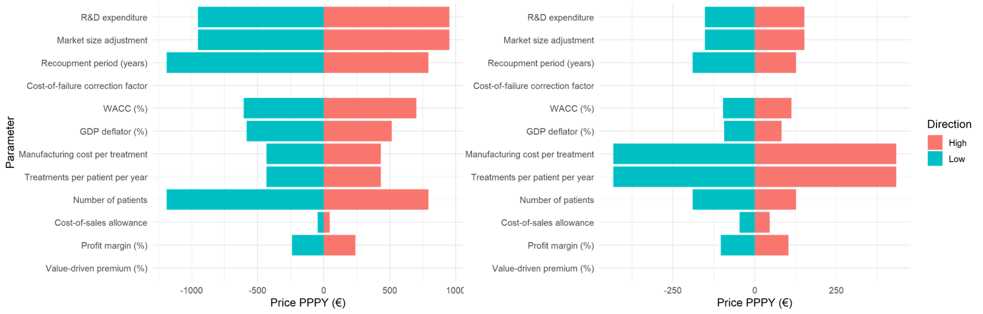
Figure 1: Tornado diagram of sensitivity analysis for scenarios 1e and 1f

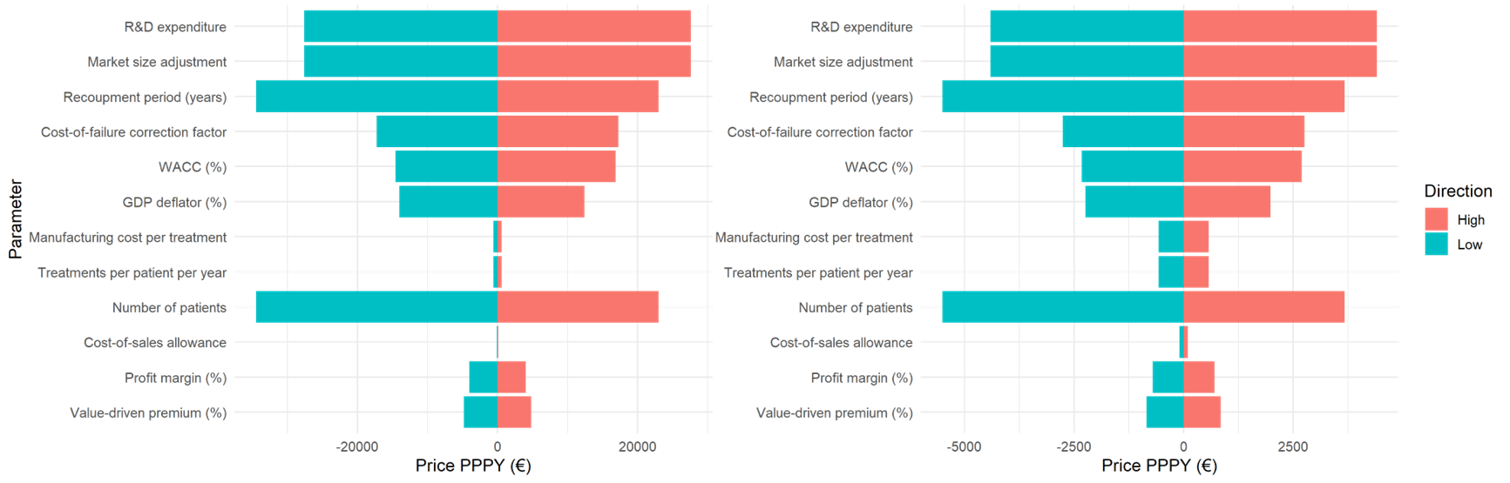

Figure 2: Tornado diagram of sensitivity analysis for scenarios 2a and 2b

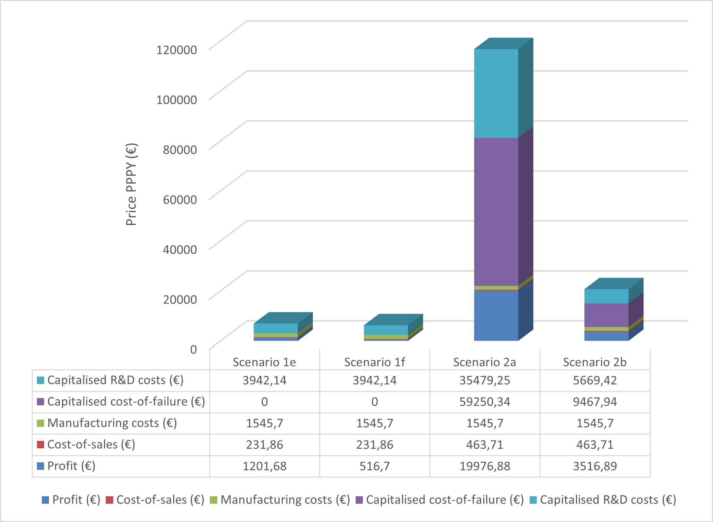
Figure 3: Breakdown of cost components’ relative influence final price PPPY in scenarios 1e-f, and 2a-b

