Supplementary Materials

Table S1. Unit area content of bendiocarb in microencapsulated fabrics with different washing cycles
Number of washes | Peak area of C₂ | Content per unit area (mg/m²)
0 | 20319 | 127.64
5 | 10745 | 67.50
10 | 6136 | 38.55
15 | 5990 | 37.63
20 | 5485 | 34.46

Table S2. Content of glufosinate bendiocarb per unit area in microencapsulated fabrics with different slow-release cycles
Number of washes | Peak area of C₂ | Content per unit area (mg/m²)
0 | 20603 | 131.51
7 | 17854 | 113.96
14 | 12259 | 78.25
21 | 8037 | 51.30
28 | 6336 | 40.44

Figure S1. Plot of liquid phase test for bendiocarb content in microencapsulated fabrics with different washing cycles

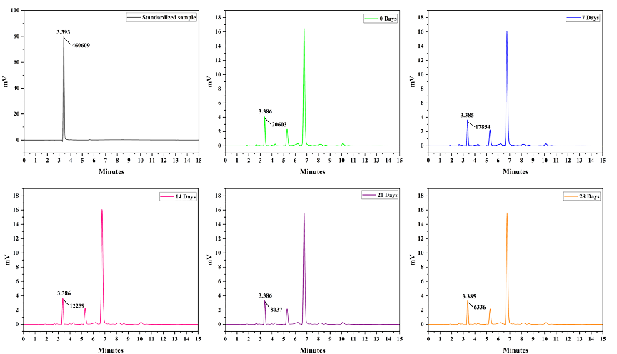
Fig. S1. Liquid phase test of oxamethonium content in microencapsulated fabrics with different slow-release cycles

