Supporting Information

Preparation of UiO-66-NH₂/MgAl-LDHs @ Sodium Alginate Fiber Membrane and Determination of Oil Water Separation Performance
Hongmei Wangª, Jiawen Zhangª, Zhenggang Wang^{a*}, Shuang Huª, Zhuang Fuª, Bo Hu^{b}, Xichao Liang^{b*}.
ªHunan Provincial Key Laboratory of Materials Protection for Electric Power and Transportation, Changsha University of Science and Technology, Changsha 410114, PR China.
^{b}Research and Application of Regenerative Cellulose Fiber Key Laboratory of Sichuan Province, YiBin Grace Group Co., LTD, Yibin 644000, China

* Corresponding authors.
E-mail addresses: zhenggangwang16@163.com (Zhenggang Wang), xichaoliang@126.com (Xichao Liang).

Fig. S1.SEM images of MgAl-LDH (a) and UiO-66-NH₂ (b). 3
Fig. S2. XRD spectra of U-LDH₃@SA (a) and Raman spectra of synthesized UiO-66-NH2, MgAl-LDH and U-LDH₃ (b). 3
Fig. S3. SEM images of U-LDH₃@SA. 3
Fig. S4. Pore size distribution of pure SA (a) and U-LDH₃@SA (b). 4

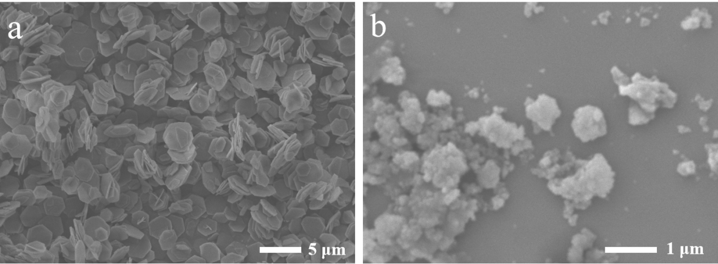
Fig. S1. SEM images of MgAl-LDH (a) and UiO-66-NH₂ (b).
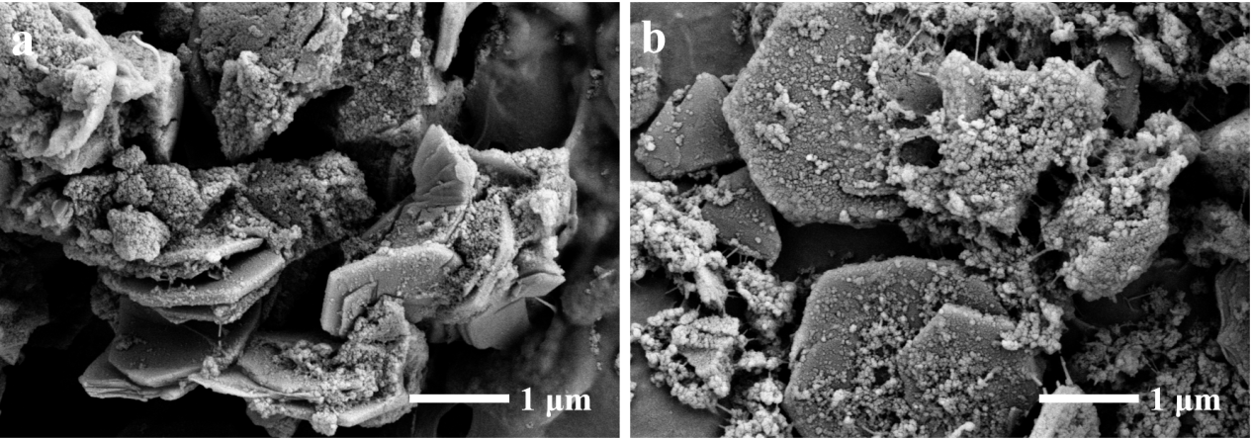
Fig. S2. SEM images of U-LDH₃@SA.
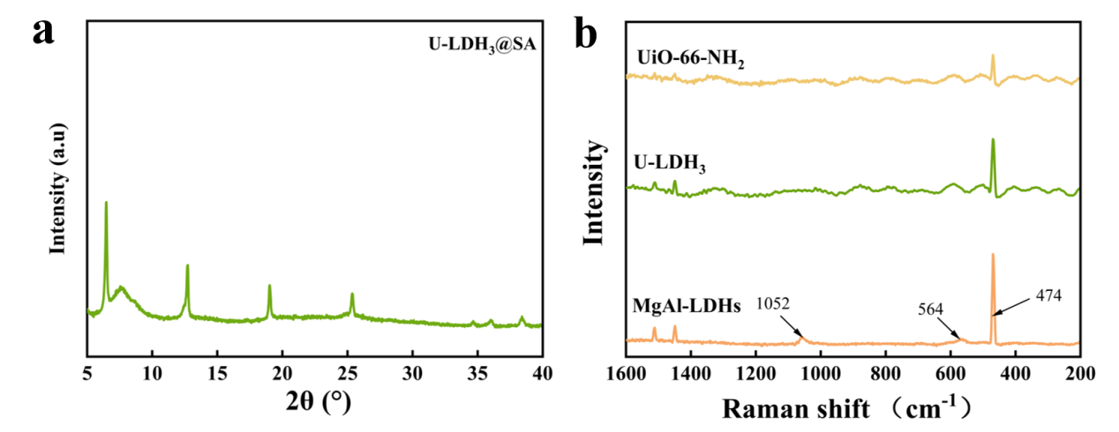

Fig. S3. XRD spectra of U-LDH₃@SA (a) and Raman spectra of synthesized UiO-66-NH2, MgAl-LDH and U-LDH₃ (b).

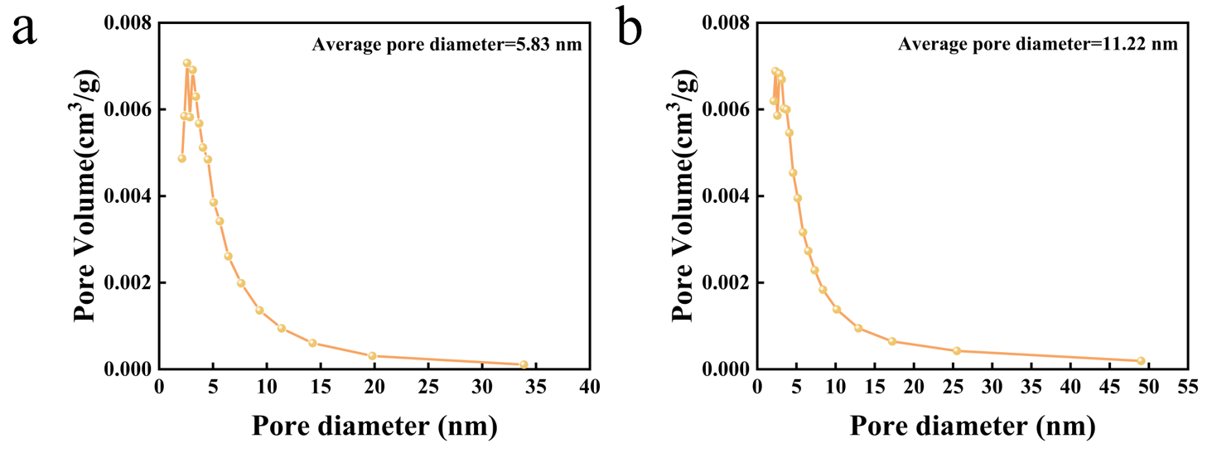

Fig. S4. Pore size distribution of pure SA (a) and U-LDH₃@SA (b).

