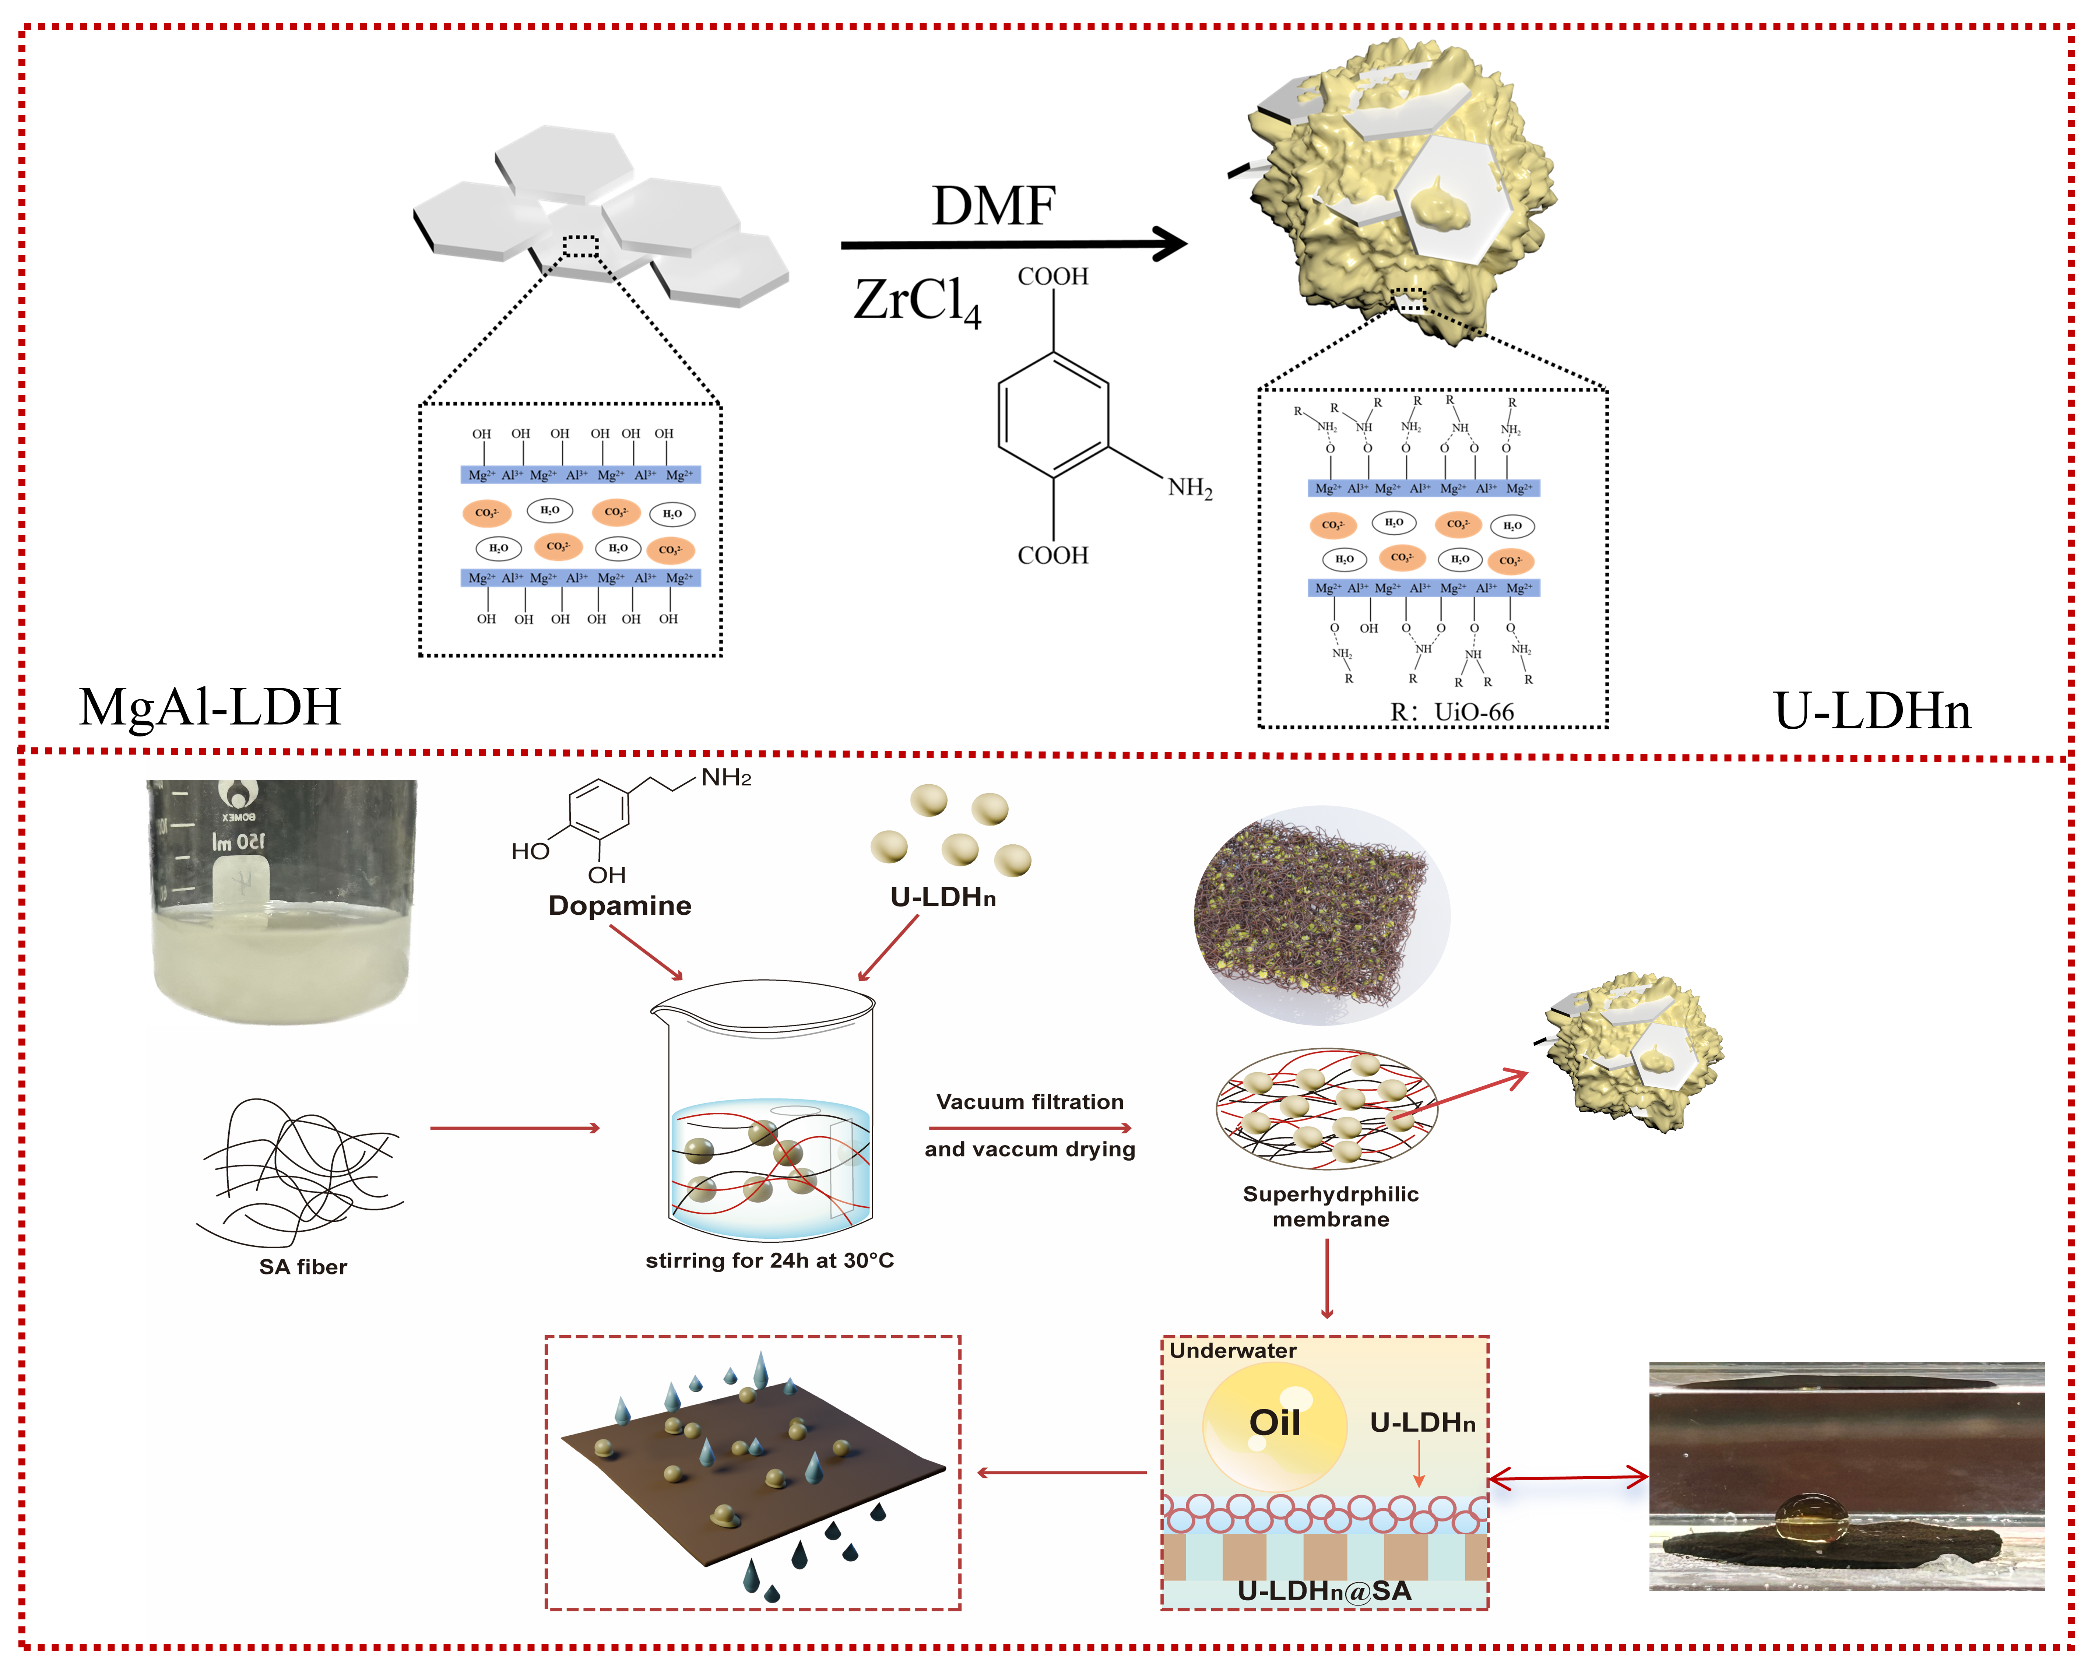
Scheme 1. Schematic illustration of membrane preparation process

