Supplementary Information for:
Comparison of Statistical Models for Time-Dependent Repellency Using the Novel Pole-Dance Bioassay against Tetranychus urticae Koch
Junho Yoon
Research Institute of Agricultural and Life Sciences, Seoul National University, Seoul, 08826, South Korea

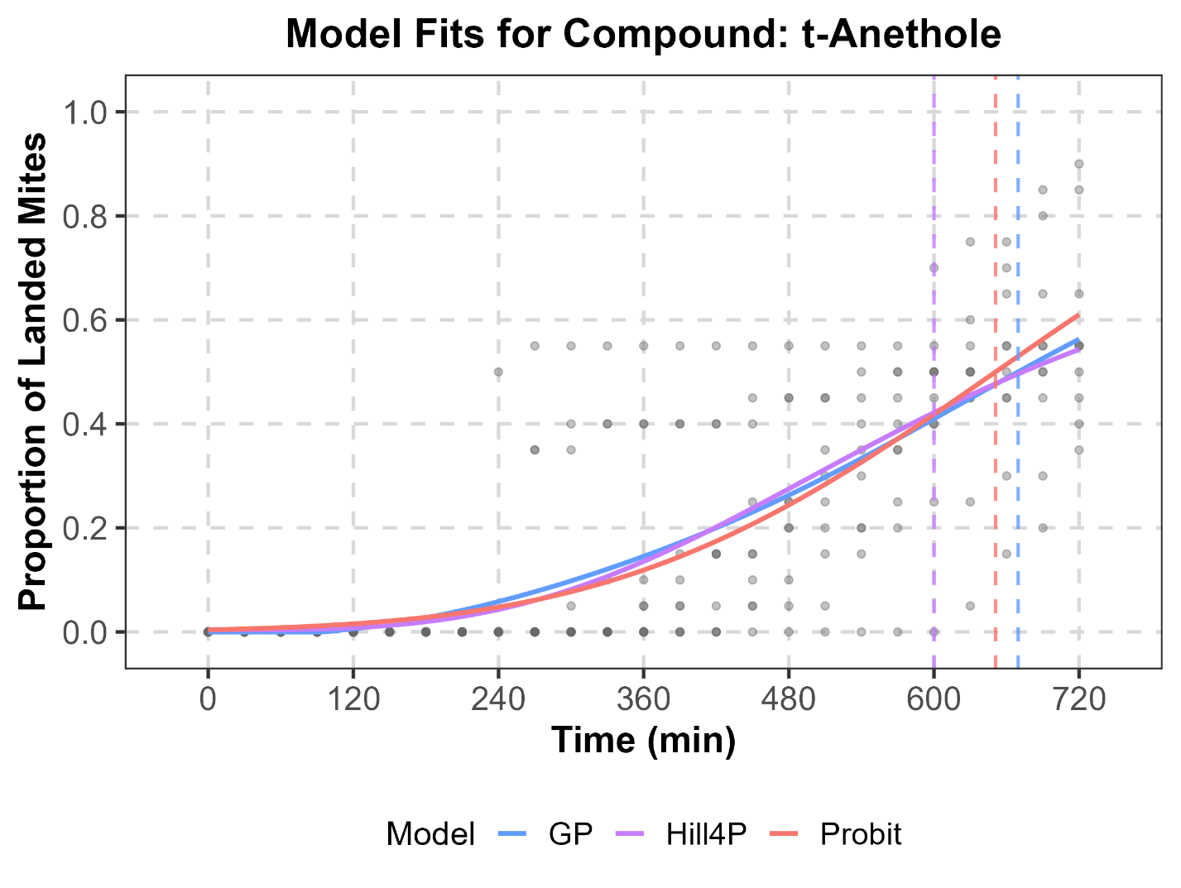
Supplementary Fig. S1. Comparison of observed time-dependent landing data for T. urticae exposed to t-Anethole (points) with fitted trajectories from Probit, Hill2P (not converged), Hill4P, and GP models.

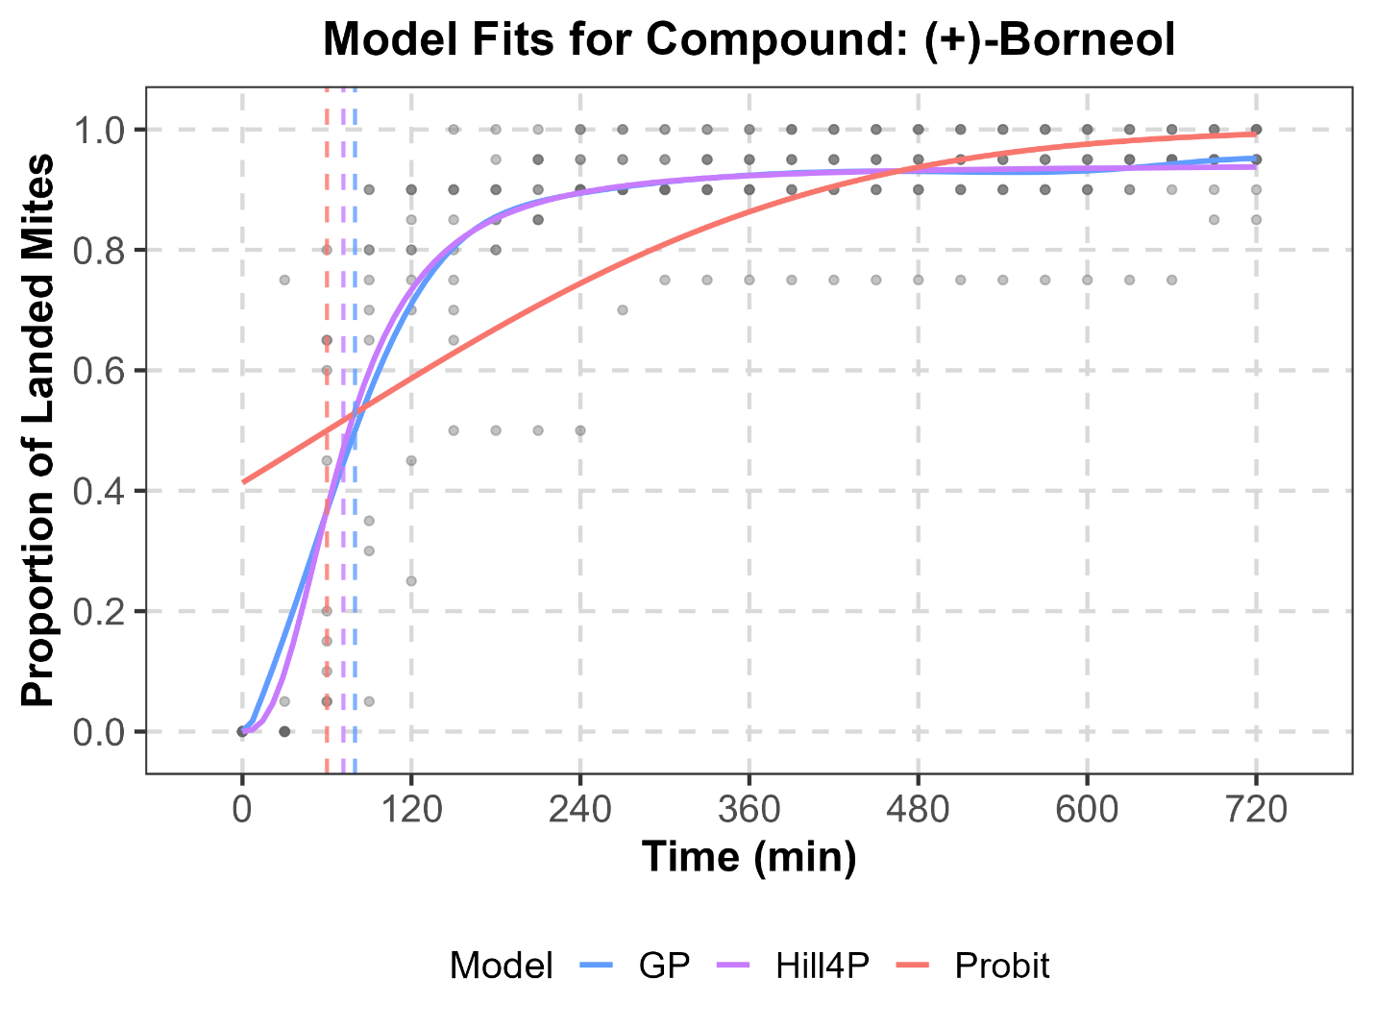
Supplementary Fig. S2. Comparison of observed time-dependent landing data for T. urticae exposed to (+)-borneol (points) with fitted trajectories from Probit, Hill2P (not converged), Hill4P, and GP models.

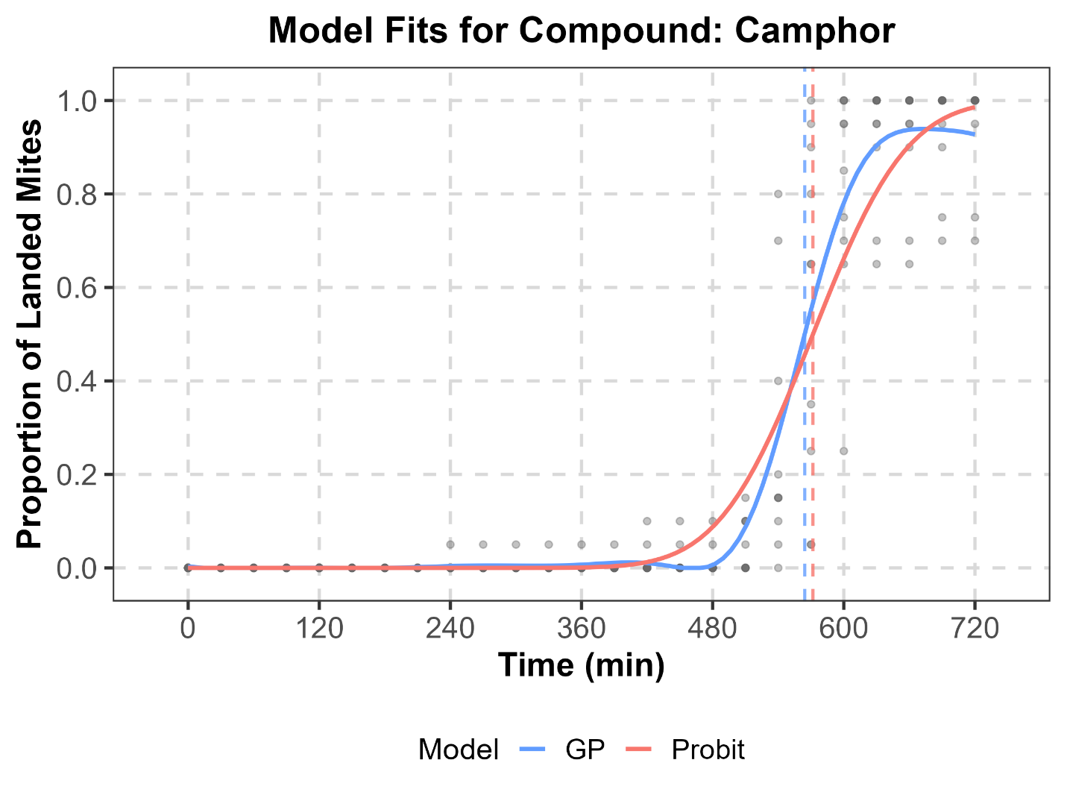
Supplementary Fig. S3. Comparison of observed time-dependent landing data for T. urticae exposed to camphor (points) with fitted trajectories from Probit, Hill2P (not converged), Hill4P (not converged), and GP models.

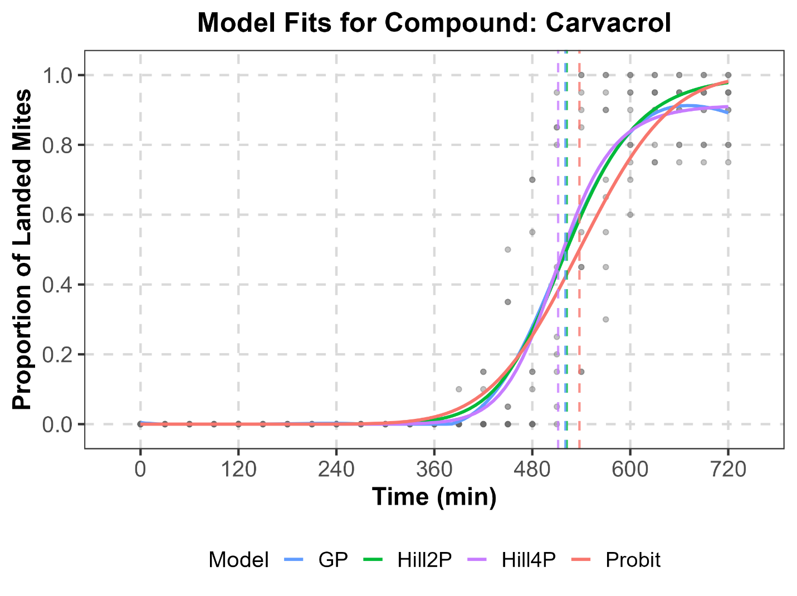
Supplementary Fig. S4. Comparison of observed time-dependent landing data for T. urticae exposed to camphor (points) with fitted trajectories from Probit, Hill2P, Hill4P, and GP models.

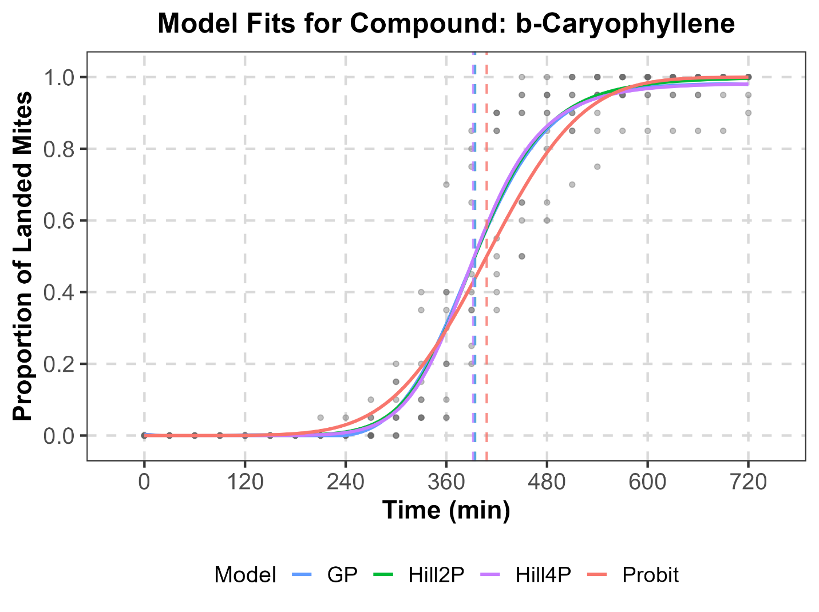
Supplementary Fig. S5. Comparison of observed time-dependent landing data for T. urticae exposed to β-caryophyllene (points) with fitted trajectories from Probit, Hill2P, Hill4P, and GP models.

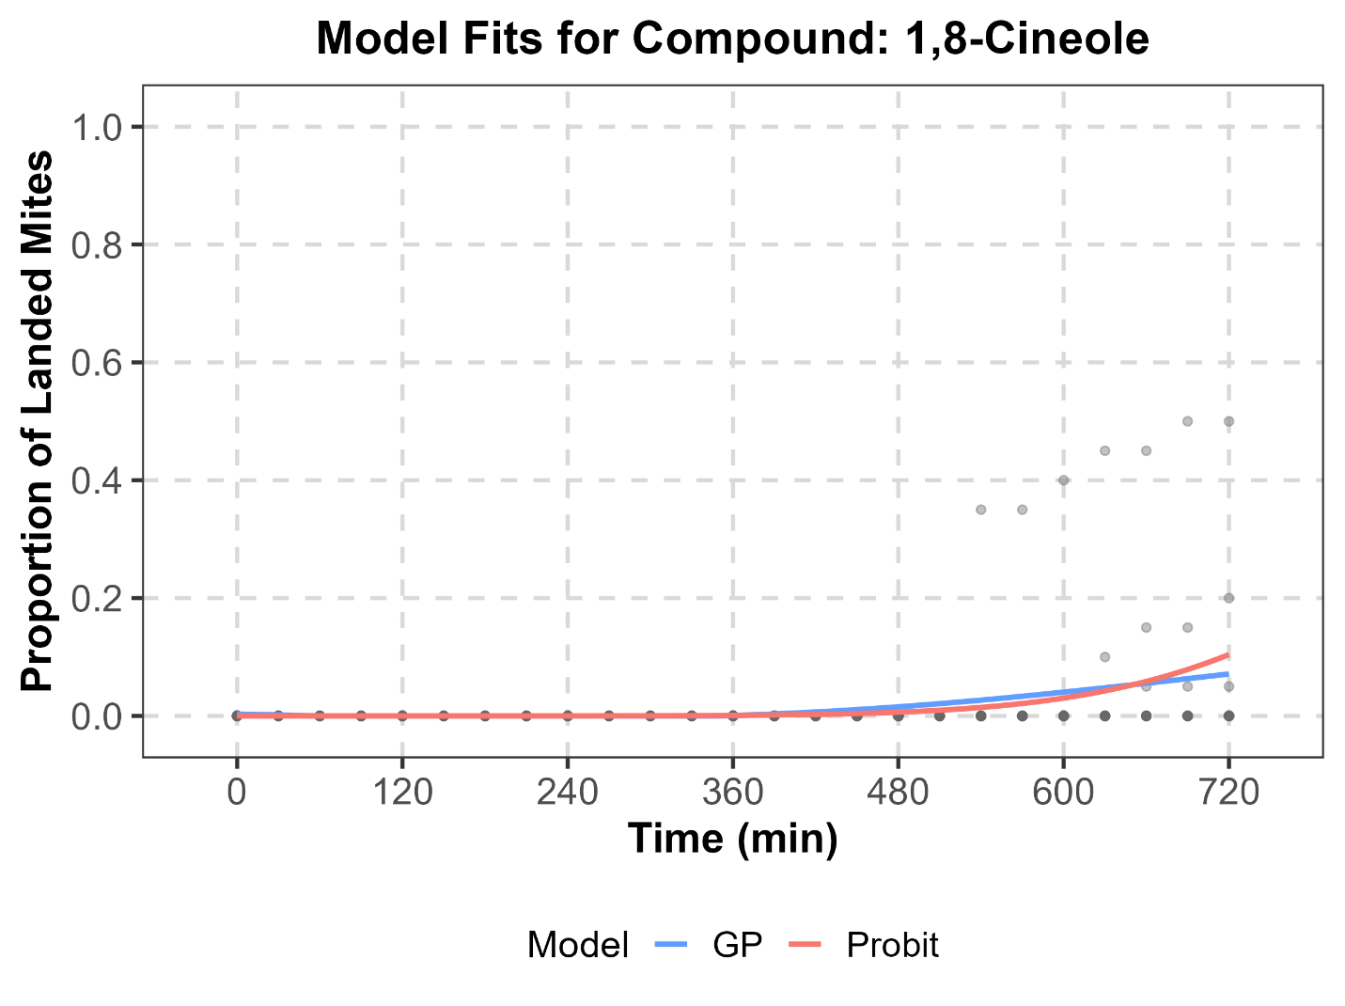
Supplementary Fig. S6. Comparison of observed time-dependent landing data for T. urticae exposed to 1,8-cineole (points) with fitted trajectories from Probit, Hill2P (not converged), Hill4P (not converged), and GP models.

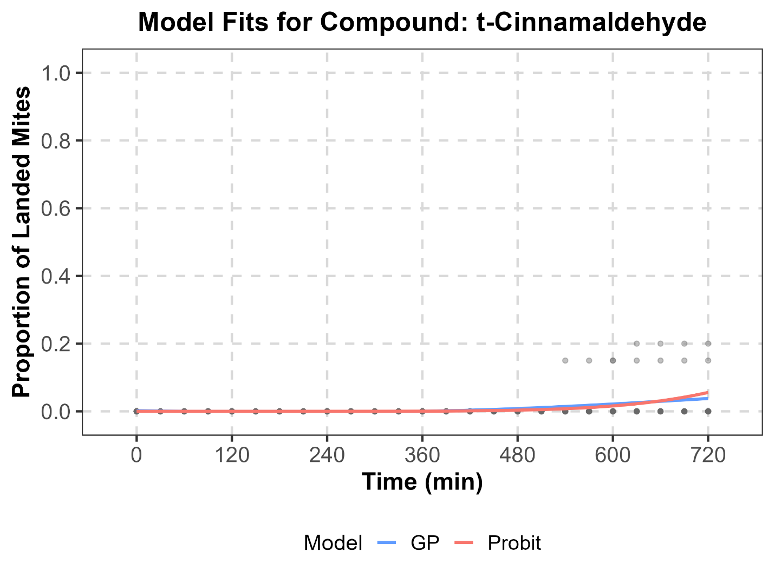
Supplementary Fig. S7. Comparison of observed time-dependent landing data for T. urticae exposed to t-cinnamaldehyde (points) with fitted trajectories from Probit, Hill2P (not converged), Hill4P (not converged), and GP models.

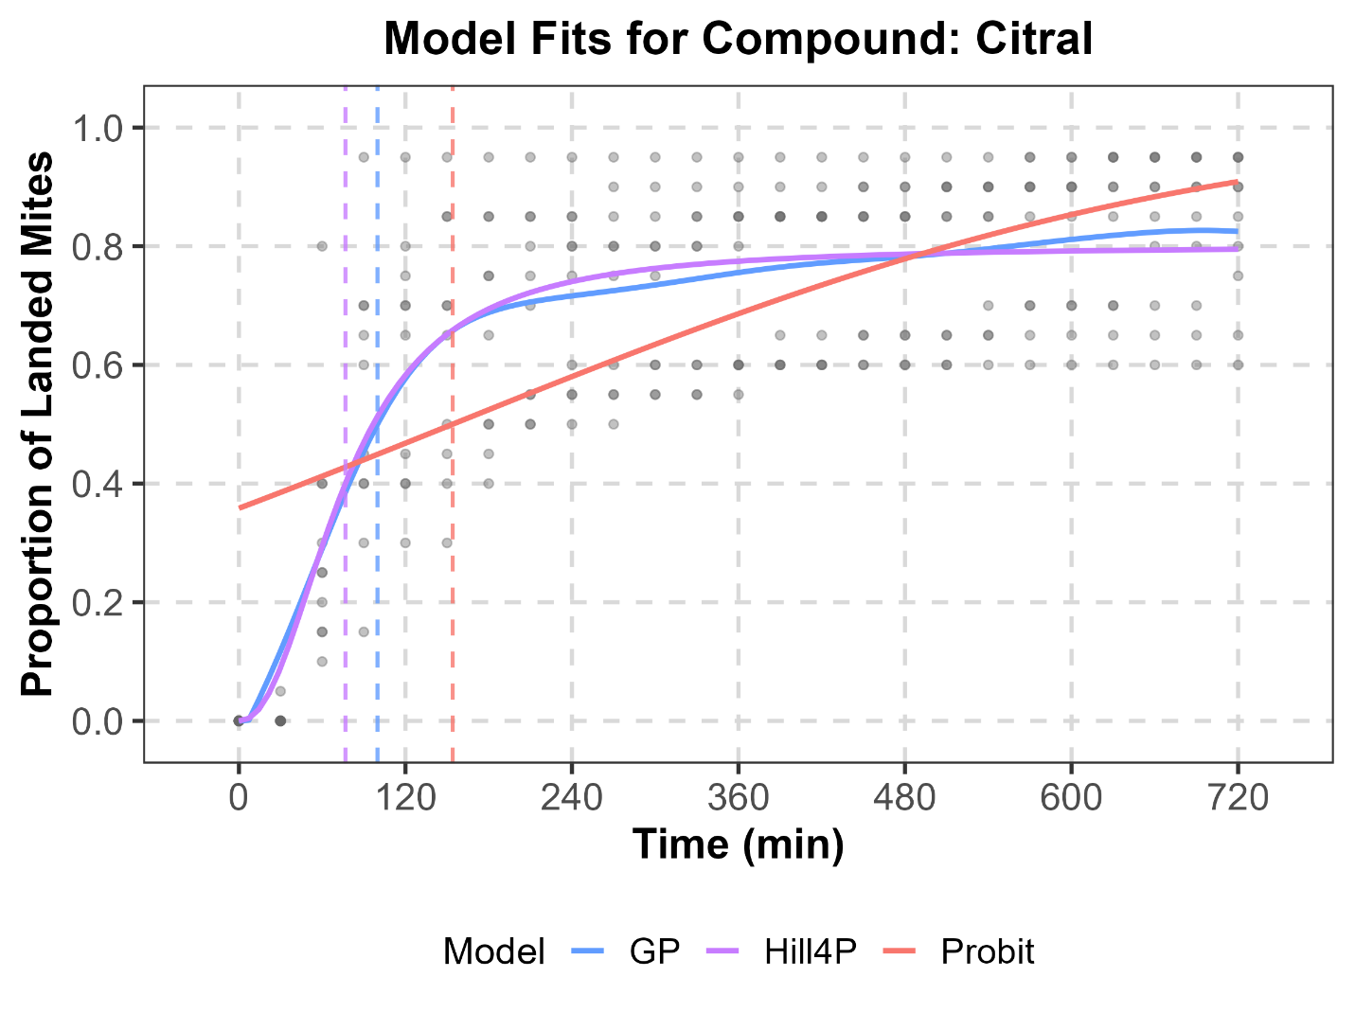 Supplementary Fig. S8. Comparison of observed time-dependent landing data for T. urticae exposed to citral (points) with fitted trajectories from Probit, Hill2P, Hill4P (not converged), and GP models.

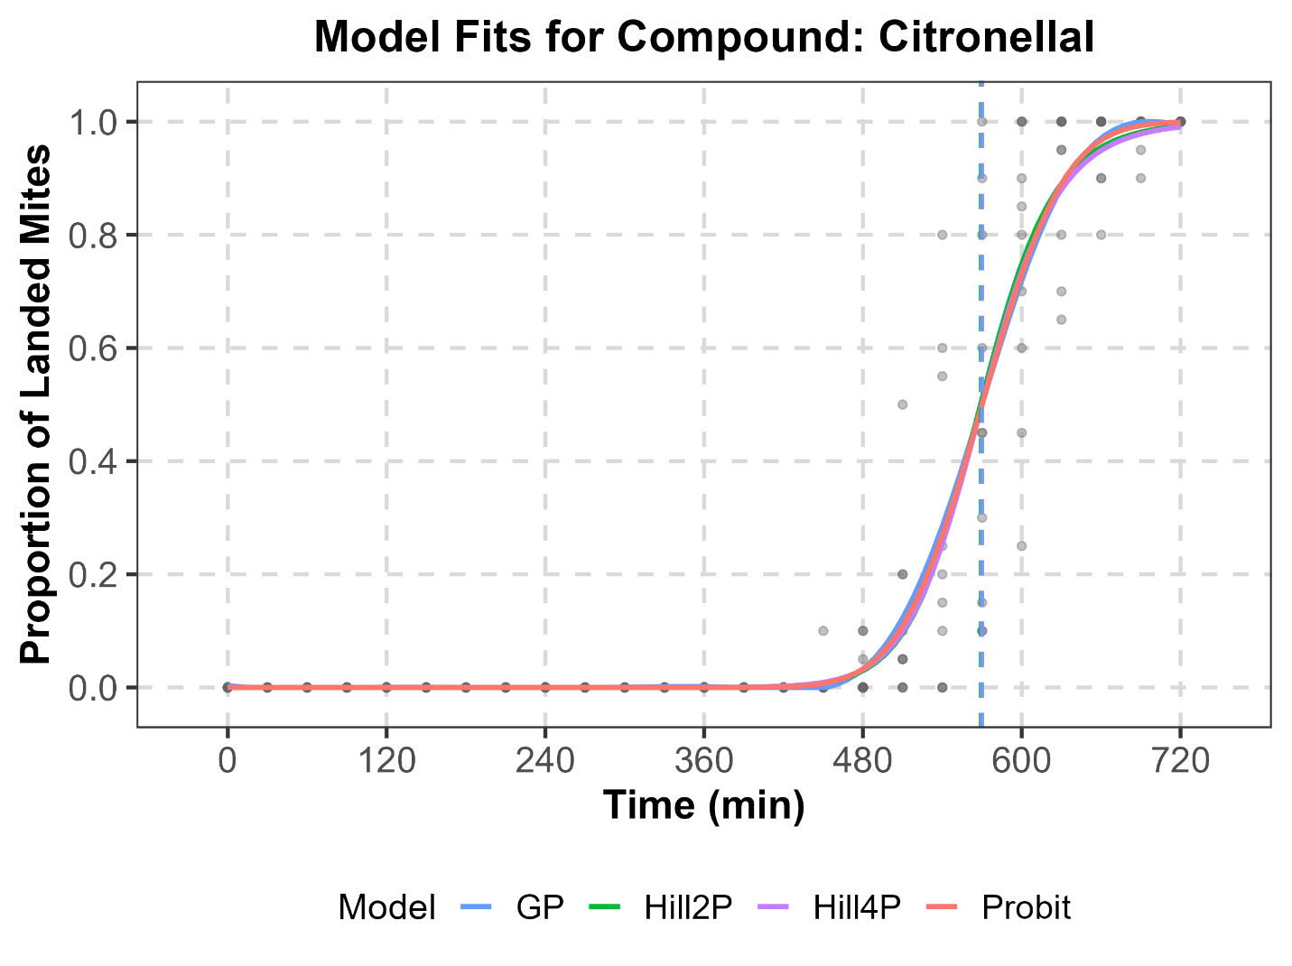
Supplementary Fig. S9. Comparison of observed time-dependent landing data for T. urticae exposed to citronellal (points) with fitted trajectories from Probit, Hill2P, Hill4P, and GP models.

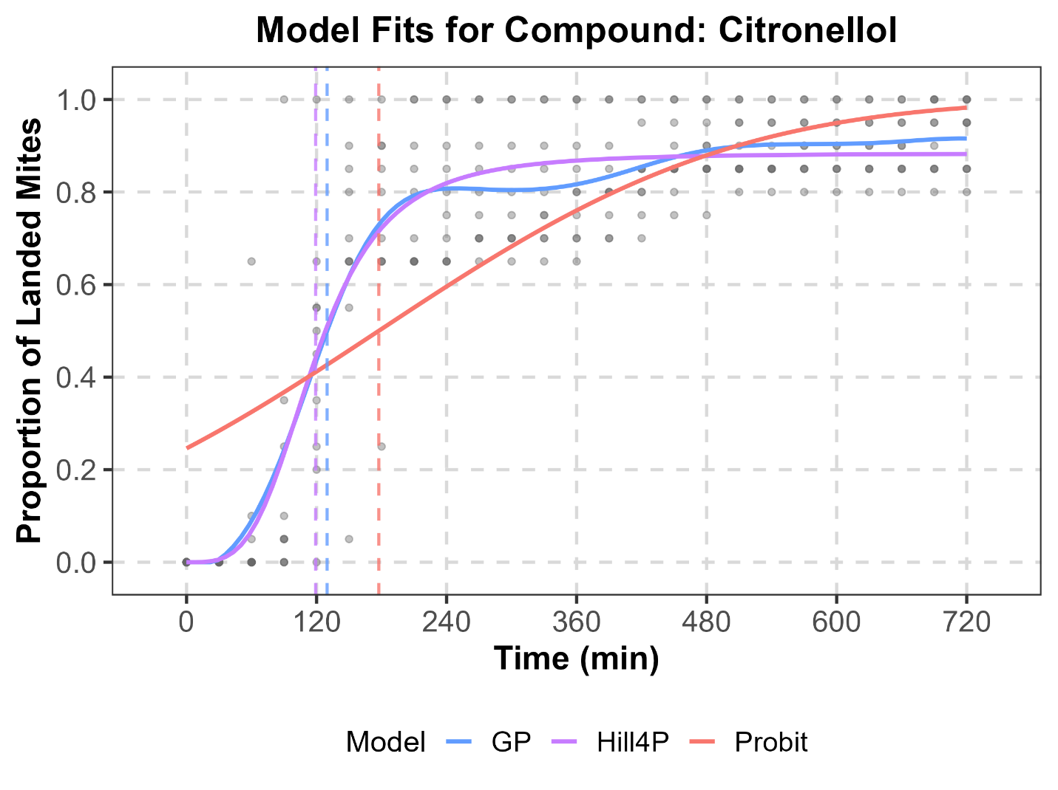
Supplementary Fig. S10. Comparison of observed time-dependent landing data for T. urticae exposed to citronellal (points) with fitted trajectories from Probit, Hill2P (not converged), Hill4P, and GP models.

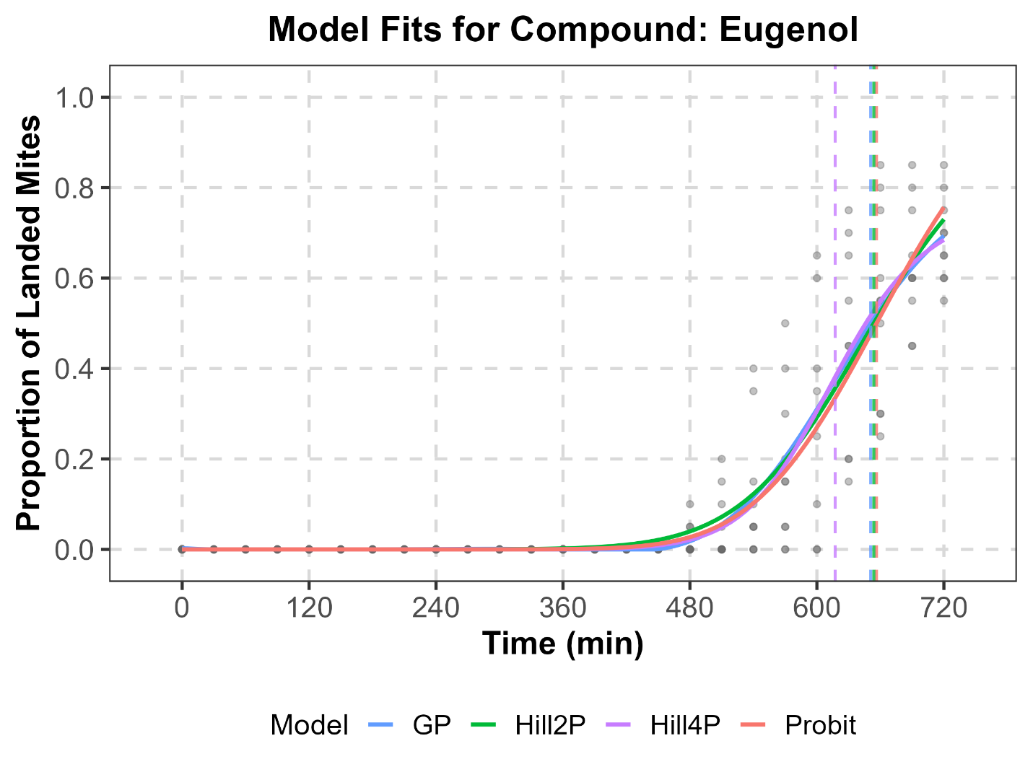
Supplementary Fig. S11. Comparison of observed time-dependent landing data for T. urticae exposed to eugenol (points) with fitted trajectories from Probit, Hill2P, Hill4P, and GP models.

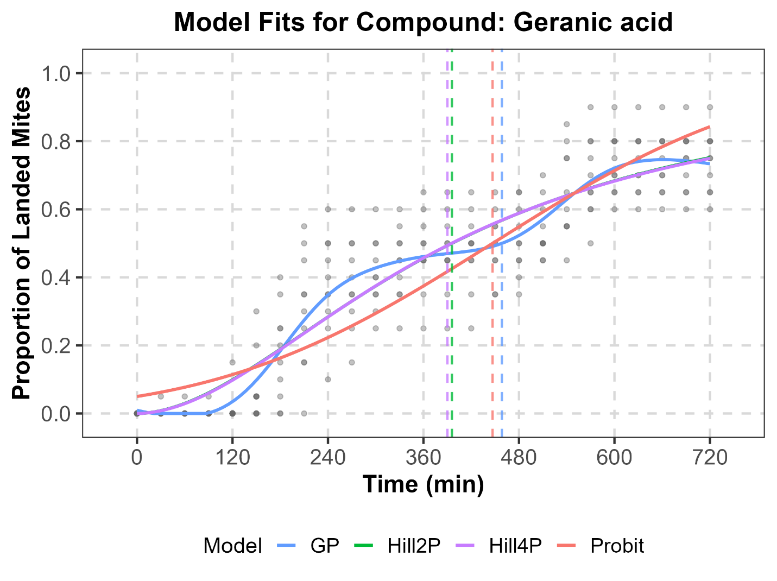
Supplementary Fig. S12. Comparison of observed time-dependent landing data for T. urticae exposed to geranic acid (points) with fitted trajectories from Probit, Hill2P, Hill4P, and GP models.

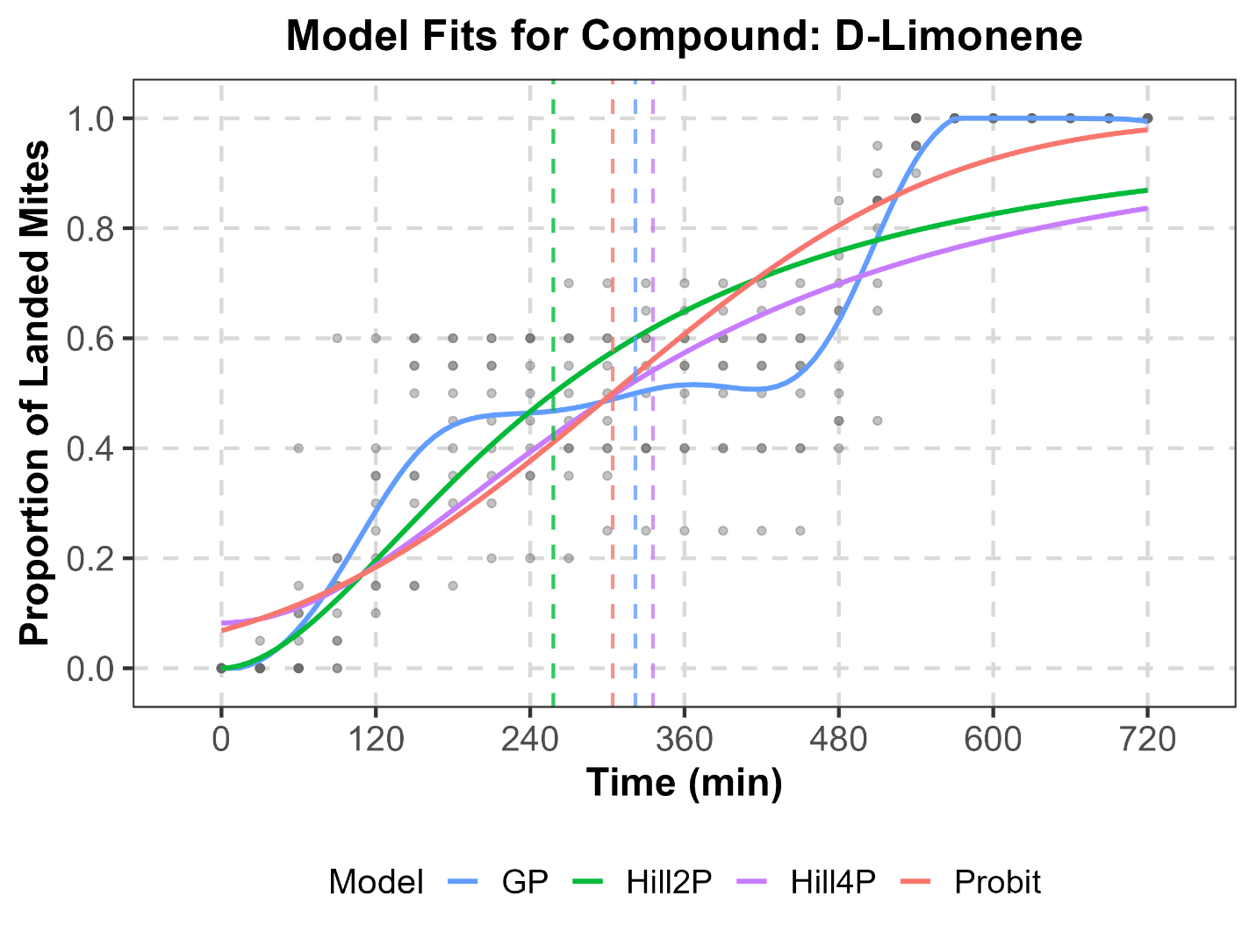
Supplementary Fig. S13. Comparison of observed time-dependent landing data for T. urticae exposed to D-limonene (points) with fitted trajectories from Probit, Hill2P, Hill4P, and GP models.

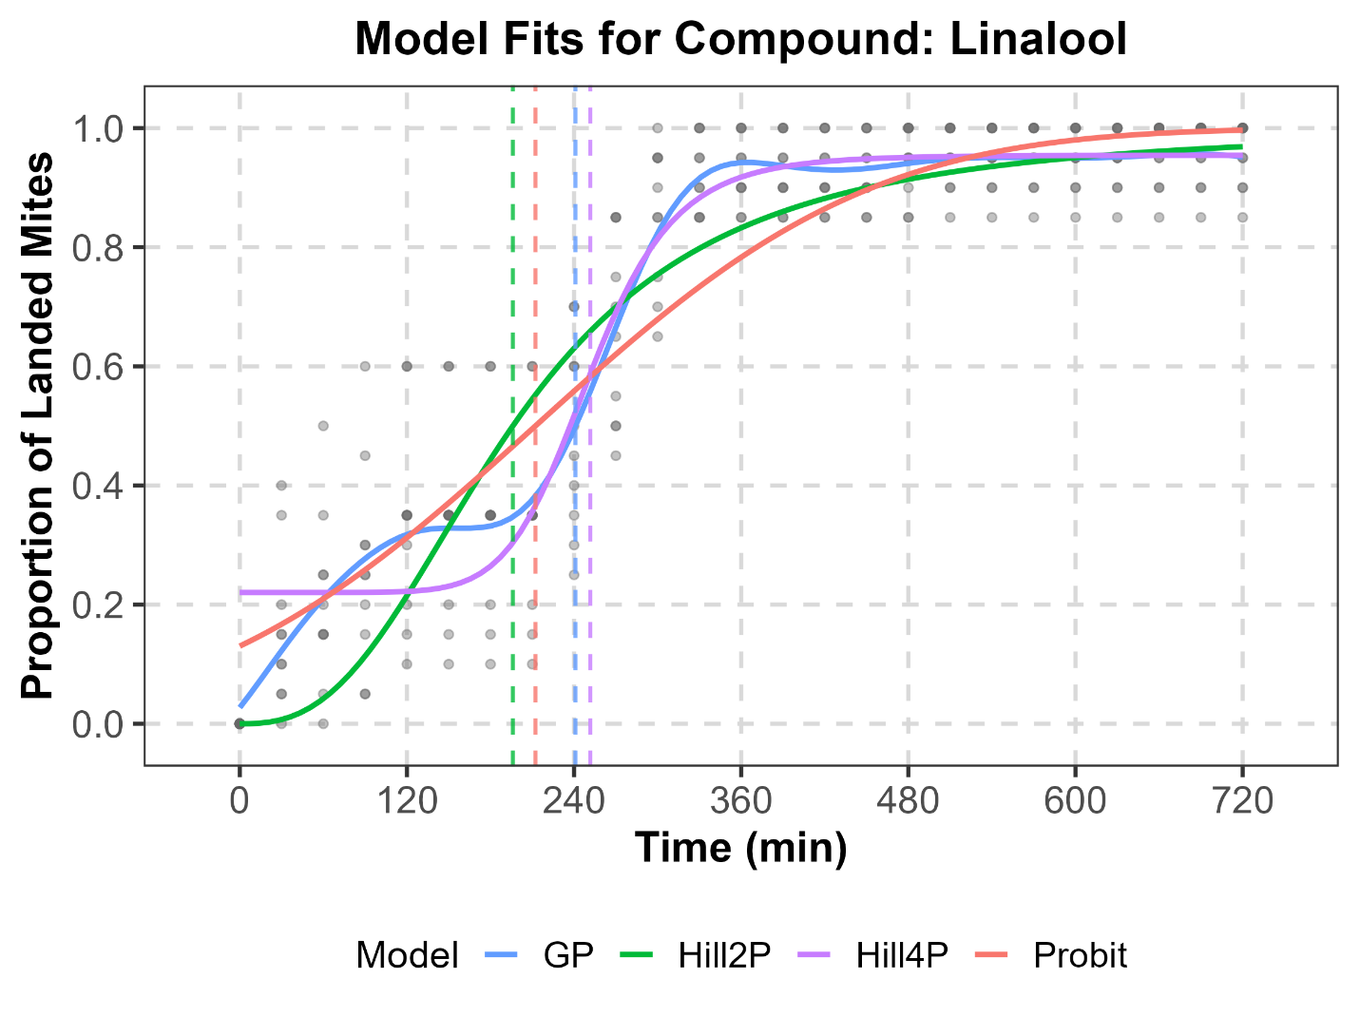
Supplementary Fig. S14. Comparison of observed time-dependent landing data for T. urticae exposed to linalool (points) with fitted trajectories from Probit, Hill2P, Hill4P, and GP models.

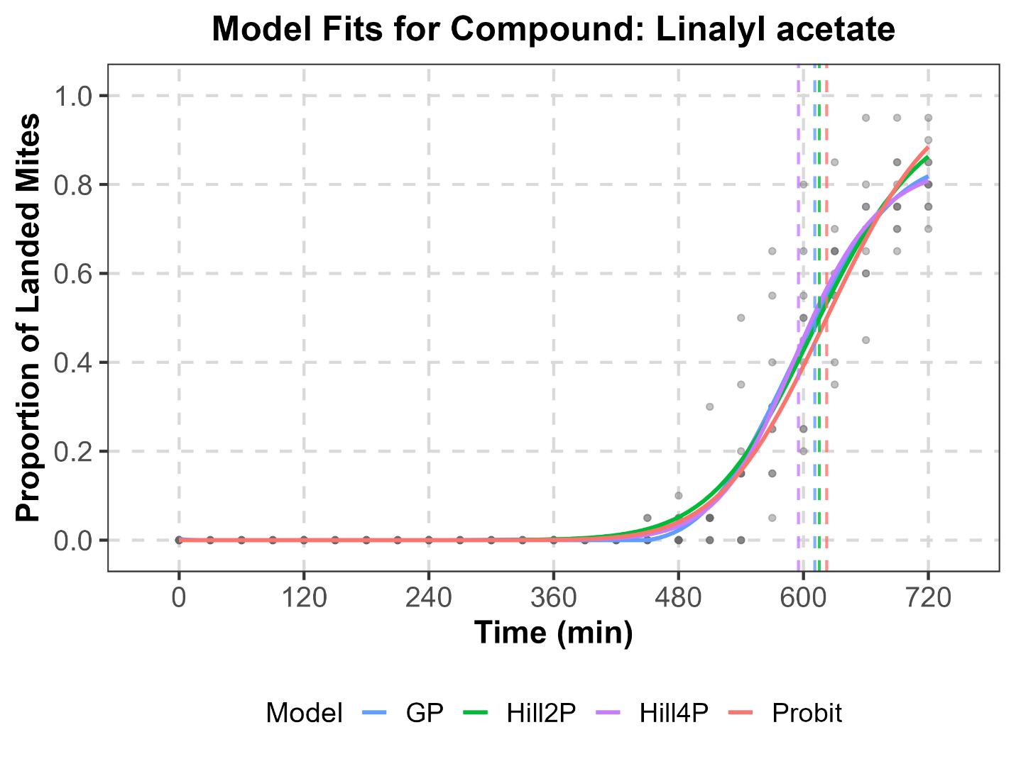
Supplementary Fig. S15. Comparison of observed time-dependent landing data for T. urticae exposed to linalyl acetate (points) with fitted trajectories from Probit, Hill2P, Hill4P, and GP models.

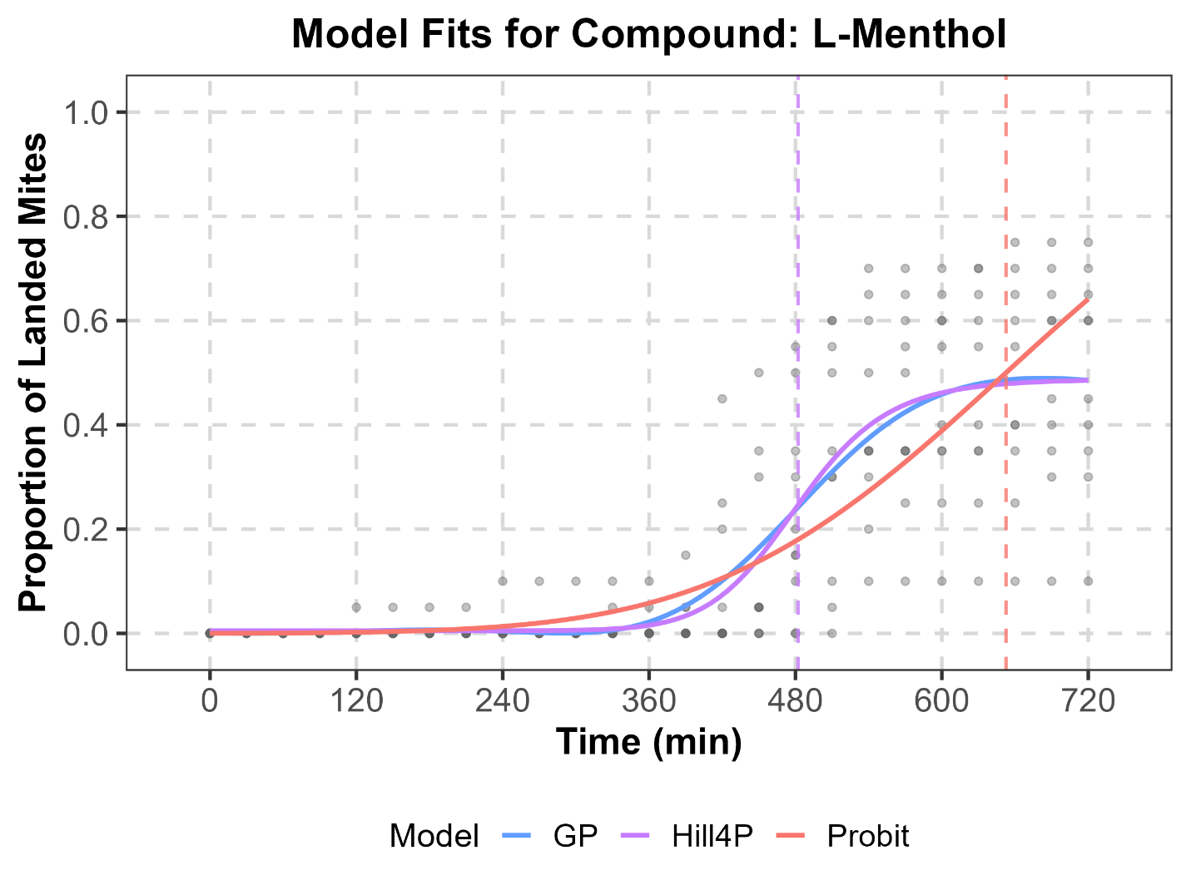
Supplementary Fig. S16. Comparison of observed time-dependent landing data for T. urticae exposed to L-Menthol (points) with fitted trajectories from Probit, Hill2P (not converged), Hill4P, and GP models.

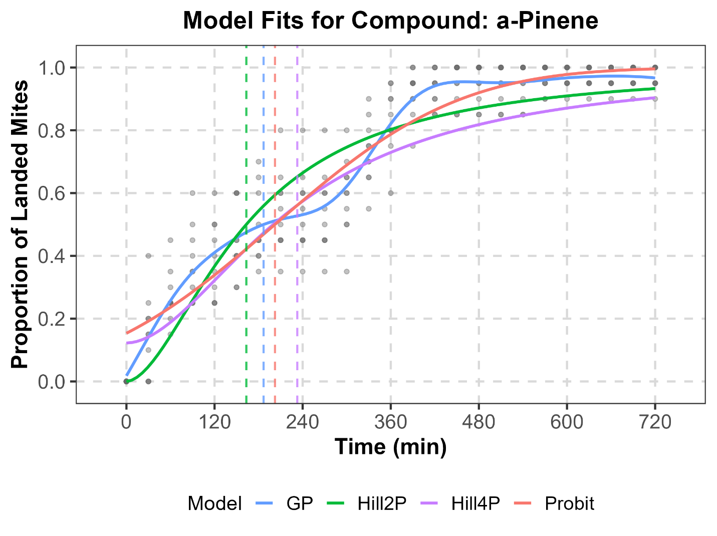
Supplementary Fig. S17. Comparison of observed time-dependent landing data for T. urticae exposed to α-pinene (points) with fitted trajectories from Probit, Hill2P, Hill4P, and GP models.

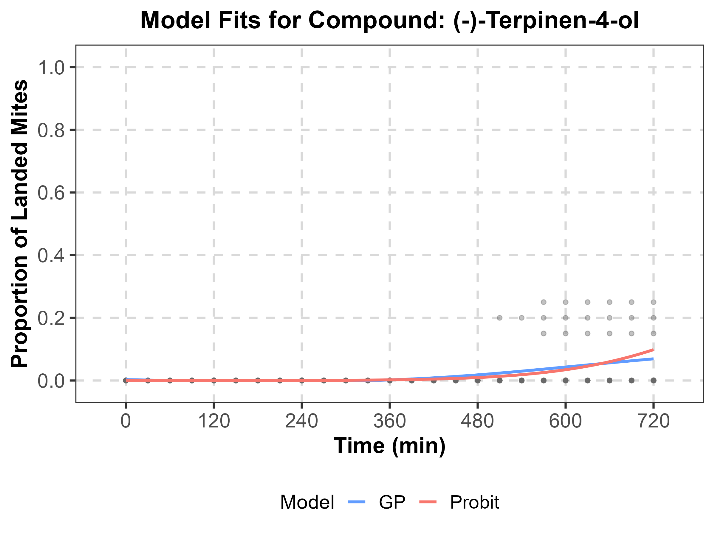
Supplementary Fig. S18. Comparison of observed time-dependent landing data for T. urticae exposed to (-)-terpinen-4-ol (points) with fitted trajectories from Probit, Hill2P, Hill4P, and GP models.

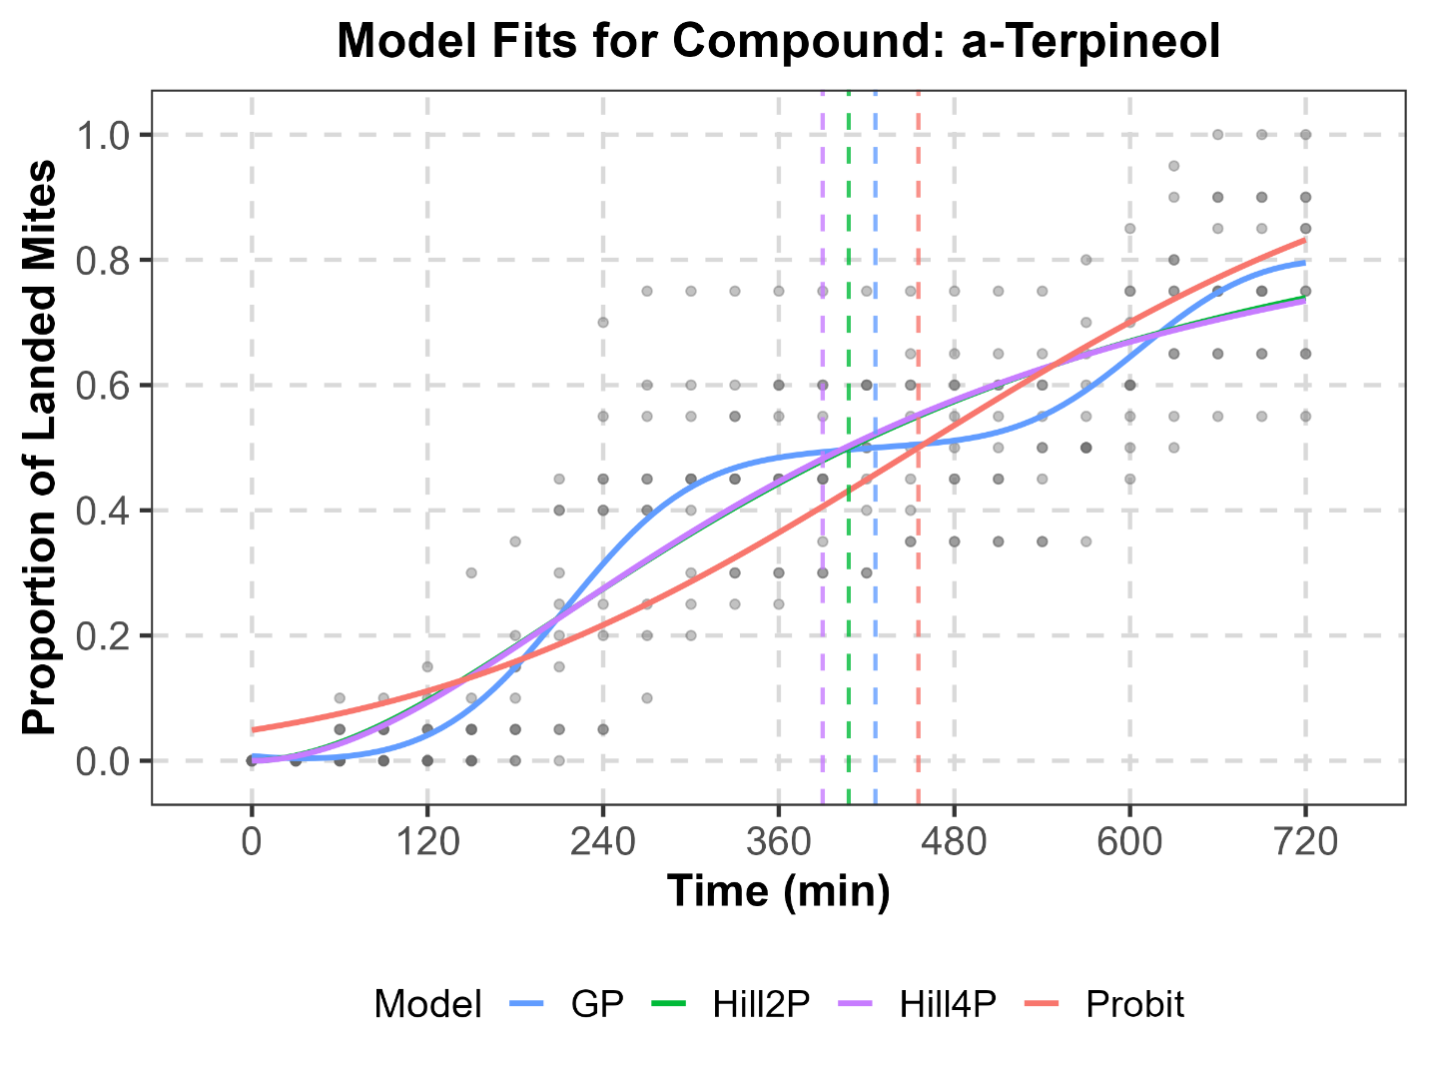
Supplementary Fig. S19. Comparison of observed time-dependent landing data for T. urticae exposed to α-terpineol (points) with fitted trajectories from Probit, Hill2P, Hill4P, and GP models.

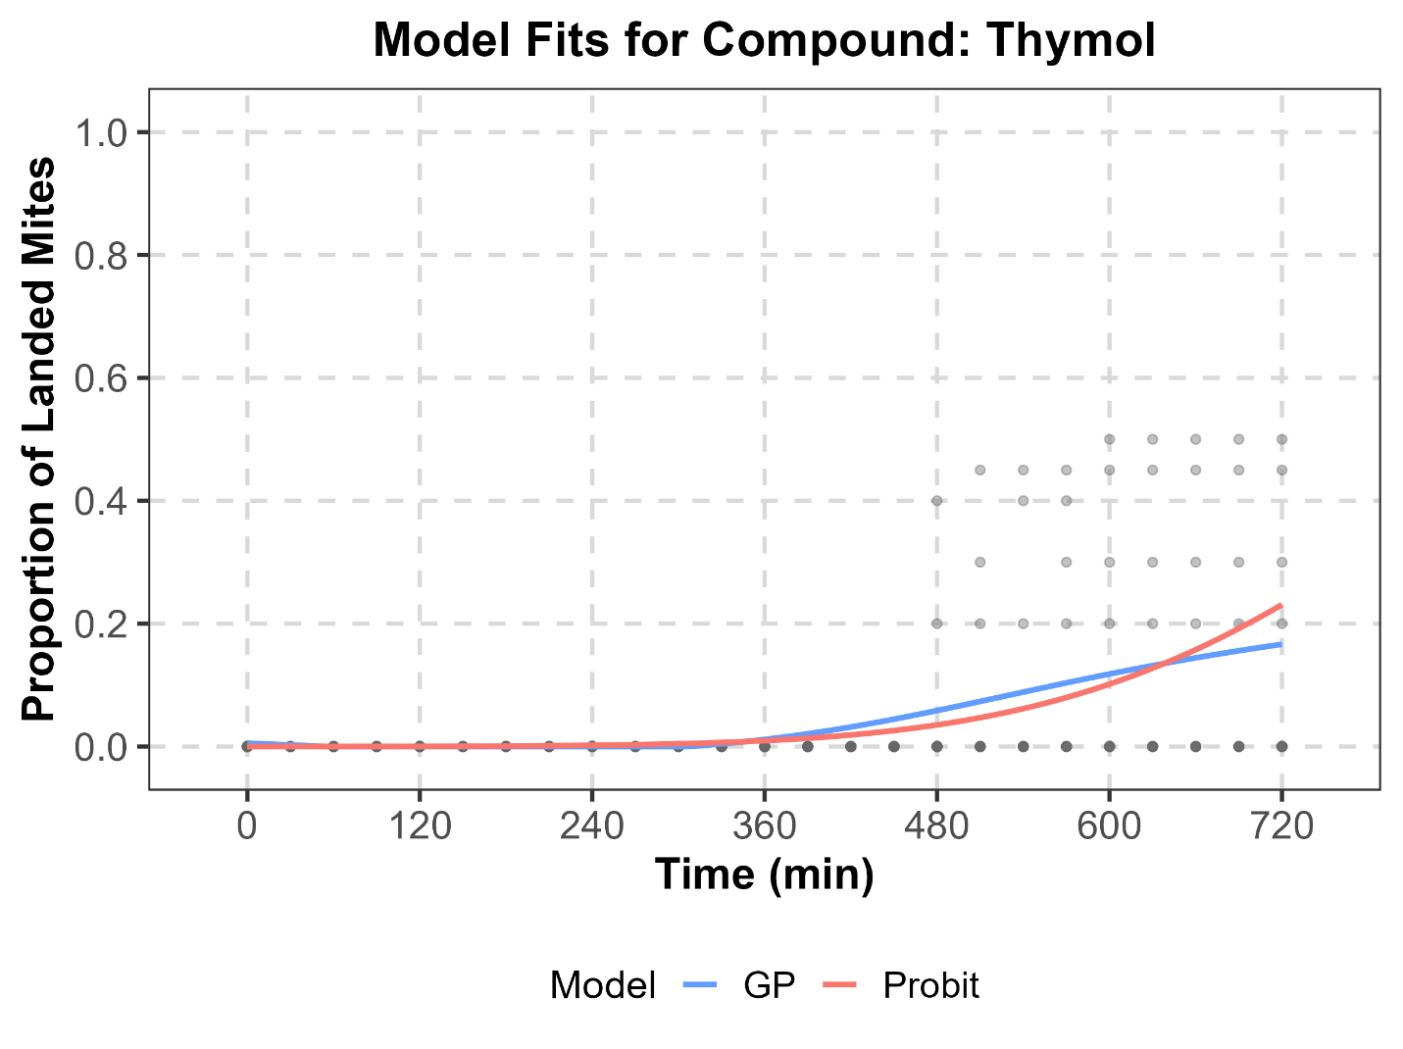
Supplementary Fig. S20. Comparison of observed time-dependent landing data for T. urticae exposed to thymol (points) with fitted trajectories from Probit, Hill2P (not converged), Hill4P (not converged), and GP models.

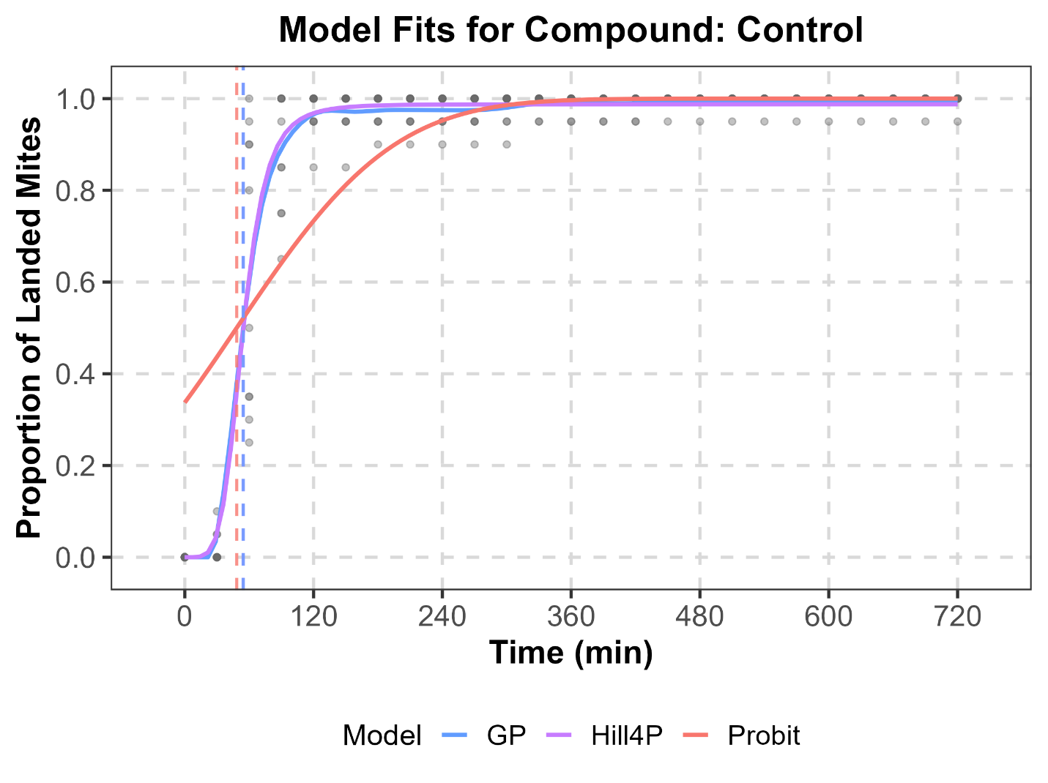
Supplementary Fig. S21. Comparison of observed time-dependent landing data for T. urticae exposed to solvent control (points) with fitted trajectories from Probit, Hill2P (not converged), Hill4P, and GP models.

Supplementary Table S1. Fit statistics, estimated ET₅₀, and estimated AUC of experimental data.
Compound | Model | RMSE | MAE | R² | ET₅₀  (min, 95% CI) | AUC  (min, 95% CI)
t-Anethole | Probit | 0.152 | 0.103 | 0.596 | 650.98 (626.595 - 677.424) | 136.414 (123.597 - 136.476)
t-Anethole | Hill2P | 0.152 | 0.101 | 0.597 | 672.412 (634.85 - 725.24) | 137.059 (125.434 - 137.111)
t-Anethole | Hill4P | 0.152 | 0.102 | 0.595 | 600.018 (510.02 - 717.321) | 137.834 (126.305 - 137.888)
t-Anethole | GP | 0.151 | 0.103 | 0.601 | 669.543 (628.842 - 708.017) | 138.267 (126.409 - 138.326)
(+)-Borneol | Probit | 0.190 | 0.141 | 0.576 | 60.081 (9.657 - 105.782) | 578.798 (550.235 - 578.781)
(+)-Borneol | Hill2P | 0.129 | 0.084 | 0.800 | 76.314 (61.9 - 88.365) | 599.569 (578.178 - 599.796)
(+)-Borneol | Hill4P | 0.125 | 0.079 | 0.810 | 71.704 (60.552 - 87.645) | 588.831 (568.453 - 589.189)
(+)-Borneol | GP | 0.127 | 0.081 | 0.806 | 79.999 (62.947 - 94.352) | 589.094 (568.249 - 589.228)
Camphor | Probit | 0.121 | 0.060 | 0.898 | 571.765 (560.043 - 582.982) | 148.578 (127.422 - 148.893)
Camphor | Hill2P | NA | NA | NA | NA | NA
Camphor | Hill4P | NA | NA | NA | NA | NA
Camphor | GP | 0.110 | 0.051 | 0.915 | 564.183 (550.829 - 578.487) | 150.238 (130.028 - 150.69)
Carvacrol | Probit | 0.142 | 0.075 | 0.870 | 537.702 (524.643 - 549.683) | 182.874 (161.803 - 183.065)
Carvacrol | Hill2P | 0.136 | 0.072 | 0.881 | 522.107 (506.435 - 537.849) | 193.197 (172.092 - 193.504)
Carvacrol | Hill4P | 0.134 | 0.069 | 0.884 | 511.583 (492.196 - 529.927) | 187.526 (167.907 - 187.818)
Carvacrol | GP | 0.134 | 0.070 | 0.883 | 520.435 (499.537 - 537.539) | 188.262 (168.731 - 188.472)
β-Caryophyllene | Probit | 0.105 | 0.059 | 0.945 | 408.043 (398.851 - 417.596) | 311.962 (290.353 - 312.161)
β-Caryophyllene | Hill2P | 0.098 | 0.054 | 0.952 | 394.128 (383.525 - 405.383) | 318.565 (296.955 - 318.844)
β-Caryophyllene | Hill4P | 0.097 | 0.056 | 0.952 | 392.034 (380.079 - 403.696) | 315.947 (294.755 - 316.305)
β-Caryophyllene | GP | 0.097 | 0.056 | 0.952 | 394 (379.929 - 406.819) | 315.874 (294.628 - 316.142)
1,8-Cineole | Probit | 0.070 | 0.024 | 0.106 | NA | 9.658 (7.625 - 9.707)
1,8-Cineole | Hill2P | 0.069 | 0.024 | 0.111 | 1080 (771.814 - 1080) | 10.216 (8.408 - 10.248)
1,8-Cineole | Hill4P | NA | NA | NA | NA | NA
1,8-Cineole | GP | 0.069 | 0.025 | 0.112 | NA | 10.892 (9.398 - 10.907)
t-Cinnamaldehyde | Probit | 0.034 | 0.013 | 0.117 | NA | 5.151 (4.067 - 5.177)
t-Cinnamaldehyde | Hill2P | NA | NA | NA | NA | NA
t-Cinnamaldehyde | Hill4P | NA | NA | NA | NA | NA
t-Cinnamaldehyde | GP | 0.034 | 0.014 | 0.131 | NA | 5.8 (4.986 - 5.807)
Citral | Probit | 0.199 | 0.163 | 0.458 | 153.992 (82.805 - 198.785) | 480.651 (454.633 - 480.645)
Citral | Hill2P | 0.157 | 0.133 | 0.663 | 111.731 (94.099 - 129.758) | 495.521 (476.426 - 495.451)
Citral | Hill4P | 0.149 | 0.127 | 0.696 | 76.825 (64.758 - 92.28) | 491.275 (473.998 - 491.577)
Citral | GP | 0.149 | 0.128 | 0.697 | 99.855 (77.144 - 119.738) | 490.121 (472.155 - 490.302)
Citronellal | Probit | 0.106 | 0.043 | 0.924 | 570.021 (560.742 - 579.547) | 149.996 (128.411 - 150.474)
Citronellal | Hill2P | 0.106 | 0.043 | 0.924 | 568.885 (556.379 - 580.295) | 149.181 (127.733 - 149.627)
Citronellal | Hill4P | 0.106 | 0.044 | 0.924 | 569.934 (554.955 - 583.649) | 148.07 (126.744 - 148.467)
Citronellal | GP | 0.106 | 0.044 | 0.923 | 569.833 (556.944 - 584.467) | 150.534 (128.83 - 150.911)
Citronellol | Probit | 0.196 | 0.149 | 0.644 | 177.409 (138.857 - 207.677) | 506.547 (483.538 - 506.541)
Citronellol | Hill2P | 0.147 | 0.107 | 0.800 | 135.205 (118.654 - 150.75) | 529.079 (508.279 - 529.238)
Citronellol | Hill4P | 0.138 | 0.096 | 0.821 | 119.155 (103.464 - 134.027) | 516.88 (497.739 - 517.235)
Citronellol | GP | 0.136 | 0.093 | 0.827 | 129.714 (114.688 - 145.189) | 516.387 (496.391 - 516.716)
Eugenol | Probit | 0.093 | 0.044 | 0.841 | 656.312 (645.086 - 667.288) | 76.925 (61.485 - 77.159)
Eugenol | Hill2P | 0.092 | 0.044 | 0.845 | 653.731 (639.696 - 666.041) | 80.598 (65.572 - 80.799)
Eugenol | Hill4P | 0.091 | 0.041 | 0.848 | 617.259 (591.562 - 665.361) | 79.003 (64.603 - 79.243)
Eugenol | GP | 0.091 | 0.042 | 0.848 | 650.748 (629.115 - 667.21) | 78.917 (59.962 - 79.11)
Geranic acid | Probit | 0.124 | 0.103 | 0.804 | 446.865 (432.549 - 461.427) | 289.849 (271.86 - 289.885)
Geranic acid | Hill2P | 0.109 | 0.085 | 0.850 | 395.721 (378.225 - 411.34) | 297.943 (281.821 - 298.006)
Geranic acid | Hill4P | 0.109 | 0.085 | 0.850 | 390.007 (303.329 - 450.012) | 297.637 (281.549 - 297.703)
Geranic acid | GP | 0.099 | 0.074 | 0.876 | 458.521 (373.356 - 493.924) | 295.229 (274.02 - 295.4)
D-Limonene | Probit | 0.157 | 0.119 | 0.786 | 304.099 (288.301 - 319.977) | 411.327 (389.729 - 411.354)
D-Limonene | Hill2P | 0.167 | 0.137 | 0.758 | 257.972 (237.755 - 280.889) | 399.548 (380.757 - 399.648)
D-Limonene | Hill4P | 0.174 | 0.149 | 0.778 | 335.358 (293.586 - 429.325) | 370.764 (352.755 - 370.82)
D-Limonene | GP | 0.111 | 0.075 | 0.893 | 321.848 (223.277 - 450.801) | 409.828 (388.287 - 410.292)
Linalool | Probit | 0.131 | 0.100 | 0.855 | 212.273 (197.369 - 226.671) | 495.608 (473.108 - 495.629)
Linalool | Hill2P | 0.136 | 0.097 | 0.850 | 196.055 (174.755 - 217.342) | 482.667 (461.739 - 482.822)
Linalool | Hill4P | 0.118 | 0.087 | 0.880 | 251.629 (221.522 - 263.931) | 497.929 (475.671 - 498.175)
Linalool | GP | 0.103 | 0.074 | 0.909 | 240.935 (228.638 - 252.921) | 501.102 (480.093 - 501.336)
Linalyl acetate | Probit | 0.079 | 0.037 | 0.920 | 622.313 (614.515 - 630.384) | 102.286 (83.806 - 102.568)
Linalyl acetate | Hill2P | 0.077 | 0.037 | 0.925 | 615.23 (605.862 - 624.036) | 107.257 (89.144 - 107.488)
Linalyl acetate | Hill4P | 0.075 | 0.033 | 0.928 | 595.15 (577.444 - 613.649) | 105.407 (88.179 - 105.717)
Linalyl acetate | GP | 0.075 | 0.033 | 0.928 | 610.898 (595.878 - 623.395) | 104.709 (87.304 - 104.949)
L-Menthol | Probit | 0.139 | 0.086 | 0.656 | 652.576 (630.211 - 679.339) | 112.836 (99.49 - 112.933)
L-Menthol | Hill2P | 0.134 | 0.088 | 0.679 | 660.327 (629.122 - 702.832) | 120.269 (107.957 - 120.339)
L-Menthol | Hill4P | 0.126 | 0.079 | 0.717 | 482.172 (458.563 - 513.113) | 116.39 (105.859 - 116.542)
L-Menthol | GP | 0.126 | 0.079 | 0.715 | NA | 116.464 (105.91 - 116.569)
α-Pinene | Probit | 0.102 | 0.078 | 0.890 | 202.27 (189.948 - 214.704) | 502.174 (479.52 - 502.183)
α-Pinene | Hill2P | 0.119 | 0.094 | 0.856 | 163.257 (149.088 - 180.097) | 490.398 (470.305 - 490.573)
α-Pinene | Hill4P | 0.128 | 0.108 | 0.880 | 232.645 (201.699 - 269.766) | 459.134 (437.841 - 459.18)
α-Pinene | GP | 0.086 | 0.064 | 0.923 | 186.864 (148.914 - 253.156) | 506.182 (484.936 - 506.225)
(-)-Terpinen-4-ol | Probit | 0.051 | 0.024 | 0.162 | NA | 10.517 (8.575 - 10.549)
(-)-Terpinen-4-ol | Hill2P | NA | NA | NA | NA | NA
(-)-Terpinen-4-ol | Hill4P | NA | NA | NA | NA | NA
(-)-Terpinen-4-ol | GP | 0.050 | 0.025 | 0.187 | NA | 11.52 (10.062 - 11.533)
α-Terpineol | Probit | 0.148 | 0.118 | 0.734 | 455.281 (437.736 - 472.216) | 283.717 (265.597 - 283.75)
α-Terpineol | Hill2P | 0.136 | 0.107 | 0.775 | 407.737 (386.604 - 428.483) | 290.823 (274.964 - 290.883)
α-Terpineol | Hill4P | 0.136 | 0.106 | 0.775 | 389.865 (271.88 - 480.872) | 290.69 (269.758 - 290.747)
α-Terpineol | GP | 0.126 | 0.096 | 0.808 | 425.953 (316.123 - 532.273) | 287.168 (270.119 - 287.303)
Thymol | Probit | 0.111 | 0.058 | 0.203 | NA | 30.062 (25.406 - 30.12)
Thymol | Hill2P | 0.109 | 0.061 | 0.221 | 1080 (913.174 - 1080) | 32.825 (28.905 - 32.857)
Thymol | Hill4P | NA | NA | NA | NA | NA
Thymol | GP | 0.108 | 0.060 | 0.235 | NA | 32.242 (28.734 - 32.271)
Control | Probit | 0.150 | 0.081 | 0.739 | 48.359 (11.669 - 73.286) | 645.941 (623.458 - 645.909)
Control | Hill4P | 0.069 | 0.034 | 0.939 | 54.375 (49.692 - 62.332) | 653.699 (632.184 - 655.099)
Control | GP | 0.068 | 0.032 | 0.940 | 54.47 (47.071 - 63.741) | 653.492 (631.798 - 654.976)
Control | Hill | 0.069 | 0.029 | 0.939 | 54.556 (48.808 - 62.3) | 661.034 (639.371 - 662.251)

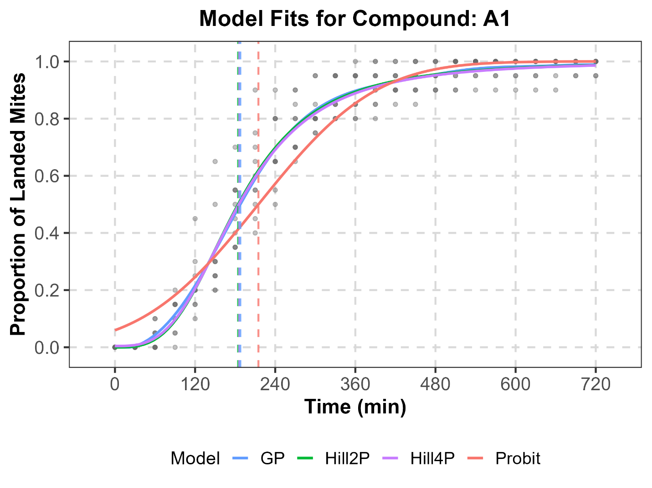
Supplementary Fig. S22. Comparison of simulated time-dependent landing data for T. urticae exposed to A1 (points) with fitted trajectories from Probit, Hill2P, Hill4P, and GP models.

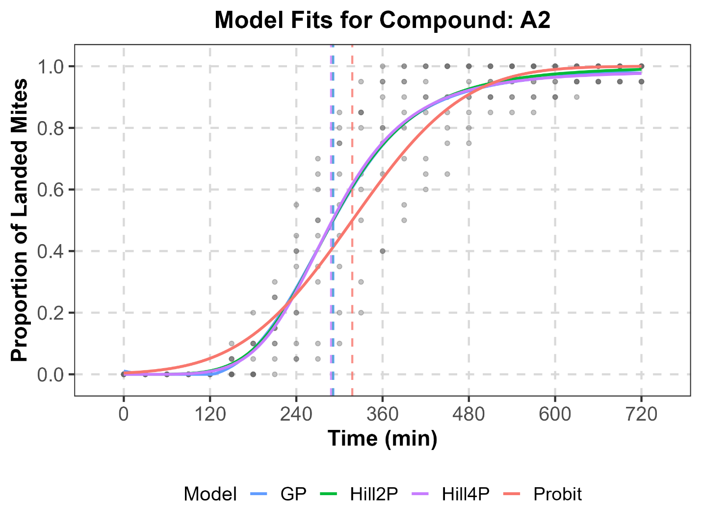
Supplementary Fig. S23. Comparison of simulated time-dependent landing data for T. urticae exposed to A2 (points) with fitted trajectories from Probit, Hill2P, Hill4P, and GP models.

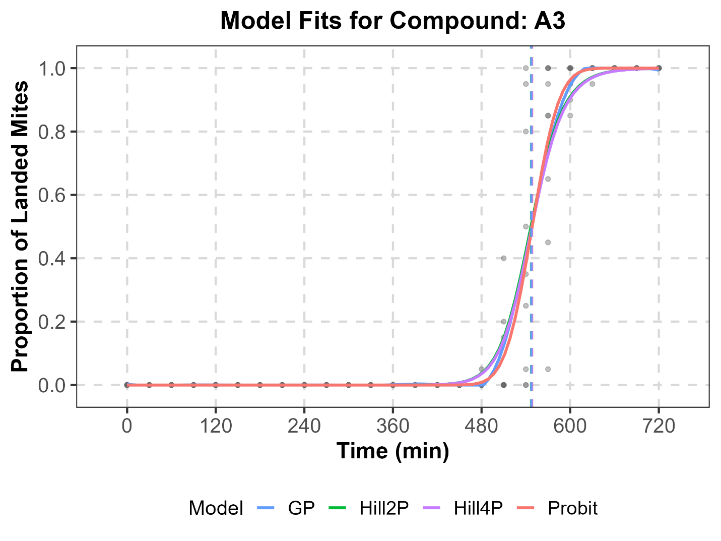
Supplementary Fig. S23. Comparison of simulated time-dependent landing data for T. urticae exposed to A3 (points) with fitted trajectories from Probit, Hill2P, Hill4P, and GP models.

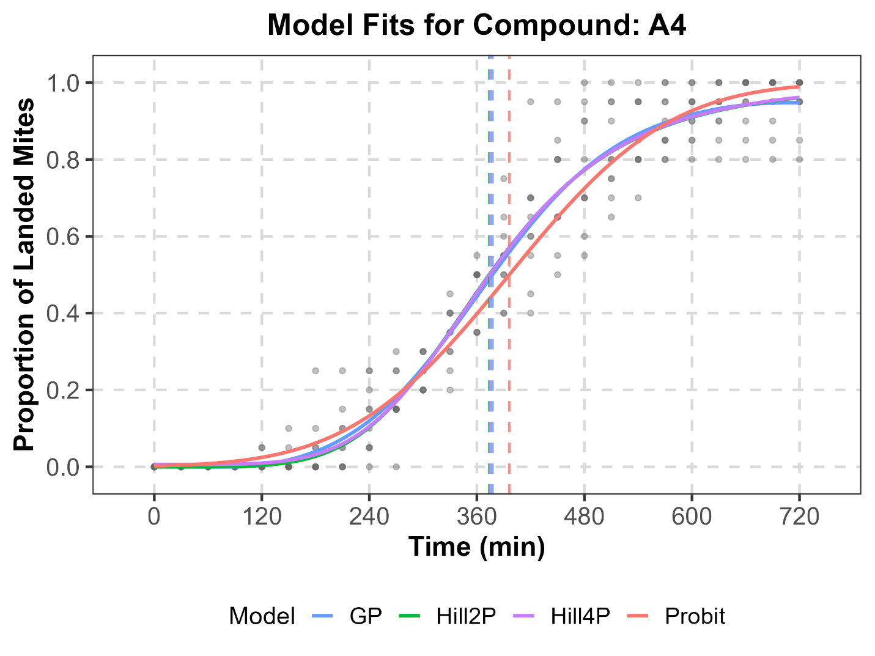
Supplementary Fig. S24. Comparison of simulated time-dependent landing data for T. urticae exposed to A4 (points) with fitted trajectories from Probit, Hill2P, Hill4P, and GP models.

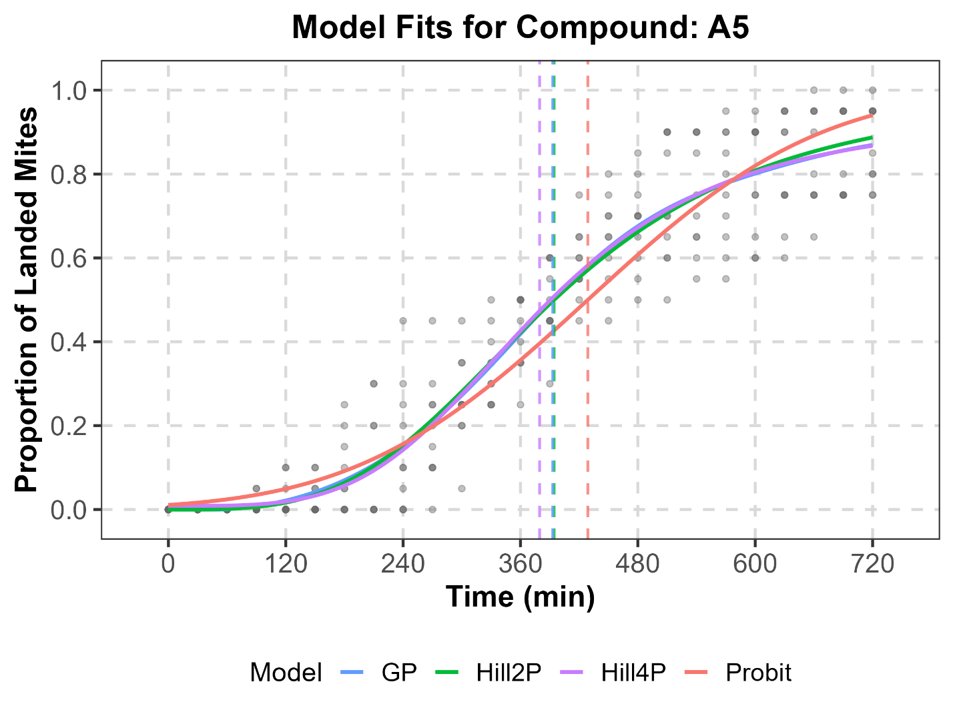
Supplementary Fig. S25. Comparison of simulated time-dependent landing data for T. urticae exposed to A5 (points) with fitted trajectories from Probit, Hill2P, Hill4P, and GP models.

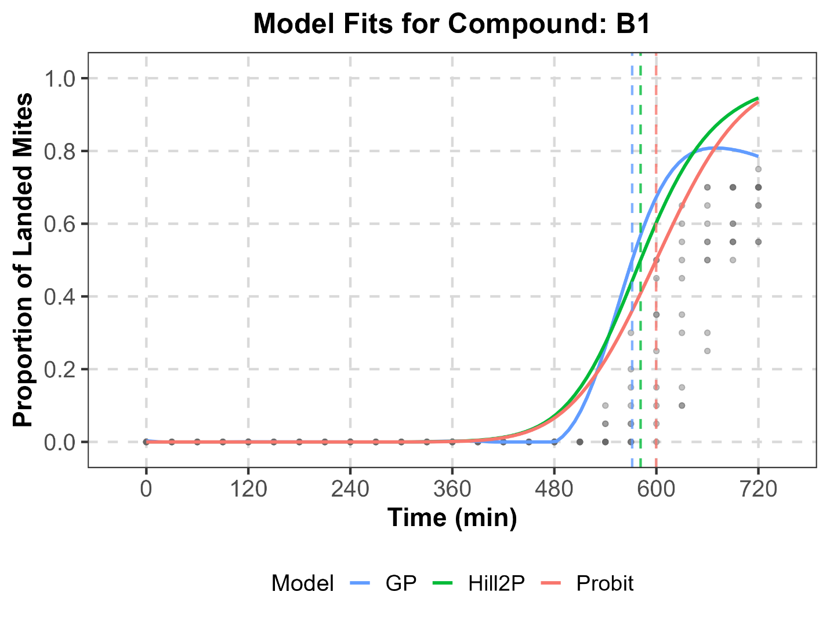
Supplementary Fig. S26. Comparison of simulated time-dependent landing data for T. urticae exposed to B1 (points) with fitted trajectories from Probit, Hill2P, Hill4P (not converged), and GP models.

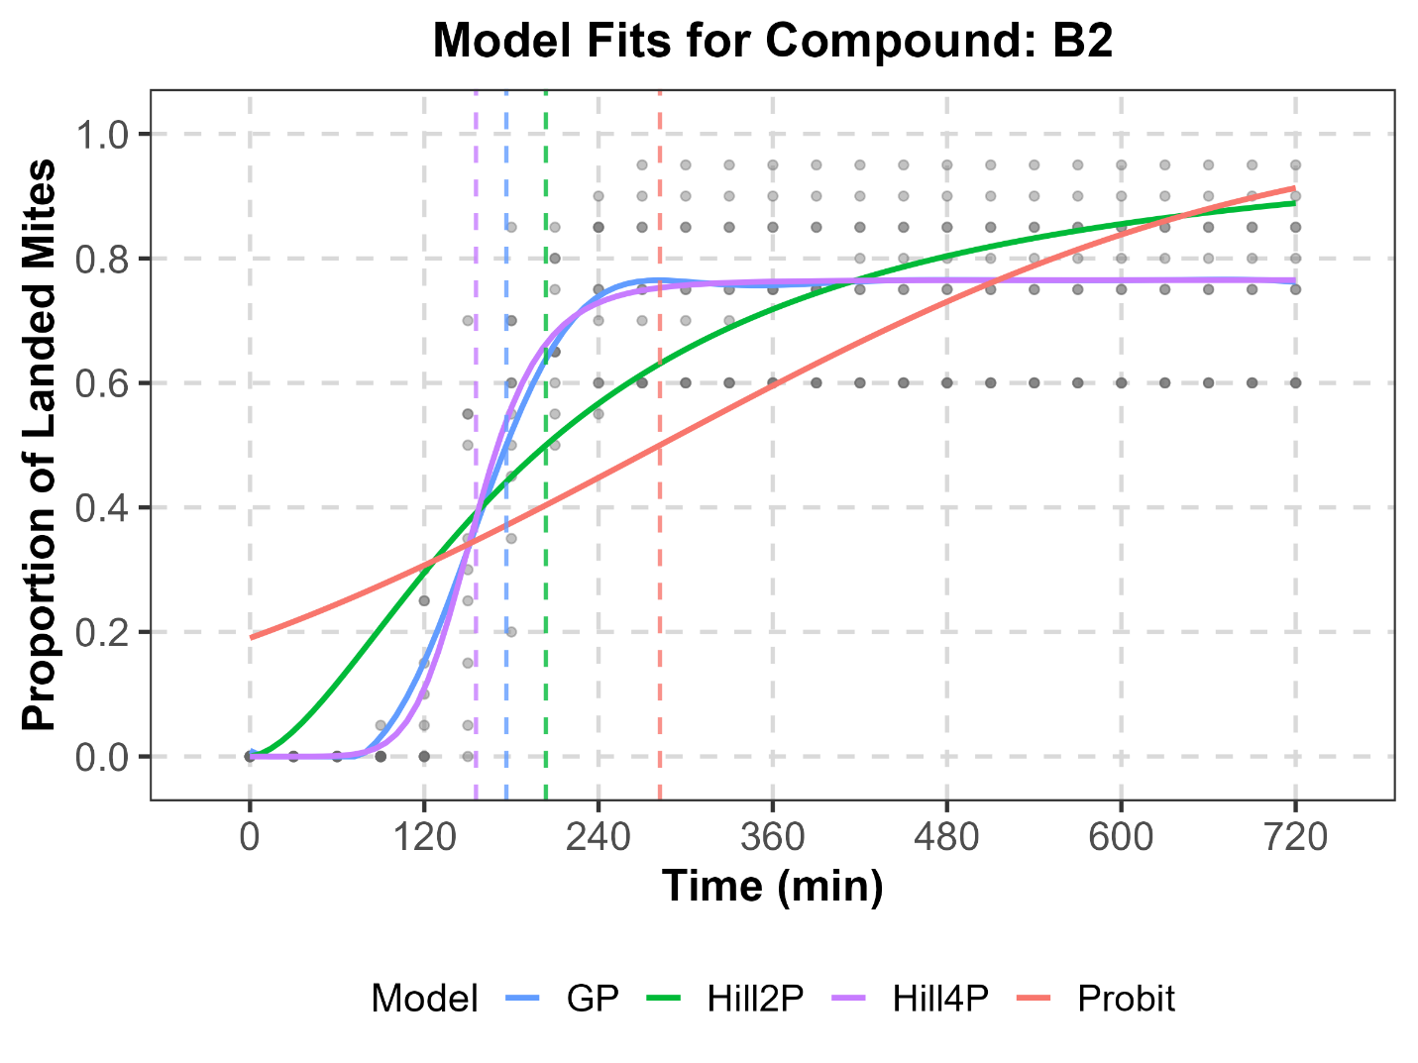
Supplementary Fig. S27. Comparison of simulated time-dependent landing data for T. urticae exposed to B2 (points) with fitted trajectories from Probit, Hill2P, Hill4P, and GP models.

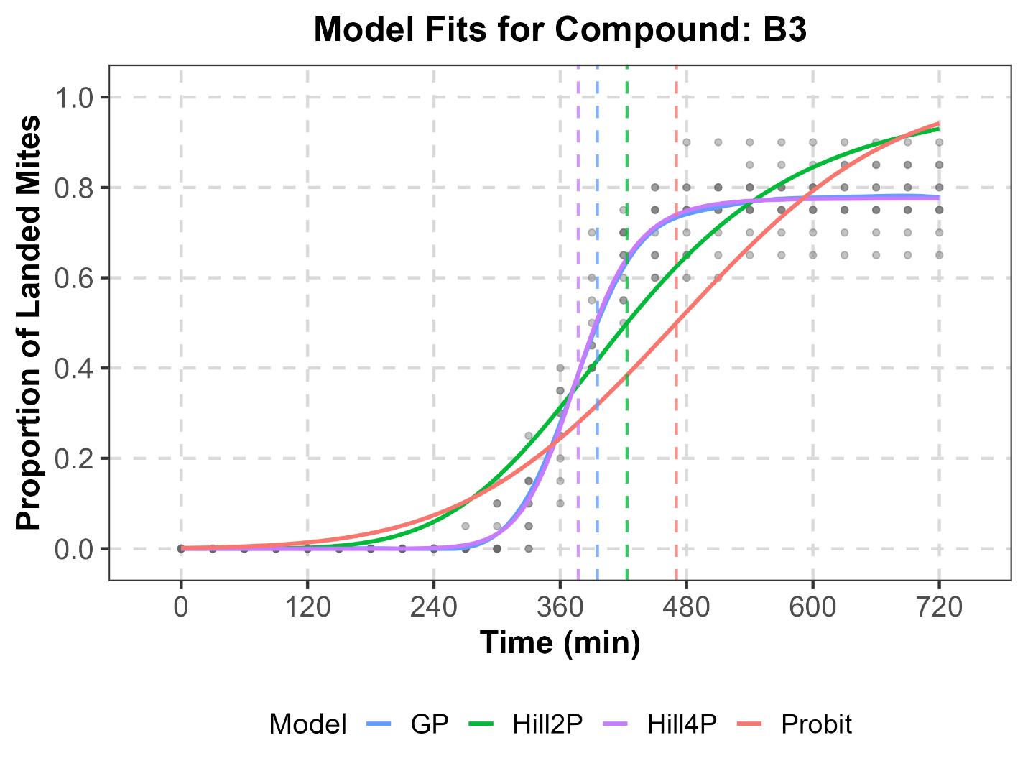
Supplementary Fig. S28. Comparison of simulated time-dependent landing data for T. urticae exposed to B3 (points) with fitted trajectories from Probit, Hill2P, Hill4P, and GP models.

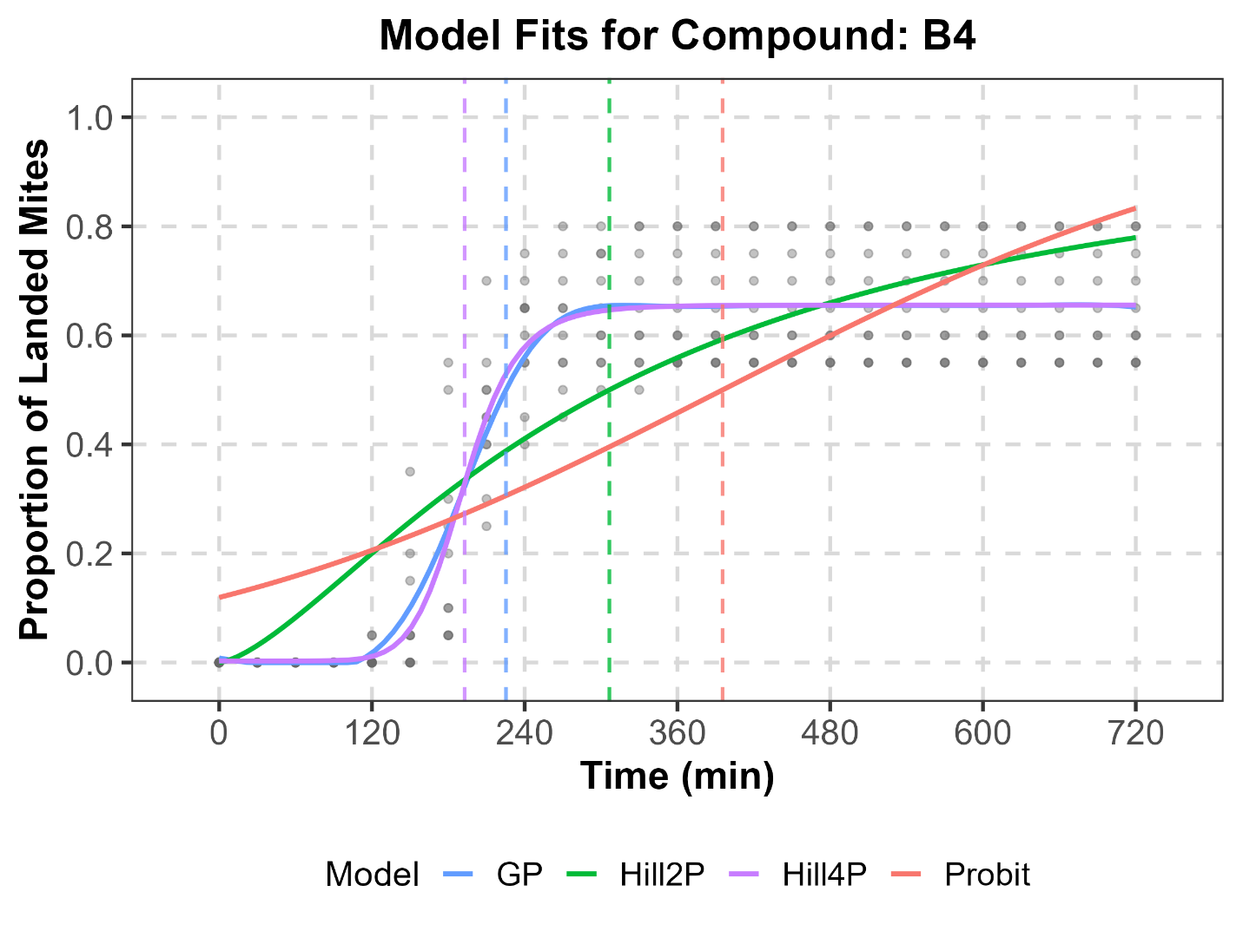
Supplementary Fig. S29. Comparison of simulated time-dependent landing data for T. urticae exposed to B4 (points) with fitted trajectories from Probit, Hill2P, Hill4P, and GP models.

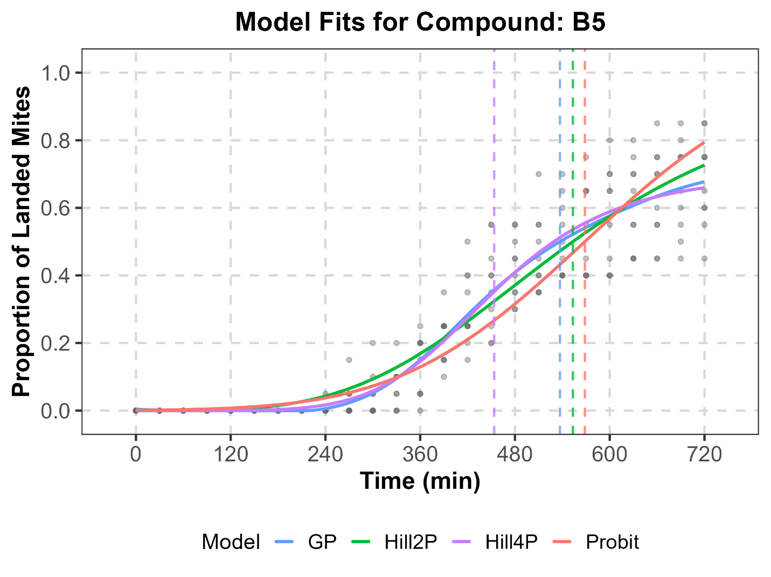
Supplementary Fig. S30. Comparison of simulated time-dependent landing data for T. urticae exposed to B5 (points) with fitted trajectories from Probit, Hill2P, Hill4P, and GP models.

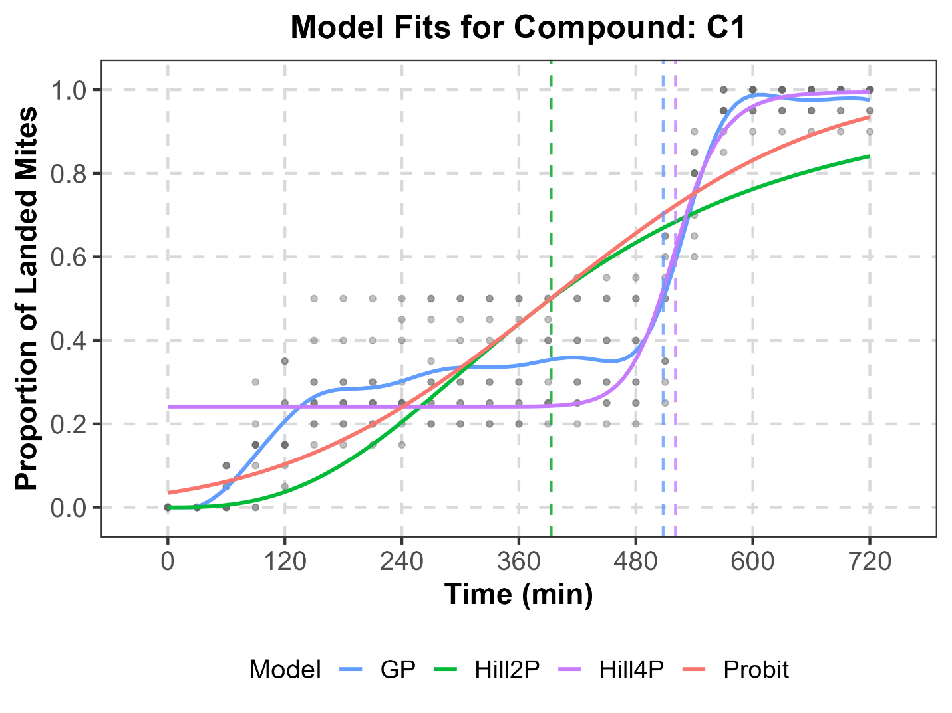
Supplementary Fig. S31. Comparison of simulated time-dependent landing data for T. urticae exposed to C1 (points) with fitted trajectories from Probit, Hill2P, Hill4P, and GP models.
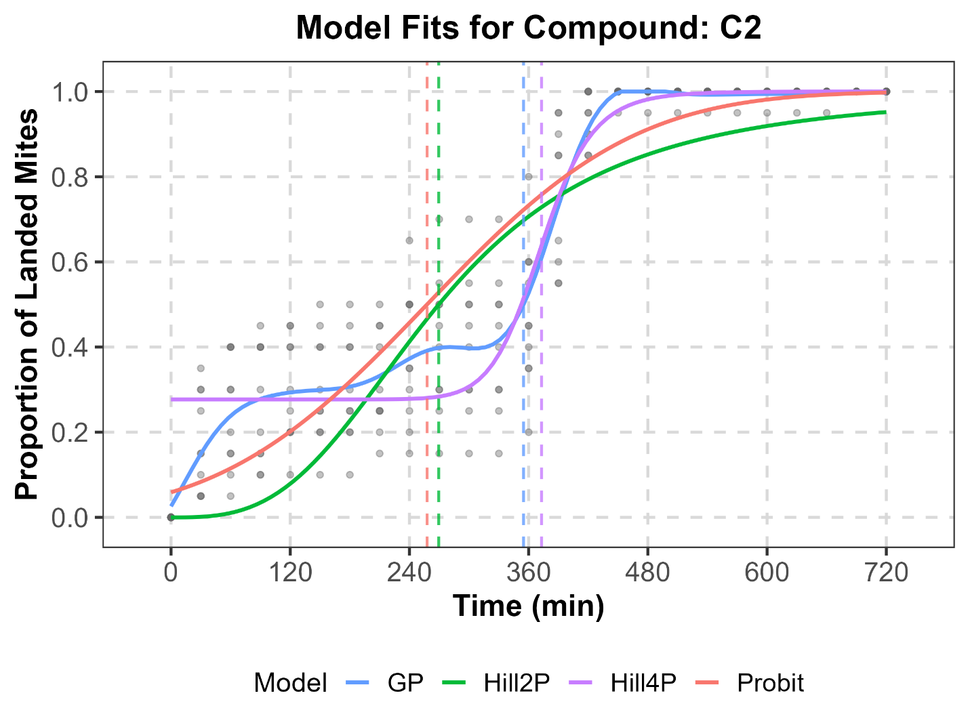
Supplementary Fig. S32. Comparison of simulated time-dependent landing data for T. urticae exposed to C2 (points) with fitted trajectories from Probit, Hill2P, Hill4P, and GP models.
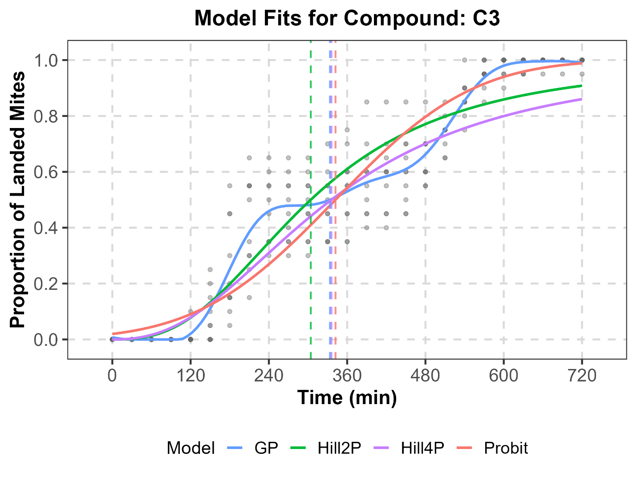
Supplementary Fig. S33. Comparison of simulated time-dependent landing data for T. urticae exposed to C3 (points) with fitted trajectories from Probit, Hill2P, Hill4P, and GP models.
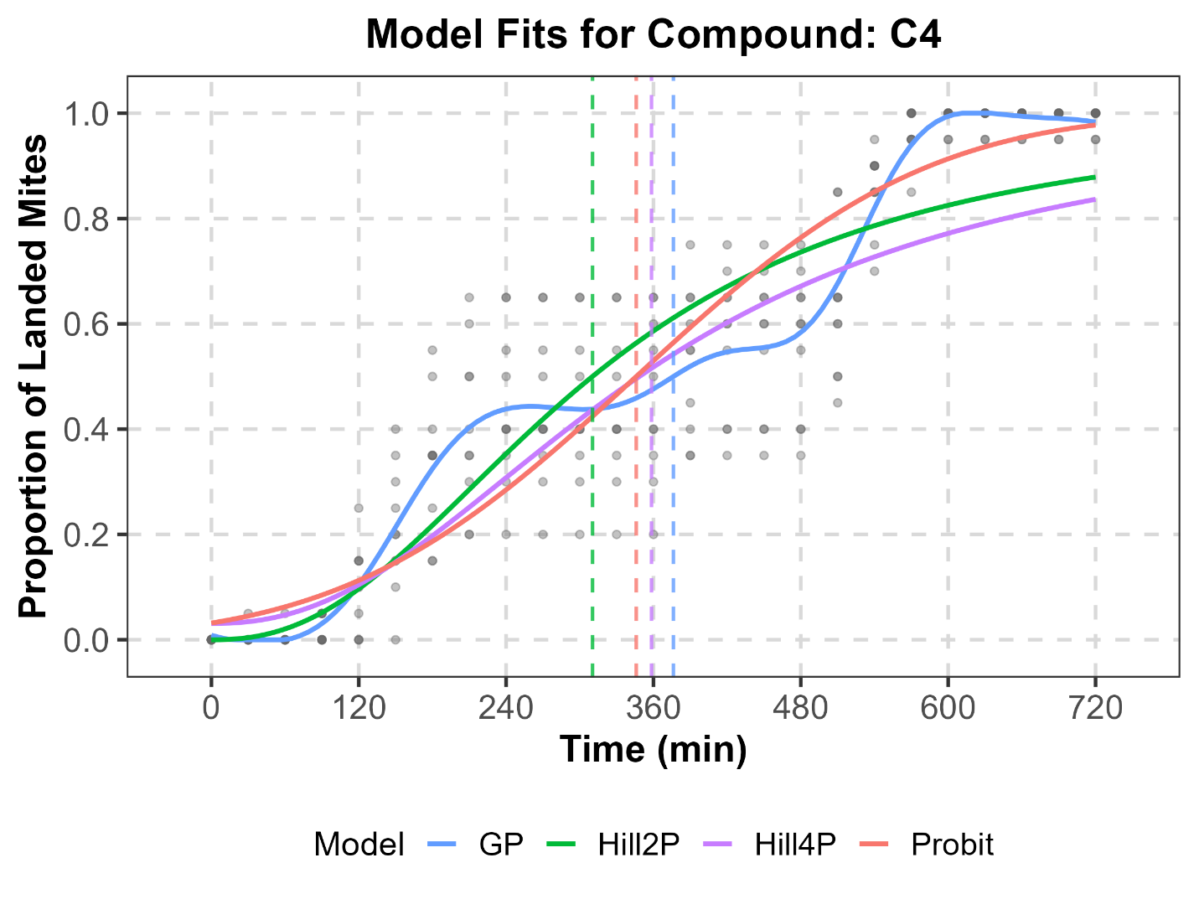
Supplementary Fig. S34. Comparison of simulated time-dependent landing data for T. urticae exposed to C4 (points) with fitted trajectories from Probit, Hill2P, Hill4P, and GP models.
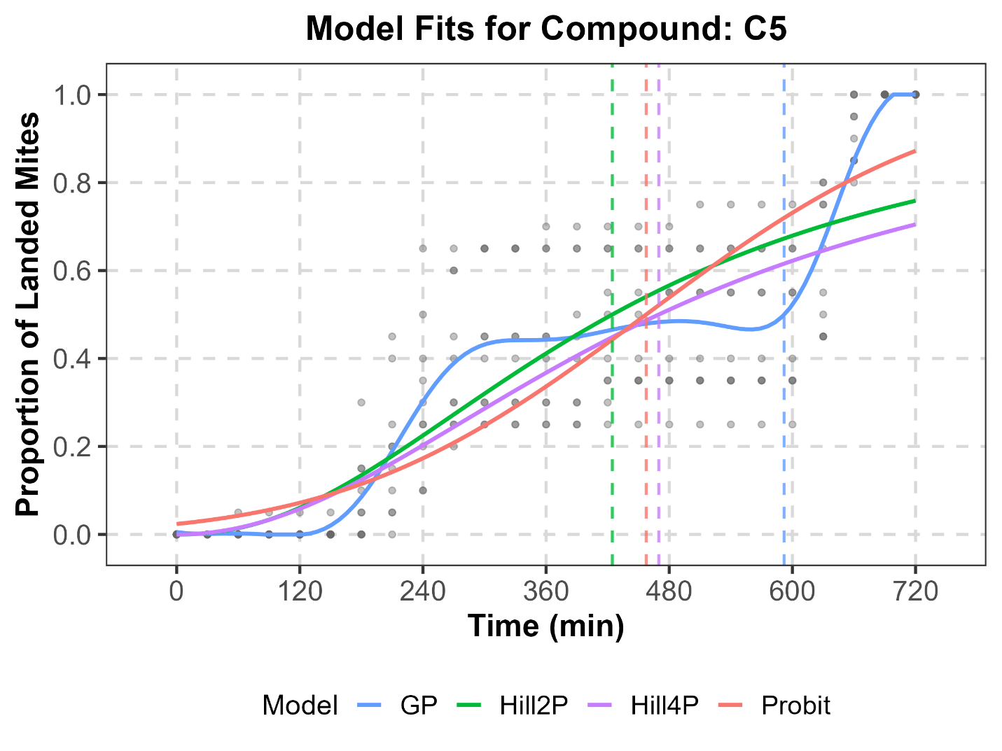
Supplementary Fig. S35. Comparison of simulated time-dependent landing data for T. urticae exposed to C5 (points) with fitted trajectories from Probit, Hill2P, Hill4P, and GP models.

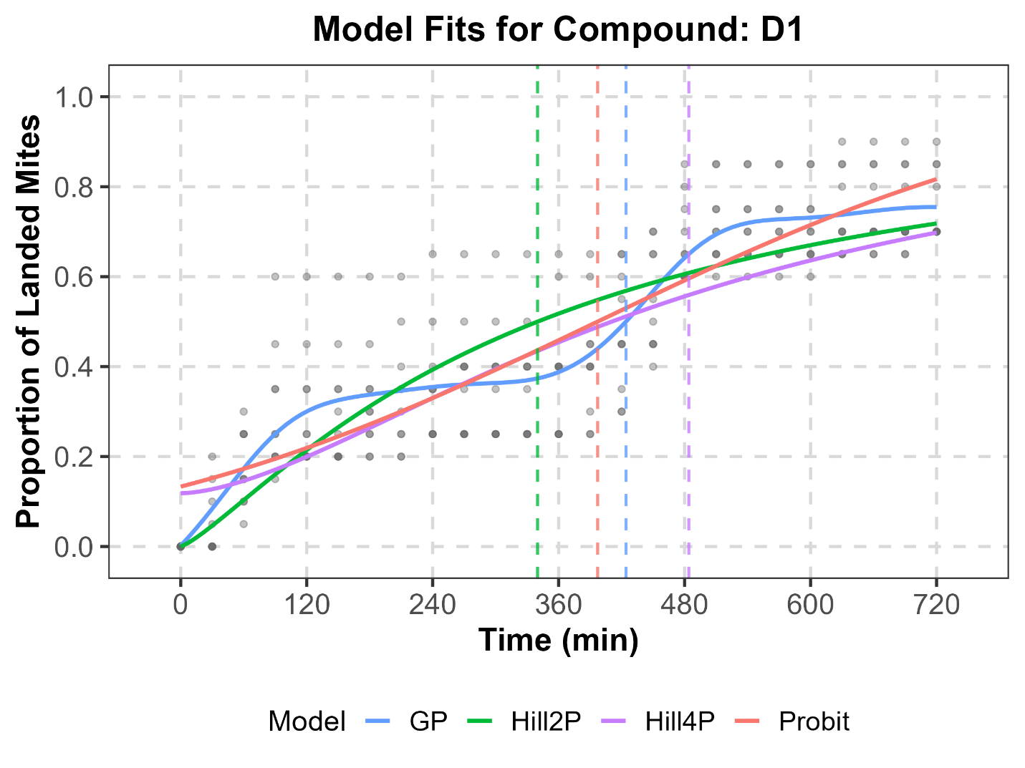
Supplementary Fig. S36. Comparison of simulated time-dependent landing data for T. urticae exposed to D1 (points) with fitted trajectories from Probit, Hill2P, Hill4P, and GP models.
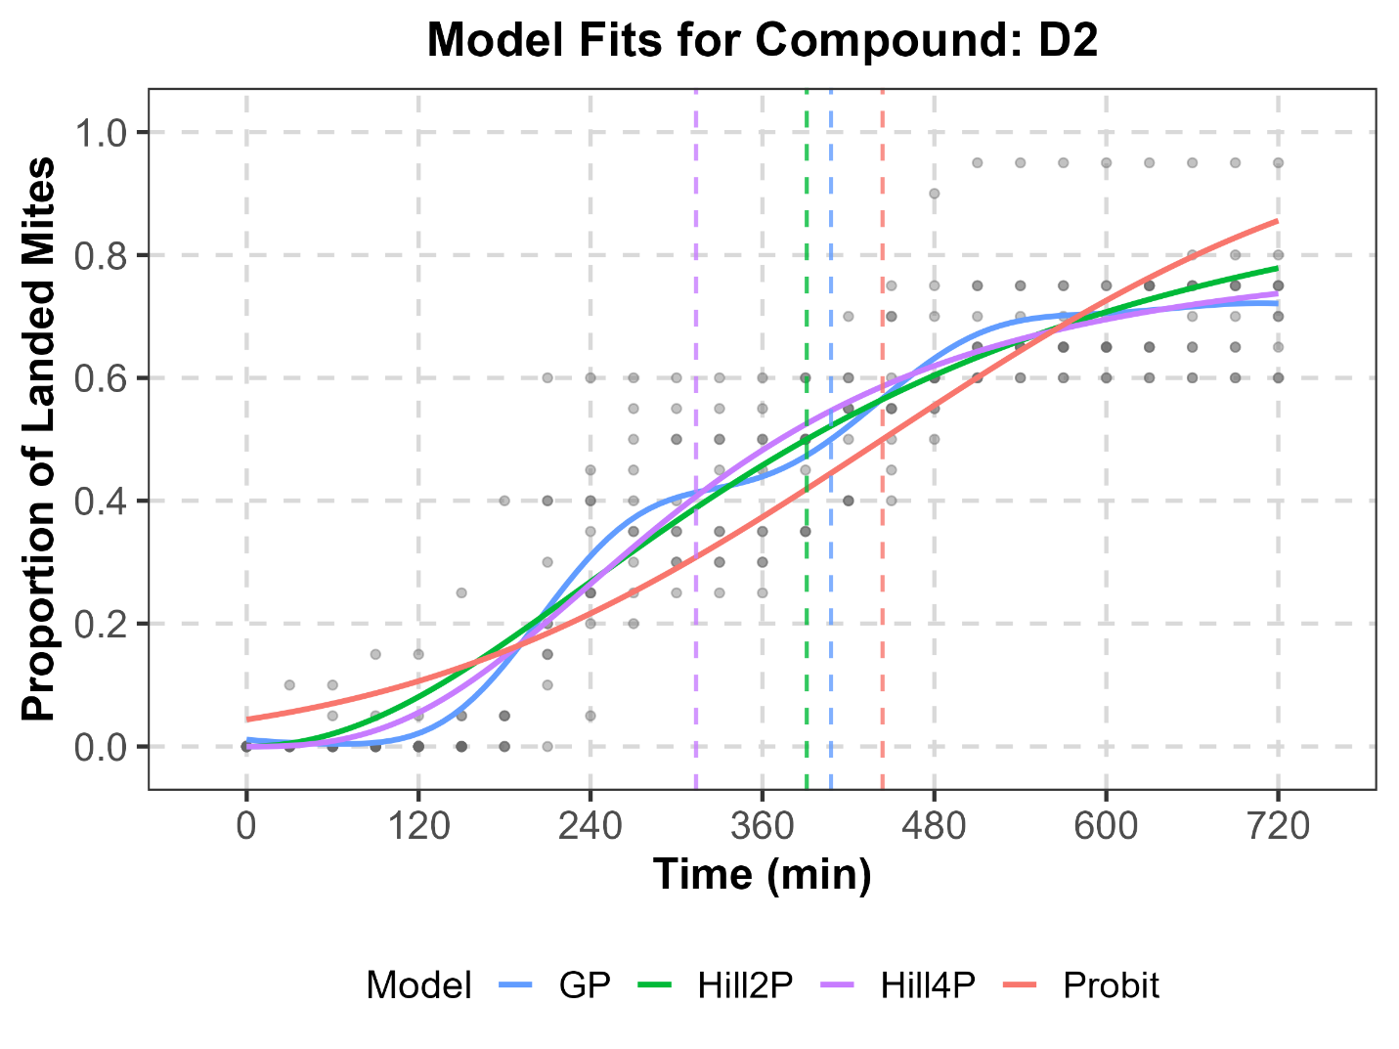
Supplementary Fig. S37. Comparison of simulated time-dependent landing data for T. urticae exposed to D2 (points) with fitted trajectories from Probit, Hill2P, Hill4P, and GP models.
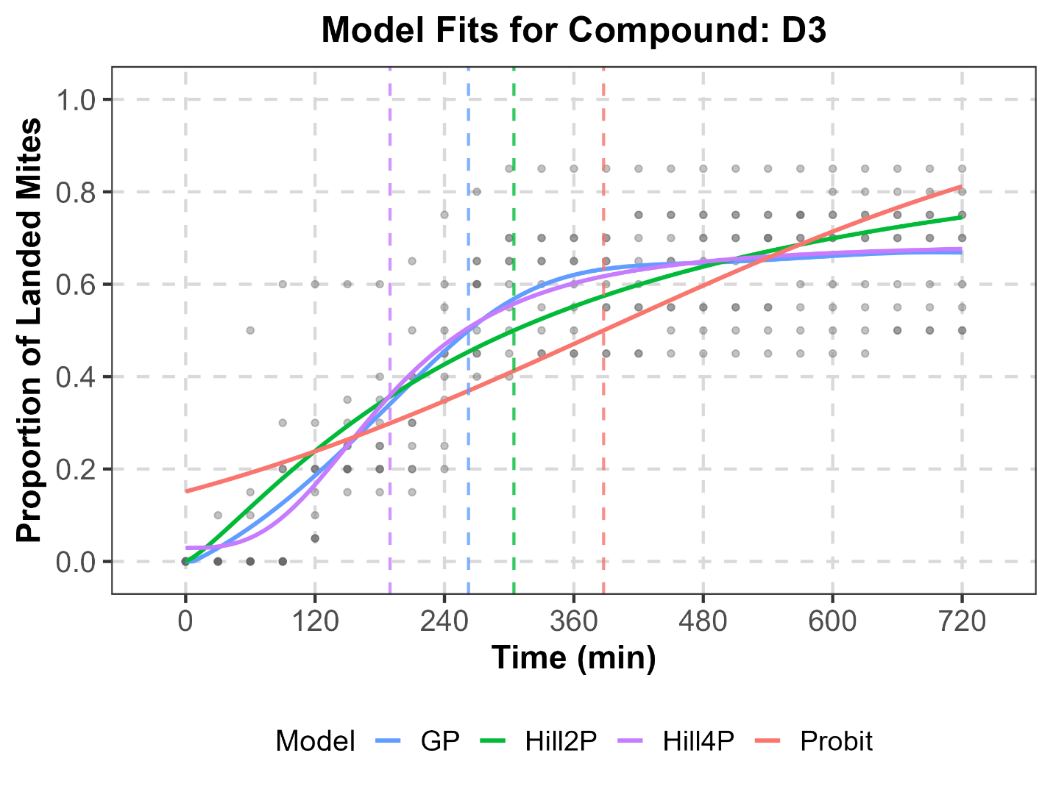
Supplementary Fig. S38. Comparison of simulated time-dependent landing data for T. urticae exposed to D3 (points) with fitted trajectories from Probit, Hill2P, Hill4P, and GP models.
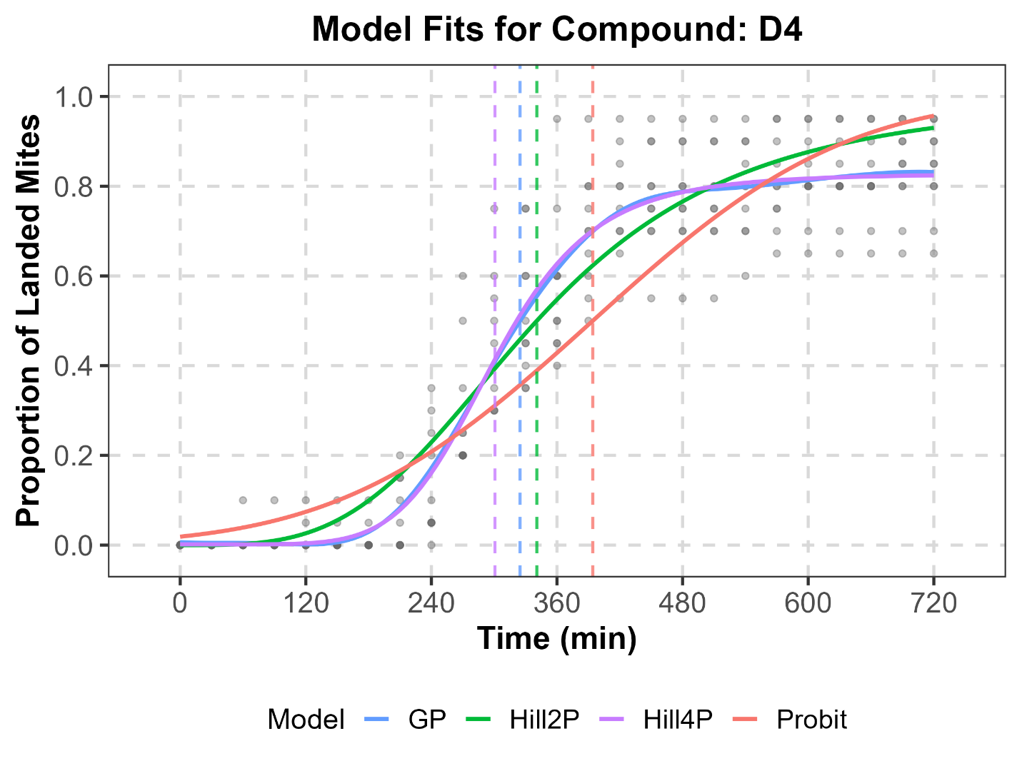
Supplementary Fig. S39. Comparison of simulated time-dependent landing data for T. urticae exposed to D4 (points) with fitted trajectories from Probit, Hill2P, Hill4P, and GP models.
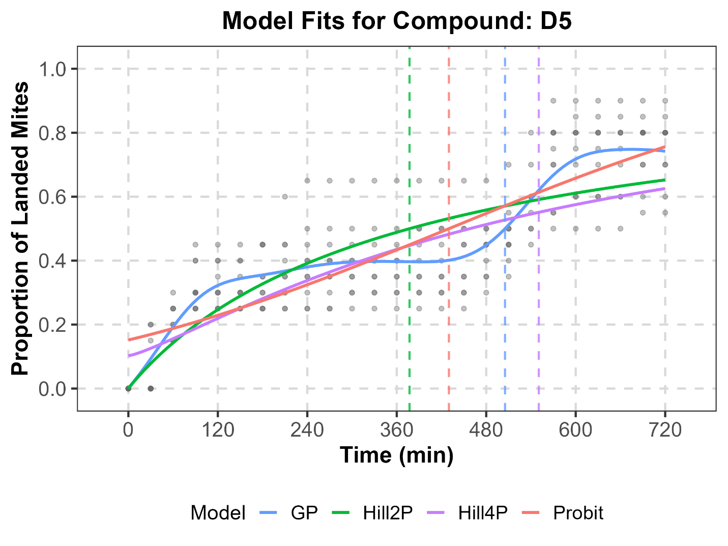
Supplementary Fig. S40. Comparison of simulated time-dependent landing data for T. urticae exposed to D5 (points) with fitted trajectories from Probit, Hill2P, Hill4P, and GP models.

Supplementary Table S2. Fit statistics, estimated ET₅₀, and estimated AUC of synthetic data
Compound | Model | RMSE | MAE | R² | ET₅₀  (min, 95% CI) | AUC  (min, 95% CI)
A1 | Probit | 0.092 | 0.063 | 0.937 | 214.873 (206.016 - 223.057) | 501.589 (479.962 - 501.628)
A1 | Hill2P | 0.069 | 0.049 | 0.964 | 184.404 (176.889 - 192.061) | 506.103 (484.754 - 506.32)
A1 | Hill4P | 0.069 | 0.049 | 0.964 | 186.041 (176.508 - 194.209) | 504.614 (483.251 - 504.858)
A1 | GP | 0.069 | 0.049 | 0.964 | 187.769 (177.226 - 198.37) | 507.92 (486.52 - 508.135)
A2 | Probit | 0.128 | 0.086 | 0.909 | 317.897 (305.712 - 329.857) | 401.948 (380.301 - 402.047)
A2 | Hill2P | 0.116 | 0.073 | 0.925 | 290.925 (280.452 - 306.314) | 411.267 (389.89 - 411.46)
A2 | Hill4P | 0.116 | 0.073 | 0.925 | 288.28 (273.57 - 302.405) | 408.792 (387.689 - 409.003)
A2 | GP | 0.116 | 0.073 | 0.925 | 291.494 (276.894 - 305.17) | 408.552 (387.344 - 408.729)
A3 | Probit | 0.097 | 0.028 | 0.946 | 548.535 (538.777 - 557.931) | 171.472 (149.658 - 172.327)
A3 | Hill2P | 0.099 | 0.033 | 0.945 | 546.871 (534.431 - 558.581) | 171.718 (150.118 - 172.386)
A3 | Hill4P | 0.099 | 0.033 | 0.945 | 548.134 (537.093 - 558.672) | 170.464 (148.558 - 171.109)
A3 | GP | 0.097 | 0.029 | 0.946 | 547.317 (531.325 - 559.26) | 172.107 (143.98 - 172.852)
A4 | Probit | 0.086 | 0.061 | 0.952 | 396.198 (389.402 - 404.939) | 324.207 (302.734 - 324.29)
A4 | Hill2P | 0.080 | 0.056 | 0.958 | 373.772 (366.095 - 381.961) | 326.545 (305.891 - 326.698)
A4 | Hill4P | 0.080 | 0.057 | 0.958 | 375.209 (362.636 - 390.934) | 327.889 (307.121 - 328.015)
A4 | GP | 0.080 | 0.057 | 0.958 | 377.437 (367.883 - 385.769) | 328.296 (307.823 - 328.406)
A5 | Probit | 0.108 | 0.085 | 0.901 | 428.833 (418.849 - 440.182) | 295.286 (275.112 - 295.341)
A5 | Hill2P | 0.099 | 0.076 | 0.918 | 394.394 (385.08 - 403.598) | 300.303 (281.261 - 300.397)
A5 | Hill4P | 0.098 | 0.077 | 0.918 | 379.533 (362.534 - 410.174) | 299.884 (281.2 - 299.962)
A5 | GP | 0.098 | 0.076 | 0.919 | 392.826 (382.224 - 404.754) | 299.988 (281.295 - 300.071)
B1 | Probit | 0.125 | 0.061 | 0.856 | 599.703 (588.405 - 613.444) | 122.539 (102.765 - 122.77)
B1 | Hill2P | 0.117 | 0.058 | 0.877 | 581.374 (567.786 - 595.748) | 136.494 (109.791 - 136.754)
B1 | Hill4P | NA | NA | NA | NA | NA
B1 | GP | 0.105 | 0.043 | 0.899 | 571.497 (555.365 - 589.047) | 128.877 (111.595 - 129.201)
B2 | Probit | 0.210 | 0.178 | 0.570 | 282.264 (247.035 - 307.48) | 416.907 (395.894 - 416.912)
B2 | Hill2P | 0.159 | 0.127 | 0.757 | 203.733 (187.007 - 222.801) | 442.745 (423.503 - 442.818)
B2 | Hill4P | 0.120 | 0.093 | 0.858 | 155.67 (145.796 - 168.677) | 427.577 (410.927 - 428.09)
B2 | GP | 0.121 | 0.094 | 0.857 | 176.532 (163.466 - 186.07) | 428.077 (411.523 - 428.479)
B3 | Probit | 0.131 | 0.094 | 0.870 | 470.228 (457.511 - 483.371) | 253.683 (233.532 - 253.765)
B3 | Hill2P | 0.101 | 0.071 | 0.928 | 423.426 (415.957 - 433.051) | 279.253 (259.273 - 279.376)
B3 | Hill4P | 0.059 | 0.038 | 0.974 | 377.076 (371.307 - 382.706) | 263.442 (246.651 - 263.73)
B3 | GP | 0.059 | 0.038 | 0.974 | 395.269 (387.81 - 401.745) | 263.36 (246.474 - 263.738)
B4 | Probit | 0.184 | 0.158 | 0.594 | 395.492 (373.43 - 420.626) | 334.601 (316.787 - 334.624)
B4 | Hill2P | 0.142 | 0.116 | 0.761 | 306.533 (286.862 - 326.553) | 354.315 (337.475 - 354.356)
B4 | Hill4P | 0.094 | 0.073 | 0.894 | 192.903 (184.063 - 202.461) | 343.672 (329.295 - 344.093)
B4 | GP | 0.094 | 0.074 | 0.893 | 225.311 (214.136 - 235.52) | 344.213 (330.067 - 344.58)
B5 | Probit | 0.100 | 0.067 | 0.865 | 568.514 (555.456 - 581.011) | 172.81 (156.047 - 172.901)
B5 | Hill2P | 0.090 | 0.064 | 0.891 | 553.311 (539.29 - 571.732) | 181.673 (166.248 - 181.746)
B5 | Hill4P | 0.086 | 0.059 | 0.900 | 453.749 (428.636 - 496.639) | 178.512 (164.326 - 178.601)
B5 | GP | 0.085 | 0.058 | 0.901 | 536.904 (509.935 - 573.081) | 177.215 (162.671 - 177.325)
C1 | Probit | 0.155 | 0.120 | 0.793 | 392.758 (376.81 - 408.085) | 330.422 (309.836 - 330.466)
C1 | Hill2P | 0.176 | 0.144 | 0.743 | 393.09 (370.521 - 422.182) | 299.077 (281.033 - 299.156)
C1 | Hill4P | 0.134 | 0.100 | 0.843 | 520.575 (503.947 - 528.675) | 322.569 (301.13 - 322.852)
C1 | GP | 0.089 | 0.069 | 0.930 | 507.999 (497.499 - 517.6) | 326.524 (305.424 - 327.113)
C2 | Probit | 0.146 | 0.103 | 0.835 | 257.728 (245.285 - 272.783) | 458.233 (436.239 - 458.27)
C2 | Hill2P | 0.172 | 0.137 | 0.803 | 269.516 (239.575 - 295.606) | 413.175 (392.643 - 413.317)
C2 | Hill4P | 0.125 | 0.084 | 0.880 | 372.932 (346.16 - 384.122) | 448.245 (426.138 - 448.583)
C2 | GP | 0.101 | 0.069 | 0.921 | 354.816 (340.274 - 372.027) | 454.228 (431.986 - 454.463)
C3 | Probit | 0.124 | 0.090 | 0.885 | 342.118 (330.387 - 354.386) | 377.337 (348.975 - 377.396)
C3 | Hill2P | 0.123 | 0.096 | 0.888 | 304.178 (290.151 - 322.843) | 373.851 (354.285 - 373.953)
C3 | Hill4P | 0.134 | 0.106 | 0.897 | 335.9 (323.68 - 349.002) | 342.699 (324.168 - 342.788)
C3 | GP | 0.089 | 0.059 | 0.941 | 333.612 (249.624 - 377.187) | 379.047 (357.408 - 379.489)
C4 | Probit | 0.139 | 0.102 | 0.846 | 346.008 (333.881 - 360.513) | 373.24 (351.933 - 373.28)
C4 | Hill2P | 0.146 | 0.115 | 0.830 | 310.304 (292.275 - 327.759) | 363.939 (345.012 - 364.048)
C4 | Hill4P | 0.154 | 0.127 | 0.843 | 358.371 (330.434 - 385.628) | 336.322 (317.927 - 336.384)
C4 | GP | 0.101 | 0.072 | 0.917 | 376.263 (329.362 - 417.63) | 372.985 (351.583 - 373.348)
C5 | Probit | 0.172 | 0.132 | 0.712 | 457.524 (436.985 - 480.199) | 275.161 (256.55 - 275.206)
C5 | Hill2P | 0.169 | 0.131 | 0.721 | 424.549 (399.059 - 451.5) | 277.931 (261.584 - 277.997)
C5 | Hill4P | 0.174 | 0.134 | 0.725 | 469.824 (437.559 - 499.949) | 252.976 (237.896 - 253.031)
C5 | GP | 0.125 | 0.092 | 0.848 | 591.929 (331.423 - 615.649) | 273.725 (252.085 - 274.21)
D1 | Probit | 0.123 | 0.098 | 0.755 | 397.136 (380.557 - 412.051) | 334.553 (316.113 - 334.57)
D1 | Hill2P | 0.130 | 0.098 | 0.729 | 339.954 (319.818 - 363.363) | 332.52 (317.044 - 332.537)
D1 | Hill4P | 0.133 | 0.104 | 0.746 | 484.031 (417.448 - 537.093) | 309.755 (294.777 - 309.785)
D1 | GP | 0.107 | 0.085 | 0.815 | 424.086 (407.089 - 439.924) | 338.178 (321.788 - 338.24)
D2 | Probit | 0.127 | 0.101 | 0.809 | 443.817 (429.006 - 459.562) | 290.722 (272.111 - 290.758)
D2 | Hill2P | 0.108 | 0.081 | 0.862 | 390.842 (376.912 - 406.269) | 300.312 (283.612 - 300.389)
D2 | Hill4P | 0.106 | 0.077 | 0.867 | 313.66 (283.179 - 360.001) | 297.898 (282.014 - 298.003)
D2 | GP | 0.101 | 0.075 | 0.879 | 407.806 (383.875 - 427.09) | 296.804 (280.945 - 296.982)
D3 | Probit | 0.166 | 0.136 | 0.605 | 387.549 (363.924 - 406.741) | 341.784 (323.326 - 341.798)
D3 | Hill2P | 0.137 | 0.108 | 0.732 | 304.344 (283.508 - 326.058) | 352.872 (336.791 - 352.891)
D3 | Hill4P | 0.129 | 0.103 | 0.761 | 189.441 (169.036 - 359.989) | 348.512 (333.654 - 348.606)
D3 | GP | 0.128 | 0.102 | 0.766 | 262.287 (236.164 - 281.192) | 349.294 (334.724 - 349.374)
D4 | Probit | 0.144 | 0.109 | 0.844 | 394.16 (382.511 - 409.896) | 327.859 (307.189 - 327.907)
D4 | Hill2P | 0.114 | 0.084 | 0.904 | 340.725 (329.456 - 351.759) | 348.848 (328.835 - 348.968)
D4 | Hill4P | 0.099 | 0.072 | 0.926 | 300.775 (291.415 - 314.385) | 337.264 (319.464 - 337.466)
D4 | GP | 0.099 | 0.071 | 0.926 | 324.712 (305.471 - 338.154) | 337.078 (318.986 - 337.256)
D5 | Probit | 0.125 | 0.104 | 0.691 | 429.919 (411.215 - 450.739) | 317.435 (300.181 - 317.449)
D5 | Hill2P | 0.131 | 0.107 | 0.660 | 377.153 (346.053 - 413.513) | 317.782 (303.197 - 317.753)
D5 | Hill4P | 0.135 | 0.110 | 0.673 | 550.545 (420.009 - 631.417) | 293.758 (280.326 - 293.769)
D5 | GP | 0.102 | 0.081 | 0.794 | 505.202 (491.417 - 522.753) | 320.106 (303.833 - 320.157)

