Sample Collection and Processing
Approximately 8mls of whole blood was collected in Roche ccfDNA tubes or PAXgene blood ccfDNA tubes. Plasma was separated by centrifugation at 1600g for a duration of 15 minutes continuously, followed by a second centrifugation of the separated plasma at 4500g for 15 minutes. Separated plasma was stored in 1.5ml Eppendorf tubes at –80°C.
Extraction and Quantification of cfDNA
cfDNA was extracted from plasma using the QIAamp Circulating Nucleic Acid Kit (Qiagen, Cat no – 51304, 51306) according to the manufacturers instruction. Briefly, it involved four main steps; first, samples are lysed to inactivate DNases and RNases and allow complete release of nucleic acids from bound proteins, lipids and vesicles. Second, the lysates are transferred onto a QIAamp Mini column, and circulating nucleic acids are adsorbed from a large volume onto the small silica membrane as the lysate is drawn through by vacuum pressure. Third, while the nucleic acids remain bound to the membrane, contaminants are washed away in a 3 step wash process. The final step involves elution of highly purified nucleic acid. The quantification of cfDNA was done by Qubit fluorimeter 3.0 using the qubit high-sensitivity assay (Thermo Fisher Scientific, Walthan, MA, USA)
Library Preparation and targeted sequencing
Libraries were constructed using 50ng (in 30ul) of extracted cfDNA using the ThruPLEX Tag-Seq HV kit according to the manufacturer’s protocol. The process involved addition of unique ThruPLEX HV Unique Dual indexed (UDI) PCR primers to aid with sample tracking. Seven cycles were performed to ensure a yield of >500ng depending on the concentration of the input DNA. This was followed by a purification step through magnetic separation using AMPure XP beads (Beckman coulter, CA USA). The final library was quantified and validated using the Qubit HS kit and the Bio-analyser High Sensitivity DNA kit, according to manufacturer’s instructions. Library hybridization and capture was done using the xGen hybridization capture kit according to the manufacturer’s instruction.
Panel Design and Verification
The procedure used a custom-made NGS panel targeting mutational hotspots in 17 EBL and HL-related genes (MYC, IGH, IGK, IGL, ID3, TP53, TNFAIP3, NFKBIE, SOCS1, EP300, BTK, STAT6, CSF2RB, ITPBK, XPO1, B2M) selected based on results from previous studies, and EBV genes expressed in latently infected cells; EBER1, EBER2 and EBNA2. The final panel manufactured by Integrated DNA Technologies (IDT) consisted of 731 probes at a size of 148 kilo-bases to permit for compatibility with either the iSeq100 or MiSeq sequencing platforms. The final panel design with the genomic coordinates of our genes of interest is listed in Table I. Sequencing was conducted on the MiSeq platform using the MiSeq reagent kit v2 (300 cycles) at a loading concentration of 10 pM, with 6 samples per run.
Table 1: Genomic Targets for EBVL Next Generation Sequencing Panel
Genome | Reference | Ref. | Transcript | Target (exons) | Chr | Start | Stop | Comments
EBV | EBV-WT | EBER1 | NC_007605.1 |  |  | 6,629 | 6,795 | 100% identical to EBV type 2 EBER1, for EBV detection
EBV | EBV-WT | EBER2 | NC_007605.1 |  |  | 6,956 | 7,128 | 100% identical to EBV type 2 EBER2, for EBV detection
EBV | EBV-WT | EBNA2 | YP_401644.1_10 |  |  | 659 | 790 | Specific to EBV Type 1. For EBV strain identification
Human | hg19 | 5' MYC |  |  | 8 | 128,746,246 | 128,747,679 | Class 2 breakpoints, covers 20 breakpoints from study referenced
Human | hg19 | MYC | NM_002467.5 | 1 | 8 | 128,747,680 | 128,748,869 | Class 1/2 breakpoints, typically seen in eBL
Human | hg19 | MYC | NM_002467.5 |  | 8 | 128,748,870 | 128,750,493 | Class 1 breakpoints
Human | hg19 | MYC | NM_002467.5 | 2 | 8 | 128,750,494 | 128,751,265 | Commonly mutated in BL. Included as 'safety net' encase translocations aren't captured
Human | hg19 | ITPKB | NM_002221.3 | 2 | 1 | 226,923,228 | 226,925,159
Human | hg19 | XPO1 | NM_003400 | 1-15 | 2 | 61,719,470 | 61,719,471 | c.1711-12 (p.E517) cHL hotspot, but also PMBL (1711) & CLL (1712)
Human | hg19 | TNFAIP3 | NM_001270508.1 | 1-9 | 6 | 138,188,581 | 138,204,449
Human | hg19 | NFKBIE | NM_004556.2 | 1-6 | 6 | 44,226,953 | 44,233,502
Human | hg19 | STAT6 | NM_001178078 | 11-18 | 12 | 57,492,575 | 57,498,369 | c.1249A>T and c.1255G>A hotspots, but common in PMBL
Human | hg19 | EP300 | NM_001429.3 | 24-29 | 22 | 41,564,453 | 41,569,788
Human | hg19 | BTK | NM_001287344 | 1-19 | X | 100,604,438 | 100,641,183
Human | hg19 | B2M | NM_004048.2 | 1-2 | 15 | 45,003,675 | 45,007,899 | Mutations frequent in splice donor/acceptor region of intron 1
Human | hg19 | SOCS1 | NM_003745 | 1-2 | 16 | 11,348,262 | 11,350,036
Human | hg19 | CSF2RB | NM_00395.3 | 6, 14 | 22 | 37,325,681 | 37,335,000
Human | hg19 | TP53 | NM_000546.5 | 4-8 | 17 | 7,577,019 | 7,579,590 | BL and HL
Human | hg19 | ID3 | NM_002167.4 | 1-3 | 1 | 23,884,409 | 23,886,285
Human | hg19 | IGHA2 | ENST00000390539.2 | 1-3 | 14 | 106,053,226 | 106,054,732 | IG C gene
Human | hg19 | IGHA2 |  |  | 14 | 106,056,222 | 106,056,838 | Sα region
Human | hg19 | IGHA2 |  |  | 14 | 106,057,056 | 106,057,601 | Sα region
Human | hg19 | IGHA1 | ENST00000390547.2 | 1-3 | 14 | 106,173,457 | 106,175,002 | IG C gene
Human | hg19 | IGHA1 |  |  | 14 | 106,177,009 | 106,177,963 | Sα region
Human | hg19 | IGHG1 | ENST00000390548.2 | 1-6 | 14 | 106,202,680 | 106,209,408 | IG C gene
Human | hg19 | IGHG1 |  |  | 14 | 106,210,947 | 106,211,836 | Sγ region. Contains 7 breakpoints from 2 publications
Human | hg19 | IGHG1 |  |  | 14 | 106,212,432 | 106,212,705 | Sγ region. Contains 4 breakpoints from 2 publications
Human | hg19 | IGHG3 |  |  | 14 | 106,213,054 | 106,213,828 | nc region. Contains 3 breakpoints from 2 publications
Human | hg19 | IGHG3 | ENST00000390551.2 | 1-7 | 14 | 106,235,439 | 106,237,742 | IG C gene
Human | hg19 | IGHG3 |  |  | 14 | 106,239,969 | 106,240,335 | Sγ region. Contains 6 breakpoints from 2 publications
Human | hg19 | IGHM | ENST00000390559.2 | 1-4 | 14 | 106,320,349 | 106,322,323 | IG C gene
Human | hg19 | IGHM |  |  | 14 | 106,324,109 | 106,324,904 | Sμ region. Contains 7 breakpoints from 2 publications
Human | hg19 | IGHM |  |  | 14 | 106,325,023 | 106,325,998 | Sμ region. Contains 12 breakpoints from 2 publications
Human | hg19 | IGHM |  |  | 14 | 106,326,019 | 106,326,648 | Sμ region. Contains 18 breakpoints from 2 publications
Human | hg19 | IGHM |  |  | 14 | 106,326,933 | 106,327,173 | Sμ region. Contains 3 breakpoints from 2 publications
Human | hg19 | IGJ |  |  | 14 | 106,328,547 | 106,329,405 | nc region. Contains 8 breakpoints from 2 publications
Human | hg19 | IGHJ6 | ENST00000390560.2 | 1 | 14 | 106,329,406 | 106,329,470 | IG J gene
Human | hg19 | IGHJ6-J5 |  |  | 14 | 106,329,469 | 106,330,023 | nc region. 11 breakpoints from 1 publication
Human | hg19 | IGHJ5 | ENST00000488476 | 1 | 14 | 106,330,024 | 106,330,072 | IG J gene
Human | hg19 | IGHJ5-J4 |  |  | 14 | 106,330,073 | 106,330,423 | nc region
Human | hg19 | IGHJ4 | ENST00000461719 | 1 | 14 | 106,330,424 | 106,330,470 | IG J gene
Human | hg19 | IGHJ3 | ENST00000463911 | 1 | 14 | 106,330,797 | 106,330,845 | IG J gene
Human | hg19 | IGHJ2 | ENST00000390564.2 | 1 | 14 | 106,331,409 | 106,331,460 | IG J gene
Human | hg19 | IGHJ1 | ENST00000390565.1 | 1 | 14 | 106,331,617 | 106,331,668 | IG J gene
Human | hg19 | IGHV1-2 | ENST00000390594.2 | 1-2 | 14 | 106,452,671 | 106,453,170 | IG V gene. Contains 3 breakpoints from 2 publications
Human | hg19 | IGHV1-3 | ENST00000390595.2 | 1-2 | 14 | 106,471,246 | 106,471,723
Human | hg19 | IGHV2-5 | ENST00000390597 | 1-2 | 14 | 106,494,135 | 106,494,597
Human | hg19 | IGHV3-7 | ENST00000390598 | 1-2 | 14 | 106,518,400 | 106,518,932
Human | hg19 | IGHV1-8 | ENST00000390599.2 | 1-2 | 14 | 106,539,079 | 106,539,577 | Associated predominantly with EBV-negative e/sBL
Human | hg19 | IGHV1-18 | ENST00000390605.2 | 1-2 | 14 | 106,641,563 | 106,642,056 | 3 breakpoint positions from 2 publications
Human | hg19 | IGHV3-21 | ENST00000390607.2 | 1-2 | 14 | 106,691,673 | 106,692,203 | Associated with EBV-positive e/sBL
Human | hg19 | IGHV3-23 | ENST00000390609 | 1-2 | 14 | 106,725,198 | 106,725,733 | 2 breakpoint positions from 2 publications, more prevalent in DLBCL than s/eBL
Human | hg19 | IGHV3-30 | ENST00000390613.2 | 1-2 | 14 | 106,791,005 | 106,791,536 | 1 breakpoint position from 2 publications
Human | hg19 | IGHV4-31 | ENST00000438142.2 | 1-2 | 14 | 106,805,209 | 106,805,716
Human | hg19 | IGHV3-33 | ENST00000390615.2 | 1-2 | 14 | 106,815,722 | 106,816,253
Human | hg19 | IGHV4-34 | ENST00000390616.2 | 1-2 | 14 | 106,829,594 | 106,830,076 | Equally prevalent in DLBCL
Human | hg19 | IGHV4-39 | ENST00000390619.2 | 1-2 | 14 | 106,877,619 | 106,878,126
Human | hg19 | IGHV1-46 | ENST00000390622.2 | 1-2 | 14 | 106,967,049 | 106,967,788 | 2 breakpoints from 2 publications
Human | hg19 | IGHV5-51 | ENST00000390626.2 | 1-2 | 14 | 107,034,729 | 107,035,221
Human | hg19 | IGHV4-59 | ENST00000455737.1 | 1-3 | 14 | 107,081,806 | 107,083,830
Human | hg19 | IGHV1-69 | ENST00000390633.2 | 1-2 | 14 | 107,169,931 | 107,170,428
Human | hg19 | IGHV2-70 | ENST00000390634.2 | 1-2 | 14 | 107,178,820 | 107,179,338
Human | hg19 | IGLJ1 | ENST00000390320 | 1 | 22 | 23,235,872 | 23,235,998
Human | hg19 | IGLJ2 | ENST00000390322.2 | 1 | 22 | 23,241,661 | 23,241,835
Human | hg19 | IGLJ3 | ENST00000390324.2 | 1 | 22 | 23,247,030 | 23,247,205
Human | hg19 | IGLJ4 | ENST00000390326.2 | 1 | 22 | 23,252,744 | 23,252,776
Human | hg19 | IGLJ5 | ENST00000390327.2 | 1 | 22 | 23,256,408 | 23,256,479
Human | hg19 | IGLJ6 | ENST00000390328 | 1 | 22 | 23,260,304 | 23,260,373
Human | hg19 | IGLV6-57 | ENST00000390285.3 | 1-2 | 22 | 22,550,113 | 22,550,860
Human | hg19 | IGLV1-51 | ENST00000390290.2 | 1-2 | 22 | 22,676,828 | 22,677,336
Human | hg19 | IGLV1-44 | ENST00000390297.2 | 1-2 | 22 | 22,735,135 | 22,735,715 | More frequent than that observed in DLBCL
Human | hg19 | IGLV1-40 | ENST00000390299.2 | 1-2 | 22 | 22,764,098 | 22,764,614
Human | hg19 | IGLV3-25 | ENST00000390305.2 | 1-2 | 22 | 23,029,190 | 23,029,735
Human | hg19 | IGLV2-14 | ENST00000390312.2 | 1-2 | 22 | 23,101,189 | 23,101,707
Human | hg19 | IGKJ1 | ENST00000390242 | 1 | 2 | 89,161,398 | 89,161,435
Human | hg19 | IGKJ2 | ENST00000390241.2 | 1 | 2 | 89,161,037 | 89,161,074
Human | hg19 | IGKJ3 | ENST00000390240 | 1 | 2 | 89,160,733 | 89,160,770
Human | hg19 | IGKJ4 | ENST00000390239.2 | 1 | 2 | 89,160,398 | 89,160,434
Human | hg19 | IGKJ5 | ENST00000390238 | 1 | 2 | 89,160,080 | 89,160,117
Human | hg19 | IGKC | ENST00000390237.2 | 1 | 2 | 89,156,674 | 89,157,196
Human | hg19 | IGKV4-1 | ENST00000390243.2 | 1-2 | 2 | 89,184,913 | 89,185,669
Human | hg19 | IGKV1-5 | ENST00000496168.1 | 1-2 | 2 | 89,246,819 | 89,247,475
Human | hg19 | IGKV3-20 | ENST00000492167.1 | 1-2 | 2 | 89,442,057 | 89,442,643
Human | hg19 | IGKV1-33 | ENST00000473726.1 | 1-2 | 2 | 89,567,758 | 89,568,263
Human | hg19 | IGKV1-37 | ENST00000465170.1 | 1-2 | 2 | 89,597,021 | 89,597,542
Human | hg19 | IGKV1-39 | ENST00000498574.1 | 1-2 | 2 | 89,619,383 | 89,619,904
Human | hg19 | IGKV1-27 | ENST00000498435 | 1-2 | 2 | 89,512,908 | 89,513,413
Human | hg19 | rs28372410 |  |  | 1 | 248,512,064 | 248,512,064 | unique human snps
Human | hg19 | rs4542826 |  |  | 2 | 33,413,949 | 33,413,949 | unique human snps
Human | hg19 | rs2717225 |  |  | 3 | 122,873,923 | 122,873,923 | unique human snps
Human | hg19 | rs2303808 |  |  | 5 | 39,074,296 | 39,074,296 | unique human snps
Human | hg19 | rs2286213 |  |  | 7 | 18,914,251 | 18,914,251 | unique human snps
Human | hg19 | rs7039358 |  |  | 9 | 90,401,638 | 90,401,638 | unique human snps
Human | hg19 | rs34084011 |  |  | 10 | 28,233,933 | 28,233,933 | unique human snps
Human | hg19 | rs7497712 |  |  | 15 | 100,821,647 | 100,821,647 | unique human snps
Human | hg19 | rs3816550 |  |  | 19 | 17,173,487 | 17,173,487 | unique human snps
Human | hg19 | rs723469 |  |  | 21 | 32,525,345 | 32,525,345 | unique human snps

Bio-informatics Analysis
The sequence data was analyzed and stored by a bespoke pipeline (courtesy of the Oxford Molecular Diagnostic Centre) in a HIPAA (Health Insurance Portability and Accountability Act of 1996) compliant, AWS (Amazon Web Services) cloud. Paired reads were combined and statistics generated on the total number of reads and invalid reads, using a custom tool (udini). The raw sequence data in FASTQ format was aligned to GRCh37 (hs37d5) with BWA-MEM2. Sorting was done using samtools. De-duplication of reads and generation of error rates and family sizes was done by a custom-made tool (elduderino). The de-duplicated FASQ was re-aligned to GRCh37 with BWA-MEM2 and fragment sizes calculated using read pairs by a custom script (available on request). Another custom script (available on request) was used to map the reads onto the genomic regions (targeted genes) of interest and calculate copies per cell for the EBV genes (mean depth of EBV gene/mean depth for all other targeted genes). The last base at the end of each read was trimmed using a custom tool (trim) and the trimmed SAM file converted into a BAM file and indexed. A custom script (available on request) was used to generate summary statistics for coverage for all targets at different coverage depths and for different genes. Custom scripts (available on request) were developed for variant calling using varscan, and annotation of the variants using ensembls Variant Effect Predictor (VEP). IgCaller (Version 1.2 software utilizing the hg19 reference genome) was used to comprehensive analyze the rearrangements of the immunoglobulin genes and identify oncogenic translocations and Genomic Rearrangement Identification Software Suite with additional Picards options and Samtools as aligner (GRIDSS, version 2.13.2) was also included as structural variation caller. To visualize and distinguish true variants from false variants, Integrated Genome Viewer (IGV, version 2.13.0) was used. EBV DNA size ratio was calculated as the proportion of EBV DNA fragments with size between 180 - 200 base pairs (Total EBV DNA with size 180 - 200bp/Total autosomal DNA with size between 180 - 200 bp). Calculation of the size ratio and selection of the fragment size window was determined based on the methodology of a previous study looking at EBV DNA in nasopharyngeal carcinoma (W.K.J. Lam, et al, Proc. Natl. Acad. Sci. U.S.A, 2018) . The lower the EBV size ratio, the lower the proportion of EBV DNA molecules of size 180 – 200bp. The distribution of the fragment sizes for reads that map to regions of EBV and for reads that map to the autosomes was calculated and recorded as the EBV entropy and autosome entropy respectively. This gives a measure of how wide or clustered the distribution is of fragment sizes. The EBV DNA size ratio, EBV entropy and autosome entropy were calculated using custom scripts (Figure 1).

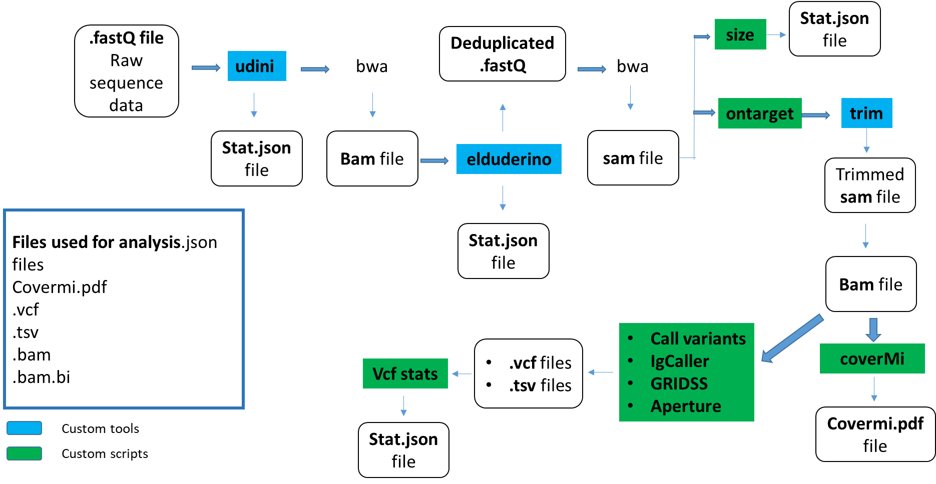
Figure 1: Bio-informatics pipeline

Sequencing Metric (units) | Median (Range)
Coverage depth | 1966 (97 – 5836)
Alignment (%) | 2.82 (0.33 – 7.48)
Yield (gb) | 5.7 (1.4 – 8.05)
Cluster (%) | 88.56 (58.5 – 96.04)
Error rate (%) | 0.56 (0.3 – 2.79)
Q30 (%) | 93.59 (64.18 – 98.01)
Percentage panel covered at least 100x | 98 (0 – 99)
Ti/tv ratio | 1.44 (0 – 2.07)
Percentage of Reads Off-target | 61.46 (37.91 – 99.98)
Table 2: Summary of Sequencing Metrics, n=308

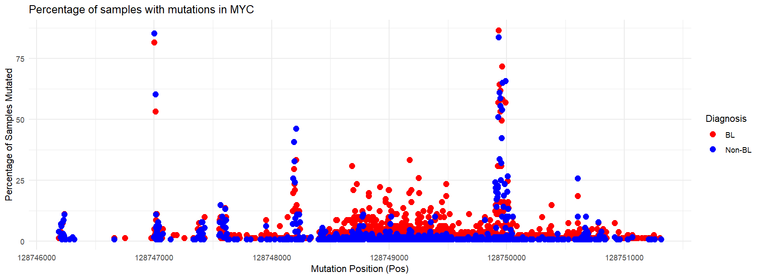
Figure 2: Distribution of MYC mutations in BL and non-Bl samples expressed as a percentage of samples

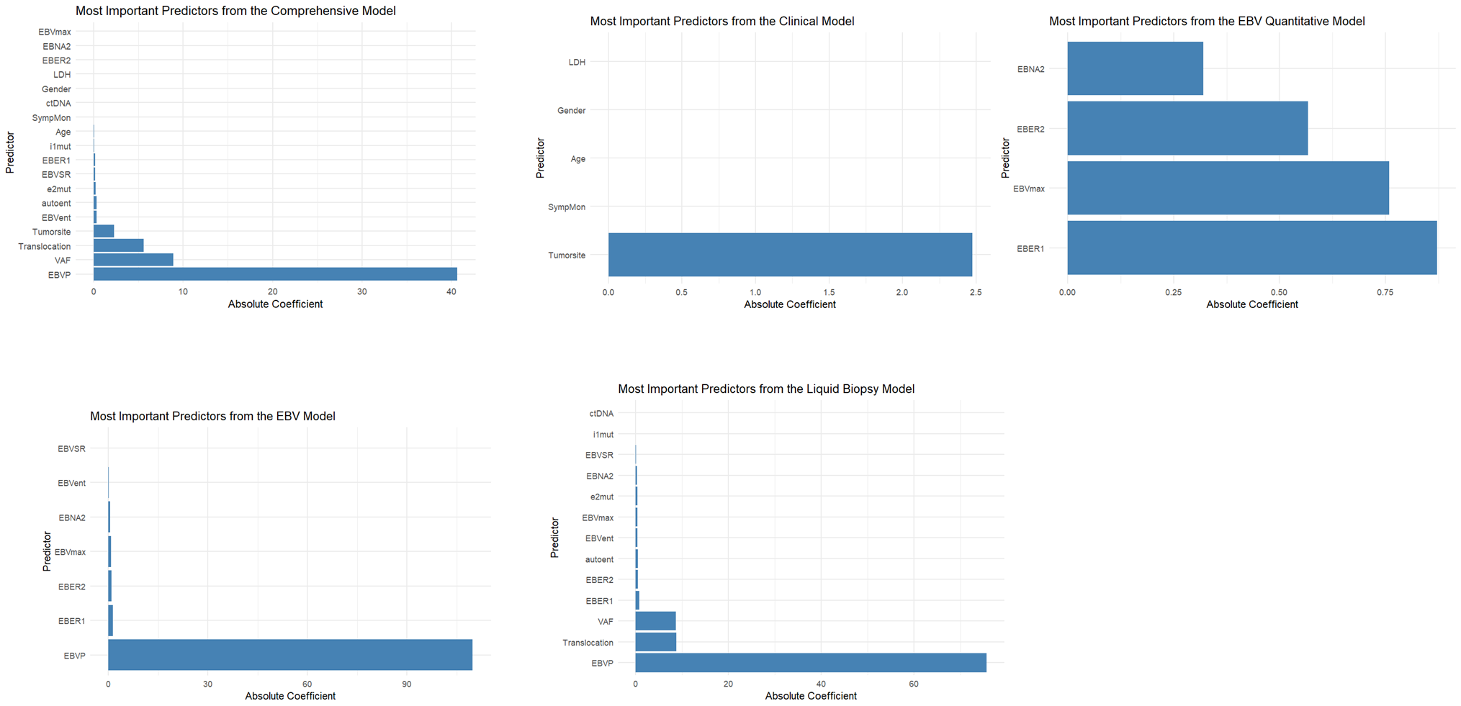

Figure 3: Most Important Predictors from the Five Diagnostic Models

