Table 1. The community targeted in the household survey
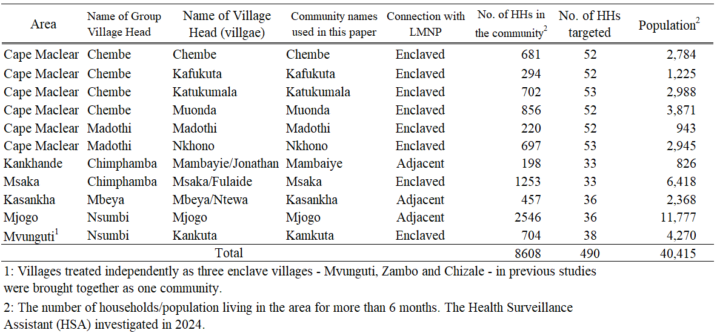

Table 2. Proportion of income sources in the household
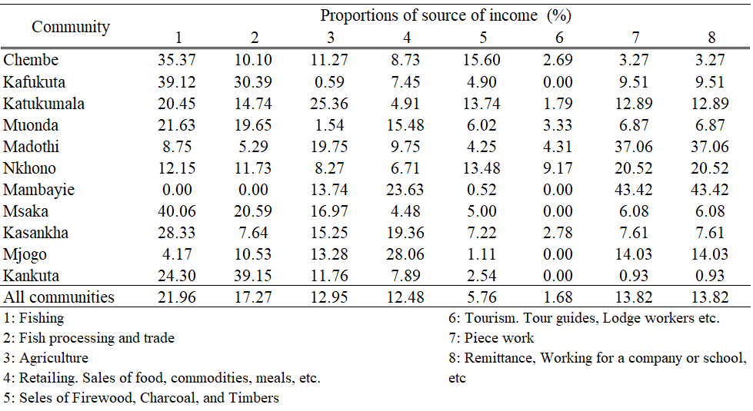

Table 3. Proportion of energy sources used in the household
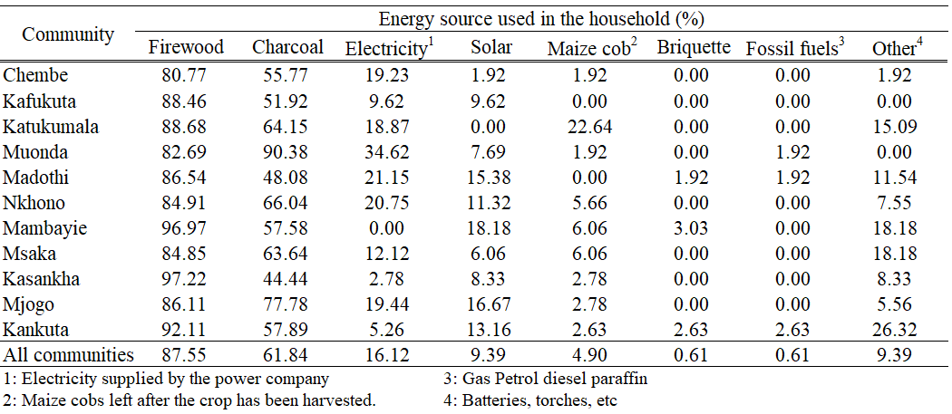

Table 4. Percentage of households using each type of cooking stove
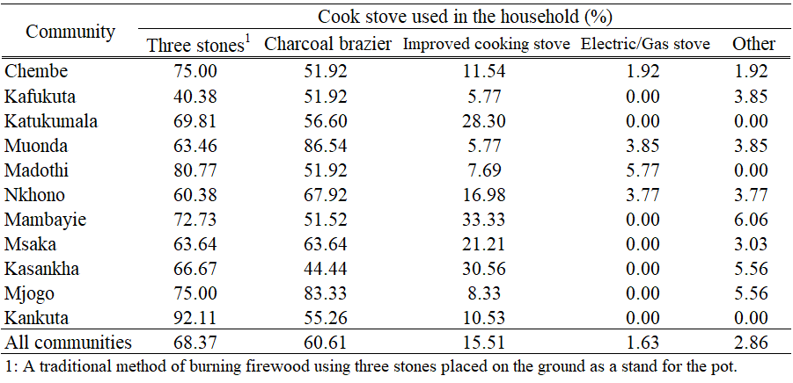

Table 5. Proportion of methods for obtaining firewood by household
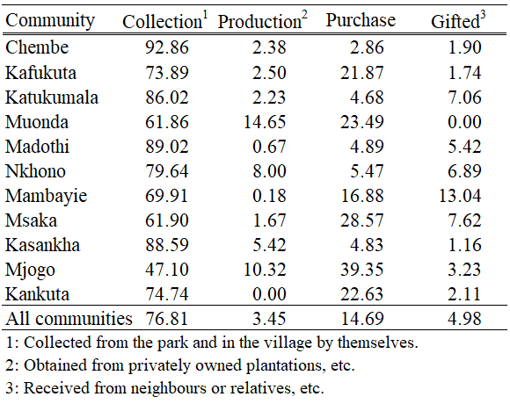

Table 6. Percentage of households that use firewood for each purpose
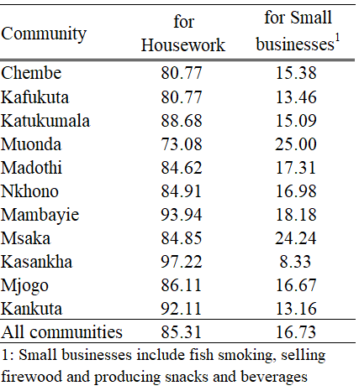

Table 7. Percentage of households collecting various forest resources inside and outside LMNP.
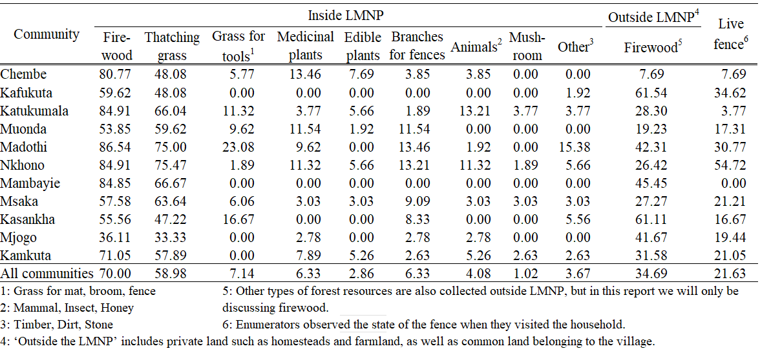

Table 8. Firewood Collection Statistics by Community (Mean with 90% CI)
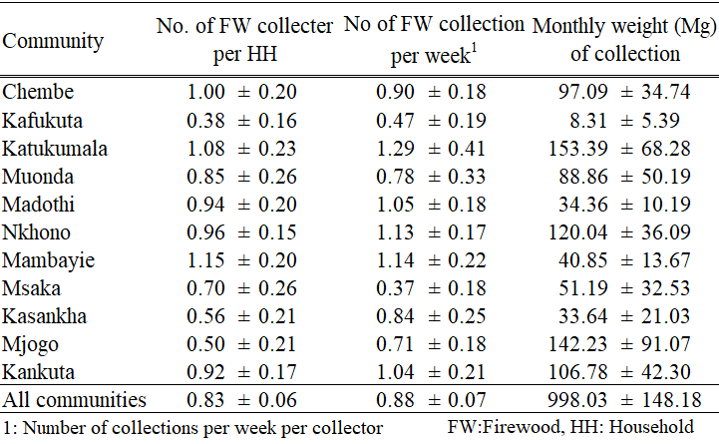

Table 9. Principal Component Analysis on Household Income
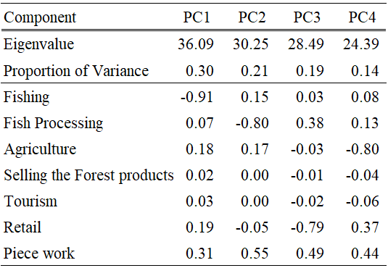

Table 10. Principal Component Analysis of Household Energy Sources
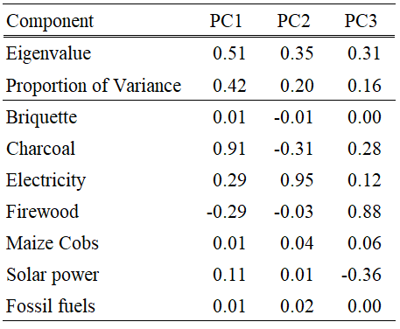

Table 11. Results of the Generalized Linear Model: Predicting the monthly amount of firewood collected per household based on socioeconomic factors.
