Supplementary Data

Supplementary Figures

Figure S1: Mouse models for milder SMA, ALS and SMARD1 lack cerebellar pathology.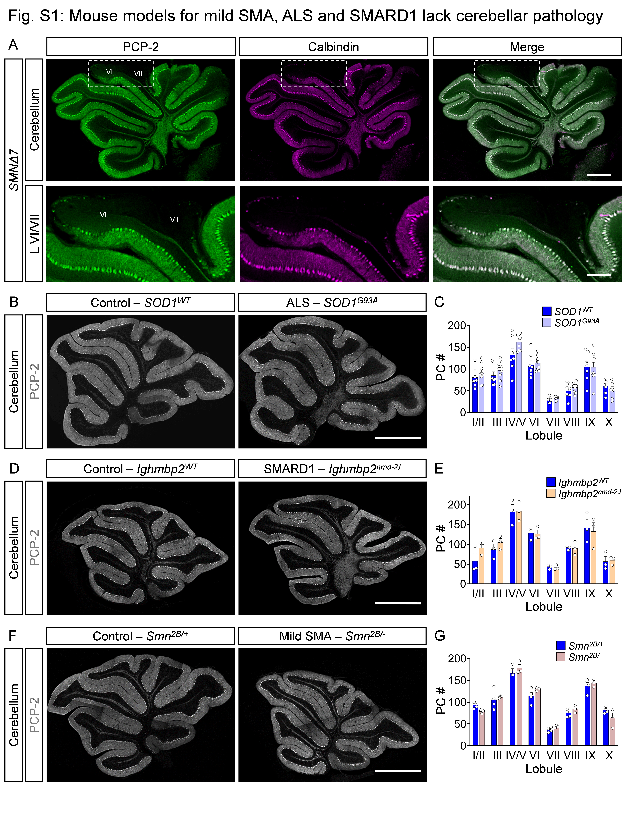
(A) Immunostaining of PCP-2 (green) and calbindin (magenta) in the cerebellum (upper panel) and lobule VI/VII (lower panel) of SMNΔ7 mice at P10 (scale bar for upper panel = 500 μm and lower panel = 200 μm). (B) PCP-2 staining (grey) and (C) quantification of PCs per lobule from SOD1^{WT} control (N = 7) and SOD1^{G93A} ALS (N = 9) mice at P130 (scale bar = 1 mm). (D) PCP-2 staining (grey) and (E) quantification of PCs per lobule from the cerebellum of Ighmbp2^{WT} control (N = 3) and Ighmbp2^{nmd-2J} SMARD1 (N = 3) mice at P52. (F) PCP-2 staining and (G) quantification of PCs (grey) per lobule from the cerebellum of Smn^{2B/+} control (N = 4) and Smn^{2B/-} (N = 3) mice at P23. Statistical analysis was performed using multiple t-tests.

Figure S2: SMA PCs are hyperactive at P5.
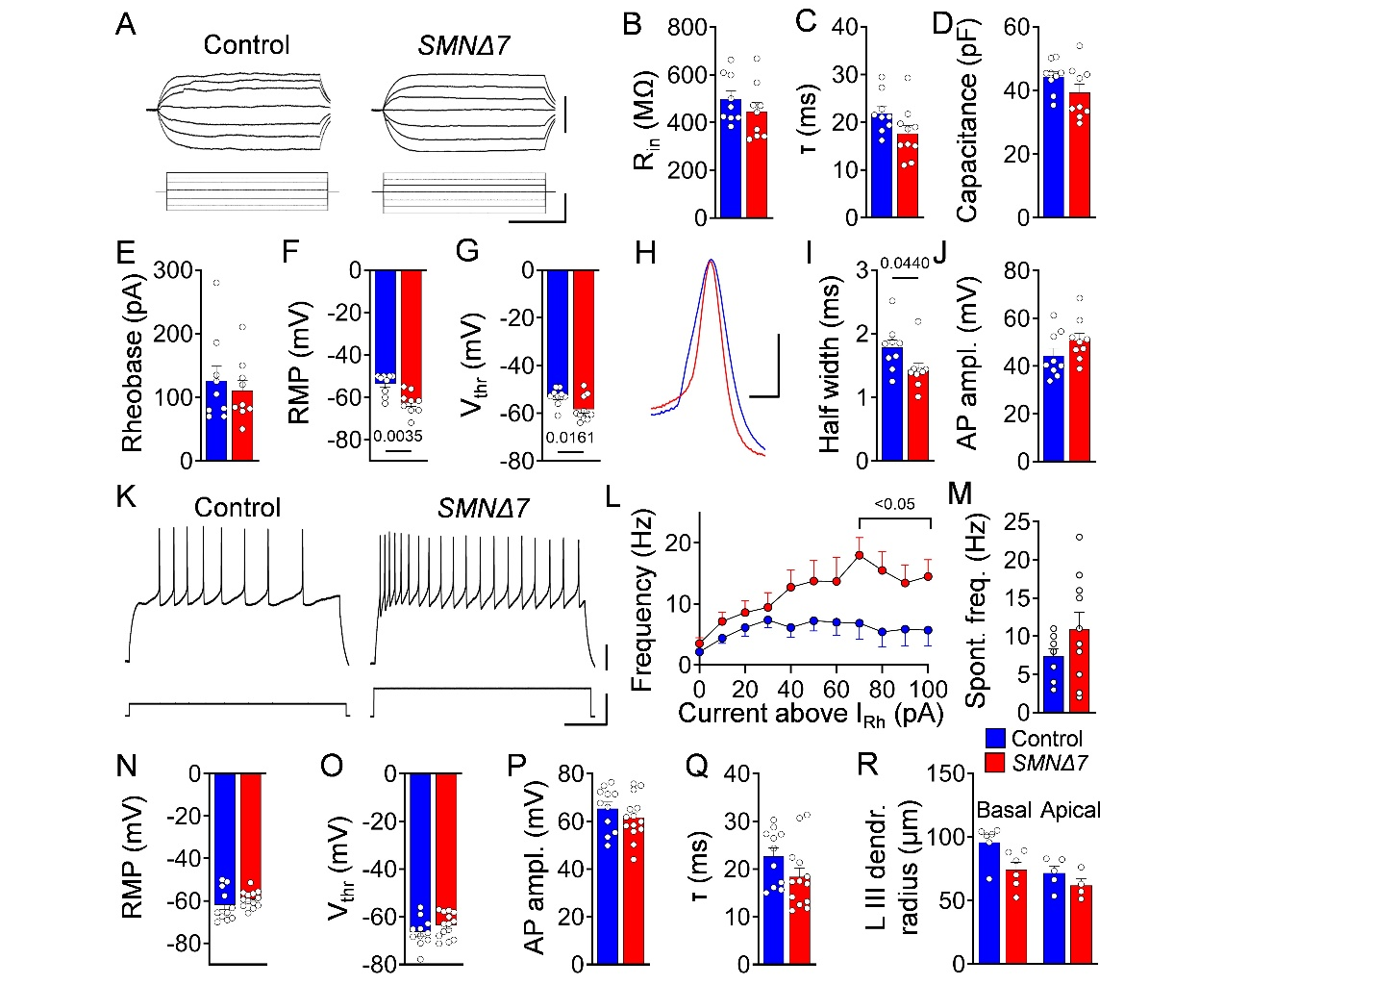
(A) Representative voltage responses to current injections in lobules VI/VII PCs from control and SMNΔ7 mice at P5 (scale bars: 10 mV, 40 pA, 100 ms). Quantification of (B) input resistance (R_{in}), (C) membrane time constant (τ), (D) capacitance, (E) rheobase, (F) resting membrane potential (RMP), and (G) action potential (AP) threshold (V_{thr}) in control (n = 9) and SMNΔ7 (n = 10) PCs from at least N = 4 mice per genotype at P5. (H) Representative AP traces and quantification of (I) AP half-width and (J) amplitude (scale bars: 20 mV, 2 ms). (K) Representative traces of AP firing in response to current injection (scale bars: 20 mV, 200 pA, 200 ms), and (L) quantification of firing frequency as a function of current injection above rheobase. (M) Quantification of spontaneous firing frequency in control and SMNΔ7 PCs at P5. Quantification of (N) RMP, (O) AP V_{thr}, (P) AP amplitude, and (Q) τ in lobules VI/VII PCs from control (n = 13) and SMNΔ7 (n = 14) mice at P10 (at least N = 4 mice per genotype). (R) Dendritic tree radius quantification for basal and apical PCs in lobule III from control (N = 3) and SMNΔ7 (N = 4) mice at P10. Statistical significance determined by unpaired t-test (B–G, I, J, M–Q) or one-way ANOVA (R).

Figure S3: Differential expression of VGLUT1/2 onto and VGAT synapses derived from PCs
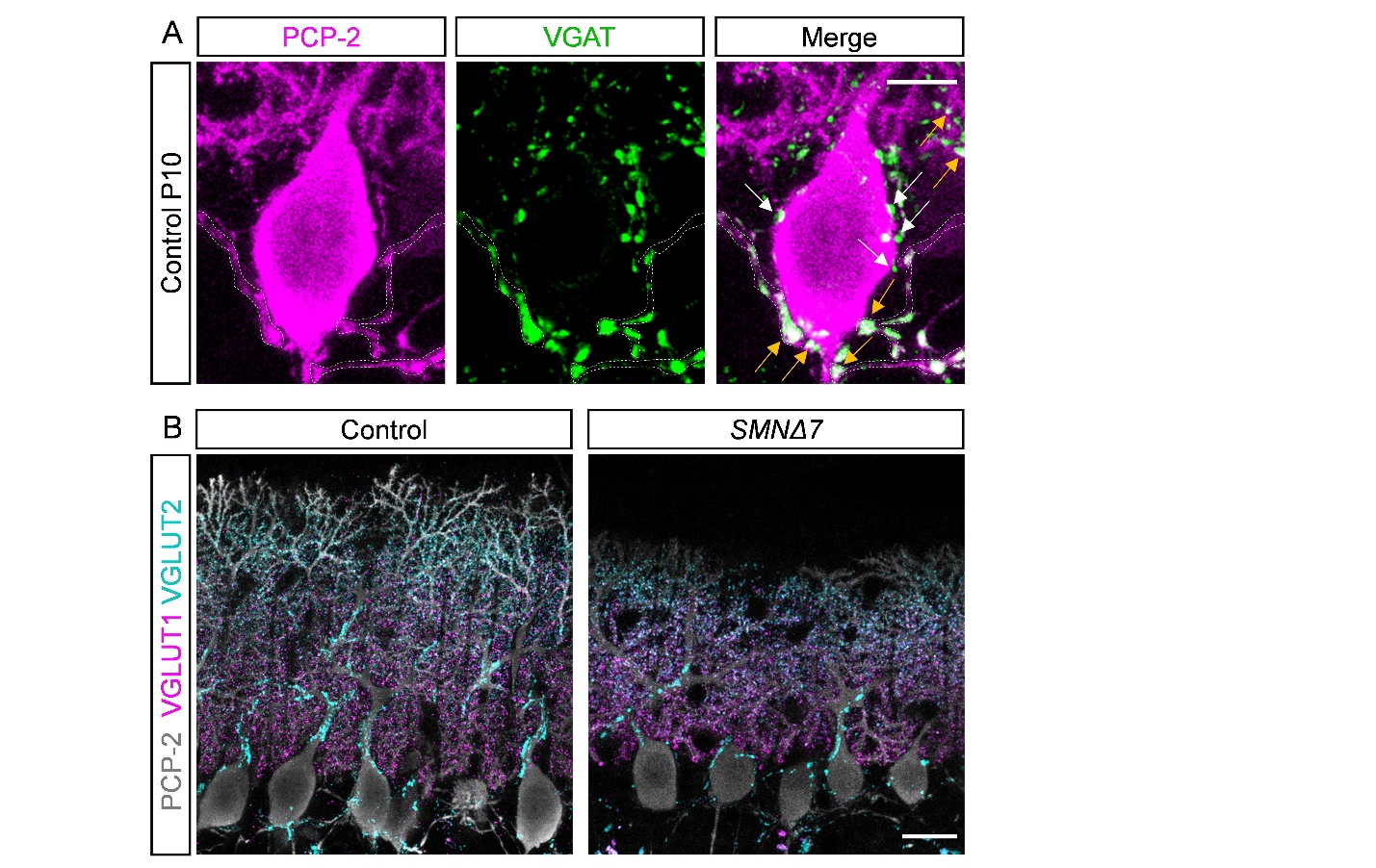
(A) Immunostaining of PCP-2 (magenta) and VGAT (green) to visualize PCs and inhibitory synapses from neighboring PCs (dotted outlines, yellow arrows) or other sources (white arrows) (scale bar = 10 μm) of a WT mice at P10. (B) Immunostaining of PCP-2 (grey) and VGLUT1 (magenta) and VGLUT2 (cyan) to label glutamatergic synapses onto PCs of a WT mouse at P10 (scale bar = 20 μm).

Figure S4: No synaptic dysfunction in resistant lobules of SMA mice
(A) Immunostaining of PCP-2 (grey) and VGLUT1 (magenta) in control and SMNΔ7 apical PCs of lobule III at P10 (scale bar = 20 mm). (B) Quantification of VGLUT1 synapses on soma, proximal (0–50 μm), and distal (50–100 μm) dendrites of apical PCs in lobule III from control (N = 3–5) and SMNΔ7 (N = 3–4) mice at P10. (C) Immunostaining of PCP-2 (grey) and VGAT (green) of control and SMNΔ7 apical PCs in lobule III at P10 (scale bar = 20 μm). (D) Quantification of VGAT synapses on soma, proximal (0–50 μm), and distal (50–100 μm) dendrites of apical PCs in lobule III from control (N = 3–6) and SMNΔ7 (N = 3–5) mice. (E) Immunostaining of PCP-2 (grey) and VGLUT2 (cyan) in control and SMNΔ7 apical PCs from lobule III at P10 (scale bar = 20 μm). (F) Quantification of VGLUT2 synapses on soma, proximal (0–50 μm), and distal (50–100 μm) dendrites of apical PCs in lobule III from control (N = 3–6) and SMNΔ7 (N = 3–5) mice. (G) Immunostaining of PCP-2 (grey), VGLUT1 (magenta, left panel), VGLUT2 (cyan, middle panel), and VGAT (green, right panel) in PCs of lobules VI/VII from Smn^{2B/+} and Smn^{2B/–} mice at P23 (scale bar = 25 μm). (H) Quantification of VGLUT1⁺ (left panel), VGLUT2⁺ (middle panel), and VGAT⁺ (right panel) synapses on the soma (upper panel) and the dendrites up to 100 μm (lower panel) in PCs from Smn^{2B/+} (N = 3–4) and Smn^{2B/–} (N = 3–4) mice at P23. (I) Representative traces of EPSCs in control and SMNΔ7 PCs from lobule III following 200 Hz parallel fiber stimulation at P10 (scale bar: 100 pA and 5 ms). (J) Quantification of EPSC amplitude changes of the second, third, fourth, and fifth response normalized to the first response in control (n = 6) and SMNΔ7 (n = 5) PCs from lobule III of at least N = 3 mice per genotype at P10. (K) Ratio of EPSC amplitude/stimulation from control (n = 6) and SMNΔ7 (n = 5) PCs in lobule III and stimulation intensity for parallel fibers. Statistical analysis was performed using unpaired t-test (B, D, F, H, K) and two-way ANOVA (J).

Figure S5: Functional input and output from GCs are unaltered in SMA mice.
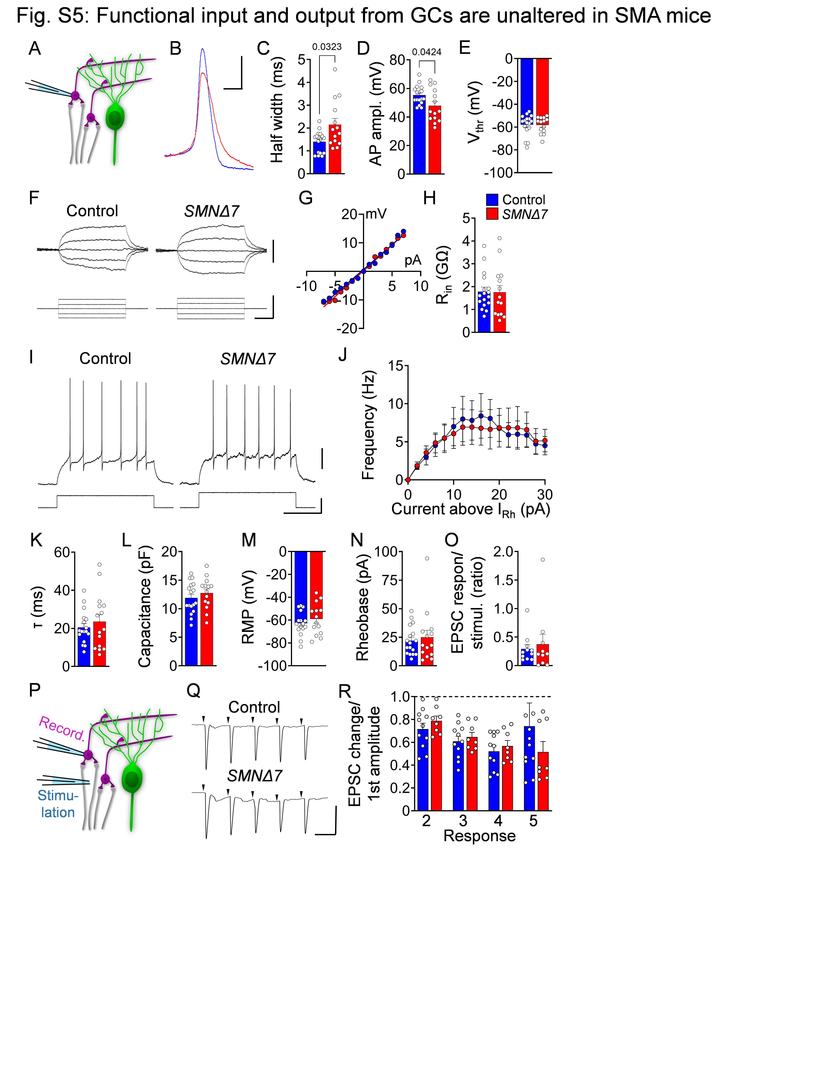
(A) Schematic of the whole-cell patch-clamp approach for analysis of GCs. (B) Representative traces of AP and quantification of (C) half width, (D) AP amplitude and (E) V_{thr} in control (n = 17) and SMNΔ7 (n = 14) GCs of lobules VI/VII from at least N = 4 mice per genotype at P10 (scale bars = 20 mV, 10 mV and 1 ms). (F) Membrane responses following current injections in control and SMNΔ7 GCs of lobules VI/VII at P10 (scale bars = 30 mV, 100 pA and 10 ms). (G) Current to voltage plot in control and SMNΔ7 GCs at P10. (H) Quantification of R_{in} in control (n = 17) and SMNΔ7 (n = 14) GCs at P10. (I) Representative traces of firing rates in control and SMNΔ7 GCs from lobule VI/VII following current injection at P10 (scale bars = 20 mV, 10 pA and 200 ms). (J) Firing frequency depending on the current injection above rheobase in control (n = 17) and SMNΔ7 (n = 14) GCs from at least N = 4 mice per genotype at P10. Quantification of (K) τ, (L) capacitance, (M) RMP and (N) rheobase in control (n = 17) and SMNΔ7 (n = 14) GCs from lobules VI/VII. (O) Ratio of EPSC amplitude/stimulation of control (n = 11) and SMNΔ7 (n = 8) GCs in lobules VI/VII. (P) Schematic of the approach for EPSC measurements of GCs following mossy fiber stimulation. (Q) Representative traces from control and SMNΔ7 GCs in lobules VI/VII following 100 Hz mossy fiber stimulation at P10 (scale bar = 200 pA and 10 ms). (R) Quantification of EPSC amplitude changes of the second, third, fourth and fifth response normalized to the first response in control (n = 11) and SMNΔ7 (n = 8) GCs from lobules VI/VII following mossy fiber stimulation at P10. Statistical analysis was performed using unpaired t-test (C–E, H, K–O) and two-way ANOVA (R).

Figure S6: PV-Cre promoter remains inactive in lobules VI/VII until the second postnatal week.
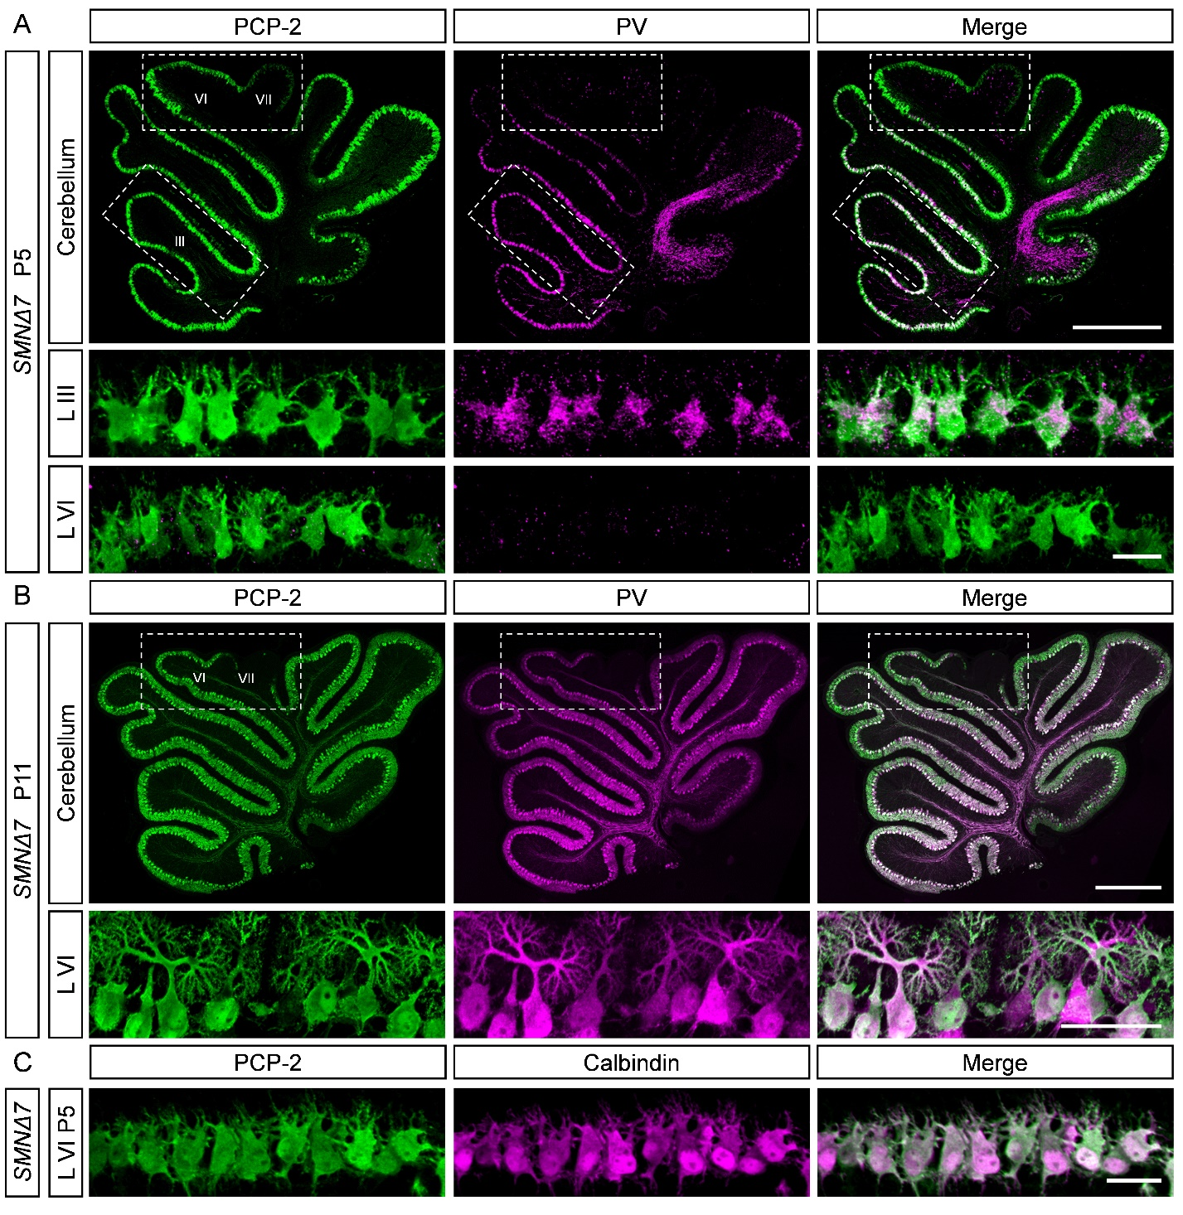
Immunostaining of PCP-2 (green) and parvalbumin (magenta) in the cerebellum, lobule III and lobules VI/VII from SMNΔ7 mice at (A) P5 and (B) P11 (scale bar: upper panel = 500 μm, lower panel = 20 μm for A, upper panel = 500 μm, lower panel = 50 μm for B). (C) Immunostaining of PCP-2 (green) and calbindin (magenta) in lobules VI/VII from SMNΔ7 mice at P5 (scale bar = 20 μm).

Figure S7: p53 pathway activation is reduced in resistant lobules.
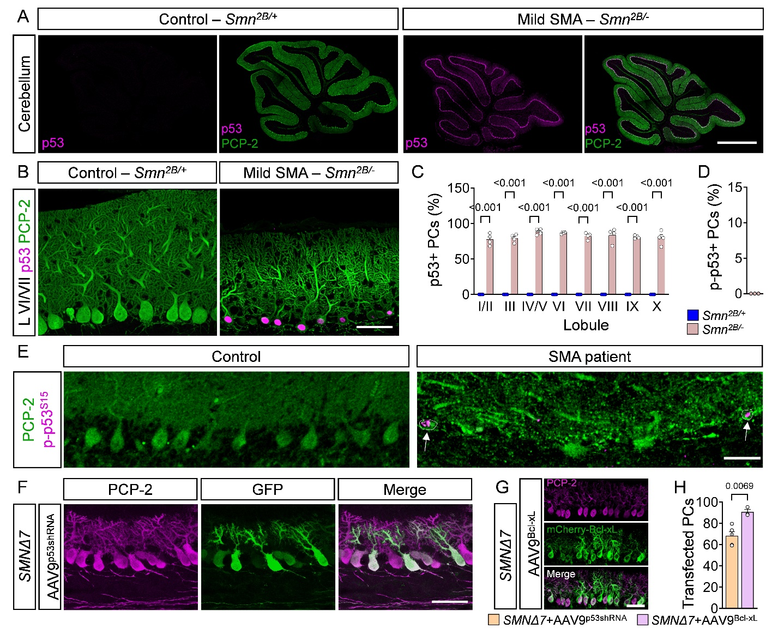
Immunostaining of p53 (magenta) and PCP-2 (green) in (A) cerebellar sections and (B) lobules VI/VII from Smn^{2B/+} control and Smn^{2B/-} mice at P23 (scale bar: cerebellum = 1 mm, lobules VI/VII = 50 μm). (C) Quantification of p53⁺ PCs in %in different lobules and (D) p-p53^{S18+} PCs in % from Smn^{2B/+} control (N = 4) and Smn^{2B/-} SMA (N = 4) mice at P23. (E) Immunostaining of p-p53^{S15} (magenta) and PCP-2 (green) in the human vermis from control and SMA Type I autopsy tissue (circles and arrows indicate p-p53^{S15+} degenerating PCs (scale bar = 50 μm). (F) Immunostaining of PCP-2 (magenta) and GFP (green) in lobules VI/VII from SMNΔ7+AAV9-p53s_{hRNA} mice at P10 (scale bar = 50 μm). (G) Immunostaining of PCP-2 (magenta) and mCherry-Bcl-xL (green) in lobules VI/VII from SMNΔ7 mice injected with AAV9-Bcl-xL-mcherry (scale bar = 50 μm). (H) Percentage of transfected PCs from SMNΔ7 mice treated with AAV9-p53_{shRNA} (N = 5) and AAV9-Bcl-xL-mcherry (N = 3) at P10. Statistical analysis was performed using two-way ANOVA (C) and unpaired t-test (H).
Figure S8: Selective viral SMN restoration in PCs.
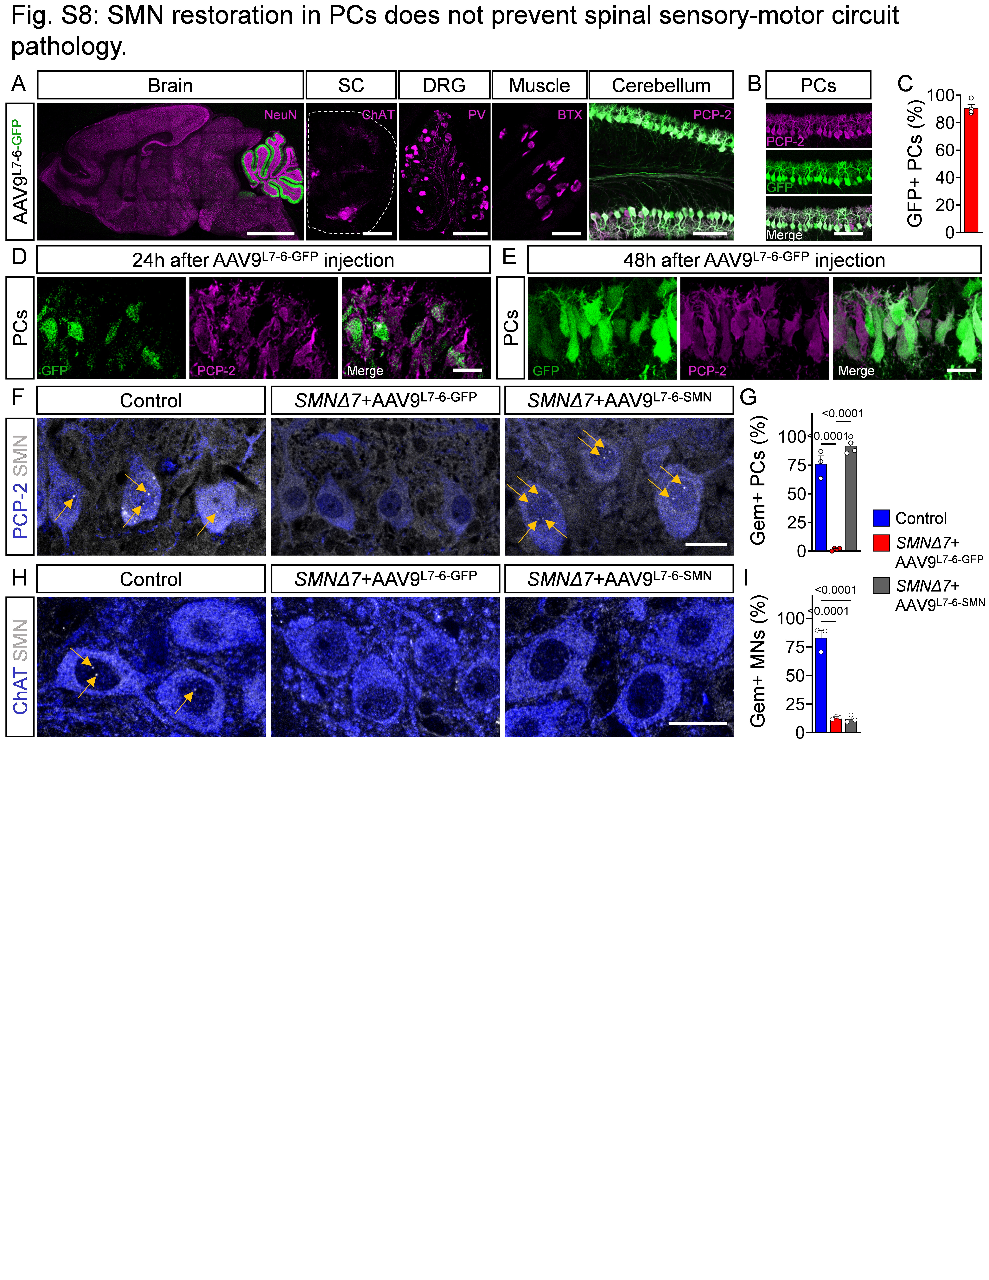
(A) Immunostaining of GFP (green) in combination with either NeuN (magenta) in the brain, ChAT (magenta) in the spinal cord (SC), parvalbumin (magenta) in the dorsal root ganglion (DRG), α-bungarotoxin (BTX) (magenta) in the muscle and PCP-2 (magenta) in the cerebellum from SMNΔ7+AAV9-L7-6-GFP mice at P10 (scale bar: brain = 2 mm, SC/DRG = 200 µm, muscle = 50 µm, cerebellum = 100 µm). (B) Immunostaining of PCP-2 (magenta) and GFP (green) in PCs from SMNΔ7+AAV9-L7-6-GFP mice at P10 (scale bar = 100 μm). (C) Percentage of GFP⁺ PCs in lobules VI/VII. Immunostaining of GFP (green) and PCP-2 (magenta) in the cerebellum (D) 24 h and (E) 48 h after AAV9-L7-6-GFP injection of P1 and P2 mice, respectively (scale bar = 20 µm). (F) Immunostaining of PCP-2 (blue) and SMN (grey) in cerebellar lobules VI/VII from control, SMNΔ7+AAV9-L7-6-GFP and SMNΔ7+AAV9-L7-6-SMN mice at P10 (scale bar = 20 µm). (G) Quantification of Gem⁺ PCs from control (N = 3), SMNΔ7+AAV-9L7-6-GFP (N = 4) and SMNΔ7+AAV9-L7-6-SMN (N = 4) mice at P10. (H) Immunostaining of ChAT (blue) and SMN (grey) in L1 spinal cords from control, SMNΔ7+AAV9-L7-6-GFP and SMNΔ7+AAV9-L7-6-SMN mice at P10 (scale bar = 20 µm). (I) Quantification of motor neurons (MNs) from control (N = 3), SMNΔ7+AAV9-L7-6-GFP (N = 3) and SMNΔ7+AAV9-L7-6-SMN (N = 3) mice at P10. Statistical analysis was performed using one-way ANOVA.

Figure S9: SMN restoration in PC does not improve sensory-motor circuit, parallel fiber boutons and subset of USV properties in SMA mice.
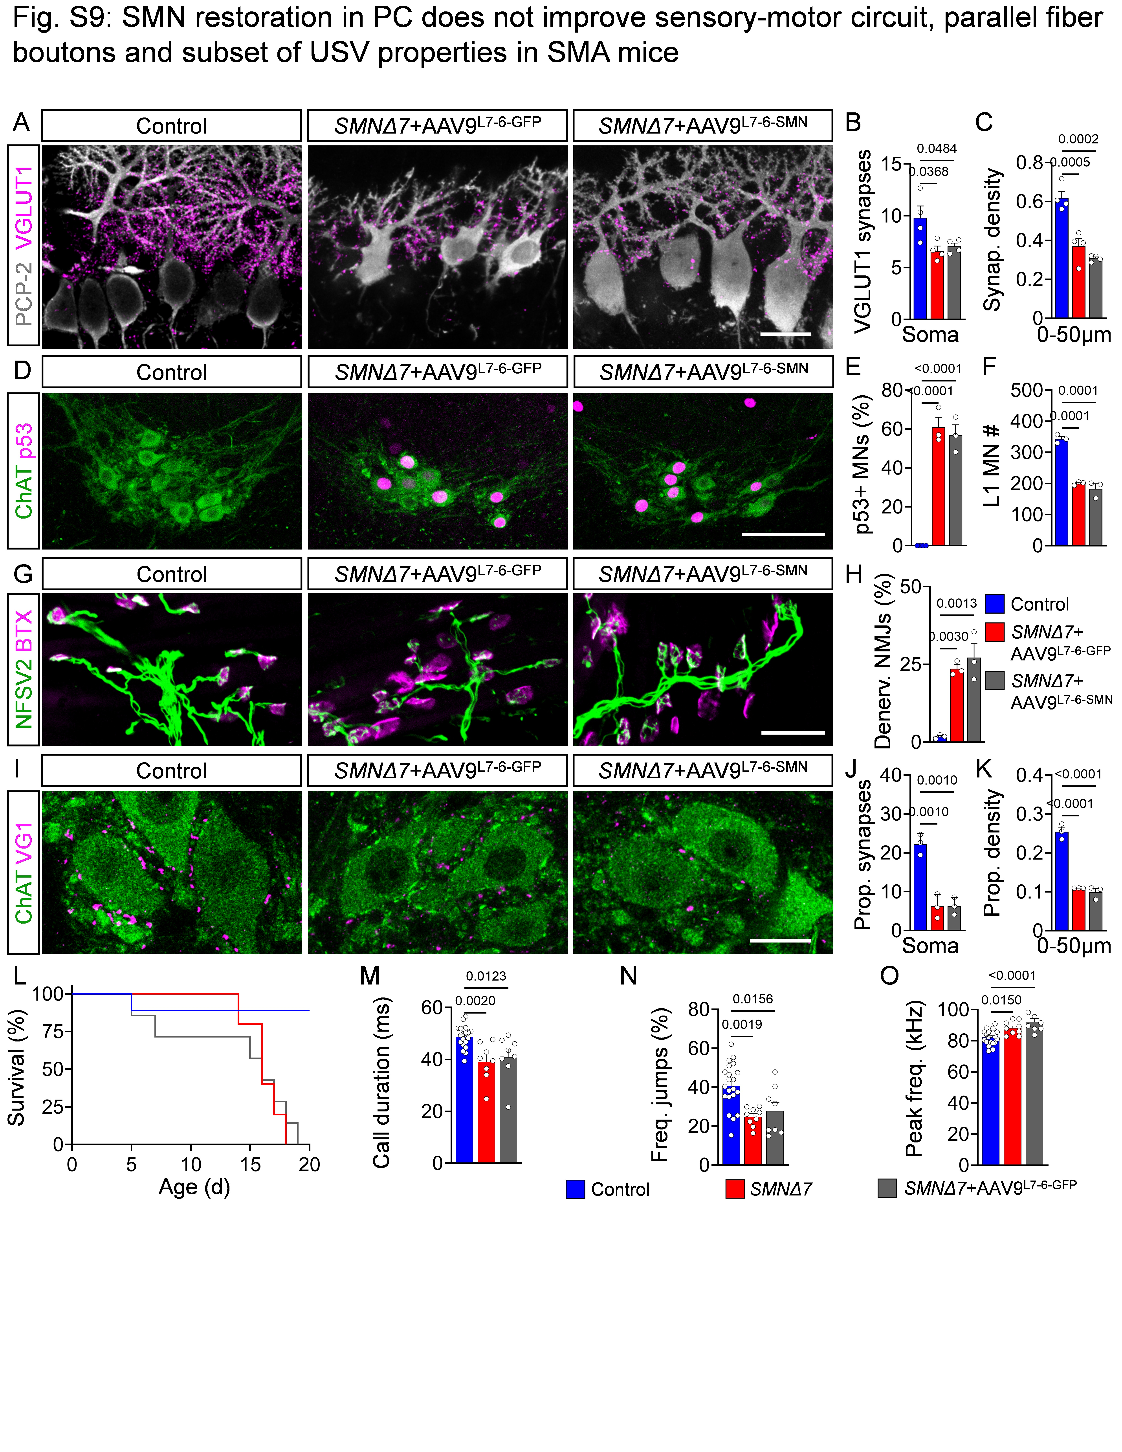
(A) Immunostaining of PCP-2 (grey) and VGLUT1 (magenta) in control, SMNΔ7+AAV9-L7-6-GFP and SMNΔ7+AAV9-L7-6-SMN mice (scale bar = 20 μm). Quantification of (B) VGLUT1 synapses and (C) dendritic synaptic density (0–50 μm from the soma) in lobules VI/VII from control (N = 6), SMNΔ7+AAV9-L7-6-GFP (N = 5) and SMNΔ7+AAV9-L7-6-SMN (N = 5) mice. (D) Immunostaining of ChAT (green) and p53 (magenta) in ventral L1 spinal cord sections from control, SMNΔ7+AAV9-L7-6-GFP and SMNΔ7+AAV9-L7-6-SMN mice at P10 (scale bar = 100 μm). Quantification of (E) p53⁺ MNs in % and (F) the number of L1 MNs from control (N = 3), SMNΔ7+AAV9-L7-6-GFP (N = 3) and SMNΔ7+AAV9-L7-6-SMN (N = 3) mice at P10. (G) Immunostaining of neurofilament (NF), synaptic vesicle 2 (SV2) (green) and BTX (magenta) in the quadratus lumborum muscle from control, SMNΔ7+AAV9-L7-6-GFP and SMNΔ7+AAV9-L7-6-SMN mice at P10 (scale bar = 50 μm). (H) Percentage of denervated NMJs in control (N = 3), SMNΔ7+AAV9-L7-6-GFP (N = 3) and SMNΔ7+AAV9-L7-6-SMN (N = 3) mice at P10. (I) Immunostaining of ChAT (green) and VGLUT1 (magenta) in the L1 ventral spinal cord from control, SMNΔ7+AAV9-L7-6-GFP and SMNΔ7+AAV9-L7-6-SMN mice (scale bar = 20 μm). Quantification of proprioceptive VGLUT1⁺ synapses onto the (J) soma and (K) dendritic synaptic density (0–50 μm away from the soma) in control (N = 3), SMNΔ7+AAV9-L7-6-GFP (N = 3) and SMNΔ7+AAV9-L7-6-SMN (N = 3) mice at P10. (L) Survival of control (N = 7), SMNΔ7+AAV9-L7-6-GFP (N = 5) and SMNΔ7+AAV9-L7-6-SMN (N = 7) mice until P20. Quantification of (M) call duration, (N) frequency jumps, and (O) peak frequency at maximum amplitude in control (N = 22), SMNΔ7 (N = 8) and SMNΔ7+AAV9-L7-6-SMN (N = 8) mice at P5. Note that the data for control and untreated SMA mice are the same as presented in Fig. 4, the AAV9-L7-6-SMN–treated SMA mutants were littermates of the other two groups, and all experiments were conducted at the same time. Statistical analysis was performed using one-way ANOVA (B, C, E, F, H, J, K, M–O) and Log-rank (Mantel–Cox) test (L).

Supplementary Tables
Supplementary Table 1: List of patients.
Patient ID | Group | Cause of Death | Sex | Age (m) | PMI (h) | Origin
5954 | Control | SUDI | male | 5 | 13 | NIH
5817 | Control | Aspyxia | male | 7.1 | 24 | NIH
5886 | Control | SUDI | male | 1.5 | 27 | NIH
5977 | Control | Smoke inhalation | female | 80.2 | 22 | NIH
6172 | Control | SUDI | male | 3.5 | 34 | NIH
717 | Control | SUDI | female | 2.8 | 24 | NIH
1061 | Control | SUDI | male | 2.1 | 17 | NIH
1132 | Control | SUDI | male | 2.2 | 9 | NIH
1283 | Control | SUDI | female | 2.9 | 23 | NIH
4445 | Control | Aspyxia | male | 3 | 16 | NIH
5637 | Control | SUDI | male | 1.3 | 29 | NIH
8006 | Control | cardiomyopathy | male | 3.1 | 12 | NIH
8008 | Control | Viral infection | female | 4.8 | 25 | NIH
8011 | Control | Asphyxia | male | 5 | 41 | NIH
8012 | Control | SUDI | male | 0.8 | 28 | NIH
1897 | SMA Type I | SMA complications | male | 10.7 | 3 | NIH
4994 | SMA Type I | SMA complications | female | 2 | 19 | NIH
4589 | SMA Type I | Respiratory failure | male | 5.2 | 6 | NIH
4629 | SMA Type I | Cardiopulmonary arrest | male | 5.6 | 3 | NIH
19_01 | SMA Type I | SMA complications | female | 11 | 19 | JHU
14_05 | SMA Type I | Respiratory arrest | male | 8 | 6 | JHU
24_01 | SMA Type I | Refractory hypoxemia | male | 7 | 2 | JHU
SUDI = sudden unexpected death in infancy, NIH = National Institute of Health, JHU = Johns Hopkins University

Supplementary Table 2: List of antibodies
Name | Company | Cat # | Host | Reactivity | Dilution
PCP-2 | Santa Cruz | Sc-137064 | Mouse | Mouse/Human | 1:400
Parvalbumin | Synaptic Systems | 195 006 | Chicken | Mouse | 1:5,000
Calbindin | Synaptic Systems | 214006 | Chicken | Mouse | 1:500
p53 | Leica Novocastra | NCL-p53-CM5p | Rabbit | Mouse | 1:1,000
p-p53^{S15/18} | Cell Signaling | 9284 (Lots: 12,15) | Rabbit | Mouse | 1:500
p-p53^{S15} | Cell Signaling | E9Y4U | Rabbit | Human | 1:500
VGLUT1 | Synaptic Systems | 135 304 | Guinea pig | Mouse | 1:5,000
VGLUT2 | Synaptic Systems | 135 403 | Rabbit | Mouse | 1:1000
VGAT | Synaptic Systems | 131 004 | Guinea pig | Mouse | 1:500
SMN | BD Transd. Labs | 610646 | Mouse | Mouse | 1:100
SV2 | DSHB | SV2-c | Mouse | Mouse | 1:500
Neurofilament | DSHB | 2H3-c | Mouse | Mouse | 1:1000
Bungarotoxin | Invitrogen | B35451 | N/A | Mouse | 1:1000
ChAT | Millipore | AB144P | Goat | Mouse | 1:500

