Interview Guide
Checklist interview:
- Could you please review the information letter again (especially sections 4, 8, and 10)?
- Signing of an informed consent form if that has not been done yet
- Mention again that the interview will be recorded from this point on
Thank you for participating in this study on the COPD clinical knowledge model developed for the Department of Pulmonology at the MUMC+. We will now conduct an interview consisting of two parts, each of which includes three cases. In total, you will be presented with six cases. At the beginning of each part, I will briefly explain again what is expected of you. If you have any questions along the way, please do not hesitate to ask. Is everything clear so far?
We will start with some general questions:
- What is your position within the Department of Pulmonology?
- How long have you been working in this role? (This may include experience at other locations)
- How old are you currently?
Thank you for your answers. For your information: this is the only personal data I will collect and use from you. We will now proceed to part 1.
This part consists, as mentioned before, of three cases. For each case, you will receive a description of a patient, their symptoms, and measurement values. If any questionnaires have been completed, you will see those as well. You may take your time to review this information.
Once you have read through all the information in the case, I will ask you to indicate what you would do with this patient. This could be a specific treatment, but it could also be that you would like to ask for additional information, for example. Try to be as specific as possible with your response and make it reflect as closely as possible how you would treat a patient in real-life practice.
Is the task clear?
You may now review the first case. If you have any questions, please feel free to ask.
[Provide case 1 and wait until it has been reviewed. Once they are ready, ask:]
What would you do with this patient?
[Provide case 2 and wait until it has been reviewed. Once they are ready, ask:]
What would you do with this patient?
[Provide case 3 and wait until it has been reviewed. Once they are ready, ask:]
What would you do with this patient?
Thank you for your responses to the three cases.
[If there is time for a break, you can offer a 5-minute pause.]
We will now continue with part 2.
This part also consists of three cases and is very similar to part 1. However, in addition to the patient information and the data they provided, you will now also receive a recommendation. This is the recommendation generated by the COPD clinical knowledge model based on the same information you have received.
Your task is to indicate whether you agree with the model’s recommendation or not. In either case, I would also like you to explain why you do or do not agree with the model. For example, you might feel that the model was too cautious in its recommendation, or perhaps not cautious enough. Again, please try to be as specific as possible in your explanation of whether or not you would apply the model’s recommendation in real-life practice.
Is the task for this part clear? Then I will now give you the first case of part 2 — that is, case 4 overall.
[Provide case 4 and wait until it has been reviewed. Once they are ready, ask:]
Would you accept and apply this recommendation? Why or why not?
[Provide case 5 and wait until it has been reviewed. Once they are ready, ask:]
Would you accept and apply this recommendation? Why or why not?
[Provide case 6 and wait until it has been reviewed. Once they are ready, ask:]
Would you accept and apply this recommendation? Why or why not?
That was the final question. Thank you very much for your valuable input and participation in the study. Do you have any further questions about the research?
Then I will now stop the recording.

Part 1
Open question: What would you do?
- What additional information do you need?
- What is the professional’s thought process? What reasoning is behind it? Why do they do that?

Case 1 – Measurement Error
The values in this case are not ok, but the (EXACT) questionnaire is ok.
Ms. Aerts, born on March 8, 1968 (56 years old) and known to have COPD Gold 2B, has baseline values of 95% SpO2, 86 bpm heart rate, and 21 breaths per minute respiratory rate. Today, she reported the following values: SpO2 of 88%, heart rate of 110 bpm, and respiratory rate of 35 breaths per minute. In response, the CERT questionnaire was administered. During the assessment, Ms. Aerts indicated that she does not have more coughing, mucus, or shortness of breath than usual. She was also not limited in her daily activities, such as household chores and outdoor activities.
The complete CERT questionnaire was filled out by Ms. Aerts as follows:
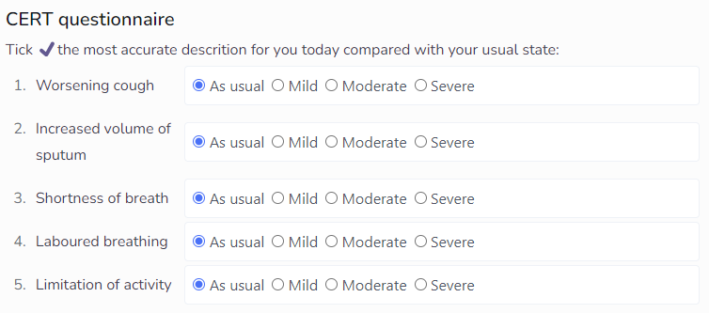
What would you do with this patient?
Model recommendation:
- Measure oxygen saturation, heart rate, and respiratory rate again after 2 minutes.

Case 2 – Classic Case (Exacerbation)
Medication is needed.
Mr. Berends, born on April 14, 1977 (47 years old), is known to have COPD Gold 3E. Normally, he has the following values: 95% SpO2, 84 bpm heart rate, and 21 breaths per minute respiratory rate. Currently, his measured values are: SpO2 of 92%, heart rate of 101 bpm, and respiratory rate of 29 breaths per minute. As a result of these values, the CERT questionnaire was administered.
In the CERT questionnaire, Mr. Berends indicates that he is experiencing activity limitation due to significantly worsening cough, difficult breathing, and a slightly increased volume of mucus. The complete CERT questionnaire was filled out as follows:
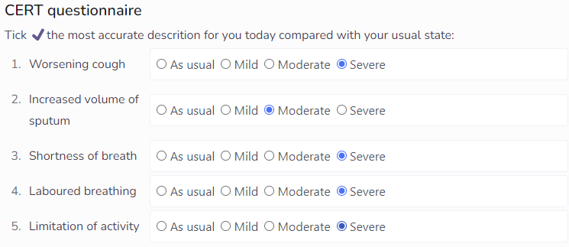
Next, Mr. Berends is asked to complete the EXACT questionnaire. In this, he indicates that he feels a tightness in his chest and is too short of breath to carry out activities. Personal care is also difficult for him. The complete questionnaire was filled out as follows:
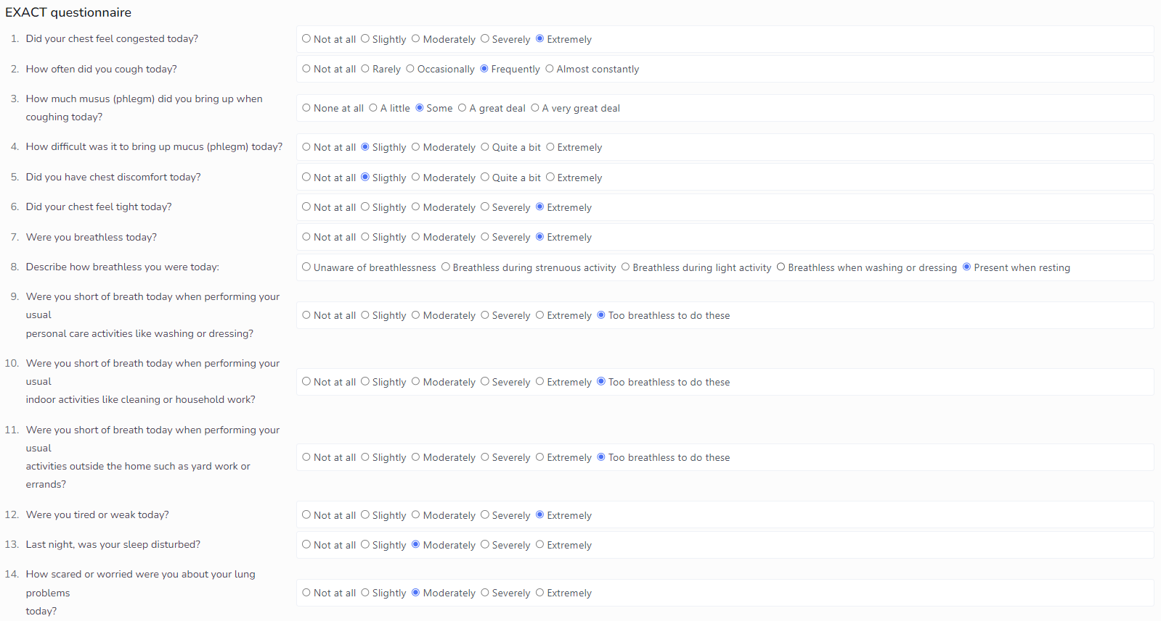
What would you do with this patient?
Model recommendations:
- Contact your healthcare professional
- Increase your inhaler dose
- Use airway clearance techniques, do your breathing exercises, remember your mindfulness exercises, and slow down your pace of life
- Please contact your healthcare professional for lab work
- Please make sure to fill out the new questionnaire tomorrow

Case 3 – EXACT Event
Follow-up on case 2; keep that case in mind.
Case 2 described the first day that Mr. Berends (born April 14, 1977; 47 years old) took his measurements. The score on the EXACT questionnaire at that time was 65. Context: an increase of more than 12 points over 2 days indicates an exacerbation.
Following advice, Mr. Berends continued his inhaler dose and applied his breathing techniques.
In the following days, his condition does not improve. On day 4, he records the following values: 91% SpO2, 100 bpm heart rate, and 29 breaths per minute respiratory rate. The EXACT questionnaire scores for days 3 and 4 are now 76 (an increase of 12 points compared to baseline) and are as follows:
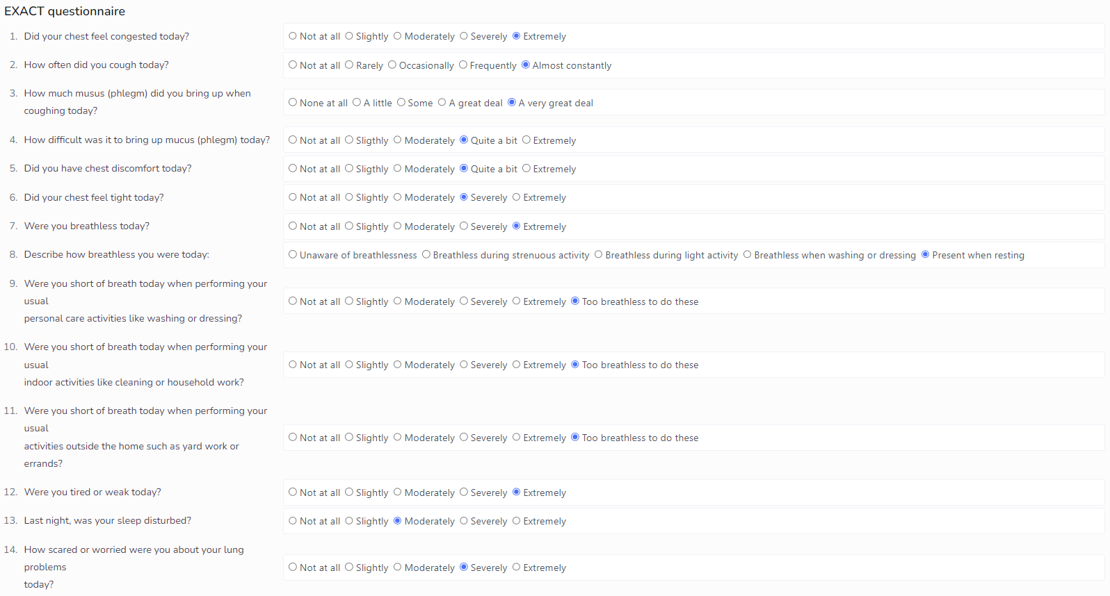
What would you do with this patient?
Model recommendations:
- Contact your healthcare professional
- Use increased inhaler dose
- Use airway clearance techniques, do your breathing exercises, remember your mindfulness exercises, and slow down your pace of life
- Please contact your healthcare professional for lab work
- Please make sure to fill out the new questionnaire tomorrow

Interview Part 2 – Adoption Questions
Closed/Adoption question: The model prescribes this advice/advice(s); would you accept and follow it?
- Acceptance yes/no: Do you agree with the tool’s advice, and why?
- If no →
  - What would you do differently?
  - Ask them whether they find the model’s approach too aggressive or not.

Case 4 – EXACT Event Follow-up
Values slowly return to baseline after an exacerbation, after which the tool indicates that no more medication is needed. Do the professionals agree with this, and why?
Values over the following days (in case asked):
- Day 5: 92% SpO2, 96 bpm HR, 27 breaths per minute RR; EXACT score 51
- Day 6: 94% SpO2, 90 bpm HR, 24 breaths per minute RR; EXACT score 40
- Day 7: 95% SpO2, 86 bpm HR, 22 breaths per minute RR; EXACT score 30
After experiencing severe symptoms for two days, it seems that Mr. Berends (47 years old, known to have COPD Gold 3E) is improving. Over the days following his exacerbation, his values gradually normalize until they return close to his baseline on day 7. The vital signs on day 7 are: 95% SpO2, 86 bpm heart rate, and 22 breaths per minute respiratory rate (his baseline vital signs are approximately 95% SpO2, 84 bpm heart rate, and 21 breaths per minute respiratory rate). The EXACT score decreased from 76 on day 4 to 30 on day 7.
The COPD monitoring tool indicates that no abnormalities are detected and that no medication is needed anymore. However, Mr. Berends is asked to enter his values into the tool again tomorrow.
Do you agree with the tool’s advice, and why?

Case 5 – Moderate CERT Questionnaire
Medication should ideally be increased, but the expectation is that many will not take action.
Ms. Clemens, born on October 21, 1949 (74 years old) and known to have COPD Gold 2B, completed her measurements and the CERT questionnaire at home using the online COPD monitoring tool before her appointment. Her baseline values are 96% SpO2, a heart rate of 88 bpm, and a respiratory rate of 22 breaths per minute. Her current values are an SpO2 of 95%, heart rate of 96 bpm, and respiratory rate of 21 breaths per minute. The CERT questionnaire is as follows:
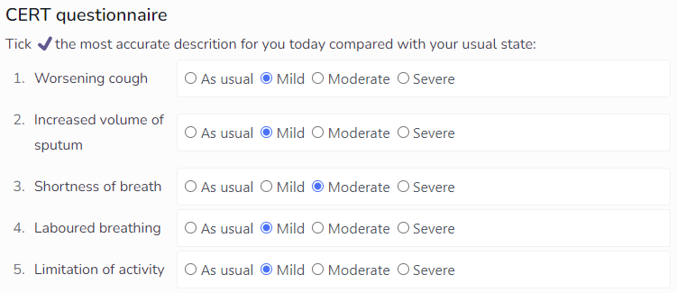
The COPD monitoring tool now asks for an EXACT questionnaire, which Ms. Clemens completes as follows:
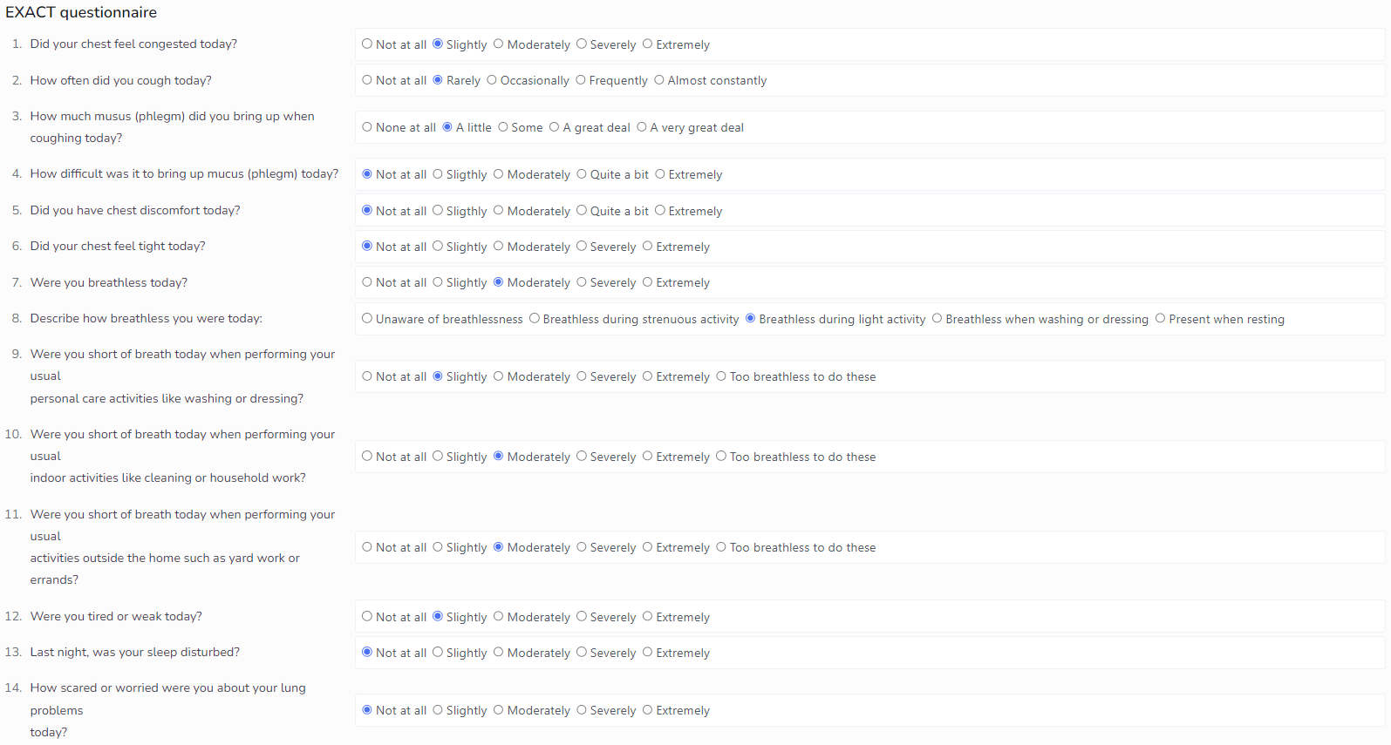
Based on all the information Ms. Clemens has provided, the tool advises her to increase her inhaler dose and to measure and enter her vital signs again the next day. According to the model, she does not need to contact her healthcare provider.
Do you agree with the tool’s advice, and why?

Case 6 – Severe Case
Ms. Van Denderen, born on February 27, 1957 (67 years old), is known to have COPD Gold 3E. Her normal vital signs are around 95% SpO2, 84 bpm heart rate, and 21 breaths per minute respiratory rate. However, she is experiencing severe coughing and has difficulty bringing up mucus. Additionally, she is extremely short of breath, making it very difficult for her to perform activities such as washing and dressing, and she cannot do heavier tasks indoors or outdoors. Ms. van Denderen is very worried and decides to measure her vital signs. The measurement shows an SpO2 of 88%, heart rate of 100 bpm, and respiratory rate of 32 breaths per minute.
She enters these values into the COPD monitoring tool, which then administers the CERT questionnaire. Ms. Van Denderen completes the questionnaire as follows:
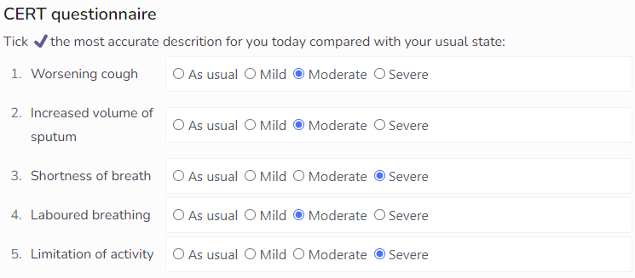
Based on her answers to the CERT, the COPD monitoring tool now administers the EXACT questionnaire. Ms. Van Denderen completes it as follows:
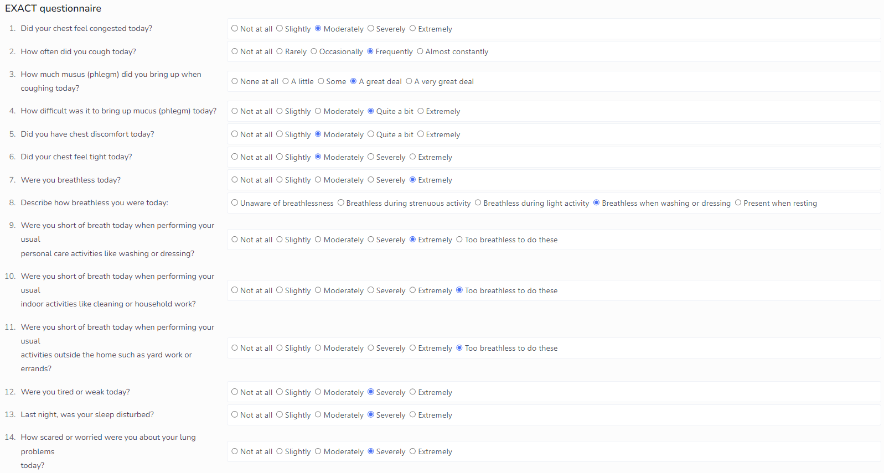
Finally, the monitoring tool also administers the acute problems questionnaire. In this, Ms. Van Denderen indicates that she has a temperature of 37.2°C and no other acute problems. The questionnaire is as follows:
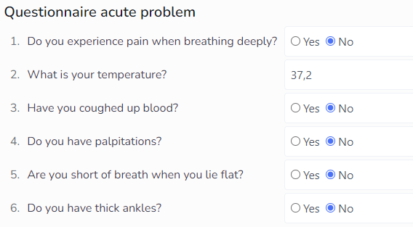

The tool gives the following advice:
- Contact your healthcare professional.
- Increase your inhaler dose.
- Perform breathing exercises and airway clearance techniques, remember your mindfulness exercises, and get plenty of rest.
- Contact your healthcare provider for laboratory tests.
- Measure your values again tomorrow and fill out a new questionnaire.
Do you agree with the tool’s advice, and why?

