Supplementary material

Supplementary Movies 1-3
Visualisation of the inhibitory effect of cabozantinib on MBM cell migration. Cells were imaged every 2 h for 72 h under constant exposure of 1 μM, 5 μM, or 15 μM cabozantinib or left untreated (control). The blue scratch wound is closing as the cells (yellow area) starts migrating into the wound. Movies tagged with 1, 2, 3 represents H1, H3 and H10 cell lines respectively. Further, the labels a, b, c, d represents the cabozantinib doses of 0 μM (control), 0.5 μM, 5 μM or 15 μM respectively.

Supplementary Figure 1
Cabozantinib induces apoptosis in MBM cell lines. a Representative dot plots of cells untreated (control) or treated with different doses of cabozantinib as indicated for 24 h. Annexin V labels apoptotic cells, while propidium iodide (PI) labels necrotic cells. b Quantification of the percentage of viable, apoptotic and necrotic cells in H1, H3 and H10 cell cultures as untreated (control) or after 24 h exposure to cabozantinib. The experiments were done in triplicate. Abbreviations: Q1: necrotic cells, Q2: late apoptotic cells, Q3: early apoptotic cells, Q4: viable cells, ns: not significant, *: p < 0.01 in late apoptotic cells between control and cells treated with highest drug dose, ***: p < 0.001 in late apoptotic cells between control and cells treated with highest drug dose.

Supplementary Figure 2
Cabozantinib induces apoptosis in MBM cell lines. a Representative dot plots of cells untreated (control) or treated with different doses of cabozantinib as indicated for 48 h. Annexin V labels apoptotic cells, while propidium iodide (PI) labels necrotic cells. b Quantification of the percentage of viable, apoptotic and necrotic cells in H1, H3 and H10 cell cultures as untreated (control) or after 48 h exposure to cabozantinib. The experiments were done in triplicate. Abbreviations: Q1: necrotic cells, Q2: late apoptotic cells, Q3: early apoptotic cells, Q4: viable cells, ns: not significant, *: p < 0.01 in early apoptotic cells between control and cells treated with highest drug dose. **: p < 0.01 in late apoptotic cells between control and cells treated with highest drug dose.

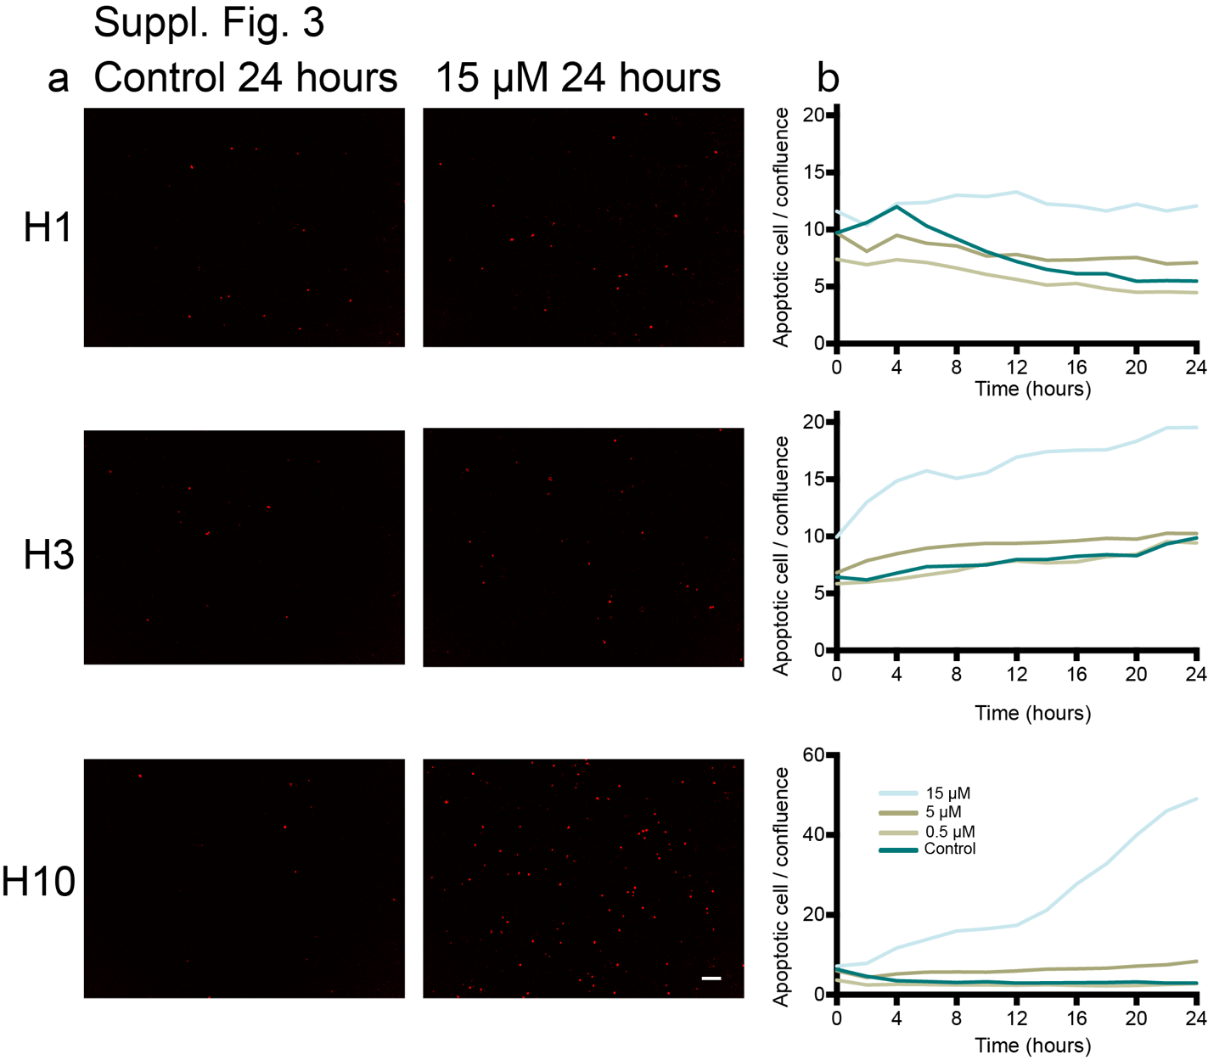
Supplementary Figure 3
Cabozantinib induces cleavage of caspase 3/7 in MBM cell lines.
a Representative images of H1, H3 and H10 cells treated with 0.5 μM, 5 μM or 15 μM cabozantinib compared to untreated cells (control). Caspase 3/7 positive cells are shown in red. b Graphic representation of changes in caspase 3/7 levels during 24 h of exposure to 0.5 μM, 5 μM or 15 μM cabozantinib, compared to untreated cells. Scale bar = 100 μm

Suppl. Fig 4
p-RTK | p-value
p-IGF-1R* | 0.0001
p-Insulin R | 0.0003
p-EphA10 | 0.0047
p-Tie-2 | 0.006
p-MerTK* | 0.0095
p-RYK | 0.0099
p-EphA6 | 0.0213
p-DDR1* | 0.0265
p-VEGF R2 | 0.0296
p-EphB6 | 0.0308
p-EphB1 | 0.0365
p-ALK | 0.0415
p-EphA4 | 0.0457
p-EphA7 | 0.0484
p-PDGF Rb | 0.0653
p-PDGF Ra* | 0.0662
p-EphB2 | 0.0691
p-MSP R | 0.0735
p-EGFR | 0.0755
p-EphA1 | 0.0835
p-VEGF R3 | 0.089
p-ErbB4 | 0.0894
p-TrkC | 0.1053
p-ROR1 | 0.1064
p-FGF R4 | 0.125
p-FGF R1 | 0.1484
p-EphB4 | 0.1533
p-TrkA | 0.1689
p-VEGF R1 | 0.1963
p-ErbB3 | 0.2229
p-Flt-3 | 0.2265
p-HGF R | 0.2449
p-ErbB2 | 0.2594
p-TrkB | 0.2638
p-ROR2 | 0.264
p-SCF R | 0.2764
p-MuSK | 0.2885
p-Axl | 0.3309
p-EphA5 | 0.3396
p-FGF R2a | 0.353
p-c-Ret | 0.5426
p-Dtk | 0.5488
p-EphB3 | 0.554
p-Tie-1 | 0.6754
p-EphA3 | 0.7144
p-DDR2 | 0.8188
p-FGF R3 | 0.9168
p-M-CSF R | 0.9237
p-EphA2 | 0.9834

Supplementary Figure 4
The list of p-RTKs tested with cabozantinib in the p-RTK array sorted after significant downregulation of protein expression. Abbreviations: * the p-RTKs selected to be tested in WB

Supplementary Figure 5
Full-length blots. The frame indicates where the blots were cropped.

