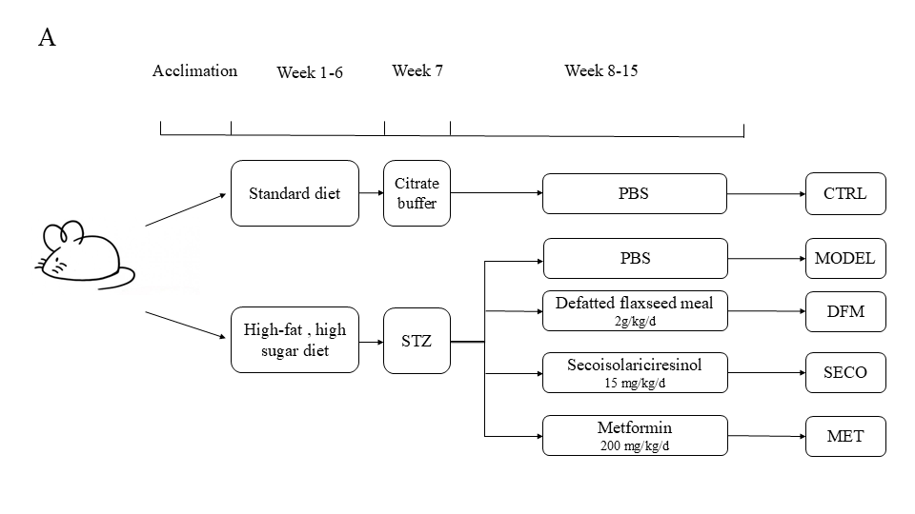
Figure S1. Experimental flow chart
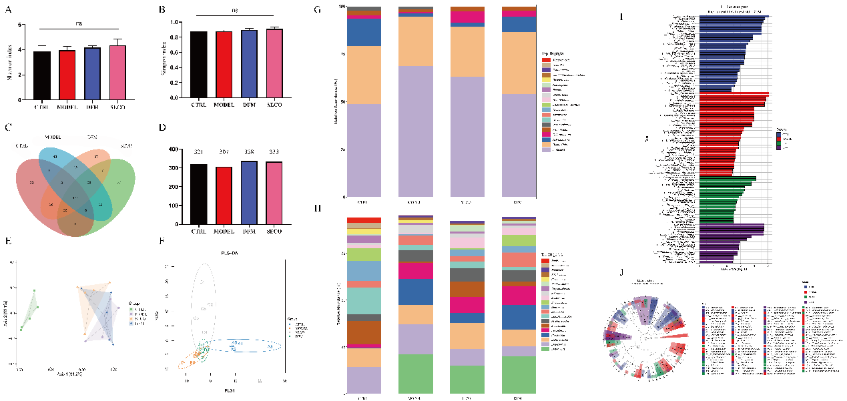
Figure S2. Effects of DFM and SECO on intestinal microbial species diversity in T2DM mice. (A) the Shannon index. (B) Simpon index. (C) Venn diagram of species in each group. (D) Total number of species in each group. (E) PCoA analysis. (F) PLS-DA analysis. (G)phylum level. (H)genus level. (I) LDA discriminant histogram. (J) LEfSe multi-level classification tree diagram. n=5
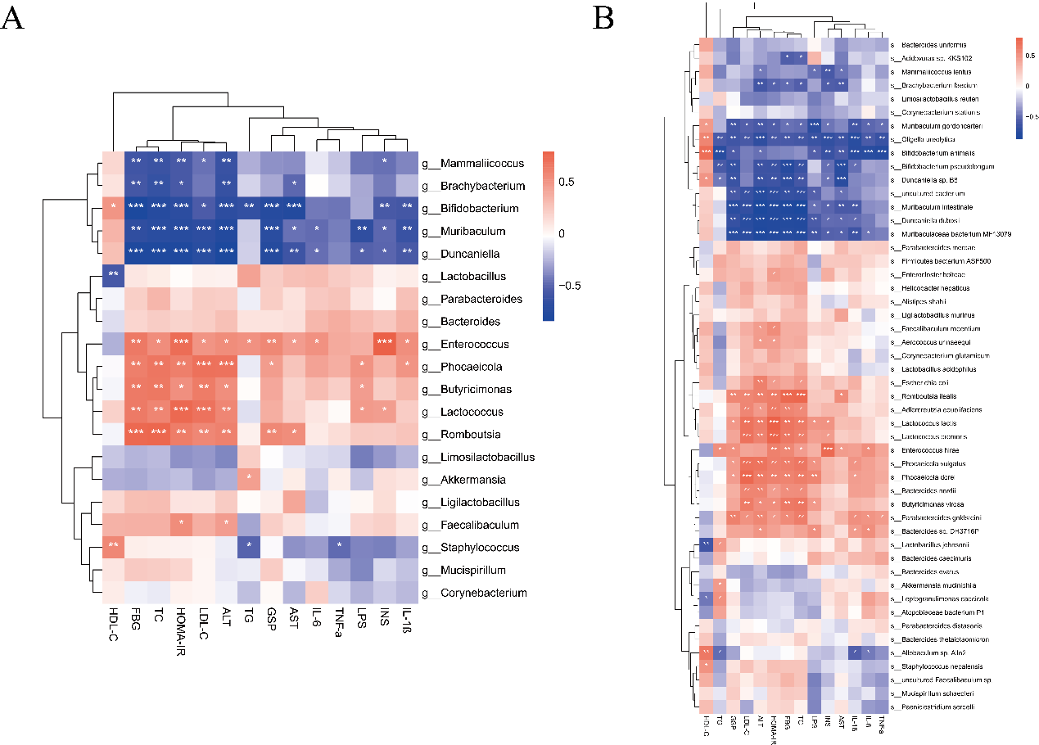
Figure S3. DFM and SECO treatment reversed the imbalance of intestinal flora abundance of mice caused by hyperglycemia and insulin resistance. (A)Sperman correlation analysis between the top 20 microbial genera in the intestinal flora and related parameters of hyperglycemic and insulin-resistant mice. (B) Sperman correlation analysis between the top 50 microbial species in the intestinal flora and related parameters of hyperglycemic and insulin-resistant mice. * P<0.05, ** P< 0.01, n=5.
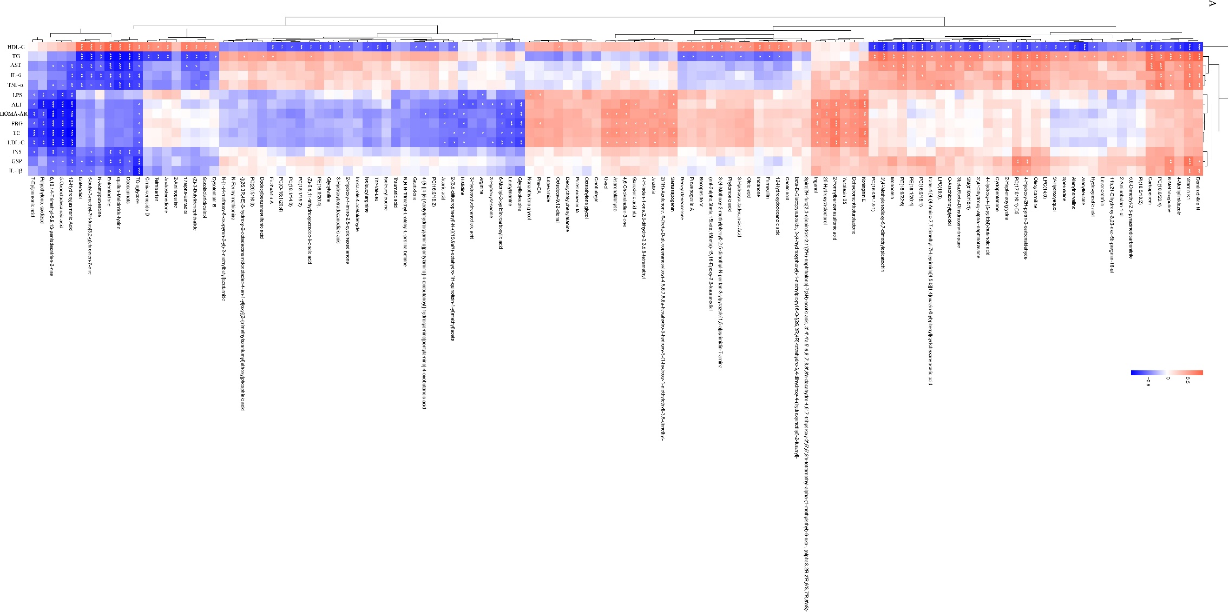
Figure S4. Spearman correlation analysis between the differential metabolites and related parameters of hyperglycemic and insulin-resistant mice.

