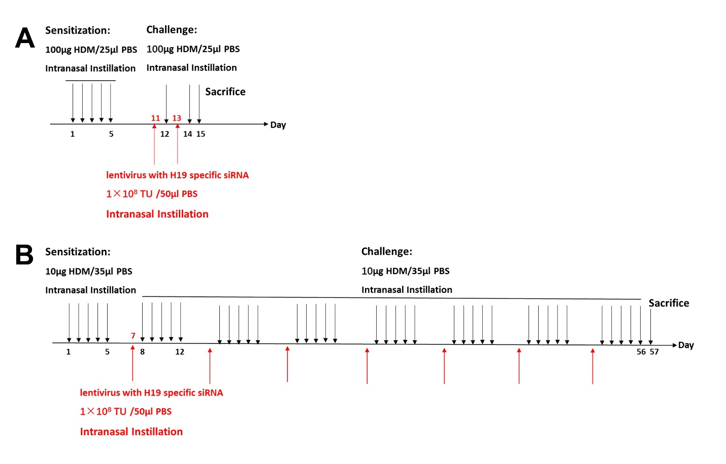
Figure S3. Protocols for murine asthma models. A. acute asthma mice model; B. chronic asthma mice model. HDM: house dust mites.

