Figure S1
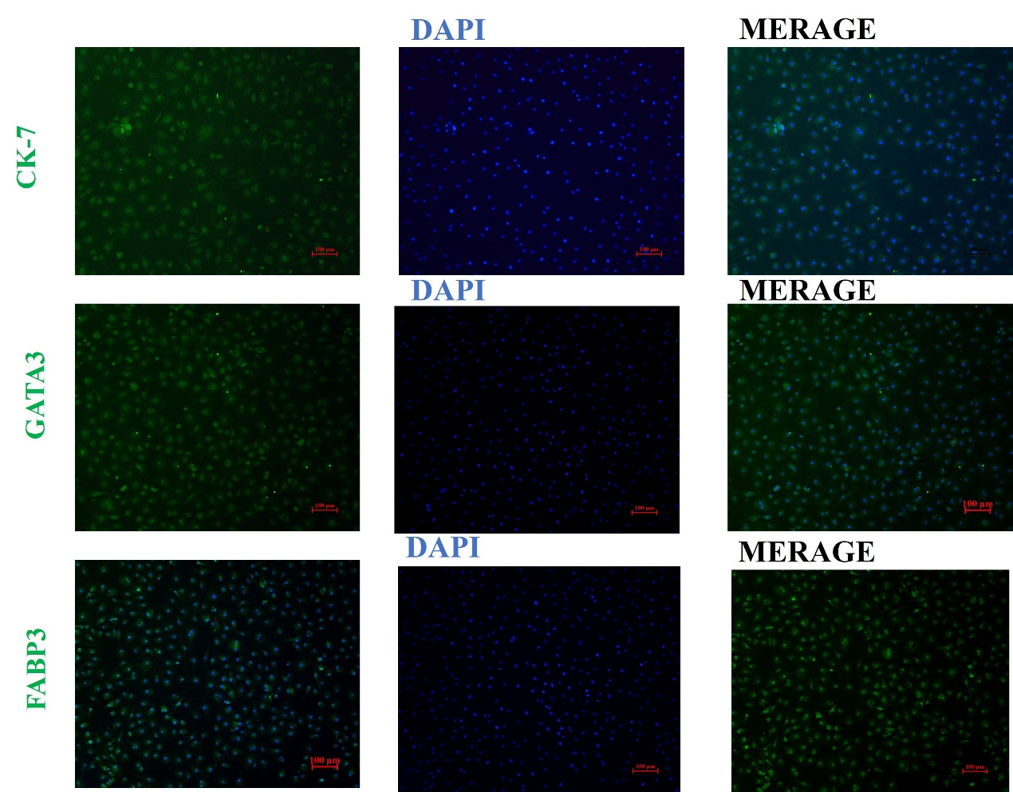
Figure S2. Identification of ovine trophoblast cells by immunohistochemical markers.
Positive staining for CK-7, GATA3, and FABP3 confirms trophoblast cell identity.

