A Novel Green Electrocatalytic Approach for the Rapid Synthesis of Stable Oxidized Polysaccharides with a Proposed Radical Oxidation Potential
Somayeh Eisvand Rajabi ª, Shahrzad Javanshir ^{a,*}, Mostafa Mahinroosta ^{b}
ª Department of Chemistry, Iran University of Science and Technology, Tehran, Iran.
^{b} Department of Energy, Materials and Energy Research Center, Karaj 3177983634, Iran.
Corresponding author: Shahrzad Javanshir, Email: shjavan@iust.ac.ir, Tel.: 021-73228308

Alginate
Alginate (Alg) is a linear copolymers that is quite abundant in nature and there is as a structural component in marine brown algae (phaeophyceae). The structure of Alg consists of (1→4) linked α-L-guluronate (G) and β-D-mannuronate (M) (Scheme 1) ¹⁻⁴.
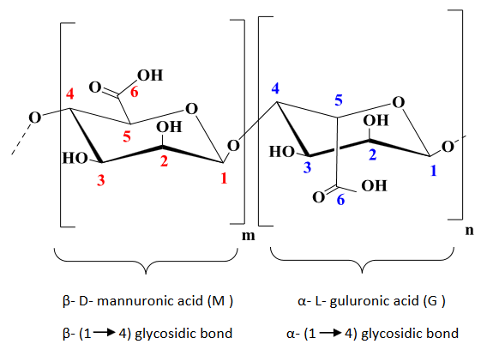
Scheme 1. The chemical structure of the Alg ⁵.

Based on our findings in all spectrums of FTIR of Alg, the broad absorption peak observed near 3455 cm⁻¹ corresponds to the O–H stretching vibrations in alginate. Peaks appearing at 1229, 1150, and 1027 cm⁻¹ are attributed to the stretching modes of C–O, C–C, and C–O–C bonds within the alginate structure, respectively ⁶⁻⁸. When comparing the spectrum of oxidized alginate (OAlg) to that of native alginate, a new absorption band emerges around 1735 cm⁻¹, which confirms the formation of aldehyde functional groups resulting from oxidation within the polysaccharide structure (Figure 1) ⁹.
Figure 1. FTIR analysis of Alg and oxidized Alg (OAlg) different samples.(a) alg, (b) 0.5 h, (c) 1h, (d) 1.5h .

The ¹H NMR spectrum of Alg reveals characteristic signals for the guluronic acid units (G) and mannuronic acid units (M) within the chemical shift range of 3.6 to 4.9 ppm. ^{10,11}. A novel resonance appearing at 4.88 ppm corresponds to the proton in the hemiacetal structure formed through interaction between the aldehyde group and an adjacent hydroxyl. In addition, one new peak at8.1 ppm further confirmed that Alg has been converted into OAlg ¹². The ¹H NMR results were in agreement with the FTIR results (Figure 2).
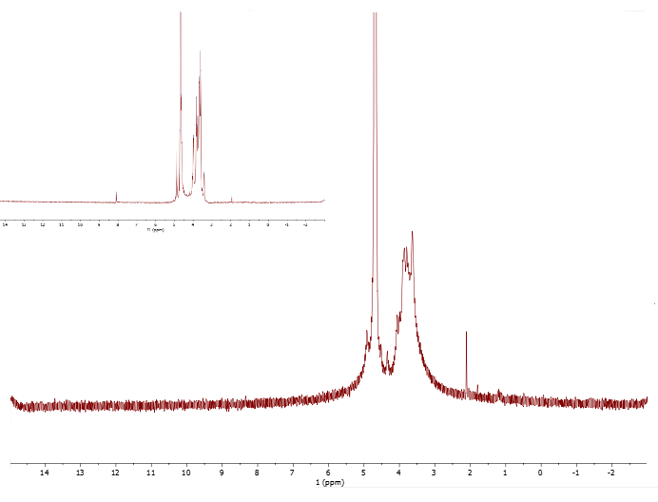
Figure 2. Comparison of ¹H NMR spectra of Alg with OAlg.

Xanthan gum
Xanthan gum (XG) is an anionic polysaccharide which composed of a glucan backbone linked through β-1,4 glycosidic bonds and substituted on every second unit with a charged trisaccharide side chain containing a D-glucuronic acid between two D-mannoses (Scheme 2) ^{13,14}.

Scheme 2. The chemical structure of the XG ¹⁵.

The FTIR spectra of XG and Oxidized xanthan (OXG) are depicted in Figure 3. The effectiveness of the oxidation procedure was confirmed by analyzing and comparing the FT-IR spectra of the pristine XG and the oxidized OXG. Both spectra showed characteristic absorption bands at 1000-1220 cm⁻¹ corresponding to C–O and C–O–C stretching vibrations, a peak near 1415 cm⁻¹ related to bending vibrations of OH groups, signals around 2920 cm⁻¹ attributed to CH stretching, and a broad band between 3000 and 3600 cm⁻¹ associated with OH stretching vibrations. The original XG showed absorption peaks at 1736 cm⁻¹ and 1620 cm⁻¹, which correspond to the carbonyl groups of acetate and pyruvate in each repeating unit. A distinct new peak appearing at 1741 cm⁻¹ was assigned to the C=O stretching vibration of aldehyde groups in OXG, demonstrating that the oxidation reaction was successfully carried out. ^{16,17}.
Figure 3. FTIR spectra of XG and OXG. (a) xantan, (b) 0.5h, (c) 1h, (d) 1.5h
As shown in Figure 4, a singlet appears at a chemical shift of 1.77 ppm, which is attributed to the methyl protons present in the pyruvic acid moieties. The signal observed at 2.01 ppm corresponds to the acetate groups. Moreover, two peaks appearing between 3.86 and 5.26 ppm are attributed to the protons of the pyranosidic rings found in the monosaccharide units of the biopolymer's structure. The peak at 8.16 ppm confirms the presence of aldehyde groups and successful oxidation ¹⁸⁻²⁰.
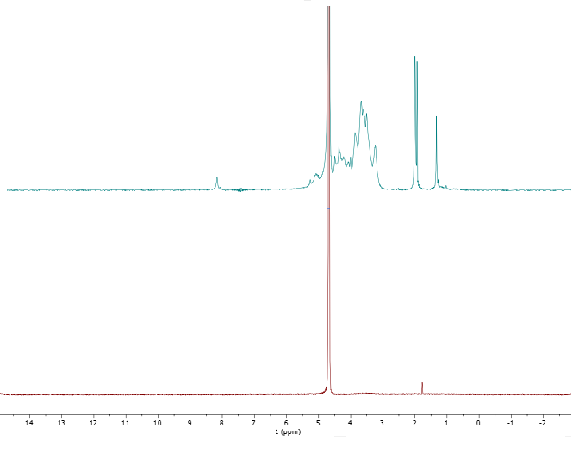
Figure 4. ¹H NMR spectra of XG and OXG.

Reference
1. Agulhon, P., Markova, V., Robitzer, M., Quignard, F. o. & Mineva, T. Structure of alginate gels: interaction of diuronate units with divalent cations from density functional calculations. Biomacromolecules 13, 1899-1907 (2012).
2. Hecht, H. & Srebnik, S. Structural characterization of sodium alginate and calcium alginate. Biomacromolecules 17, 2160-2167 (2016).
3. Huang, H. et al. Humidity-Adaptive Behaviors of Alginate/Chitosan Complex Fiber. ACS Applied Polymer Materials 6, 4634-4641 (2024).
4. Chen, X., Wang, X., Pan, T., Mao, L. & Wang, H. Highly Flexible Magnesium–Calcium Alginate Dense Hydrogel Manufactured by Soft Spray for Drug Loading. ACS Applied Polymer Materials 6, 5070-5079 (2024).
5. Augst, A. D., Kong, H. J. & Mooney, D. J. Alginate hydrogels as biomaterials. Macromolecular bioscience 6, 623-633 (2006).
6. Abou-Zeid, R. E., Awwad, N. S., Nabil, S., Salama, A. & Youssef, M. A. Oxidized alginate/gelatin decorated silver nanoparticles as new nanocomposite for dye adsorption. International journal of biological macromolecules 141, 1280-1286 (2019).
7. You, F., Wu, X., Kelly, M. & Chen, X. Bioprinting and in vitro characterization of alginate dialdehyde–gelatin hydrogel bio-ink. Bio-design and manufacturing 3, 48-59 (2020).
8. Li, Y. et al. Peptide-conjugated alginate fiber: A skeletal muscle regenerative scaffold. Carbohydrate Polymers, 123299 (2025).
9. Emami, Z., Ehsani, M., Zandi, M. & Foudazi, R. Controlling alginate oxidation conditions for making alginate-gelatin hydrogels. Carbohydrate polymers 198, 509-517 (2018).
10. Ge, L. et al. Antibacterial dialdehyde sodium alginate/ε-polylysine microspheres for fruit preservation. Food Chemistry 387, 132885 (2022).
11. Park, J., Nam, J., Yun, H., Jin, H.-J. & Kwak, H. W. Aquatic polymer-based edible films of fish gelatin crosslinked with alginate dialdehyde having enhanced physicochemical properties. Carbohydrate polymers 254, 117317 (2021).
12. Kholiya, F., Chaudhary, J. P., Vadodariya, N. & Meena, R. Synthesis of bio-based aldehyde from seaweed polysaccharide and its interaction with bovine serum albumin. Carbohydrate polymers 150, 278-285 (2016).
13. Bak, J. & Yoo, B. Effect of Fucoidan on Conformation of Xanthan Gum and Its Tribo-Rheological Properties. Biomacromolecules 25, 7274-7282 (2024).
14. Roy, A. et al. Hydrophobically modified xanthan: an amphiphilic but not associative polymer. Biomacromolecules 15, 1160-1170 (2014).
15. Jadav, M., Pooja, D., Adams, D. J. & Kulhari, H. Advances in xanthan gum-based systems for the delivery of therapeutic agents. Pharmaceutics 15, 402 (2023).
16. Ngwabebhoh, F. A. et al. Self-crosslinked chitosan/dialdehyde xanthan gum blended hypromellose hydrogel for the controlled delivery of ampicillin, minocycline and rifampicin. International Journal of Biological Macromolecules 167, 1468-1478 (2021).
17. Malik, N. S. et al. Chitosan/xanthan gum based hydrogels as potential carrier for an antiviral drug: Fabrication, characterization, and safety evaluation. Frontiers in chemistry 8, 50 (2020).
18. Amaral, C. N., Oliveira, P. F., Pedroni, L. G. & Mansur, C. R. Viscoelastic behavior of hydrogel‐based xanthan gum/aluminum lactate with potential applicability for conformance control. Journal of Applied Polymer Science 138, 50640 (2021).
19. Paiva, D., Gonçalves, C., Vale, I., Bastos, M. M. & Magalhães, F. D. Oxidized xanthan gum and chitosan as natural adhesives for cork. Polymers 8, 259 (2016).
20. Njuguna, D. G. & Schönherr, H. Xanthan gum hydrogels as high-capacity adsorbents for dye removal. ACS Applied Polymer Materials 3, 3142-3152 (2021).

