Supplementary Data

Supplementary Table1:

Cynomolgus monkey adipose-derived stem cells (ADSC) isolated information
Fat Number | Isolation time | Sex | Age | Body weight | Isolated Fat
ADSC1 | 26,March. 2016 | Male | 8 year | 7.3kg | 5 gram
ADSC2 | 26,March. 2016 | Female | 10 year | 9.5kg | 6 gram
ADSC3 | 26,March. 2016 | Male | 6 year | 6.2kg | 8 gram
ADSC4 | 16,Nov. 2016 | Male | 16 year | 16.6kg | 9.5 gram
ADSC5 | 16,Nov. 2016 | Female | 9 year | 10.3kg | 10 gram
ADSC6 | 16,Nov. 2016 | Male | 7 year | 8.2kg | 8.5 gram

Supplementary Table 2:

Primers used for Cynomolgus ADSC cells characterization and differentiation

Gene Forward Reverse

CD 10 TTGTAAGCAGCCTCAGCCG TTGTCCACCTTTTCTCGGAG
CD 13 GCCGTGTGCACAATCATCGCACT CACCAGGGAGCCCTTGAGGTG
CD 59 ACACTCTACTACATGTGACTG TGCAAAAGTCAGCCTATGCC
Vimentin CCAACGAGAAGGTGGAATTGCAGG GCCATCTTTACATTGAGCAGGTCC
BMP-6 CTCGGGGTTCATAAGGTGAA ACAGCATAACATGGGGCTTC
Sox2 ACATGATGGAGACGGAGCTGAAGC GCTGCTCCTGCATCATGCTGTAGC
AP AAGACCCCAGTTACTGGCGACAGC CCTTTCCGATGGCCTCATCCATCT
OCT4 GAAGCTGGAGAAGGAGAAGC GAACATGTGTAAGCTGCGGCCCTTG
Nanog CAAAGGCAAACAACCCACTT CTGGATGTTCTGGGTCTGGT
hTERT GACCATCTTTCTGGGTTCCA ACACTCATCAGCCAGTGCAG
Telomerase CTGCGTGTGCGTGCTCTGGAC CACCTCAGCAAACAGCTTGTTCTC
BMP2 CTGTCTTCTAGTGTTGCTGCTTCC TTCTGAGTCACTAACCTGGTGTCC
BMP4 ACACTGTGAGGAGTTTCCATCACG TTCCAGCCCACGTCACTGAAGTCC
VEGF TTTCTGCTCTCTTGGGTGCACTGG TGGCTTGTCACATCTGCAAGTACG
CD 166 AGATACCATTATCATCATACCTTGCCGACT TGTCTTTGTATTCGTGTACATCGTCG
Collagen I GCCAGGATGTCCGGCAACCAG TCCCCTCTGGGTCCTTGTTC
Collagen X GGTATAGCAGTAAGAGGAGAGCA AGGACTTCCGTAGCCTGGTTT
Pax6 CCATGTGGGCCGAACAG TGGTGAAGCTGGGCATAGG
Olig2 CCAGCAACAATTAACTTAGG CTTAGAAGAGACGCAGAG
NeuroD1 ACGCAGAAGGCAAGGTGTCC GTTCCTCGTCCTGAGAACTG
MAP-2 TGGAGGAAGCCTCGAAGATG TCTGTGCCTTGCATGTCCTT
LMX1A GCAGGAAGGTGAGAGAGACT TCCCACCACCATTTGTCTGAG
Ngn2 TGGCTGGCATCTGCTCTATT TAGGCATTGTGACGAATCTG
NURR1 AGTGGTTCGCACAGACAGTT CGCCTGGAACCTGGAATAGT
EN1 GATCGTCCATCCTCCGGTCC ATGTAGCGGTTTGCCTGGAA
TH AGCTGATTGCTGAGATCGCC GGTGTAGACCTCCTTCCAGGT
GAPDH ACCACAGTCCATGCCATCAC TCCACCACCCTGTTGCTGTA
GAPDH1 TGGAAAAACCTGCCAAGTACG GTCATACCAGGAAATGAGCTTGAC

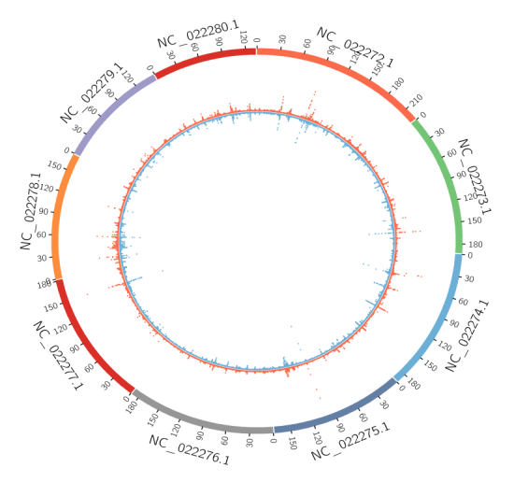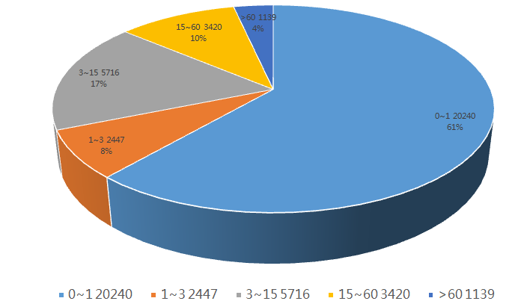

Supplementary Fig.1

Reads, genes and the genome of Cynomolgus monkey ADSCs transcriptome

Right: The Total Mapped Reads: the outermost circle shows the chromosomes of the genome. The red part of the circle inside represents the number of Reads aligned to the positive chain, The blue portion represents the number of Reads that are aligned to the negative strand.
Left: The Total Mapped Reads percentage in clean Reads were recorded in pie chart.

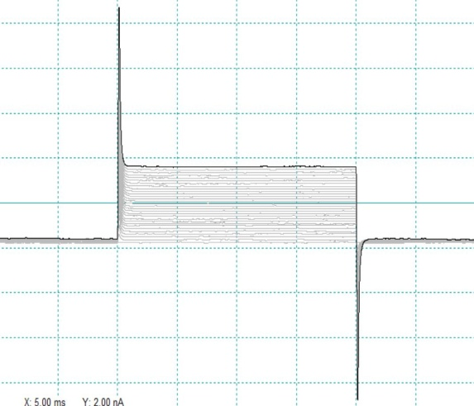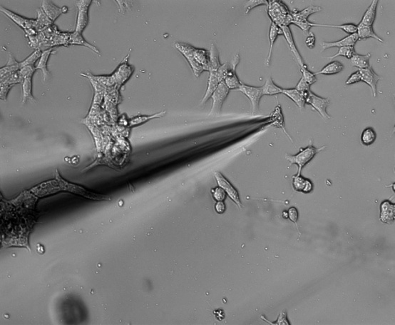

Supplementary Fig.2

Cynomolgus ADSC action potential test.
The sodium currents were not detected in this experiment (n=13). right X-axis is time, Y-axis is Amplitude, one green square means 5.00ms and 2.00nA, left is anchored the cells for measuring.

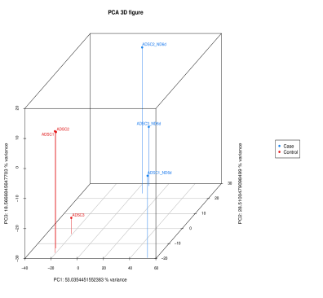

Supplementary Fig. 3
Principal component analysis (PCA) between samples.

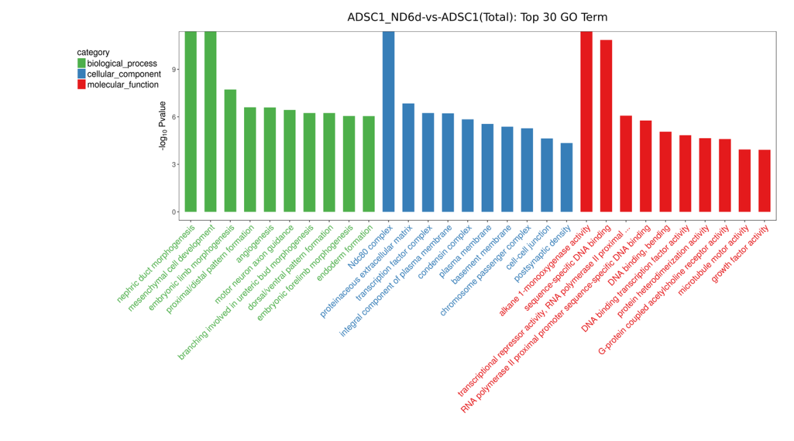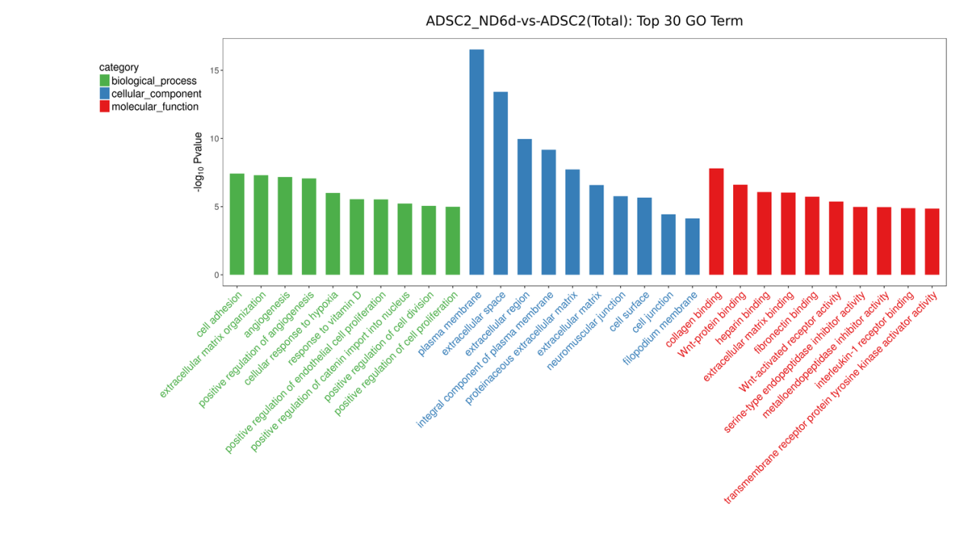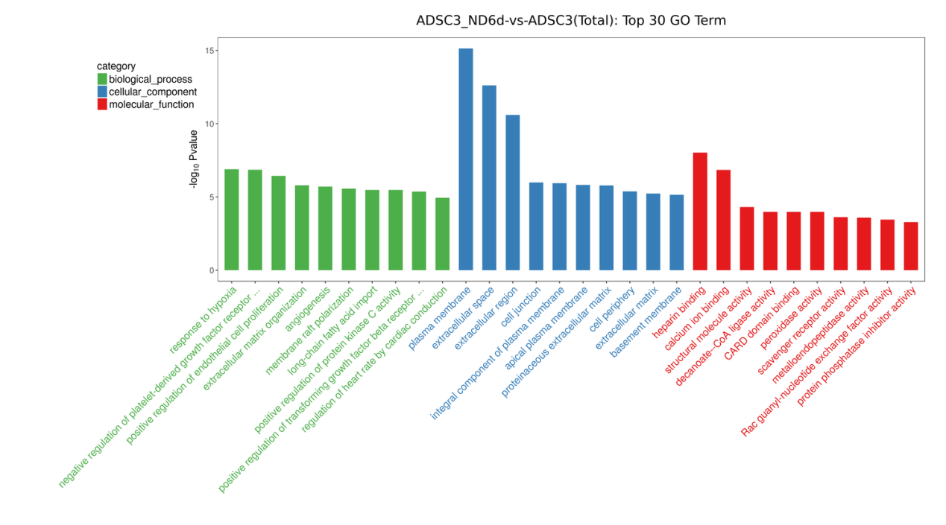

Supplementary Fig 4.
GO enrichment analysis top30 differentially expressed genes in the figure5C, the X coordinate is the name of the GO entry and the Y coordinate is -log10 pvalue

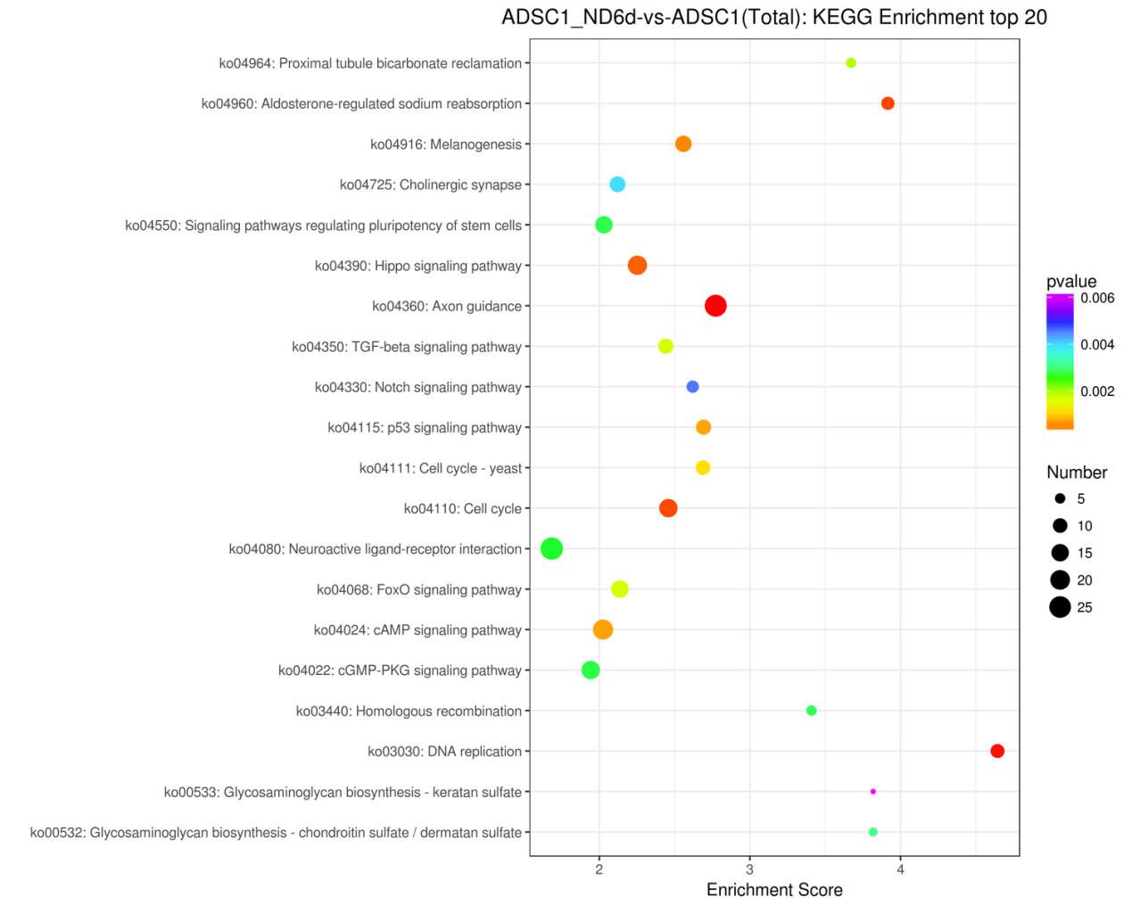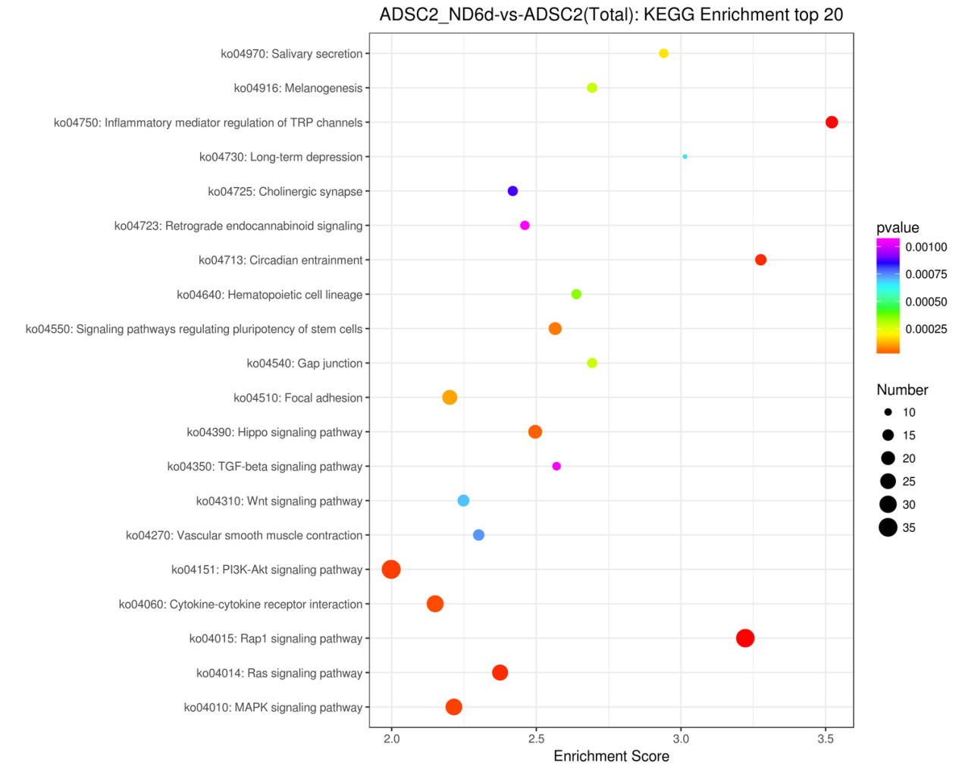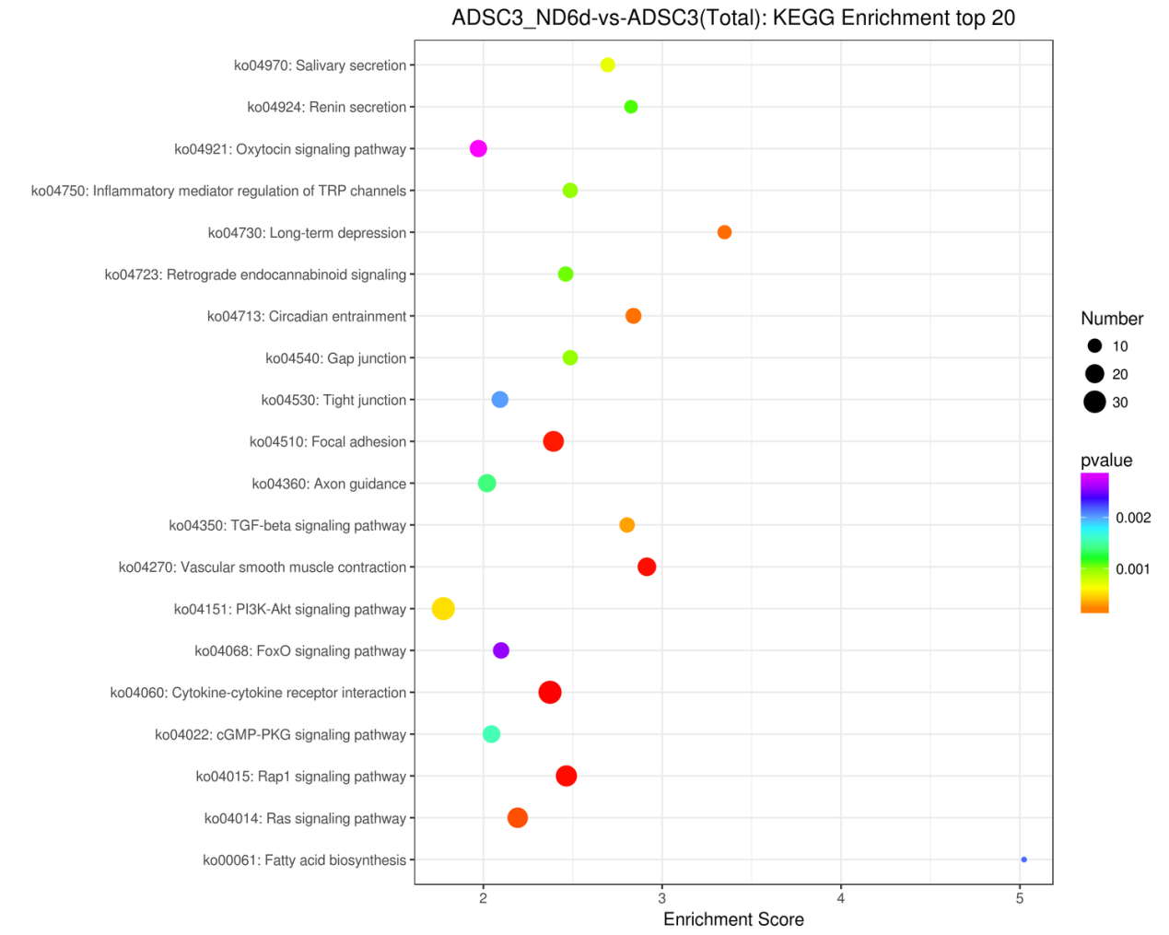

Supplementary Fig. 5: the KEGG enrichment analysis top20.
In the figure, different colors and size of bubble represent KEGG values of different ranges, and the horizontal coordinate is the enrichment score, and the vertical coordinate is the related pathway involved in the differentiation.

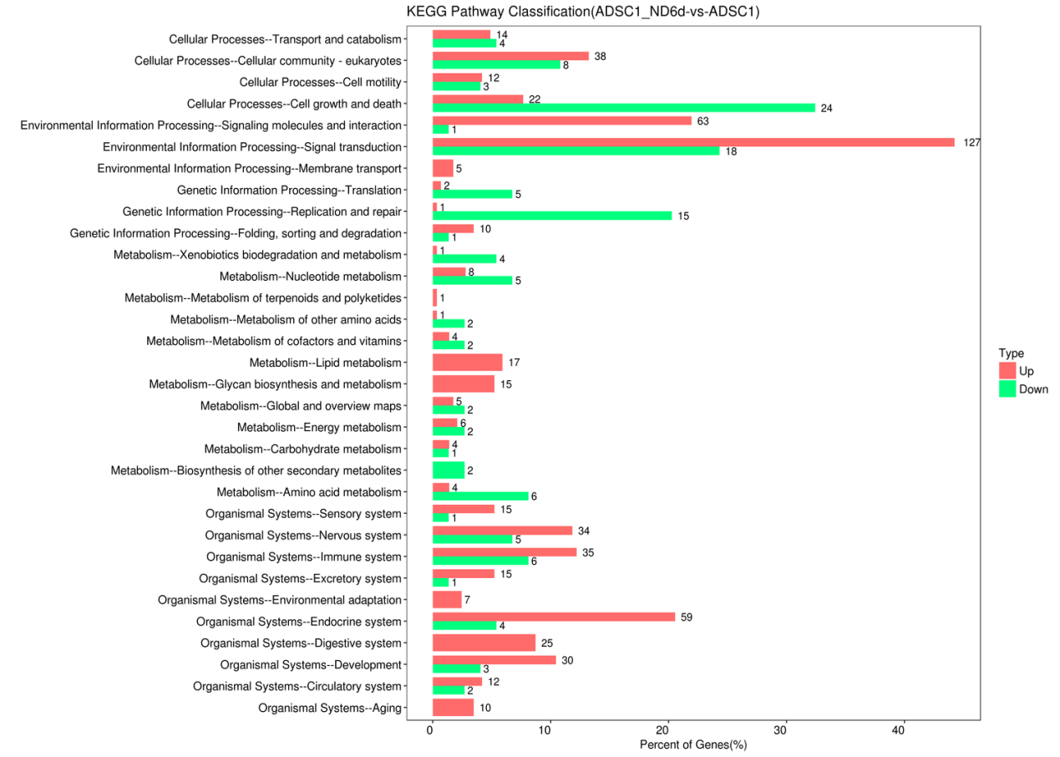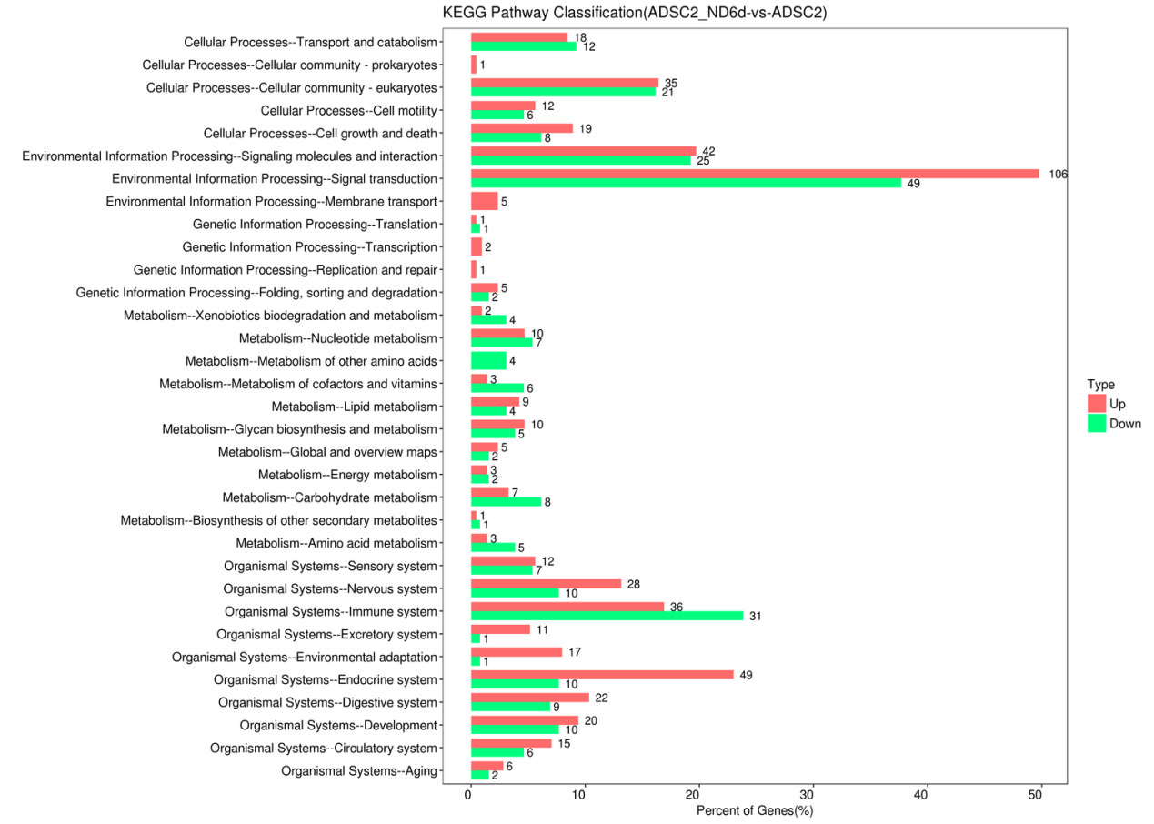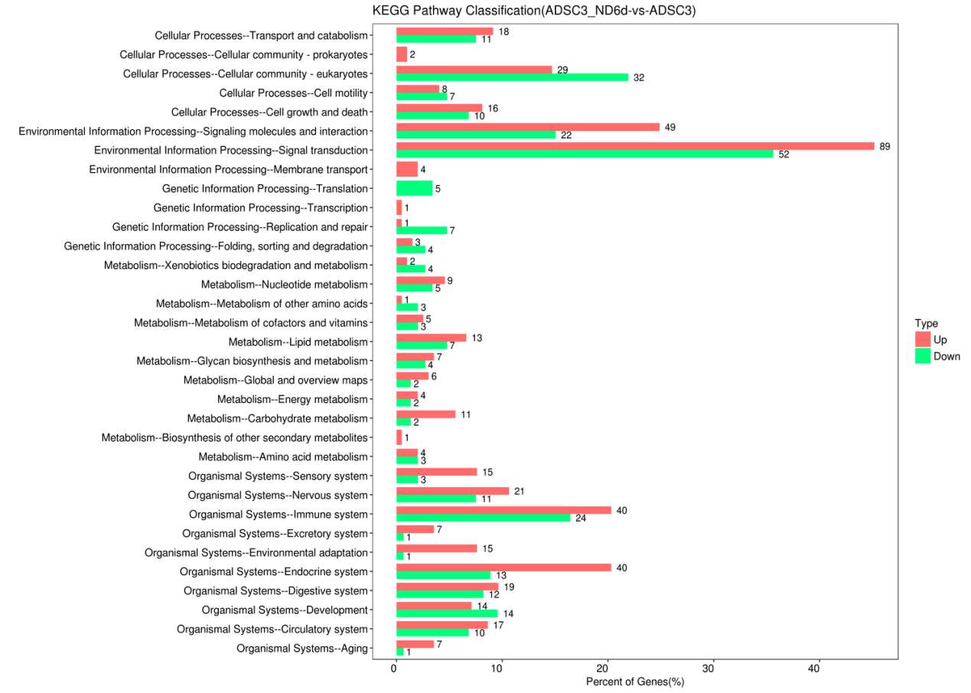

Supplementary Figure 6:
Distribution of up-regulated and down-regulated differentially expressed genes at KEGG Level2 Caption: horizontal axis are comments to the rise in Level2 stores metabolic pathways (cut) differentially expressed genes and all comments to the rise in KEGG pathways (cut) the ratio of the total number of differentially expressed genes (%), the vertical axis represents Level2 stores pathway, the name of the columns on the right side of the figures representing the annotation to the Level2 stores under the pathway of increase number of differentially expressed genes (cut).

Supplementary Fig. 7

Supplementary Fig. 8
Heatmap indicating the expression pattern across selected phenotypic groups for the most likely biomarkers.

Supplementary Fig. 9
Neurogenesis was built according to WikiPathway for ADSCs neuron-like differentiation of Cynomolgus monkey.

