Supplemental Material
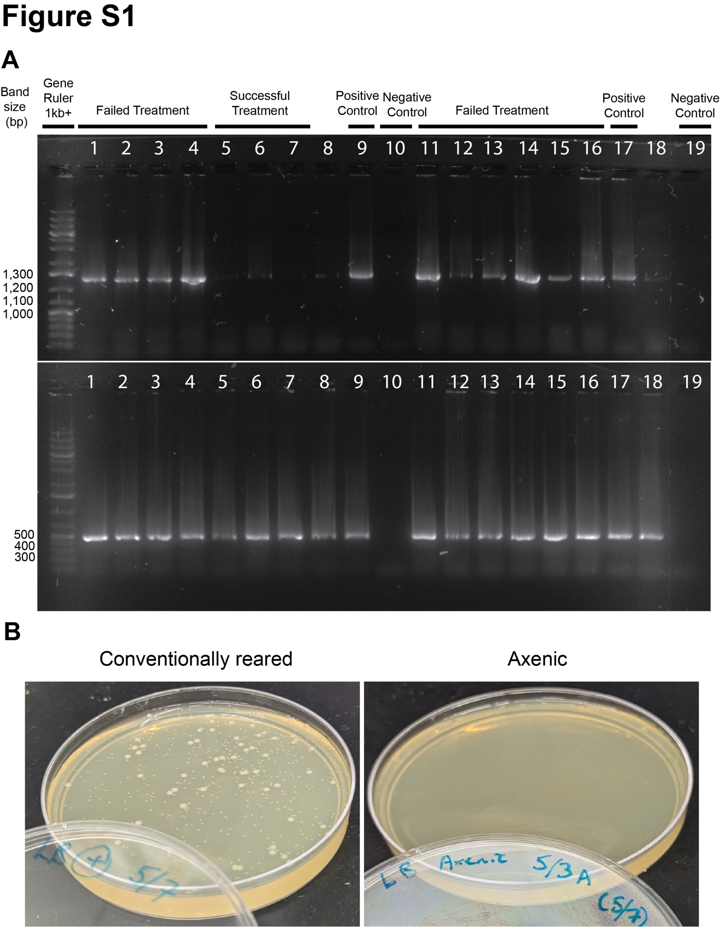
Figure S1: Verification of axenic treatment. Representative gel electrophoresis (A) and LB agar plate images (B) that verified axenic treatment. (A) The lanes on the gel showing failed or successful axenic treatment and positive or negative controls are indicated. (B) Plate images showing a positive control of conventionally raised Oregon R males with observable colony formation (left) and successful axenic treatment showed little to no colony formation (right).
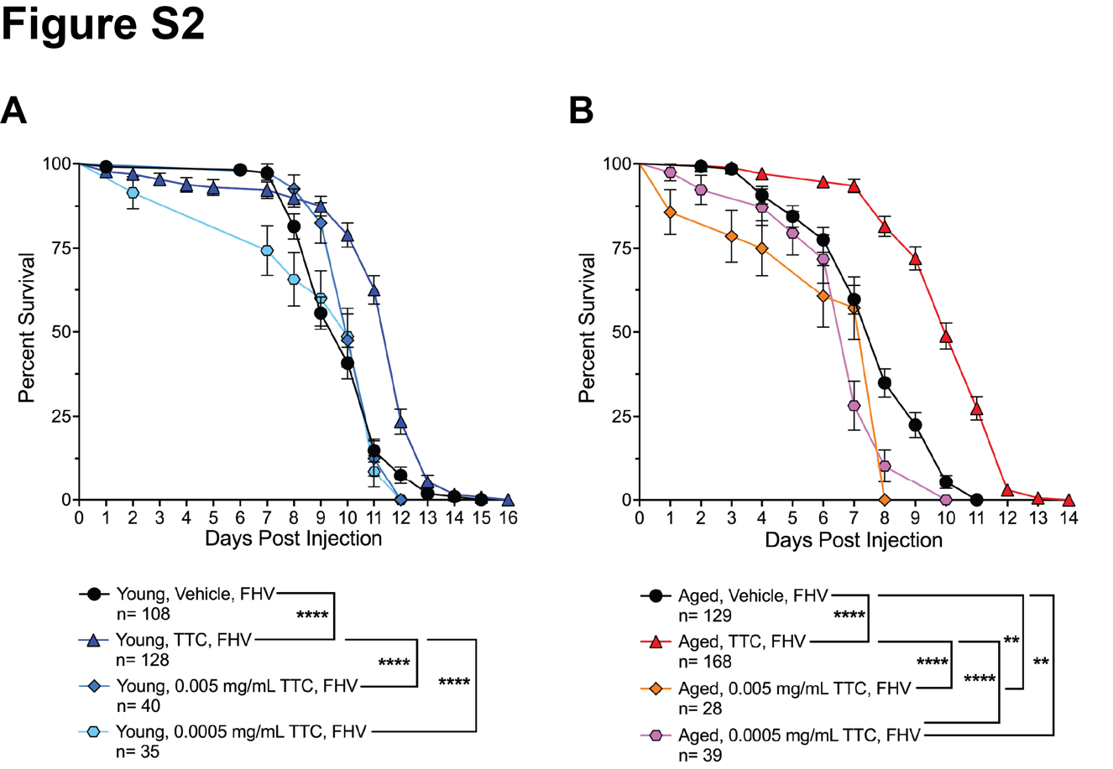
Figure S2: TTC protection after FHV infection is dose-dependent. Survival curves of young (A) and aged (B) male Oregon R flies infected with FHV or control-injected with the same volume of cell culture media. The graphs compare the survival curves of young and aged males. After injection, flies were then placed on various doses of TTC food or vehicle food. Statistics of FHV survival are based on a Log-Rank (Mantel-Cox) test. ****p<0.0001.
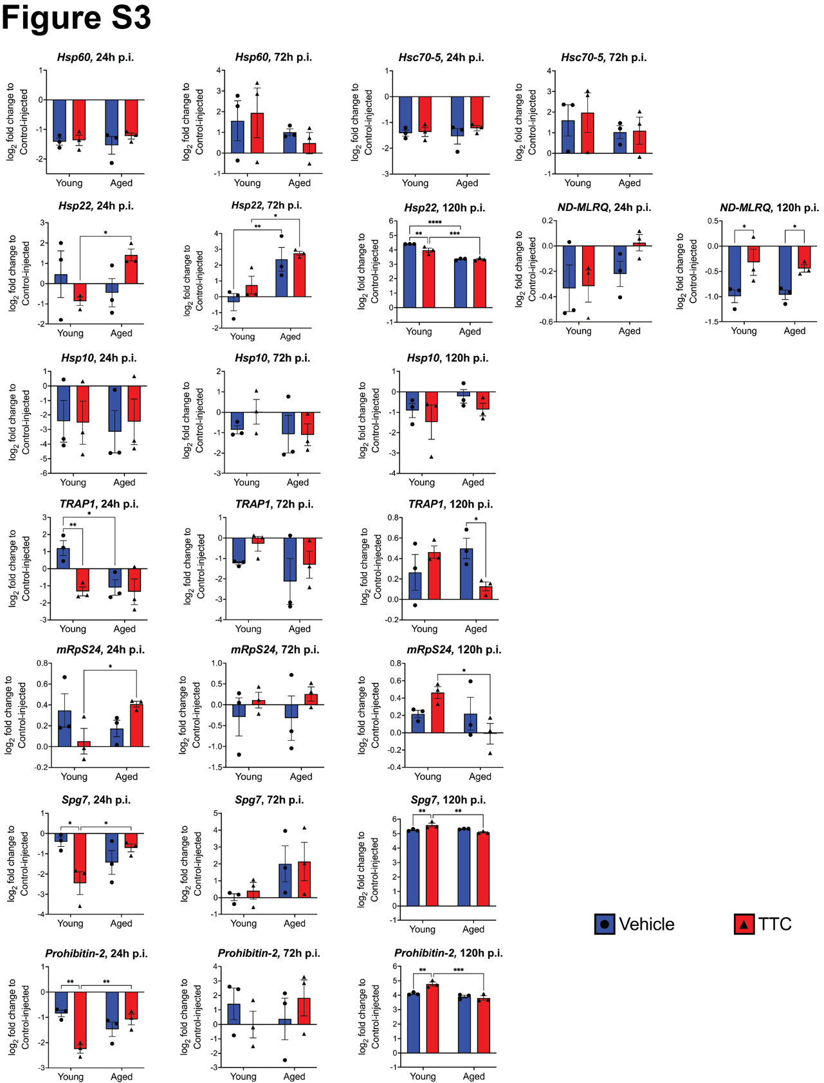
Figure S3: Additional gene expression data of genes involved in UPR^{mt}. Gene expression determined by RT-qPCR after FHV infection and comparing flies fed vehicle or TTC. Graphs depict +/- SEM of three biological replicates from groups of 5 flies. Statistics are based on a two-way ANOVA followed by Tukey post-test to correct for multiple comparisons. *p<0.05, **p<0.01, ***p<0.001, ****p<0.0001.
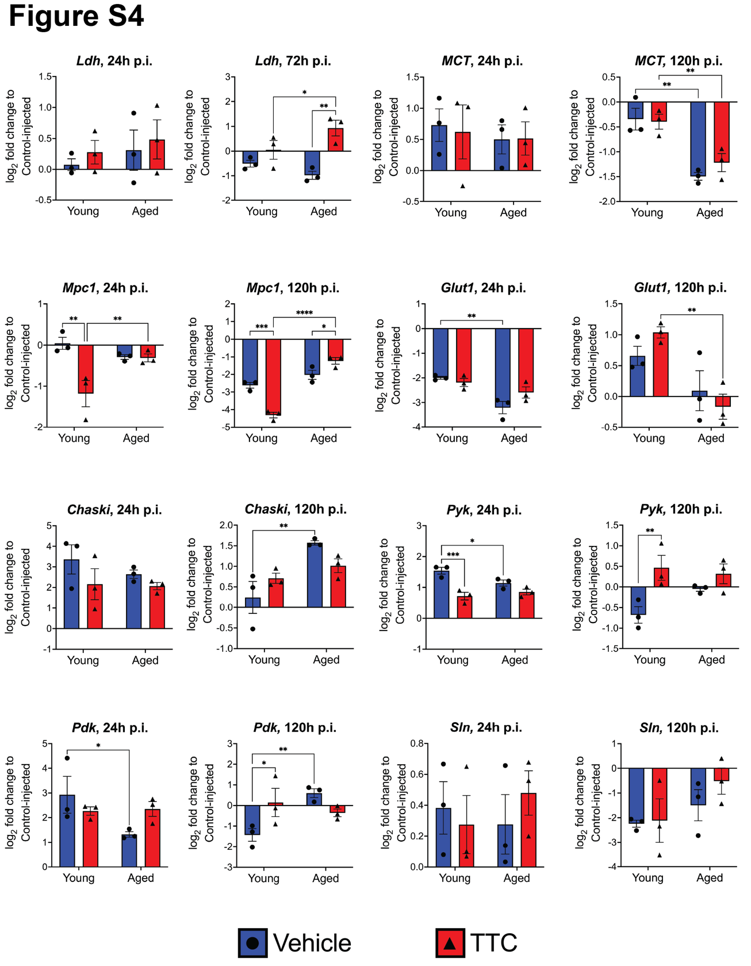
Figure S4: Additional gene expression data of genes involved in glycolysis. Gene expression determined by RT-qPCR after FHV infection and comparing flies fed vehicle or TTC. Graphs depict +/- SEM of three biological replicates from groups of 5 flies. Statistics are based on a two-way ANOVA followed by Tukey post-test to correct for multiple comparisons. *p<0.05, **p<0.01, ***p<0.001, ****p<0.0001.
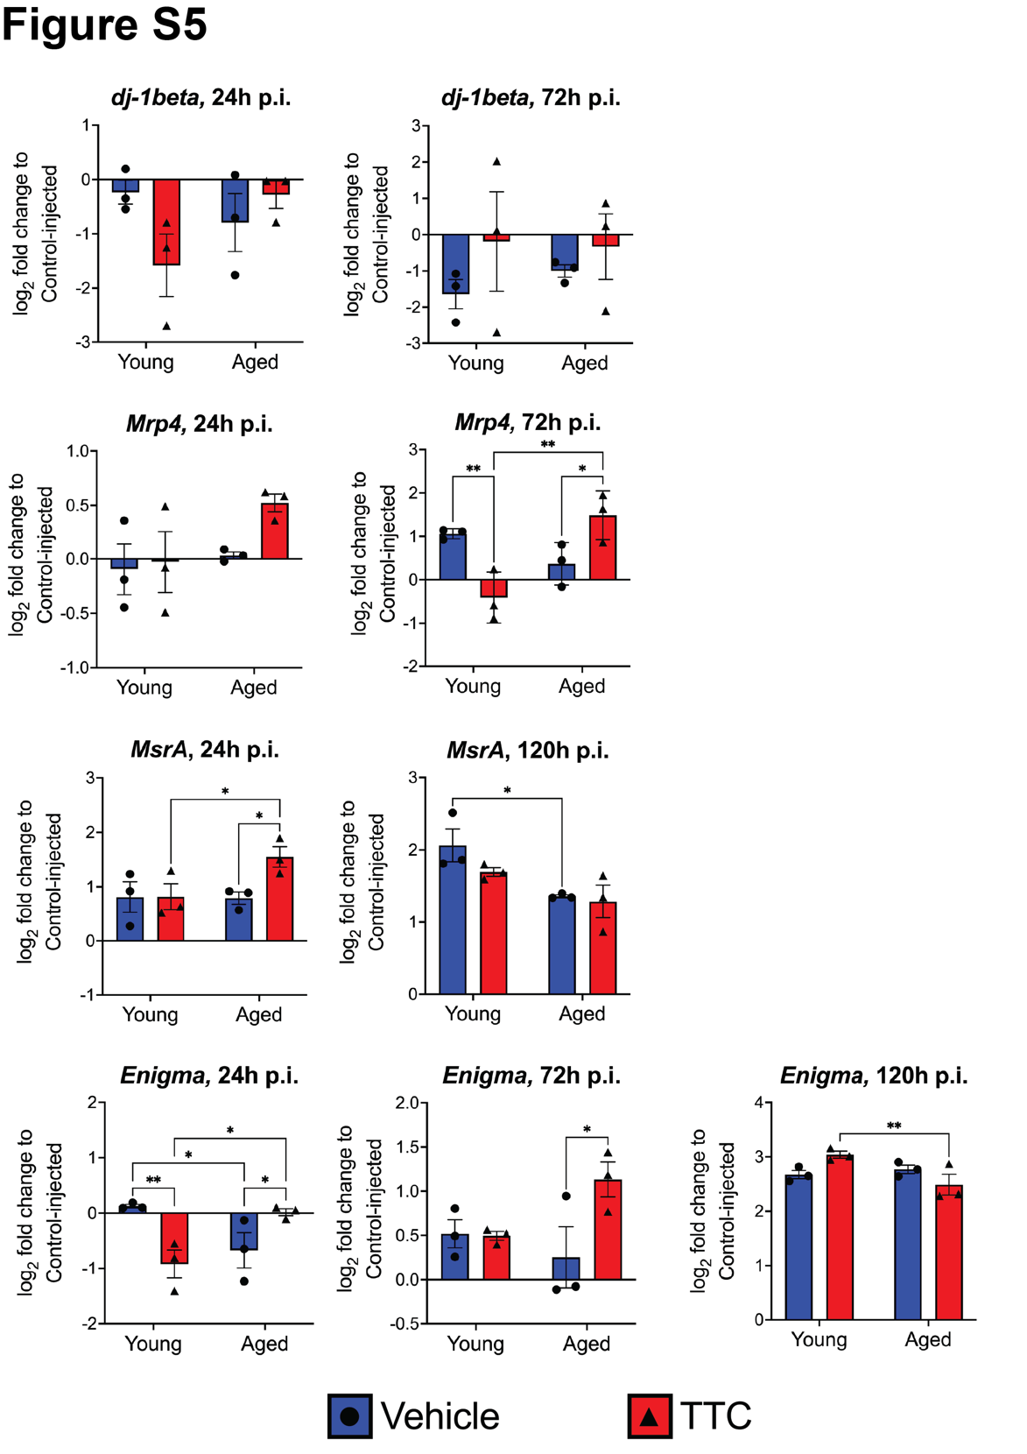
Figure S5: Additional gene expression data of genes involved in oxidative stress response.
Gene expression determined by RT-qPCR after FHV infection and comparing flies fed vehicle or TTC. Graphs depict +/- SEM of three biological replicates from groups of 5 flies. Statistics are based on a two-way ANOVA followed by Tukey post-test to correct for multiple comparisons. *p<0.05, **p<0.01.
Table S1. List of primers used in this study.

Gene Name | Primer Sequence
Hsp60  (RT-qPCR) | FW: 5’ – CGTTTGCCAGTTTCGCTTG – 3’  RV: 5’ – CCTTCAGCTCAATGGACTTGG – 3’
Hsc-70-5  (RT-qPCR) | FW: 5’ – AAGTGTCGCTCGAACTGC – 3’  RV: 5’ – GAGGTCAGGAAAGCCACTTC – 3’
Hsp22  (RT-qPCR) | FW: 5’ – GCCTCTCCTCGCCCTTTCAC – 3’  RV: 5’ – TCCTCGGTAGCGCCACACTC– 3’
Hsp-10  (RT-qPCR) | FW: 5’ – CCCGCATCTAGCGAGAATAG – 3’  RV: 5’ – CTCCTTTCGTCTTGGTCAGC – 3’
TRAP1  (RT-qPCR) | FW: 5’ – GCAGCGTTCAATATCACCATTG – 3’  RV: 5’ – GACCTCGTGGTCGGAGTATAAGG – 3’
mRpS24  (RT-qPCR) | FW: 5’ – CAAATCGTGGAACTCATGGAACA – 3’  RV: 5’ – ACACATCCTCTATGGCGGTCT – 3’
Prohibitin-2  (RT-qPCR) | FW: 5’ – AGCCGCCTATGGAGTCAGT – 3’  RV: 5’ – CTCGGAGTAAATGTCGCTCTG – 3’
ND-MLRQ  (RT-qPCR) | FW: 5’ – ATCCCGAACCATGGCAAGAG – 3’  RV: 5’ – AAGTTTGGGGCAGCACTCTT – 3’
Spg7  (RT-qPCR) | FW: 5’ – AGCATGAACAGCCCGAGAAG – 3’  RV: 5’ – CTCTGCTGCTCTTATCGCCAT – 3’
dj-1beta  (RT-qPCR) | FW: 5’ – GAAAAGCGCGCTGGTGATTT – 3’  RV: 5’ – CTTATCCGAGGCAACCTGGG – 3’
Mrp4  (RT-qPCR) | FW: 5’ – ACAAATCGGATTCCCTGGGAG – 3’  RV: 5’ – ACCCAAACGTGGAGTTTCATTTT – 3’
MsrA  (RT-qPCR) | FW: 5’ – GCCGGTTCACGATGTGAATG – 3’  RV: 5’ – GGTGGCTCCATACAGGGATT – 3’
Enigma  (RT-qPCR) | FW: 5’ – GATTCCACGGGATGAGATGGC – 3’  RV: 5’ – GGTGAGGTCTCCTCCGTTT – 3’
Rpl32  (RT-qPCR) | FW: 5’ – CCGCTTCAAGGGACAGTATC – 3’  RV: 5’ – CAATCTCCTTGCGCTTCTTG – 3’
FHV1  (Virus load) | FW: 5’ – TTTAGAGCACATGCGTCCAG – 3’  RV: 5’ – CGCTCACTTTCTTCGGGTTA – 3’
8FM  Bact515R  (Bacterial load) | FW: 5’ –AGAGTTTGATCMTGGCTCAG – 3’  RV: 5’ –TTACCGCGGCKGCTGGCAC – 3’
63F (FW)  1387R (RV)  (PCR – axenic verification) | FW: 5’ – CAGGCCTAACACATGCAAGTC – 3’  RV: 5’ – GGGCGGWGTGTACAAGGC – 3’
RpL32  (PCR – axenic verification) | FW: 5’ – GTGTATTCCGACCACGTTACA – 3’  RV: 5’ – ATACAGGCCCAAGATCGTGA – 3’

