Supporting Information for
Daytime surface temperatures of the Moon derived from high-resolution IIRS on-board Chandrayaan-2
Subhadyouti Bose^{1*}, Denesh Karunakaran^{1,2}, Tvisha Kapadia¹, Neha Panwar¹, Arpeet Chandane^{1,3}, and Neeraj Srivastava¹
¹Planetary Remote Sensing Section, Planetary Sciences Division, Physical Research Laboratory, Ahmedabad-380009, India
²Saint Anthony Falls Laboratory, Department of Civil, Environmental and Geo-Engineering, University of Minnesota, Minneapolis, MN 55414, United States
³Department of Computer Science and Engineering – AI ML, G. H. Raisoni College of Engineering and Management, Pune – 412207, India

Contents of this file

Tables S1 to S2
Figures from the comparison of temperatures from IIRS and the thermal model (Figs. S1 to S4)
Description of the Diviner dataset and its analysis
Figures S1 to S6
Introduction
This supplemental file contains additional information on the analysis of surface temperatures derived from IIRS data as well as its comparison with corresponding Diviner data. A complete list of the sixteen IIRS images along with their means as well as those derived from the corresponding Diviner images have also been mentioned (Table S1), temperature differences calculated from IIRS and Diviner means across different as well as similar latitude bands with respect to types of surfaces (Table S2).

Table S1. List of IIRS image IDs, their times of acquisition, latitudinal extents, mean temperature values along with standard deviations. Also listed are the corresponding mean Diviner temperatures and the absolute mean temperature differences (IIRS – Diviner) along with their standard deviations.
IIRS image ID | Local lunar time | Latitudinal extents (°) | Mean IIRS temp. (K) | Standard deviation (K) | Mean Diviner temp. (K) | Standard deviation (K) | Mean temp. difference (K) | Standard deviation (K)
CH2_IIR_NCI_20210121T0800523007 | 08:00 | 44 N to 43 S | 359.39 | 14.34 | 281.16 | 18.27 | 78.24 | 12.11
CH2_IIR_NCI_20240128T0832451703 | 08:32 | 28 S to 51 S | 336.01 | 12.23 | 292.84 | 17.32 | 43.98 | 11.65
CH2_IIR_NCI_20210706T0928053245 | 09:28 | 3 S to 21 N | 364.02 | 4.73 | 350.96 | 8.48 | 13.06 | 8.31
CH2_IIR_NCI_20231119T1021387279 | 10:21 | 6 S to 34 N | 353.10 | 9.78 | 346.80 | 10.60 | 6.31 | 13.16
CH2_IIR_NCI_20211130T1106576194 | 11:06 | 20 N to 44 N | 353.16 | 11.43 | 343.76 | 12.22 | 9.75 | 9.57
CH2_IIR_NCI_20211231T1149584496 | 11:49 | 22 N to 46 N | 353.84 | 12.25 | 341.58 | 11.80 | 12.43 | 5.98
CH2_IIR_NCI_20210610T1302166936 | 13:02 | 29 N to 66 N | 329.25 | 20.32 | 315.67 | 23.35 | 13.57 | 9.05
CH2_IIR_NCI_20191206T1305147603 | 13:05 | 0 to 26 N | 369.80 | 8.70 | 362.59 | 7.53 | 5.63 | 3.64
CH2_IIR_NCI_20191210T1310531966 | 13:10 | 0 to 30 N | 376.18 | 9.31 | 361.90 | 7.94 | 14.63 | 5.07
CH2_IIR_NCI_20240122T1333597453 | 13:33 | 29 S to 63 S | 310.23 | 17.15 | 301.51 | 14.38 | 8.75 | 16.88
CH2_IIR_NCI_20210126T1349194455 | 13:49 | 0 to 45 S | 356.88 | 14.45 | 343.74 | 17.99 | 13.42 | 12.65
CH2_IIR_NRI_20210129T1432285315 | 14:32 | 22 N to 42 N | 304.77 | 5.45 | 328.88 | 10.27 | 24.11 | 9.19
CH2_IIR_NCI_20240120T1432235872 | 14:32 | 36 S to 73 S | 317.30 | 20.80 | 280.90 | 29.27 | 36.96 | 19.18
CH2_IIR_NCI_20240125T1600559444 | 16:00 | 30 S to 50 S | 340.71 | 12.25 | 273.98 | 20.07 | 68 | 21.77
CH2_IIR_NCI_20210613T1601011184 | 16:01 | 10 S to 27 N | 368.07 | 4.68 | 304.43 | 21.28 | 67.79 | 17.92
CH2_IIR_NCI_20200608T1622378477 | 16:22 | 30 N to 62 N | 338.83 | 16.68 | 252.04 | 17.11 | 87 | 10.23

Table S2. Temperature differences calculated from IIRS and Diviner means across different subsets created over different latitude bands to study temperature variations as well as over similar latitude bands but comprising of different surface materials (i.e., highlands or mare)
Type | Surface | Latitudinal extents (°) | Mean difference (K) | Standard deviation (K)
Same latitudes | Highlands | 2 N to 14 N | 22.01 | 7.60
Same latitudes | Mare | 2 N to 14 N | 17.38 | 3.15
Same latitudes | Highlands | 28 N to 30 N | 25.2 | 10.20
Same latitudes | Mare | 28 N to 30 N | 11.65 | 4.48
Same latitudes | Highlands | 35 N to 40 N | 32.15 | 15.45
Same latitudes | Mare | 0 N to 4 N | 6.78 | 1.67
Same latitudes | Highlands | 0 N to 4 N | 11.23 | 3.77
Different latitudes | Mare | 0 N to 4 N | 11.23 | 3.77
Different latitudes | Mare | 10 N to 15 N | 18.38 | 2.17
Different latitudes | Highlands | 2 N to 14 N | 22.01 | 7.60
Different latitudes | Highlands | 15 N to 19 N | 28.14 | 10.87

S1. Comparison of temperatures from IIRS and the thermal model
This section presents the comparison of the temperatures obtained from the thermal model as well as from IIRS. Figs. S1 to S4 show the analysis performed by running the model as per the times of acquisition of each IIRS image selected according to our suggested time range (09:30 to 14:00 hours local lunar time).
Fig. S1: Comparison of IIRS and model-derived temperatures for Group-1 (latitudes 20, 10, and 0 at 09:28 hours local lunar time). (a)-(c) show temperature curves obtained from a lunar thermal model plotted against local lunar time at a specific latitude. The curves are used to compare the temperatures estimated from IIRS (purple star) with the model-derived temperatures (red star) as per the IIRS image acquisition time. (d) – (f) show the temperatures of the sampled pixels from the IIRS image plotted across a latitudinal bin of ±0.5° around a specific latitude. The dashed red line represents the mean value of the sampled pixels of the IIRS image, while the solid yellow line connects the model-derived temperatures calculated at a 0.5° latitudinal interval. The shaded light red band represents the 2σ bound which includes the estimated surface temperatures pixels.
Fig. S2: Comparison of IIRS and model-derived temperatures for Group-2 (latitudes 40, 30, 20, 10, and 0 at 10:21 and 11:06 hours local lunar time). (a)-(e) show temperature curves obtained from a lunar thermal model plotted against local lunar time at a specific latitude. The curves are used to compare the temperatures estimated from IIRS (purple star) with the model-derived temperatures (red star) as per the IIRS image acquisition time. (f) – (j) show the temperatures of the sampled pixels from the IIRS image plotted across a latitudinal bin of ±0.5° around a specific latitude. The dashed red line represents the mean value of the sampled pixels of the IIRS image, while the solid yellow line connects the model-derived temperatures calculated at a 0.5° latitudinal interval. The shaded light red band represents the 2σ bound, which includes the estimated surface temperature pixels.
Fig. S3: Comparison of IIRS and model-derived temperatures for Group-3 (latitudes 40 and 30 at 11:49 hours local lunar time). (a)-(b) show temperature curves obtained from a lunar thermal model plotted against local lunar time at a specific latitude. The curves are used to compare the temperatures estimated from IIRS (purple star) with the model-derived temperatures (red star) as per the IIRS image acquisition time. (c) – (d) show the temperatures of the sampled pixels from the IIRS image plotted across a latitudinal bin of ±0.5° around a specific latitude. The dashed red line represents the mean value of the sampled pixels of the IIRS image, while the solid yellow line connects the model-derived temperatures calculated at a 0.5° latitudinal interval. The shaded light red band represents the 2σ bound, which includes the estimated surface temperature pixels.

Fig. S4: Comparison of IIRS and model-derived temperatures for Group-4 (latitudes 60 to -60 at 13:02 to 13:49 hours local lunar time). (a)-(m) show temperature curves obtained from a lunar thermal model plotted against local lunar time at a specific latitude. The curves are used to compare the temperatures estimated from IIRS (purple star) with the model-derived temperatures (red star) as per the IIRS image acquisition time. (n) – (z) show the temperatures of the sampled pixels from the IIRS image plotted across a latitudinal bin of ±0.5° around a specific latitude. The dashed red line represents the mean value of the sampled pixels of the IIRS image, while the solid yellow line connects the model-derived temperatures calculated at a 0.5° latitudinal interval. The shaded light red band represents the 2σ bound, which includes the estimated surface temperature pixels.

S2. LRO-Diviner data
We have compiled ~14 years of Level-1A Diviner RDR data (CODMAC Level 3, NASA PDS L1A) (from January 2010 to December 2023) in such a way that the dataset would be subject to two important criteria – Diviner data that were acquired at the same lunar local time as their corresponding IIRS data, or within a range of ±15 minutes (irrespective of which year Diviner data was acquired) as well as be obtained from the same location, since these two parameters are the only ones upon which lunar surface temperatures are known to vary significantly (Li and Milliken, 2016; Paige et al., 2010; Vasavada, 1999). In this study, data from Diviner’s channel-6 (13 – 23 µm) was used to compare the corresponding IIRS-derived surface temperatures. Temperatures derived at this wavelength range are sensitive above 178 K (Paige et al., 2010). The usage of channel-6 is justified as surface temperatures do not fall below 178 K within the time duration and latitudes from which IIRS data have been acquired and used in this study. Additionally, other data selection parameters like solar incidence angles, Diviner orbits that sufficiently overlap with the IIRS strips, were also taken into account while selecting the Diviner data for this study. In order to retrieve surface temperatures (T_{s}) from Diviner brightness temperatures, a fixed emissivity value of 0.95 has been used. Ren et al., (2021) and Verma et al., (2022) have also used a similar value of emissivity.
Once all the selected criteria were met for the Diviner data, we processed the entire dataset to generate temperature images by interpolating Diviner orbits using the Inverse Distance Weighted (IDW) interpolation technique. IDW is a powerful interpolation tool, which is useful in the estimation of unknown values in a geographic space by providing necessary input parameters like search distance, closest points, power setting, and barriers. This proved useful in this study since there were some gaps within single as well as multiple orbits, which were filled after performing IDW. After several iterations in the interpolation process, we chose to use 100 points as the threshold for search distance, and found these criteria to work properly in the analysis. Diviner T_{s} maps thus produced were then analysed with the corresponding IIRS surface temperature images.

S3. Results from Diviner data
In order to determine the latitude ranges between which IIRS data could be reliably used to estimate the surface temperatures, we analyzed data from both tropical (± 30° latitudes) as well as temperate zones (up to ± 45° latitudes). We used the corrected IIRS temperature images to study the differences in derived IIRS surface temperatures versus their corresponding Diviner data along several different latitudes across the tropics as well as the temperate zones. We initially kept the latitudes as well as the local time constant and checked temperature variations across both maria and highlands (Table S2). Our analysis suggests that between the latitudes of ~2° N to ~14° N, mean differences obtained from IIRS and Diviner data are 17.38 ± 3.15 K for the maria regions, whereas for the highlands, the calculated mean differences are 22.01 ± 7.6 K. The derived differences are within the expected ranges as the maria regions from which the images were obtained were mostly devoid of local relief, whereas the highlands in the same latitude band, had considerably more relief, thereby affecting the temperature determination, owing to shadows being created from local topography. We also checked the mare patches located between ~0° to 4° N and found a minimal temperature variation of 6.78 ± 1.67 K, whereas the differences for a highland region located across the same latitude were found to be nearly twice (11.23 ± 3.77 K) as that of the maria, highlighting the influence different surfaces can have on the temperatures estimated from satellite-based sensors.
We also checked how temperatures were varying in the higher latitudes (i.e., the temperate regions) and analyzed data from the latitude ranges of 28° to 30° N, which also included mare and highland patches. Our results indicate that for the highlands, the temperature differences have now increased to 25.2 ± 10.2 K as compared to what was found in the lower latitudes (between 2° and 14° N). On the other hand, for the mare patch, the variation was found to be 11.65 ± 4.48 K. Although the observed difference was not as high for the case of the mare, the standard deviation derived for the mare patch has increased as compared to the previous two cases. This clearly highlights the influence of latitude on the determination of temperatures of the lunar surface. We also checked another section of the highlands located between the latitudes of 35° to 40° N and found a large difference of 32.15 ± 15.45 K for this region. It is evident that as the latitudes increase (from the equator up to ± 45°), the observed errors between IIRS and Diviner data also increase.
We followed up with another analysis focusing on estimating the temperature differences from similar surfaces over different latitude bands. In this case, the surface type and local time was kept constant while the latitude was varied (Table S2). In the first case, we checked temperature variations for the mare regions located on two different latitude bands - between 0° and 4° N as well as between 10° and 15° N. In the first case, the mean difference was found to be 11.23 ± 3.77 K, while for the second case, it was calculated to be 18.38 ± 2.17 K, respectively. Across these two latitude bands, the observed temperature differences were as expected, i.e., variations were found across latitudes while the surface type as kept constant. On the other hand, for the highland surface type, we sampled data between ~2° and 14° N as well as between 15° and 19° N latitudes. The observed temperature variations in the highlands were found to be 22.01 ± 7.60 K and 28.14 ± 10.87 K, respectively. The calculated variations clearly point towards the influence of latitude, which, in this case, lead to increasing errors. Therefore, a judicious usage of IIRS data in the highlands is required to enhance the accuracy of the derived surface temperatures.
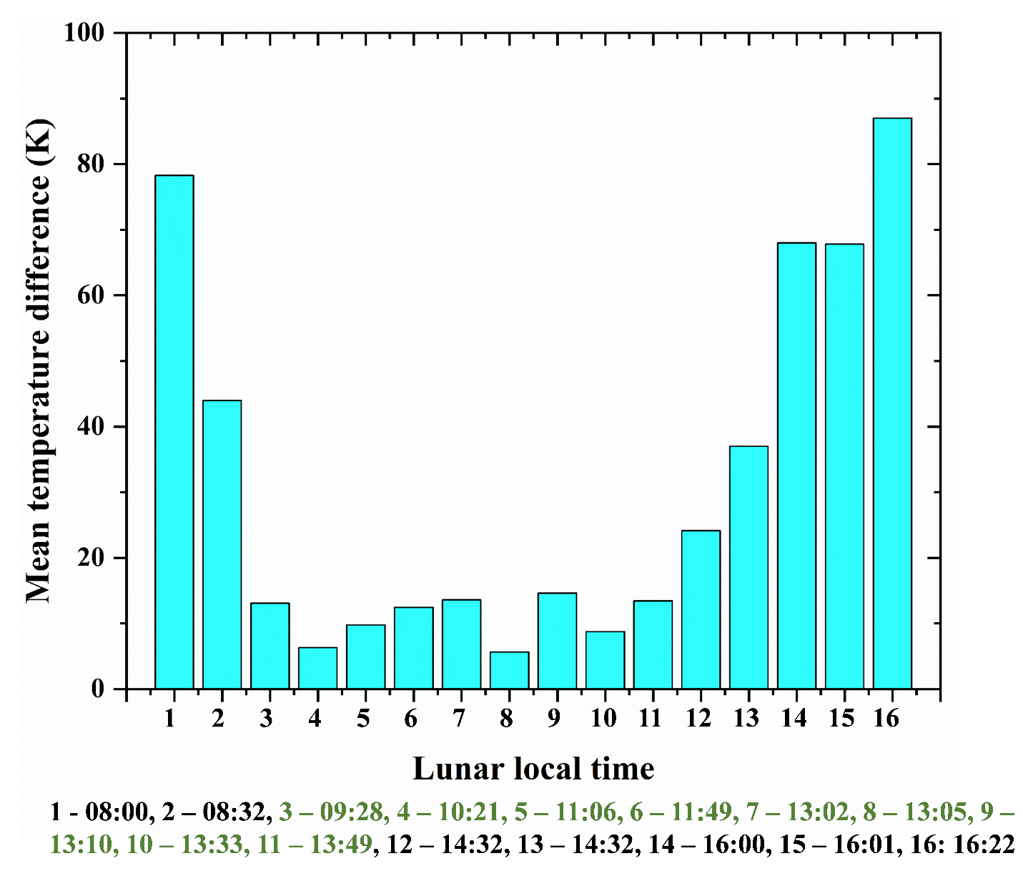
Fig. S5: Plot showing differences between mean temperatures obtained from IIRS and the corresponding Diviner images. A time block extending from ~09:30 hours up to ~14:00 hours, during which the calculated difference means are relatively smaller is also shown.

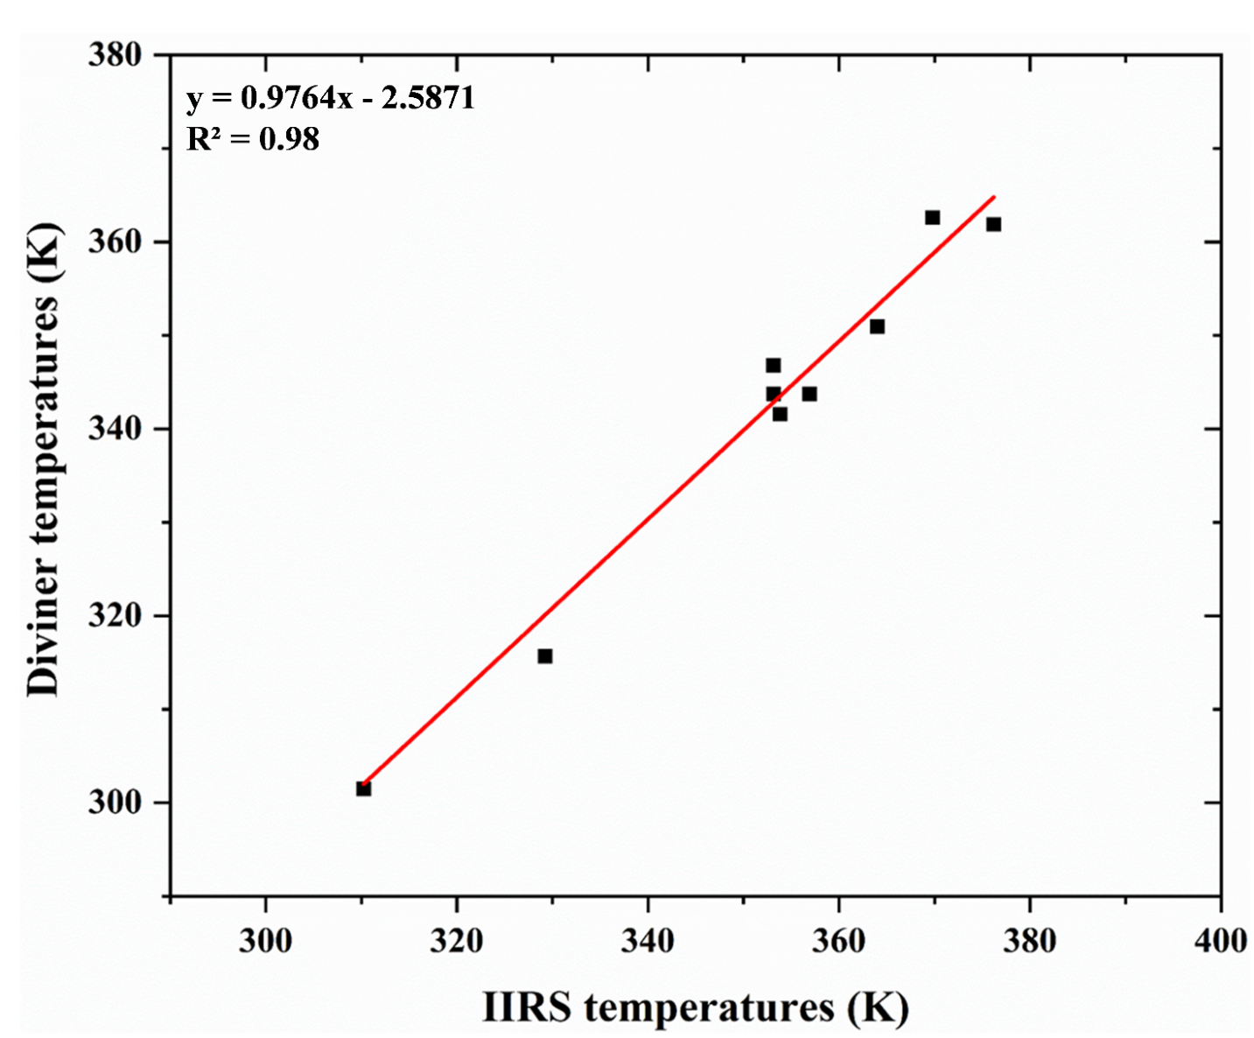
Fig. S6: A plot showing the observed correlation between mean temperatures obtained from IIRS and the corresponding Diviner images from the selected block of 9 images based on Fig. S1.

