Supplementary Materials

Modulating Chikungunya and Mayaro virus induced disease severity in mice using low concentrations of anti-IFNAR1 antibodies
Konrad Wesselmann^{a#}, Léa Luciani^{a,b}, Gregory Moureauª, Jean-Selim Driouich^{a,b}, Ornellie Bernadinª, Magali Gillesª, Xavier de Lamballerie^{a,b,c}, Antoine Nougairède^{a,b}
ªUnité des Virus Émergents (UVE: Aix-Marseille Univ, Università di Corsica, IRD 190, Inserm 1207, IRBA), France.
^{b}Assistance Publique-Hôpitaux de Marseille (AP-HM), Service de Virologie Aiguë et Tropicale, Marseille, France.
^{c}National Reference Center for Arboviruses, Inserm-IRBA, Marseille, France.

#Address correspondence to Konrad Wesselmann: konrad.wesselmann@univ-amu.fr

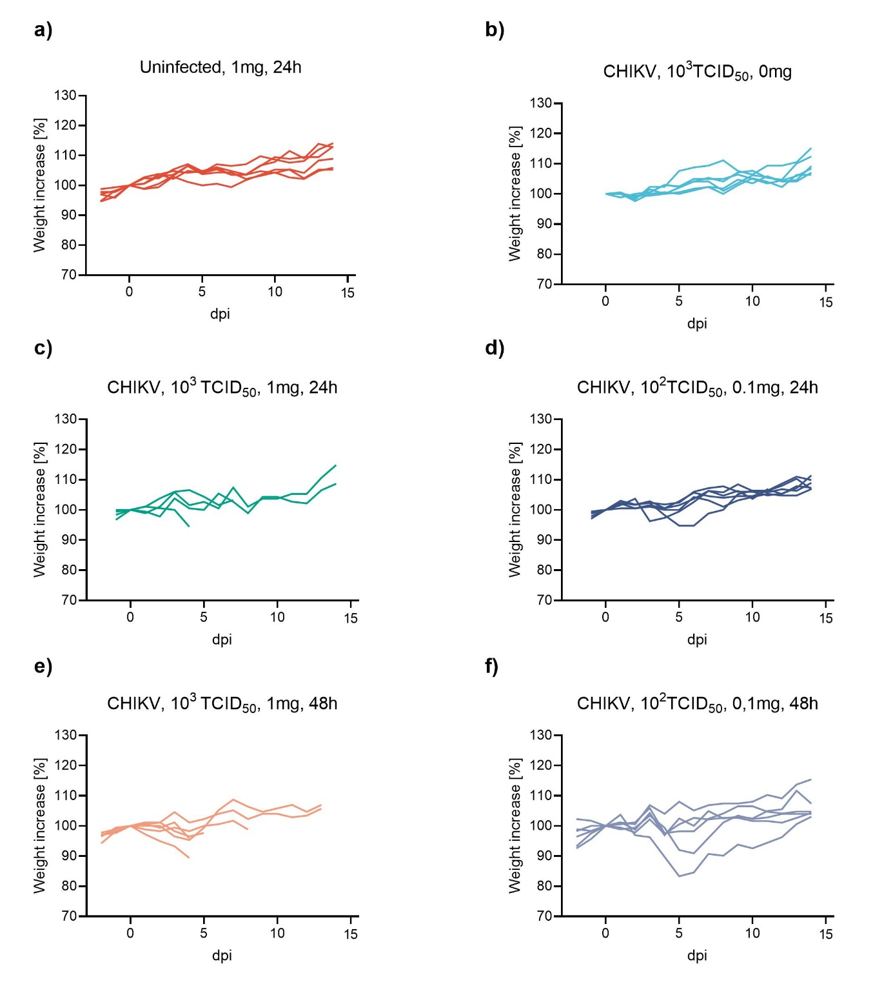
Figure S1: Normalized weights following CHIKV infection with high or low preceding doses of anti-IFNAR1 mAb during experimentation period. Normalized weight was expressed as a percentage of the initial weight (day of infection) calculated as follows: [(weight at day n / weight at day 0)*100]. Data are represented as individual weights of each replicate.
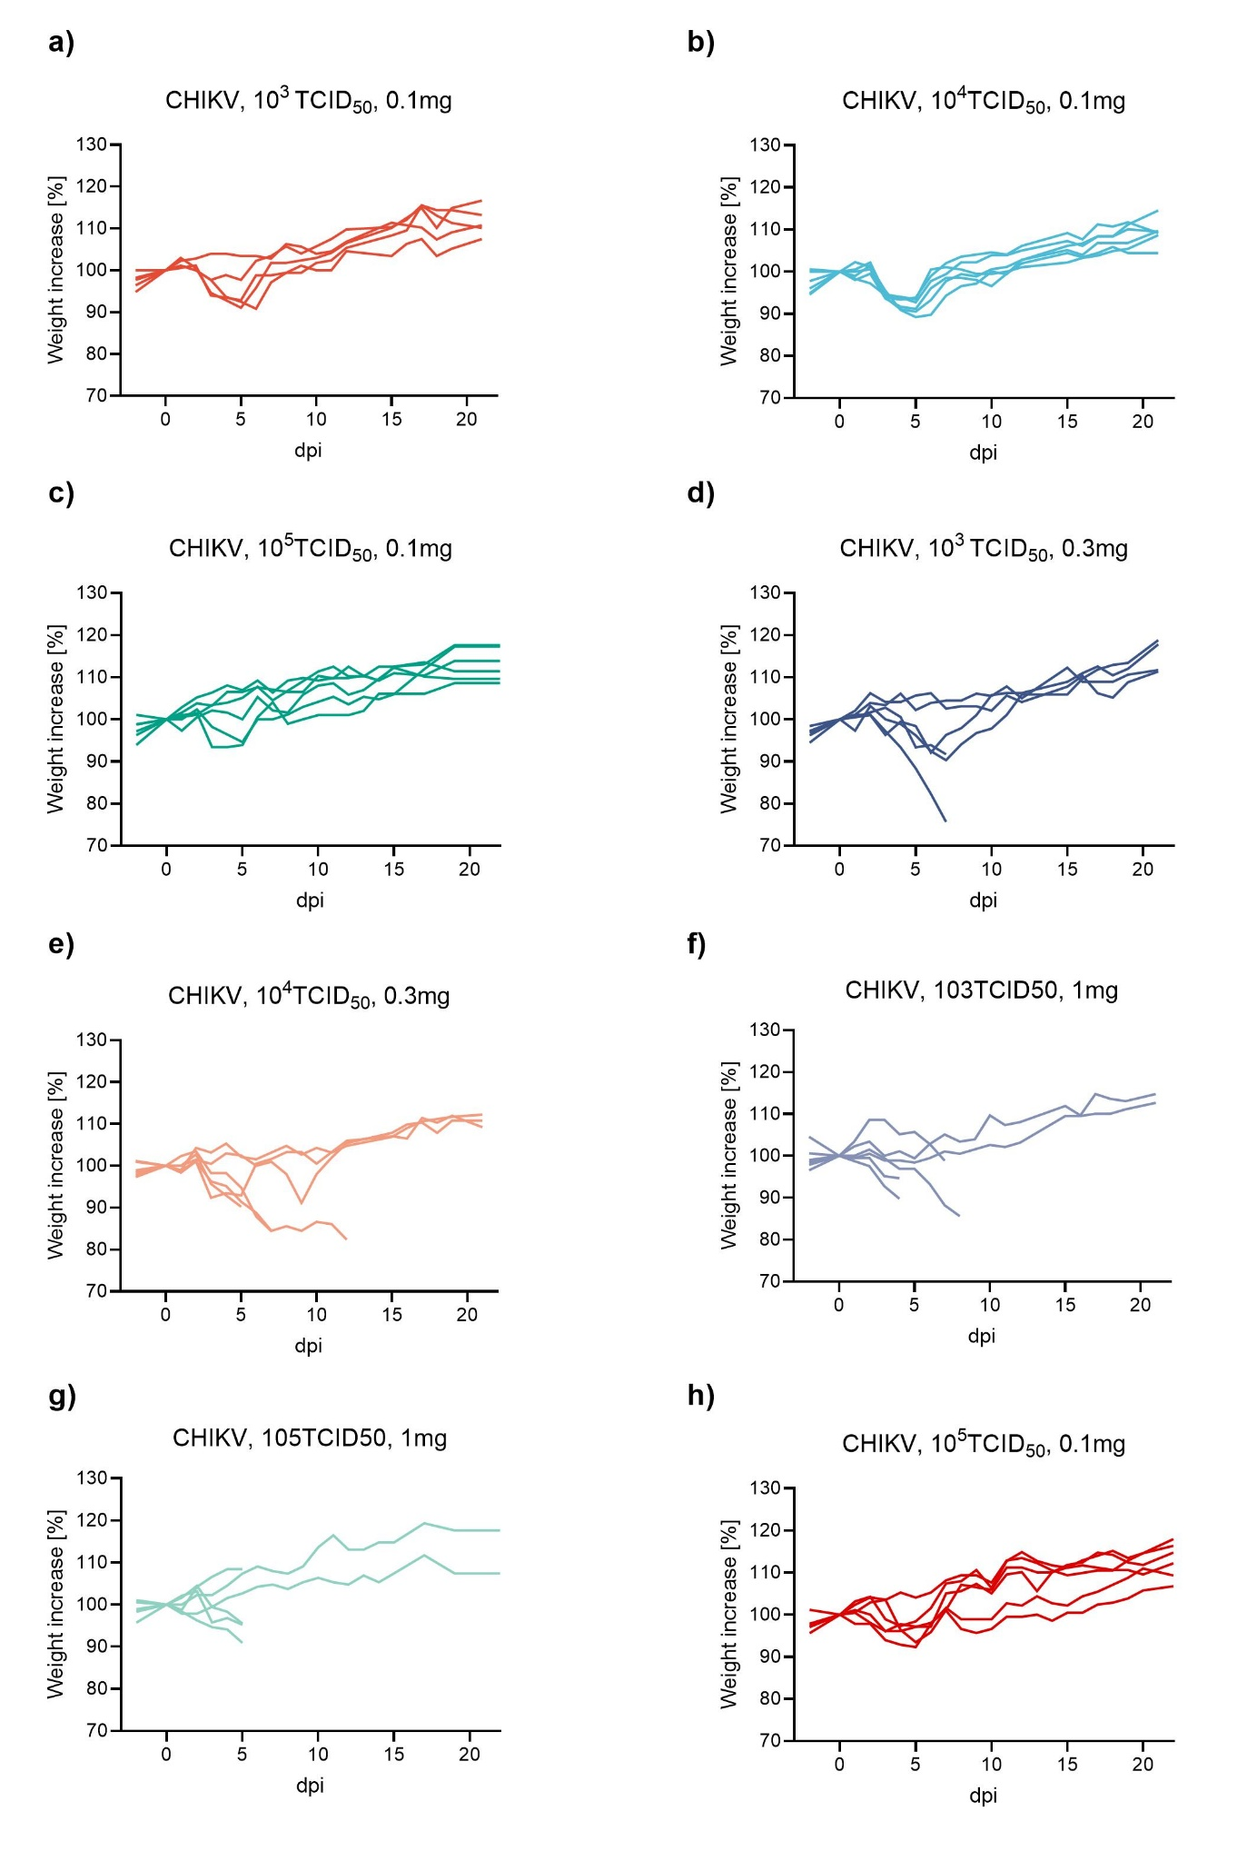
Figure S2: Normalized weights following CHIKV infection with varying infectious doses and varying preceding doses of anti-IFNAR1 mAb during experimentation period. Normalized weight was expressed as a percentage of the initial weight (day of infection) calculated as follows: [(weight at day n / weight at day 0)*100]. Data are represented as individual weights of each replicate.
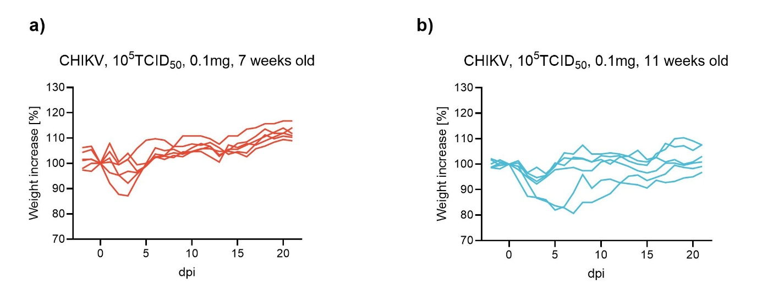
Figure S3: Normalized weights following CHIKV infection in young and mature mice with a preceding dose of 0.1mg anti-IFNAR1 mAb and a high viral titer of 105TCID50 during experimentation period. Normalized weight was expressed as a percentage of the initial weight (day of infection) calculated as follows: [(weight at day n / weight at day 0)*100]. Data are represented as individual weights of each replicate.
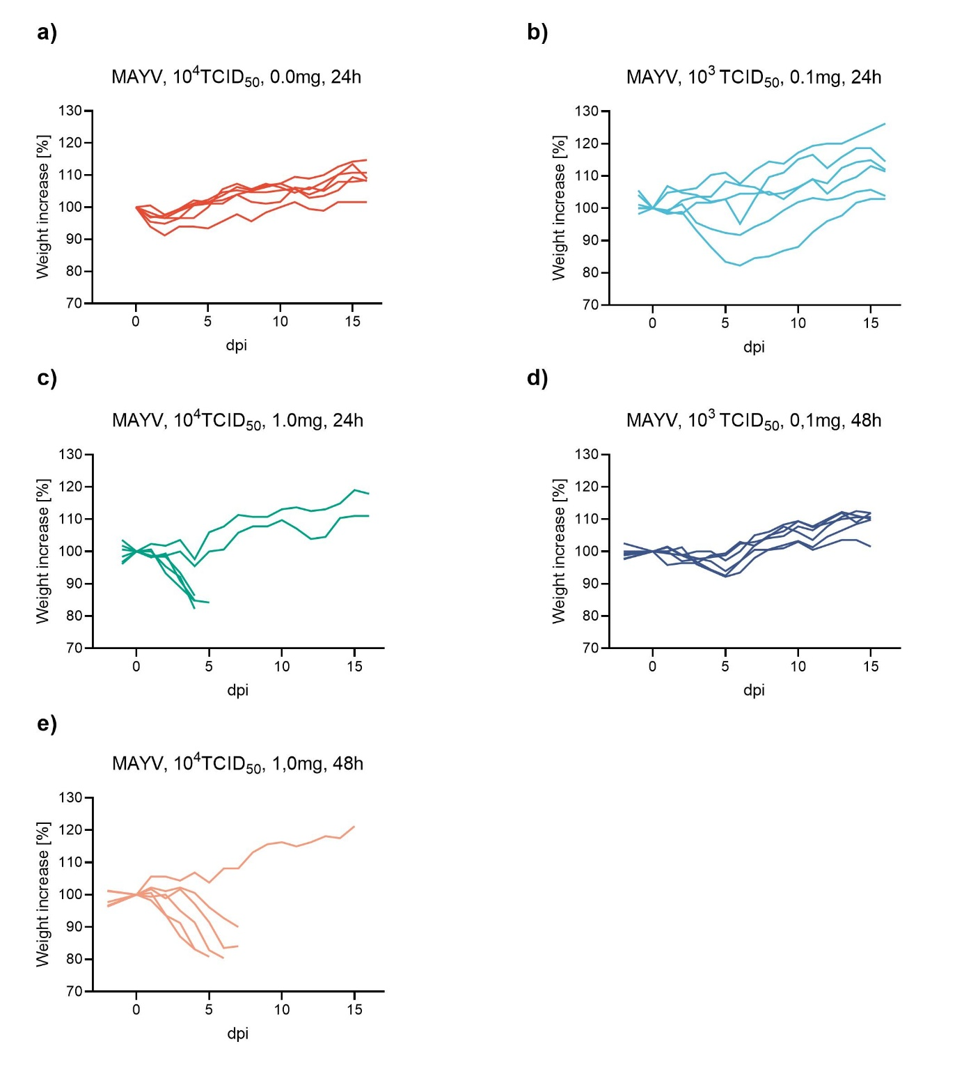
Figure S4: Normalized weights following MAYV infection with very high or very low preceding doses of anti-IFNAR1 mAb during experimentation period. Normalized weight was expressed as a percentage of the initial weight (day of infection) calculated as follows: [(weight at day n / weight at day 0)*100]. Data are represented as individual weights of each replicate.
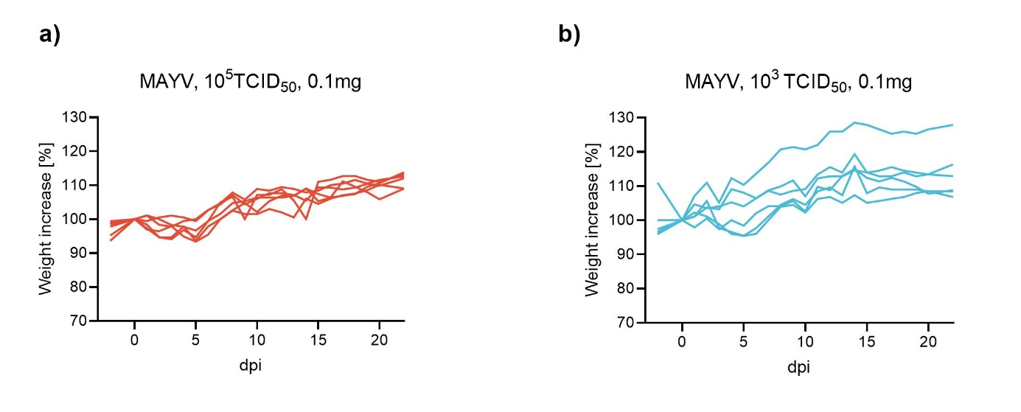
Figure S5: Normalized weights of MAYV infection with 103TCID50 or 105TCID50 and a preceding dose of 0.1mg anti-IFNAR1 mAb during experimentation period. Normalized weight was expressed as a percentage of the initial weight (day of infection) calculated as follows: [(weight at day n / weight at day 0)*100]. Data are represented as individual weights of each replicate.

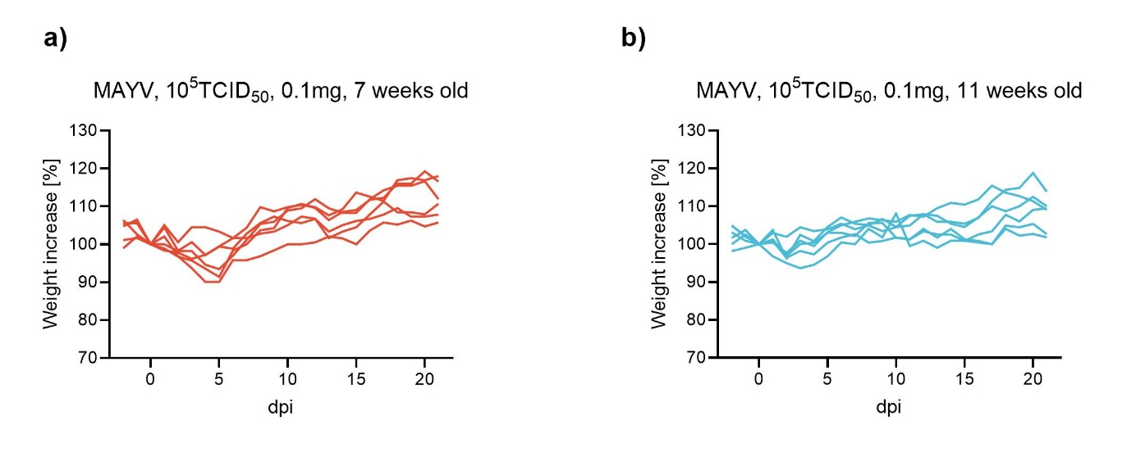
Figure S6: Normalized weights following MAYV infection in young and mature mice with a preceding dose of 0.1mg anti-IFNAR1 mAb and a high viral titer of 10⁵TCID₅₀ during experimentation period. Normalized weight was expressed as a percentage of the initial weight (day of infection) calculated as follows: [(weight at day n / weight at day 0)*100]. Data are represented as individual weights of each replicate.
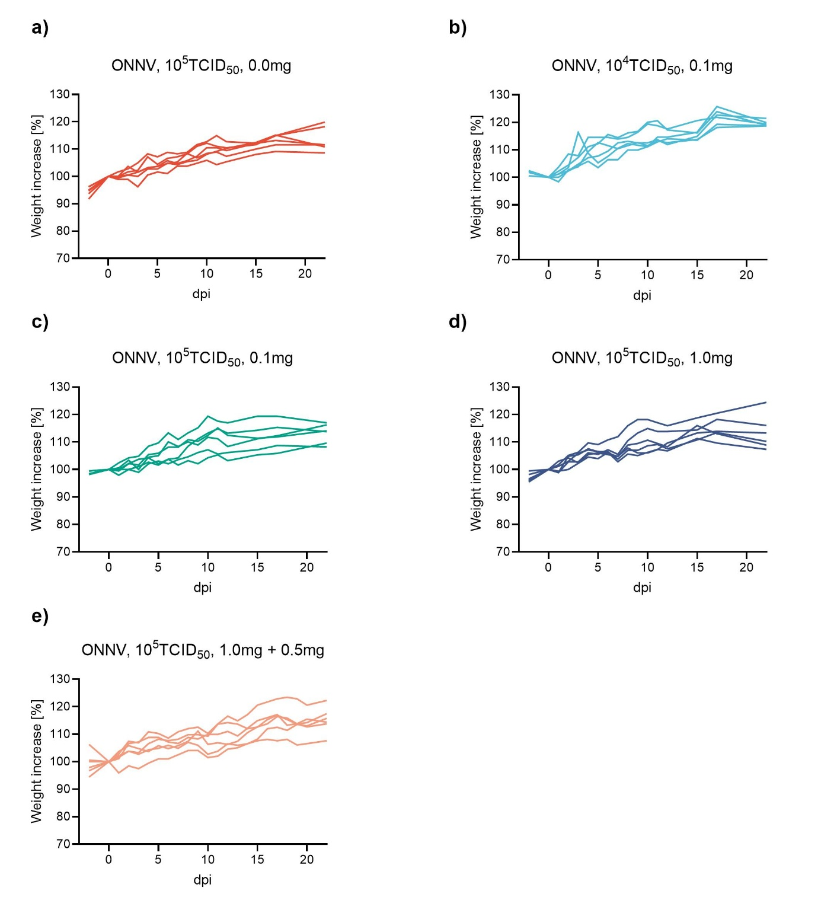
Figure S7: Normalized weights following MAYV infection with 103TCID50 or 105TCID50 and a preceding dose of 0.1mg anti-IFNAR1 mAb during experimentation period. Normalized weight was expressed as a percentage of the initial weight (day of infection) calculated as follows: [(weight at day n / weight at day 0)*100]. Data are represented as individual weights of each replicate.
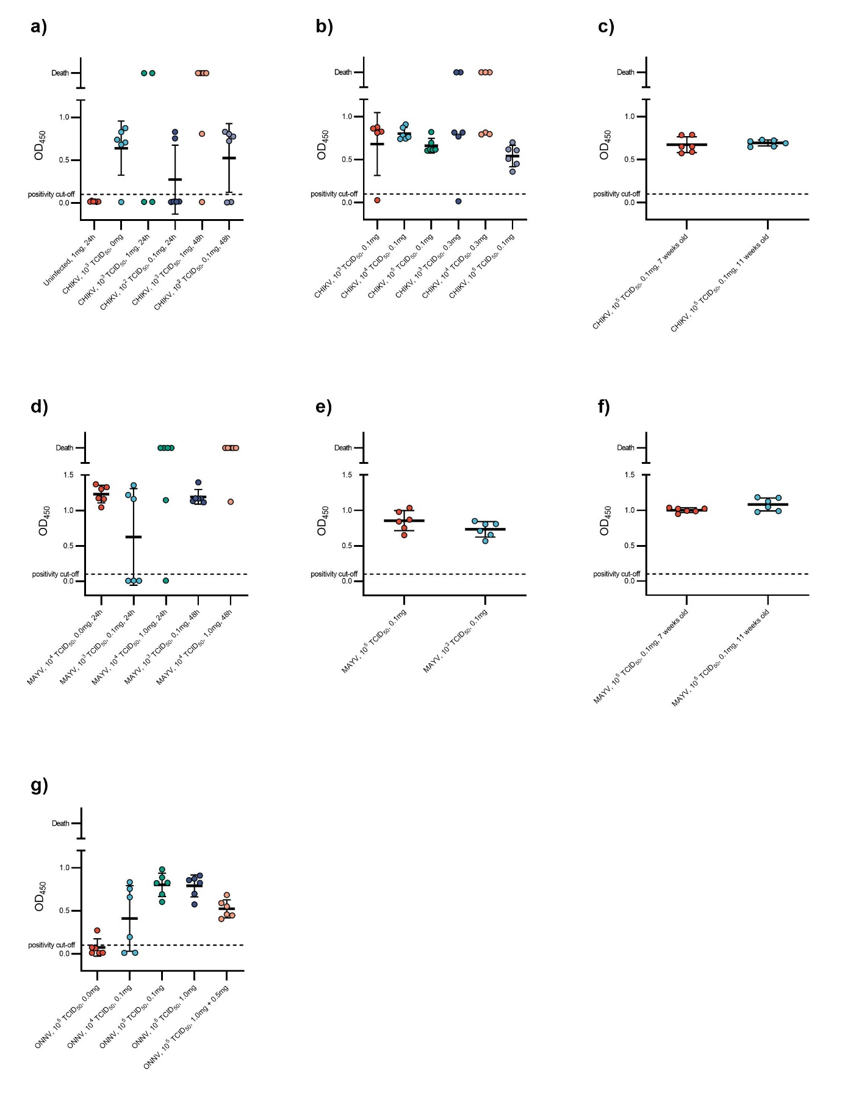Figure S8: ELISA results of mice infected with varying doses of CHIKV (a,b and c), MAYV (d, e and f) or ONNV (g) with varying doses of previously injected anti-IFNAR1 mAb (0.1, 0.3, 1 or 1+0.5mg). Virus specific ELISA tests were performed for CHIKV and MAYV. For ONNV a CHIKV-specific ELISA was used. Results are presented as optical density at 450nm.
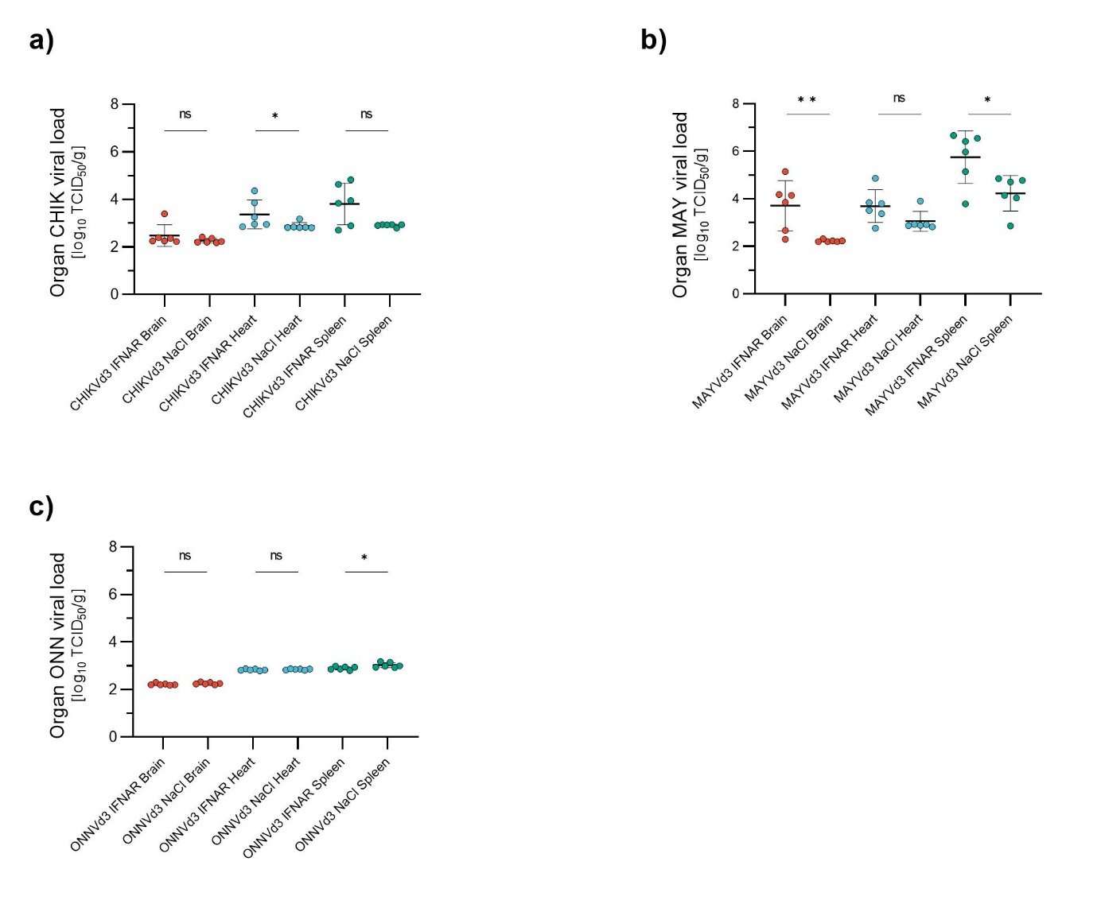
Figure S9: Infectious viral loads in various organs after infection with the established model. 7 weeks old C57BL/6J mice were injected with anti-INAR1 mAb (0.1mg) 48h before infection with CHIKV, MAYV or ONNV (10⁵TCID₅₀). Mice were euthanized at 3 (a, c and e) or 4 (b, d and f) dpi and TCID₅₀ of brain, heart and spleen were determined. At the moment of viral load determination samples had undergone two freeze-unfreeze cycles. Data are represented as mean±SD. Two-sided statistical analysis was performed using Shapiro–Wilk normality test followed by Student t-test, Student t-test with Welch correction or Mann-Whitney test (details in Table S8). *, ** and *** mean p-value ranging between 0.01−0.05, 0.05–0.001 and 0.001–0.0001 respectively. ****: p-value ≤0.0001. ns: not significant.

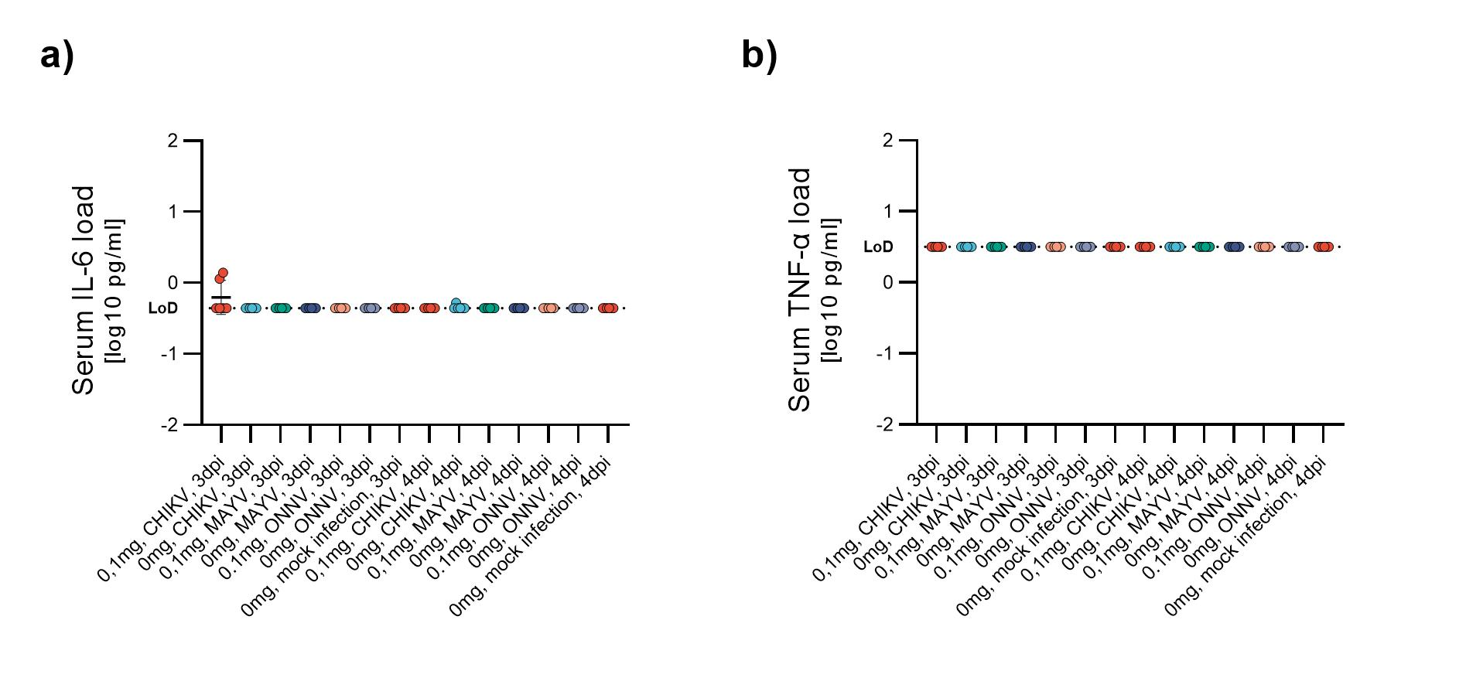
Figure S10: Serum IL-6 and TNF-α concentrations after infection with the established model. 7 weeks old C57BL/6J mice were injected with anti-INAR1 mAb (0.1mg) 48h before infection with CHIKV, MAYV or ONNV (10⁵TCID₅₀). Mice were euthanized at 3 or 4dpi and serum cytokine concentrations were determined using ProQuantum high-sensitivity immunoassays.

