Supplementary Materials
Table S1. Detailed report on each rat used in the study
SHAM rat No. | Blood biochemistry | ELISA |  |  |  |  |  | Histochemistry  AB & Gallyas | IHC +UV-Vis  Aqp's &  GFAP | Bile Acids
SHAM rat No. | Blood biochemistry | NfL | t-tau | p-tau | Aβ | MOG | GFAP | Histochemistry  AB & Gallyas | IHC +UV-Vis  Aqp's &  GFAP | Bile Acids
239 | x |  |  |  |  |  |  |  |  | x
240 | x |  |  |  |  |  |  |  |  | x
w0 322 | x |  |  |  |  |  | x
w0 323 | x |  |  |  |  |  | x
388 | x | x | x | x |  |  |  |  | x
451 | x | x | x | x |  |  |  |  |  | x
469 | x | x |  |  | x |  | x | x | x
470 | x | x | x | x | x |  | x | x | x
w0 472 | x |  |  |  | x
489 | x |  |  |  |  |  |  | x
526 | x |  |  |  | x | x
527 | x |  |  |  | x | x
528 | x |  |  |  | x | x
536 | x |  |  |  |  | x | x |  |  | x
537 | x |  |  |  |  |  | x |  |  | x
548 | x |  |  |  |  |  |  |  |  | x
549 | x |  |  |  |  |  |  |  |  | x
550 | x |  |  |  |  |  |  |  |  | x
TOTAL | n=18 | n=4 | n=3 | n=3 | n=6 | n=4 | n=6 | n=3 | n=3 | n=8
BDL rat No.
241 | x |  |  |  |  |  |  |  |  | x
242 | x |  |  |  |  |  |  |  |  | x
322 | x |  |  |  |  |  | x
323 | x |  |  |  |  |  | x
385 | x |  |  |  |  |  | x
401 | x |  |  |  |  |  | x
414 | x | x
415 | x | x
451 | x |  |  |  |  |  |  |  |  | x
468 | x |  |  |  |  |  |  | x | x
472 | x | x |  |  |  |  | x |  | x
475 | x |  |  |  |  |  |  |  | x
476 | x |  |  |  |  |  |  | x | x
477 | x |  |  |  |  |  |  | x
478 | x |  |  |  |  |  |  |  | x
481 | x | x |  |  | x
482 | x | x |  |  | x |  |  | x
485 | x |  |  |  |  |  |  |  | x
486 | x | x |  |  | x |  |  | x
487 | x | x |  |  |  |  |  | x
529 | x |  |  |  | x | x
530 | x |  |  |  |  | x
531 | x |  |  |  |  | x
532 | x |  |  |  | x | x | x |  |  | x
533 | x |  |  |  |  | x |  |  |  | x
534 | x |  |  |  |  | x | x |  |  | x
535 | x |  |  |  |  |  | x |  |  | x
579 | x |  |  | x | x
580 | x |  |  | x | x
602 | x |  | x | x
603 | x | x | x | x |  | x
606 | x | x | x | x |  | x
607 | x | x | x | x |  | x
TOTAL | n=33 | n=10 | n=4 | n=6 | n=7 | n=9 | n=8 | n=6 | n=6 | n=7

Congo Red fluorescence: when bound to β-sheet-rich amyloid fibrils, exhibits a characteristic increase in absorption accompanied by a red shift, as well as enhanced fluorescence. These spectral changes are indicative of its specific interaction with amyloid structures¹⁻⁴.
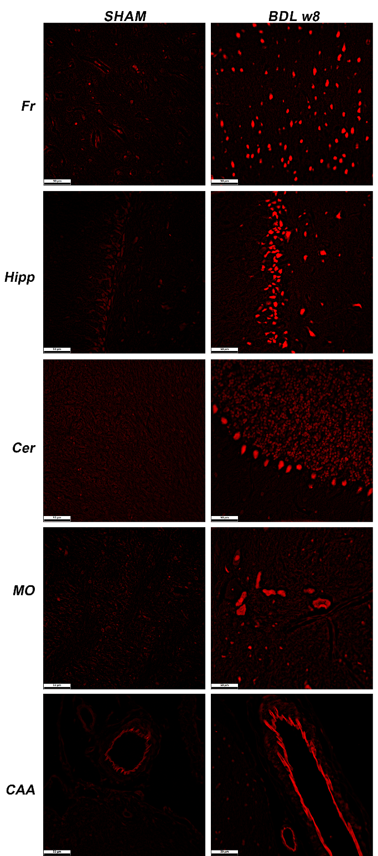
Figure 1. Visualization of amyloid deposits in the brain tissue - Congo red fluorescence using a Texas-red filter. Representative microphotographs of the BDL rats’ brain and age-matched SHAM controls (examples of: frontal cortex (Fr), hippocampus (Hipp), cerebellum (Cer), medulla oblongata (MO), and cerebral amyloid angiopathy (CAA) (scale bar 50mm).

References
1 Sen, S. & Basdemir, G. Diagnosis of renal amyloidosis using Congo red fluorescence. Pathol Int 53, 534-538, doi:10.1046/j.1440-1827.2003.01513.x (2003).
2 El-Meanawy, A., Mueller, C. & Iczkowski, K. A. Improving sensitivity of amyloid detection by Congo red stain by using polarizing microscope and avoiding pitfalls. Diagn Pathol 14, 57, doi:10.1186/s13000-019-0822-4 (2019).
3 Linke, R. P. Highly sensitive diagnosis of amyloid and various amyloid syndromes using Congo red fluorescence. Virchows Arch 436, 439-448, doi:10.1007/s004280050471 (2000).
4 Wu, C., Scott, J. & Shea, J. E. Binding of Congo red to amyloid protofibrils of the Alzheimer Abeta(9-40) peptide probed by molecular dynamics simulations. Biophys J 103, 550-557, doi:10.1016/j.bpj.2012.07.008 (2012).

