Supplementary Material
This file contains
Supplementary Section 1: Deviations from the preregistration
Supplementary Section 2: Quota fulfilment
Supplementary Section 3: Details on translation using TRAPD method
Supplementary Section 4: Additional analyses
Supplementary Section 5: Sensitivity analyses of centre group hypotheses

Supplementary Section 1: Deviations from the preregistration
Table S1
Deviations from the Preregistration, Reasons and Impact on Study
Section | Preregistered | Deviation, Reason, Impact on the Study/Results
Analysis: Relabelling of hypotheses | See preregistration. | Deviation and reason: We decided not to present the results for all hypotheses in the main manuscript, due to space reasons. For all analyses where we focused on seven different outcomes (Radicalness, Identification, Support, Normative Support, Intergroup Anxiety, Warmth, Competence), we decided to present results only on radicalness, identification, and support, those being the outcomes that most past research on RFEs has investigated. To enhance readability, we relabelled the hypotheses of the outcomes we selected to present in the main text to be H1a, H1b, … etc., although this did not correspond to their labels in the preregistration. Here, we list new and old labels of these hypotheses. Below, where we present the additional analyses and additional outcomes, we always refer to the hypothesis numbering from the preregistration.  Main text: RQ1 -> Preregistration: This was part of H2d in the preregistration. During the process of summarising our results, we realised that the exact nature of the interaction was an open research question and thus should not have been part of H2d in the first place. To avoid confusion (by having a hypothesis which in reality contains a research question), we relabelled that part of H2d that was an open question as RQ1.  Main text: H1a -> Preregistration: H2d  Main text: H1b -> Preregistration: H2a  Main text: H1c -> Preregistration: H2c  Main text: H2 -> Preregistration: We listed this under exploratory analyses, and thus without a specific hypothesis number, but did make our expectations very clear in the preregistration. This should in fact have been listed under confirmatory analyses and gotten a hypothesis number.  Main text: H3a-c -> Preregistration: H3a-c  Impact: There is no impact on the results of the study, only on the presentation of results. All results are transparently reported and interested readers can follow the hypothesis relabelling. In our view, the presentation of our results is much clearer with these changes made.
Analysis: Benjamini-Hochberg correction (BHC) | “To account for multiple testing, we will apply Benjamini-Hochberg procedure to resulting p-values, to keep α-levels at an acceptable level. We will apply the correction per group of hypotheses, i.e., to two (Hyps 0), seven (Hyps 1), seven (Hyps 2), seven (Hyps 2 robustness check), and three (Hyps 3) p-values.” | Deviation and reason: We had essentially miscounted the p-values that the tests corresponding to the hypotheses would give us, so in reality we corrected larger groups of p-values then we had specified. For the flank group hypotheses (“Hyps 1” in preregistration), we applied BHC to 21 instead of the specified seven p-values (that is because each of the seven ANOVAs provided three and not just one p-value). For the centre group hypotheses (“Hyps 2” in preregistration), we ran more ANOVA more than specified, because we forgot to list the outcome radicalness in the outcome list (making it eight instead of seven outcomes). Thus, we applied BHC to 24 instead of seven p-values. For the robustness check, each of the eight regressions resulted in nine p-values, instead of one. Thus, we applied BHC to 72 instead of seven p-values. For the non-group hypotheses (“Hyps 3” in preregistration), each ANOVA gave us three p-values, meaning we applied BHC to nine instead of three p-values.  For the manipulation checks (“Hyps 0” in preregistration), we had counted the number of p-values correctly and did not deviate from the preregistered analysis plan.  Impact: The more p-values the BHC is applied to, the larger the correction factor becomes, with which the original p-value is multiplied. In other words, applying BHC to more rather than fewer p-values leads to higher rather than lower p-values. Consequently, with this deviation, we had stricter (rather than looser) control over inflated alpha-errors. We deem this deviation to have only a small impact on the study results.
Note. For the full preregistration, see https://osf.io/k8g79/?view_only=8f678322007546449ef040d04138eabd

Supplementary Section 2: Quota Fulfilment
Particularly older females (category: female, 65+) proved difficult to reach, which is why we had to oversample male participants and participants of younger age to terminate the survey in a reasonable time frame. See Table S2 for the intended and achieved quotas for each gender and age category. There were no deviations from the region quota.
Table S2
Intended and achieved quota for gender and age
 | Male |  | Female |  | Total
Age | Intended | Achieved | Intended | Achieved | Intended | Achieved
18-29 | 123 | 130 | 115 | 122 | 238 | 252
30-39 | 119 | 126 | 115 | 122 | 234 | 248
40-49 | 111 | 118 | 111 | 119 | 222 | 237
50-59 | 128 | 135 | 130 | 139 | 258 | 274
60-65 | 68 | 75 | 70 | 77 | 138 | 152
65+ | 135 | 141 | 176 | 96 | 311 | 237
total | 683 | 725 | 717 | 675 | 1400 | 1407ª
Note. Values in cells represent absolute intended or achieved number of participants in the respective category.
ª We overrecruited n = 7 participants, who indicated to identify as diverse in terms of their gender. As there is no census data available on how many people in Austria identify as diverse, we could only calculate quotas for females and males, while naturally, we did not exclude people identifying as diverse from the survey.

Table S3
Intended and achieved quota for region of residency
Region | Intended | Achieved
South (Carinthia, Styria) | 283 | 283
East (Lower Austria, Vienna, Burgenland) | 614 | 614
West (Vorarlberg, Tyrol, Salzburg, Upper Austria) | 503 | 503
Note. Values in cells represent absolute intended or achieved number of participants in the respective category.

Supplementary Section 3: Details on translation using TRAPD method
In the first phase of the translation, the translation phase, a student assistant, LF, and JK independently translated all study materials. In the second phase, the student assistant, LF, and JK discussed their drafts with SN, who was acting as a reviewer, and differences were resolved. In the adjudication phase, a fourth independent reviewer who is a trained journalist, reviewed the vignettes for language and legibility. Adaptations here involved minor corrections of convoluted or “too English sounding” sentence structures, without altering the contents. Lastly, the vignettes were reviewed for their cultural appropriateness by the research group of the authors, which consists of environmental psychologists of all stages of training. In that step, the description that the moderate centre were “singing songs” (“Lieder singen”) was changed to “chanting slogans” (“Parolen rufen”), as the wording “Lieder singen” was perceived much more youthful and non-agentic than in the English version. Furthermore, the wording “green policies” (“grüne politische Maßnahmen”) was switched to “environmentally-friendly policies” (“umweltfreundliche Maßnahmen”). The reason for this was that in a European party system, as opposed to the American party system (where the studies from Ref ¹ were conducted), there is often a green party and the wording green policies could then be misunderstood as policies coming specifically from the green party as opposed to an environmentally-friendly policy more generally. This is undesirable because people might have specific thoughts of the green party in Austria that are unrelated to the flank and might thus interfere in the perception of the flank. Lastly, the flank and centre group in Ref ¹ were called “Climate Action Today” and “Global Warming Warning” respectively. As the direct translations of those names did not make for a very concise name for an activist group, we slightly adapted the names of the flank and centre group to be “KlimaJetzt” (“ClimateNow) and “KlimaAlarm” (“ClimateAlert”) respectively.

Supplementary Section 4: Additional Analyses

Rationale for looking at RFEs on interpersonal outcomes
Investigations of RFEs have looked at manifold outcomes. To date, the most commonly investigated outcomes have been success of the movement’s flank and centre, assessed by reviewing (historical) documentation on the movement (e.g., newspaper articles)², or measuring ‘real-life outcomes’ (e.g., donations to the movement; Haines, 1984) or self-reported attitudes towards the movements^{1,3,4}. Specifically, among self-reported outcomes, past studies have focussed on support for the movement, as well as its perceived radicalness and identification with it, as important factors in movement support^{5,6}. However, for a movement’s success, it is not just important that they can put forth their message on a public platform. Instead, activists have opportunities to convey their messages in everyday life, in (dyadic) interactions with others^{7–9}. Such activist messaging in daily life can be very effective^{7,8}, but also very socially risky. Specifically, activists will likely be able to have some influence on the message receiver^{7,8,10}, but may also face some backlash (e.g., reactance, dislike, social rejection)^{11,12}, which can discourage them, stifle their willingness to continue sending their message, and lead to reduced wellbeing^{13,14}. Most importantly, activists can convey their message more successfully if they (1) are perceived positively^{5,15–17}, and (2) do not cause excessive threat or stress in the message target^{18,19}.

Effect of the flank group’s tactics on the flank group
Hypotheses
The following hypotheses and RQs were referred to as H1a-f and RQ1 in the preregistration. For activists employing radical tactics (compared to activists employing moderate tactics), people will report (a) lower normative support, (b) lower identification, (c) lower support, (d) lower willingness to act on behalf, (e) higher intergroup anxiety, (f) lower warmth. Whether people perceive the radical or the moderate flank as more competent is an open research question (RQ1). For the literature review associated with these hypotheses, refer to the preregistration²⁰.
Results
As can be seen in Table S1, the manipulation of the flank group as using radical (versus moderate) tactics, lead to a consistently more negative evaluation of the flank group. Specifically, compared to the moderate flank group, people saw the radical flank group as less supported by others, identified less with it, supported it less, were less willing to act on behalf of it, were more anxious about interacting with it, and perceived persons belonging to it as less warm and less competent.
Table S1
Effect of the flank group’s tactics on the flank group
 | Hypothesis | Moderate  M (SD) | Radical  M (SD) | t(df) | pª | Cohen’s d  95% CIs
Identification | ✓ | 3.01 (1.79) | 1.86 (1.30) | 13.87 (1343.16) | < .001 | 0.73 [0.63, 0.84]
Support (index)^{b} | ✓ | 4.10 (1.63) | 2.51 (1.50) | 18.97 (1370.06) | < .001 | 1.01 [0.90, 1.12]
Warmth | ✓ | 4.10 (1.63) | 2.51 (1.50) | 18.97 (1405) | < .001 | 1.01 [0.90, 1.12]
Competence | ✓ | 4.08 (1.64) | 2.82 (1.58) | 14.67 (1405) | < .001 | 0.78 [0.67, 0.89]
Normative Support | ✓ | 3.87 (1.45) | 2.28 (1.21) | 22.36 (1394.15) | < .001 | 1.19 [1.08, 1.30]
Intergroup Anxiety | ✓ | 4.42 (1.82) | 3.23 (1.75) | 12.50 (1405) | < .001 | 0.67 [0.56, 0.77]
Support (single-item)^{b} | ✓ | 3.38 (1.79) | 2.13 (1.36) | 14.78 (1364.49) | < .001 | 0.78 [0.68, 0.89]
Willingness to Act on Behalf | ✓ | 3.05 (1.75) | 2.14 (1.38) | 10.89 (1377.93) | < .001 | 0.58 [0.47, 0.68]
Note. ✓ = supported, ✘ = not supported
ª Values after Benjamini-Hochberg correction for multiple testing. The correction was applied to the eight p-values
(the six values presented here as well as the two values presented in the main text).
^{b} In the main analysis, we collapsed support and willingness to act on behalf to form a support index (α = .90), for interested readers, we included the results on the single items here too

Effect of the flank group’s tactics and the centre group’s positioning on the centre group (additional outcomes)
Hypotheses
The following hypotheses and RQs were referred to as H1b,d-g and RQ2 in the preregistration For moderates (centre group) distancing themselves from radicals (flank group) people will report (b) more normative support, (d) more support, (e) more willingness to act on behalf, (f) lower intergroup anxiety, and (g) higher warmth than for moderates (centre group) endorsing radicals (flank group). These effects differ for moderates distancing themselves from (versus endorsing) other moderates—either in magnitude or direction (crossover or attenuated interaction). How competence differs between the experimental factors is an open research question (RQ2).
For the literature review associated with these hypotheses, refer to the preregistration²⁰.
Results

Table S2
Effects of the flank group’s tactics and the centre group’s positioning on the centre group
 | Moderate |  |  | Radical |  |  | Tactics |  |  |  | Positioning |  |  |  | Tactics*Positioning
 | Endorsing  M (SD) | Distancing  M (SD) |  | Endorsing  M (SD) | Distancing  M (SD) |  | F(dfª) | p^{b} | ω² |  | F(dfª) | p^{b} | ω² |  | F(dfª) | p^{b} | ω²
Normative Support | 4.25 (1.48) | 4.11 (1.45) |  | 4.81 (1.46) | 5.05 (1.48) |  | 91.44 | < .001 | 0.060 |  | 0.22 | .667 | -0.000 |  | 5.98 | .018 | 0.003
Support (single-item)^{c} | 3.84 (1.86) | 3.72 (1.80) |  | 3.96 (1.83) | 4.60 (1.81) |  | 26.61 | < .001 | 0.018 |  | 6.32^{c} | .016 | 0.004 |  | 15.13 | < .001 | 0.010
Willingness to Act on Behalf^{c} | 3.43 (1.83) | 3.41 (1.82) |  | 3.57 (1.84) | 4.25 (1.74) |  | 25.90 | < .001 | 0.017 |  | 10.70^{c} | .002 | 0.007 |  | 12.80 | < .001 | 0.008
Intergroup Anxiety | 4.72 (1.77) | 4.57 (1.81) |  | 4.98 (1.48) | 5.39 (1.56) |  | 65.00 | < .001 | 0.024 |  | 0.63 | .198 | 0.001 |  | 32.45 | .003 | 0.006
Warmth | 4.43 (1.55) | 4.05 (1.59) |  | 4.61 (1.48) | 5.16 (1.38) |  | 36.34 | < .001 | 0.043 |  | 1.84^{c} | .462 | -0.000 |  | 9.77 | < .001 | 0.021
Competence | 4.73 (1.63) | 4.59 (1.67) |  | 4.80 (1.57) | 5.30 (1.49) |  | 21.29 | < .001 | 0.014 |  | 3.86 | .058 | 0.002 |  | 14.01 | < .001 | 0.009
Intergroup Anxiety | 4.72 (1.77) | 4.57 (1.81) |  | 4.98 (1.48) | 5.39 (1.56) |  | 65.00 | < .001 | 0.024 |  | 0.63 | .198 | 0.001 |  | 32.45 | .003 | 0.006
Note. Significant effects in bold.
ª df = 1,1403 for all effects presented in this Table.
^{b} Values after Benjamini-Hochberg correction for multiple testing. The correction was applied to 27 p-values (the 18 values presented here and the values in the main text).
^{c} In the main analysis, we collapsed support and willingness to act on behalf to form a support index (α = .90), for interested readers, we included the results on the single items here too

Interaction follow-up (additional outcomes)
Hypotheses
None—these analyses were un-preregistered.
Results
Table S3
Simple effects of the flank group’s tactics on centre group as a function of their positioning
 | Moderate |  |  | Radical |  |  | Centre Positioning = Endorsing |  |  |  |  |  | Centre Positioning = Distancing
 | Endorsing  M (SD) | Distancing  M (SD) |  | Endorsing  M (SD) | Distancing  M (SD) |  | Mean Diff. | t(dfª) | p^{b} | Cohen’s d [95% CI] |  | Mean Diff. |  | t(dfª) | p^{b} | Cohen’s d [95% CI]
Warmth | 4.43 (1.55) | 4.05 (1.59) |  | 4.61 (1.48) | 5.16 (1.38) |  | -0.19 | -1.66 | .135 | -0.13 [-0.27, 0.02] |  | -1.10 |  | -9.73 | < .001 | -0.73 [-0.89, -0.57]
Competence | 4.73 (1.63) | 4.59 (1.67) |  | 4.80 (1.57) | 5.30 (1.49) |  | -0.07 | -0.61 | .576 | -0.04 [-0.19, 0.10] |  | -0.71 |  | 5.91 | < .001 | -0.45 [-0.60, -0.29]
Normative Support | 4.25 (1.48) | 4.11 (1.45) |  | 4.81 (1.46) | 5.05 (1.48) |  | -0.56 | -5.02 | < .001 | -0.38 [-0.53, -0.23] |  | -0.94 |  | -8.50 | < .001 | -0.64 [-0.80, -0.49]
Intergroup Anxiety | 4.72 (1.77) | 4.57 (1.81) |  | 4.98 (1.48) | 5.39 (1.56) |  | -0.26 | -2.04 | .068 | 0.15 [-0.30, -0.01] |  | -0.81 |  | -6.48 | < .001 | 0.49 [-0.64, -0.34]
Support (single-item)^{c} | 3.84 (1.86) | 3.72 (1.80) |  | 3.96 (1.83) | 4.60 (1.81) |  | -0.12 | -0.89 | .422 | -0.07 [-0.22, 0.08] |  | -0.88 |  | -6.40 | < .001 | -0.48 [-0.63, -0.33]
Willingness to Act on Behalf^{c} | 3.43 (1.83) | 3.41 (1.82) |  | 3.57 (1.84) | 4.25 (1.74) |  | -0.15 | -1.06 | .357 | -0.08 [-0.23, 0.07] |  | -0.84 |  | -6.13 | < .001 | -0.46 [-0.61, -0.31]
Note.
ª df = 1403 for all tests presented in this Table
^{b} Values after Benjamini-Hochberg correction for multiple testing. The correction was applied to 18 p-values (the 12 values presented here and the values in the main text).
^{c} In the main analysis, we collapsed support and willingness to act on behalf to form a support index (α = .90), for interested readers, we included the results on the single items here too

Supplementary Section 5: Sensitivity Analyses of Centre Group Hypotheses
Table S4
Robustness Checks for Target Normative Support and Target Identification
 | Normative Support |  |  |  |  |  |  |  | Identification
 | Block 1 |  |  | Block 2 |  |  |  |  | Block 1 |  |  | Block 2
Predictors | β | 95% CI | p (u) | β | 95% CI |  | p (bh) |  | β | 95% CI | p (u) | β | 95% CI | p (bh)
(Intercept) | 4.95 | 4.61, 5.30 | <.001 | 4.49 |  | 4.13, 4.85 | <.001 | 4.53 |  | 4.10, 4.95 | <.001 | 4.05 | 3.61, 4.50 | <.001
Age | -0.00 | -0.01, 0.00 | .926 | -0.00 |  | -0.01, 0.00 | .864 | 0.01 |  | 0.00, 0.01 | .019 | 0.01 | 0.00, 0.01 | .024
Gender (ref = male)
Female | 0.18 | 0.02, 0.34 | .028 | 0.23 |  | 0.08, 0.39 | .007 | 0.02 |  | -0.18, 0.21 | .879 | 0.07 | -0.11, 0.26 | .555
Diverse | 0.25 | -1.08, 1.57 | .712 | 0.20 |  | -1.08, 1.48 | .846 | -1.79 |  | -3.40, -0.19 | .028 | -1.86 | -3.43, -0.30 | .037
Education (ref = lower)
Secondary | 0.14 | -0.05, 0.33 | .136 | 0.13 |  | -0.05, 0.31 | .267 | 0.45 |  | 0.23, 0.68 | <.001 | 0.44 | 0.21, 0.66 | <.001
Higher | 0.11 | -0.09, 0.31 | .285 | 0.12 |  | -0.07, 0.32 | .317 | 0.56 |  | 0.32, 0.81 | <.001 | 0.57 | 0.33, 0.81 | <.001
Pol. Or. | -0.12 | -0.16, -0.08 | <.001 | -0.12 |  | -0.15, -0.08 | <.001 | -0.29 |  | -0.34, -0.24 | <.001 | -0.28 | -0.33, -0.23 | <.001
Flank (ref = moderate) |  |  |  | 0.94 |  | 0.73, 1.16 | <.001 |  |  |  |  | 1.04 | 0.78, 1.31 | <.001
Centre (ref = distancing) |  |  |  | 0.15 |  | -0.06, 0.36 | .267 |  |  |  |  | 0.16 | -0.10, 0.41 | .317
Flank*Centre |  |  |  | -0.33 |  | -0.64, -0.03 | .057 |  |  |  |  | -0.76 | -1.13, -0.38 | <.001
N | 1391 |  |  | 1391 |  |  |  |  | 1391 |  |  | 1391
R² / R² adjusted | 0.035 / 0.031 |  |  | 0.103 / 0.097 |  |  |  |  | 0.118 / 0.114 |  |  | 0.160 / 0.154
Note. Pol. Or. = Political Orientation, p (u) = uncorrected p-value, p (bh) = Benjamini-Hochberg corrected p-value

Table S5
Robustness Checks for Target Support and Target Willingness to Act on Behalf
 | Support (single-item)ª |  |  |  |  |  | Willingness to Act on Behalfª
 | Block 1 |  |  | Block 2 |  |  | Block 1 |  |  | Block 2
Predictors | β | 95% CI | p (u) | β | 95% CI | p (bh) | β | 95% CI | p (u) | β | 95% CI | p (bh)
(Intercept) | 5.04 | 4.64, 5.44 | <.001 | 4.65 | 4.23, 5.08 | <.001 | 4.86 | 4.47, 5.26 | <.001 | 4.53 | 4.11, 4.96 | <.001
Age | 0.00 | -0.00, 0.01 | .366 | 0.00 | -0.00, 0.01 | .384 | 0.00 | -0.01, 0.01 | .919 | 0.00 | -0.00, 0.01 | .878
Gender (ref = male)
Female | 0.05 | -0.13, 0.24 | .580 | 0.10 | -0.08, 0.28 | .384 | 0.06 | -0.12, 0.25 | .503 | 0.11 | -0.07, 0.29 | .317
Diverse | 0.59 | -0.93, 2.12 | .445 | 0.55 | -0.96, 2.05 | .582 | -0.04 | -1.55, 1.48 | .964 | -0.11 | -1.60, 1.39 | .915
Education (ref = lower)
Secondary | 0.36 | 0.14, 0.58 | .001 | 0.35 | 0.13, 0.56 | .004 | 0.31 | 0.10, 0.53 | .004 | 0.30 | 0.09, 0.51 | .012
Higher | 0.53 | 0.30, 0.76 | <.001 | 0.54 | 0.31, 0.77 | <.001 | 0.43 | 0.19, 0.66 | <.001 | 0.43 | 0.20, 0.66 | .001
Pol. Or. | -0.30 | -0.35, -0.25 | <.001 | -0.29 | -0.34, -0.25 | <.001 | -0.31 | -0.35, -0.26 | <.001 | -0.30 | -0.35, -0.26 | <.001
Flank (ref = moderate) |  |  |  | 0.84 | 0.58, 1.09 | <.001 |  |  |  | 0.79 | 0.54, 1.04 | <.001
Centre (ref = distancing) |  |  |  | 0.16 | -0.09, 0.40 | .316 |  |  |  | 0.04 | -0.20, 0.29 | .813
Flank*Centre |  |  |  | -0.66 | -1.02, -0.30 | .001 |  |  |  | -0.57 | -0.93, -0.22 | .004
N | 1391 |  |  | 1391 |  |  | 1391 |  |  | 1391
R² / R² adjusted | 0.136 / 0.132 |  |  | 0.164 / 0.159 |  |  | 0.136 / 0.132 |  |  | 0.165 / 0.159
Note. Pol. Or. = Political Orientation, p (u) = uncorrected p-value, p (bh) = Benjamini-Hochberg corrected p-value
ª In the main analysis, we collapsed support and willingness to act on behalf to form a support index (α = .90), for interested readers, we included the results on the single items here too.

Table S6
Robustness Checks for Target Intergroup Anxiety and Target Warmth
 | Intergroup Anxiety |  |  |  |  |  | Warmth
 | Block 1 |  |  | Block 2 |  |  | Block 1 |  |  | Block 2
Predictors | β | 95% CI | p (u) | β | 95% CI | p (bh) | β | 95% CI | p (u) | β | 95% CI | p (bh)
(Intercept) | 5.02 | 4.63, 5.41 | <.001 | 4.63 | 4.22, 5.04 | <.001 | 5.29 | 4.93, 5.64 | <.001 | 4.71 | 4.34, 5.08 | <.001
Age | 0.01 | 0.00, 0.02 | <.001 | 0.01 | 0.00, 0.02 | .001 | -0.00 | -0.01, 0.00 | .892 | 0.00 | -0.00, 0.00 | .996
Gender (ref = male)
Female | -0.07 | -0.24, 0.11 | .471 | -0.02 | -0.20, 0.15 | .875 | 0.14 | -0.03, 0.30 | .098 | 0.19 | 0.03, 0.35 | .035
Diverse | -1.40 | -2.87, 0.07 | .062 | -1.44 | -2.89, 0.01 | .087 | 0.71 | -0.64, 2.06 | .300 | 0.69 | -0.61, 2.00 | .384
Education (ref = lower)
Secondary | 0.24 | 0.03, 0.45 | .025 | 0.23 | 0.02, 0.43 | .056 | -0.05 | -0.25, 0.14 | .576 | -0.07 | -0.26, 0.11 | .556
Higher | 0.25 | 0.03, 0.48 | .026 | 0.26 | 0.04, 0.48 | .037 | -0.06 | -0.27, 0.14 | .536 | -0.05 | -0.25, 0.15 | .723
Pol. Or. | -0.15 | -0.19, -0.11 | <.001 | -0.14 | -0.19, -0.10 | <.001 | -0.16 | -0.20, -0.12 | <.001 | -0.15 | -0.19, -0.11 | <.001
Flank (ref = moderate) |  |  |  | 0.81 | 0.56, 1.05 | <.001 |  |  |  | 1.10 | 0.88, 1.32 | <.001
Centre (ref = distancing) |  |  |  | 0.17 | -0.07, 0.40 | .267 |  |  |  | 0.38 | 0.17, 0.60 | .001
Flank*Centre |  |  |  | -0.54 | -0.89, -0.20 | .005 |  |  |  | -0.87 | -1.18, -0.56 | <.001
N | 1391 |  |  | 1391 |  |  | 1391 |  |  | 1391
R² / R² adjusted | 0.044 / 0.040 |  |  | 0.076 / 0.070 |  |  | 0.046 / 0.042 |  |  | 0.111 / 0.105
Note. Pol. Or. = Political Orientation, p (u) = uncorrected p-value, p (bh) = Benjamini-Hochberg corrected p-value

Table S7
Robustness Checks for Target Competence
 | Competence |  |  |  |  |  | Support (Index)
 | Block 1 |  |  | Block 2 |  |  | Block 1 |  |  | Block 2
Predictors | β | 95% CI | p (u) | β | 95% CI | p (bh) | β | 95% CI | p (bh) | β | 95% CI | p (bh)
(Intercept) | 5.55 | 5.18, 5.91 | <.001 | 5.21 | 4.83, 5.60 | <.001 | 4.92 | 4.54, 5.31 | .001 | 4.66 | 4.25, 5.06 | <.001
Age | 0.00 | -0.00, 0.01 | .676 | 0.00 | -0.00, 0.01 | .681 | 0.00 | -0.00, 0.01 | .699 | 0.00 | -0.00, 0.01 | .704
Gender (ref = male) |  |  |  |  |  |  | 0.06 | -0.12, 0.23 |  | 0.11 | -0.07, 0.28
Female | 0.18 | 0.01, 0.34 | .036 | 0.22 | 0.05, 0.38 | .021 | 0.17 | -1.28, 1.63 | .510 | 0.11 | -1.32, 1.54 | .317
Diverse | 0.12 | -1.27, 1.50 | .868 | 0.08 | -1.29, 1.44 | .922 | 0.33 | 0.12, 0.54 | .814 | 0.32 | 0.11, 0.52 | .915
Education (ref = lower) |  |  |  |  |  |  | 0.46 | 0.24, 0.68 |  | 0.46 | 0.25, 0.68
Secondary | 0.12 | -0.07, 0.32 | .216 | 0.11 | -0.08, 0.31 | .345 | -0.31 | -0.35, -0.26 | .002 | -0.30 | -0.34, -0.26 | .005
Higher | 0.20 | -0.01, 0.41 | .062 | 0.21 | -0.00, 0.41 | .087 |  |  | .001 | 0.21 | -0.04, 0.45 | <.001
Pol. Or. | -0.19 | -0.24, -0.15 | <.001 | -0.19 | -0.23, -0.15 | <.001 |  |  | .001 | -0.08 | -0.32, 0.15 | <.001
Flank (ref = moderate) |  |  |  | 0.71 | 0.48, 0.94 | <.001 |  |  |  | 0.60 | 0.26, 0.94 | <.001
Centre (ref = distancing) |  |  |  | 0.15 | -0.08, 0.37 | .297 |  |  |  | 4.66 | 4.25, 5.06 | .591
Flank*Centre |  |  |  | -0.58 | -0.91, -0.26 | .001 |  |  |  | 0.00 | -0.00, 0.01 | .002
N | 1391 |  |  | 1391
R² / R² adjusted | 0.072 / 0.068 |  |  | 0.098 / 0.092
Note. Pol. Or. = Political Orientation, p (u) = uncorrected p-value, p (bh) = Benjamini-Hochberg corrected p-value

Supplementary Section 6: Visualisation of Interaction Between Flank Tactics and Centre Positioning (Additional Outcomes)
Figure 1
Effect of the flank group’s tactics and the centre group’s positioning on perceived warmth, competence, and normative support for the centre group

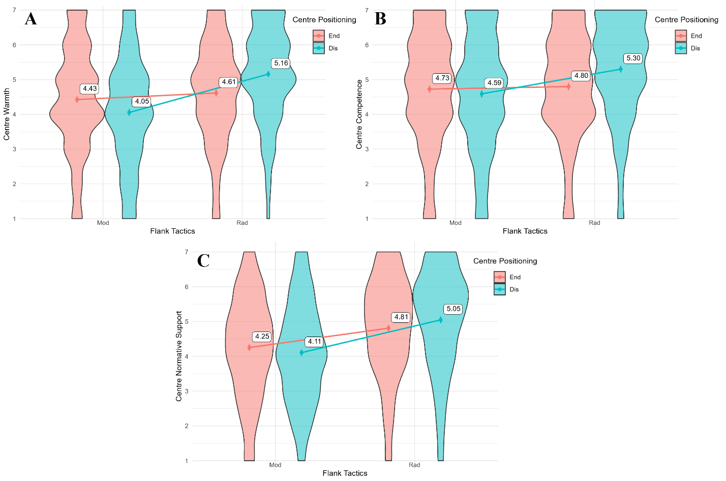
Note. A = Warmth, B = Competence, C = Normative Support
Colours represent the levels of the centre group’s positioning (i.e., distancing = red, endorsing = turquoise). The dots represent means, and the error bars represent standard errors. Across outcomes A to D, there is a significant positive RFE when the centre distance themselves from the flank; when they endorse it, there is no effect of the flank’s tactics, except for D (normative support), where there is also a positive RFE.
Figure 2
Effect of the flank group’s tactics and the centre group’s positioning on intergroup anxiety, support, and willingness to act on behalf of the centre group
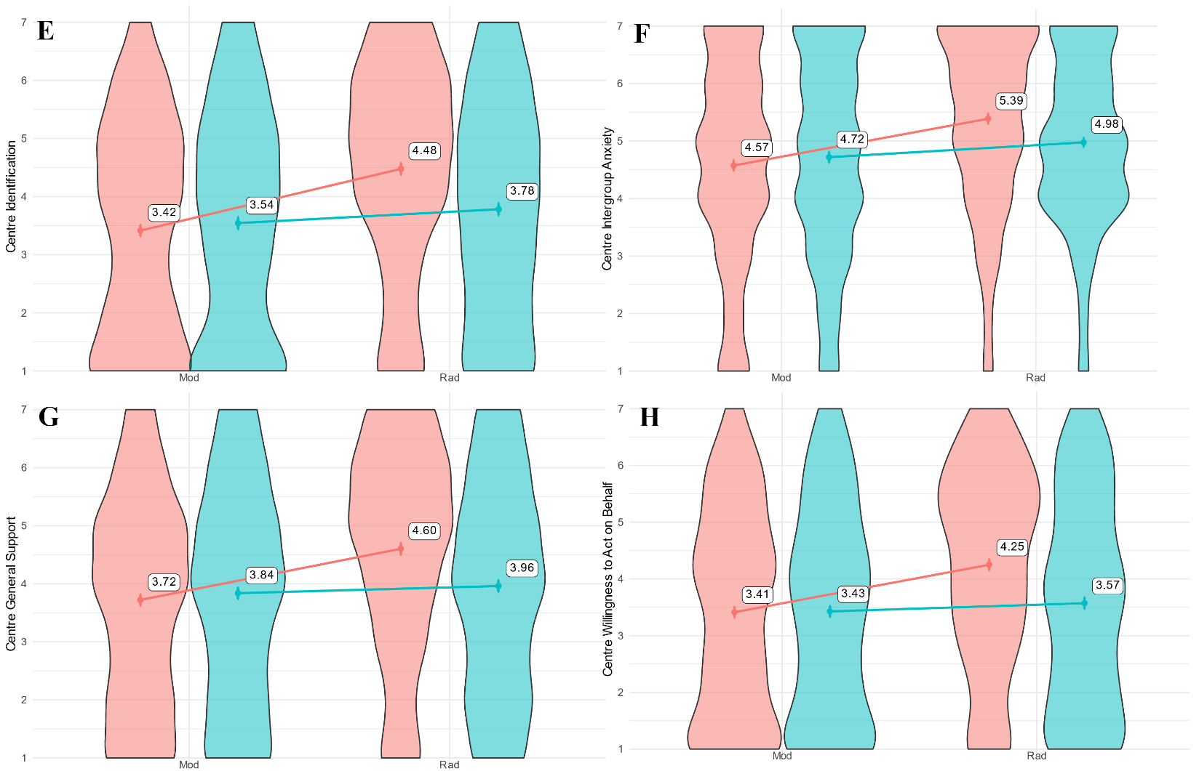
Note. E = Identification, F = Intergroup Anxiety, G = General Support, H = Willingness to Act on Behalf
Colours represent the levels of the centre group’s positioning (i.e., distancing = red, endorsing = turquoise). The dots represent means, and the error bars represent standard errors. Across outcomes E to H, there is a significant positive RFE when the centre distance themselves from the flank; when they endorse it, there is no effect of the flank’s tactics.

1. Simpson, B., Willer, R. & Feinberg, M. Radical flanks of social movements can increase support for moderate factions. PNAS Nexus 1, pgac110 (2022).
2. Baller, C. R. & Bell, S. E. An ecosystem of tactics: Bridging the radical and moderate flanks in a pipeline resistance movement. Energy Res. Soc. Sci. 117, 103714 (2024).
3. Dasch, S. T., Bellm, M., Shuman, E. & Van Zomeren, M. The radical flank: Curse or blessing of a social movement? Glob. Environ. Psychol. 2, e11121 (2024).
4. Fuller, K. et al. Extreme Protest Tactics Reduce Support for the Climate Movement and Climate Mitigation Policies. Preprint at https://doi.org/10.31235/osf.io/n6aw2 (2025).
5. Feinberg, M., Willer, R. & Kovacheff, C. The activist’s dilemma: Extreme protest actions reduce popular support for social movements. J. Pers. Soc. Psychol. 119, 1086–1111 (2020).
6. Fritsche, I., Barth, M., Jugert, P., Masson, T. & Reese, G. A Social Identity Model of Pro-Environmental Action (SIMPEA). Psychol. Rev. 125, 245–269 (2018).
7. Czopp, A. M. The passive activist: Negative consequences of failing to confront antienvironmental statements. Ecopsychology 5, 17–23 (2013).
8. Swim, J. K. & Bloodhart, B. Admonishment and praise: Interpersonal mechanisms for promoting proenvironmental behavior. Ecopsychology 5, 24–35 (2013).
9. Steentjes, K., Kurz, T., Barreto, M. & Morton, T. A. The norms associated with climate change: Understanding social norms through acts of interpersonal activism. Glob. Environ. Change 43, 116–125 (2017).
10. Panerati, S. & Salvati, M. The more positive intergroup contacts you have, the less LGBTQ+ conspiracies beliefs you will report: The role of knowledge, anxiety, and empathy. Br. J. Soc. Psychol. 64, e12866 (2025).
11. Stuart, A., Thomas, E. F. & Donaghue, N. “I Don’t Really Want to Be Associated With the Self-Righteous Left Extreme”: Disincentives to Participation in Collective Action. J. Soc. Polit. Psychol. 6, 242–270 (2018).
12. Markowski, K. L. & Roxburgh, S. “If I became a vegan, my family and friends would hate me:” Anticipating vegan stigma as a barrier to plant-based diets. Appetite 135, 1–9 (2019).
13. Bolderdijk, J. W. & Cornelissen, G. “How do you know someone’s vegan?” They won’t always tell you. An empirical test of the do-gooder’s dilemma. Appetite 168, 105719 (2022).
14. Managing Impressions - Jessica B. Greenebaum, 2012. https://journals-sagepub-com.uaccess.univie.ac.at/doi/10.1177/0160597612458898.
15. Frontiers | A new generation of consumers? A study on the pro-environmental behavior of the Fridays for Future generation based on the social identity approach. https://www.frontiersin.org/journals/sustainability/articles/10.3389/frsus.2023.1231731/full.
16. Bashir, N. Y., Lockwood, P., Chasteen, A. L., Nadolny, D. & Noyes, I. The ironic impact of activists: Negative stereotypes reduce social change influence: The ironic impact of activists. Eur. J. Soc. Psychol. 43, 614–626 (2013).
17. Stenhouse, N. & Heinrich, R. Breaking Negative Stereotypes of Climate Activists: A Conjoint Experiment. Sci. Commun. 41, 339–368 (2019).
18. Sparkman, G. & Attari, S. Z. Credibility, communication, and climate change: How lifestyle inconsistency and do-gooder derogation impact decarbonization advocacy. Energy Res. Soc. Sci. 59, 101290 (2020).
19. Parks, C. D. & Stone, A. B. The desire to expel unselfish members from the group. J. Pers. Soc. Psychol. 99, 303–310 (2010).
20. Preregistration: Radical Flank and Stance Effects. https://osf.io/k8g79/?view_only=8f678322007546449ef040d04138eabd.

