Additional File 1
Supplementary Text S1: Imputation of SNP genotypes from low pass sequencing
Calling and imputation of SNPs in the low pass data resulted in the identification and genotyping in the low-pass data of 26,809 SNPs that are also on the 60k SNP array.
Figure S6 shows the imputation accuracy and error rate for 3 different imputation strategies across the MAF range. When using STITCH for genotype calling, for 29,809 of the 59.946 SNPs no variation was found in the samples. For the remaining SNPs calls for 67.3% of all variants were obtained with a discordance rate to the array variant of 2.14%. Discordance rates when completing the remaining missing calls with BEAGLE were 19.7%, leading to an overall discordance rate on the full panel of 7.91%, corresponding to an imputation accuracy of 0.777.
In comparison, performances when using pre-phasing were much improved with discordance rates of 2.80% in BEAGLE, corresponding to an imputation accuracy of 0.925. Calls also imputed with STITCH only had a discordance rate of 1.31%. When additionally applying HBimpute, on the previously imputed BEAGLE dataset, discordance rates further reduced to 1.02%, corresponding to an imputation accuracy of 0.973 with an error rate of 0.56% in cells imputed with STITCH itself. For all three considered approaches, imputation accuracy improved with increasing minor allele frequency (although absolute discordance rates increased). Applying, HBimpute on the dataset generated from STITCH without pre-phasing did not significantly improve results.

Additional File 2
Supplementary Text S2: Genome wide association study
A genome wide association study (GWAS) was conducted using the R-package statgenGWAS [9] that included either only SNPs or a joint set of SNPs and SVs, as well as a fixed effect for sex. Separate GWAS studies were conducted for the two subpopulations.
When comparing GWAS results when using the plain SNP dataset compared to the joint dataset of SNPs and SVs, we observe similar p-values for SNP variants (correlation 0.94), however get additional peaks for SV variants. As SVs are in low linkage to SNPs these oftentimes represent new areas in the genome previously not identified as significant (e.g., chromosome 6 at ~24.4Mb for adjusted feed intake; Figure S8). Additionally, we noticed that particularly in telomeric regions high number of new peaks is observed with these regions overall containing much more SVs relative to their usually low coverage on genotyping arrays (Figure S9).
Additional File 3
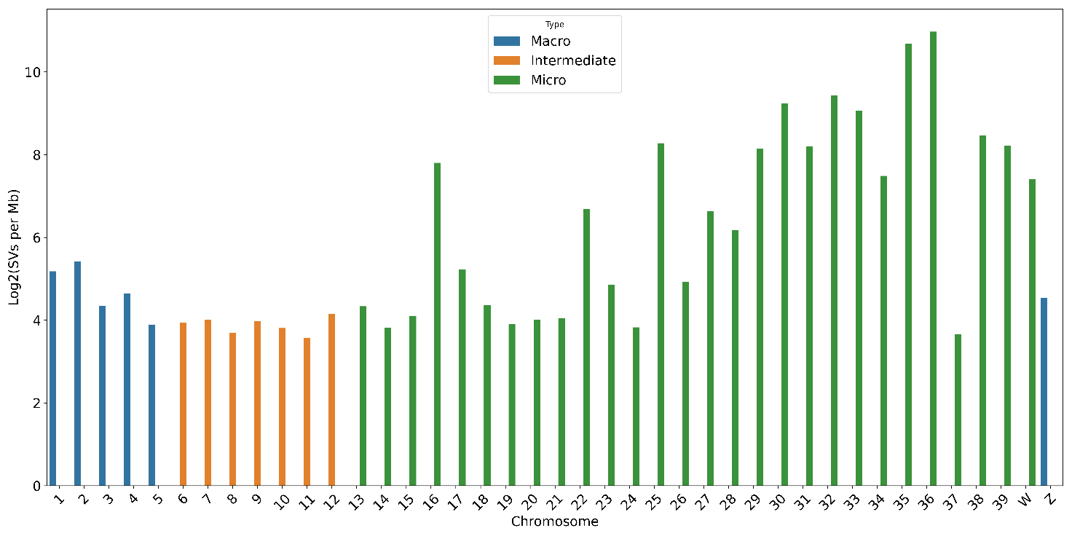
Figure S1: Structural variants per megabasepairs of sequence (log2 scale) in the whole-genome-sequence reference dataset. Chromosomes are split between macrochromosomes (>50Mbp) intermediate chromosomes (>20 Mbp < 50 Mbp) and microchromosomes (<20 Mbp).
Additional File 4
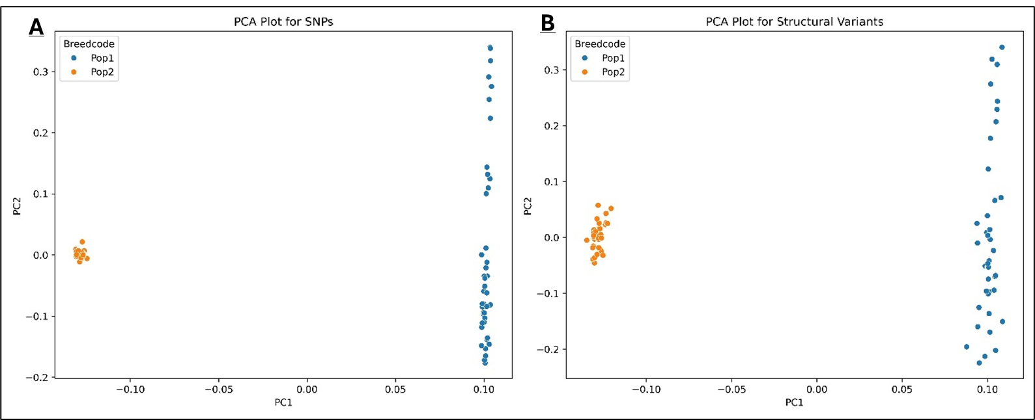
Figure S2: Principal component analysis of the whole genome sequenced individuals, the left plot (a) shows PCA based on SNP and Indel variation, the right plot (b) shows the PCA based on structural variants. The first two PCs explain 26.5 (PC1) and 1.93 (PC2) share of variance in the SNP based PCA. While being 13.7 (PC1) and 1.27 (PC2) share of variance in the SV based PCA.
Additional File 5
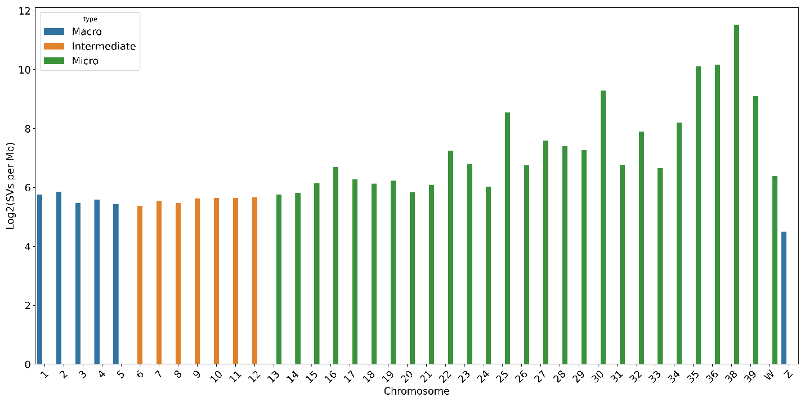Figure S3: Structural variants per megabasepairs of sequence (log2 transformed) from the low-pass-sequencing dataset. Chromosomes are split between macrochromosomes (>50Mbp) intermediate chromosomes (>20 Mbp < 50 Mbp) and microchromosomes (<20 Mbp).
Additional File 6

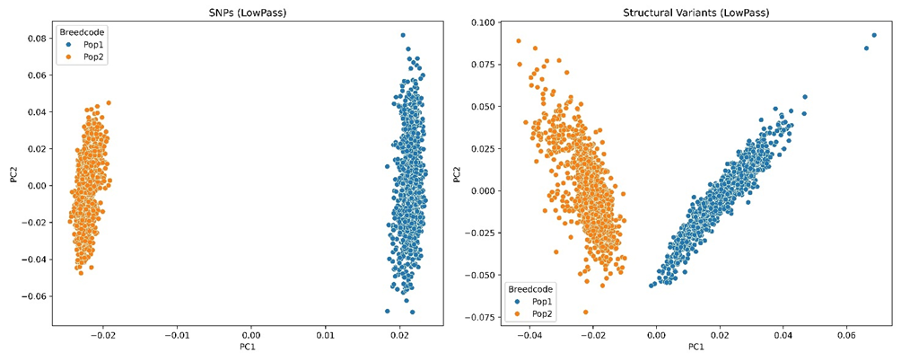
Figure S4: Principal component analysis of the low-pass sequencing dataset, the left plot shows PCA based on SNP and Indel variation, the right plot shows the PCA based on structural variation.
Additional File 7
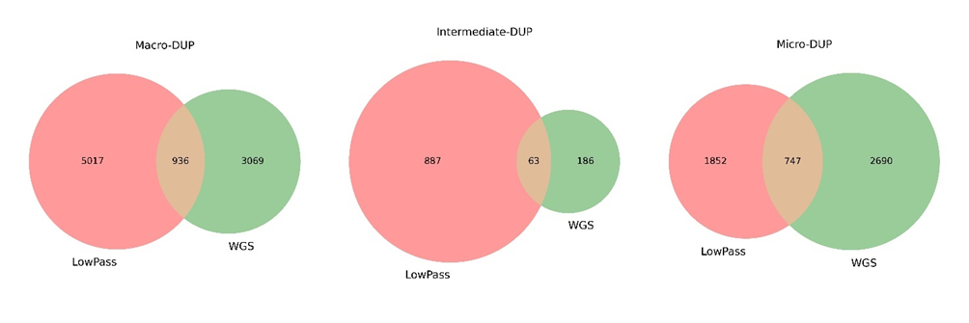
Figure S5: Overlap between duplications called on the WGS reference SV panel and LowPass SV set on the macro, intermediate, and microchromosomes.

Additional File 8
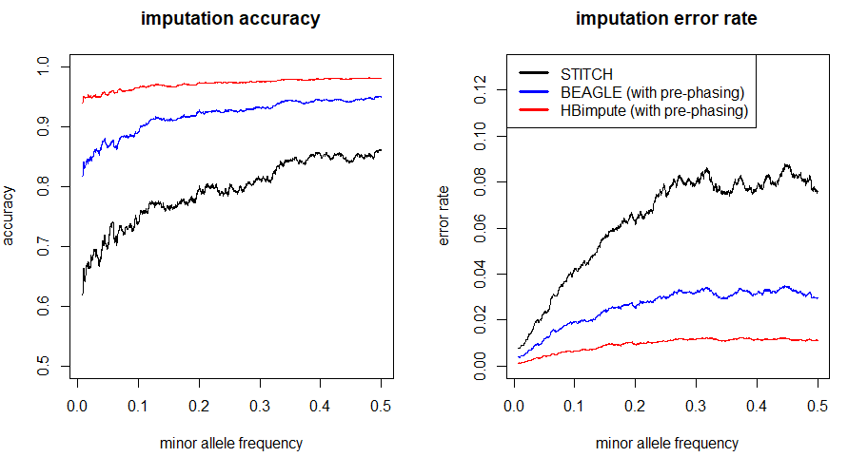Figure S6: Imputation accuracy and error rates for the different pipelines tested for imputation of low-pass sequence data depending on the minor allele frequency.
Additional File 9
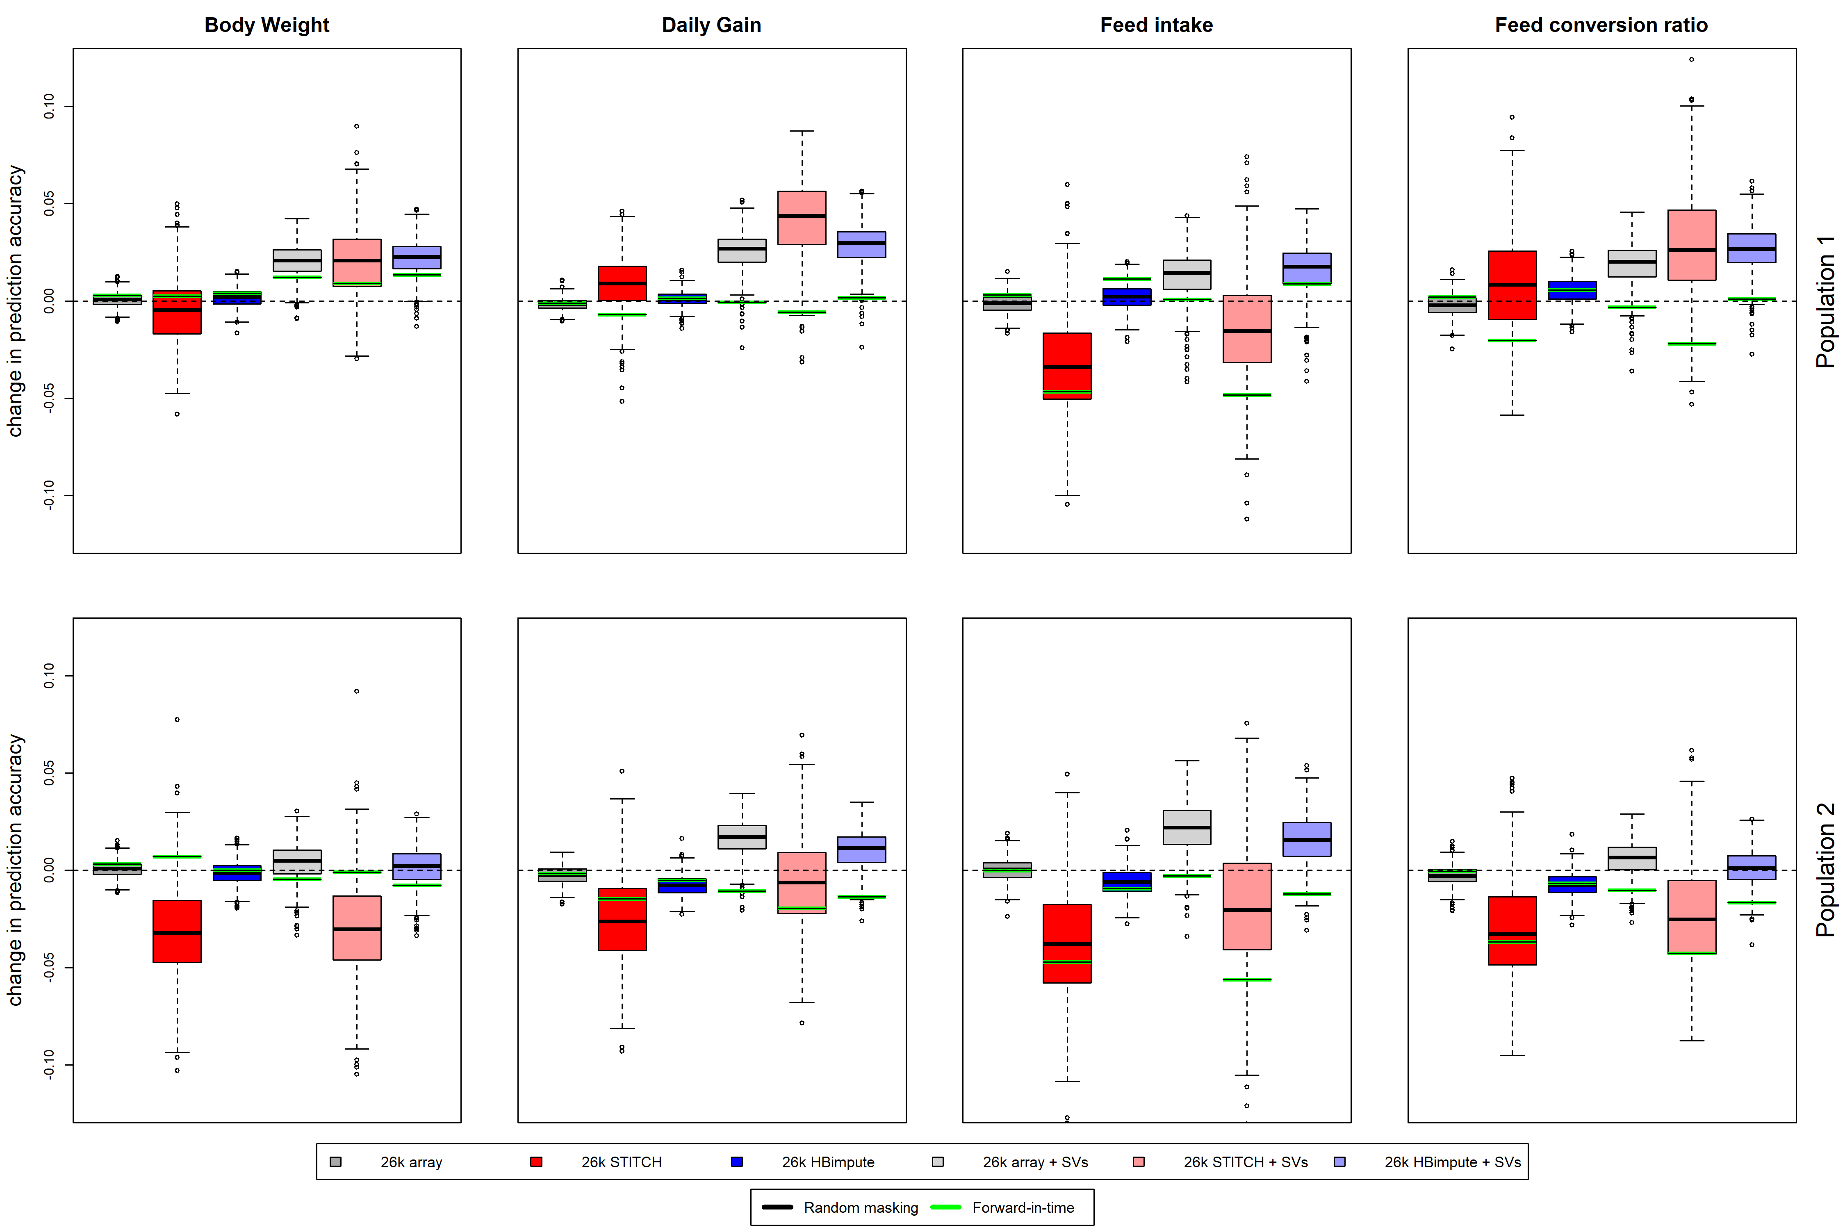
Figure S7: Prediction accuracy relative to accuracies obtained when using the full 60k array dataset for the different datasets considered that were obtained purely based on low-pass sequence data.
Additional File 10
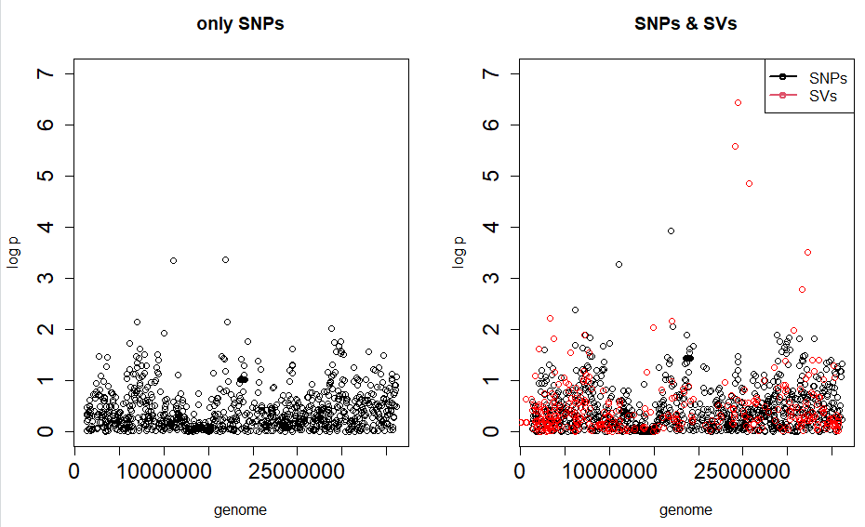
Figure S8: Manhattan plot for the genome-wide association study for adjusted feed intake for one of the two population on chromosome 6.
Additional File 11

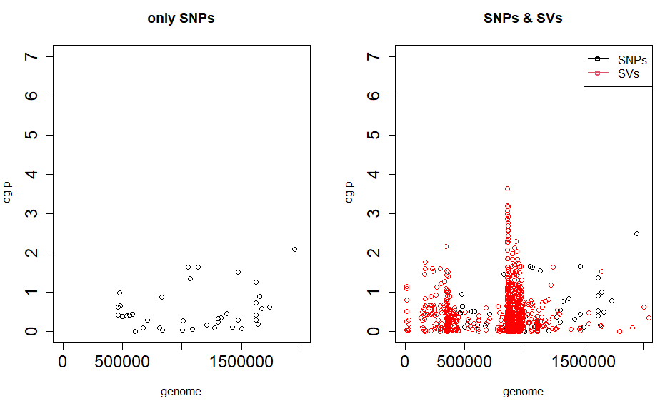
Figure S9 Manhattan plot for the genome-wide association study for adjusted feed intake for one of the two populations for one of the ends of chromosome 1.

