Supplementary Information for

Role of Earth system processes in carbon emissions budgets

Spencer K. Liddicoat*, Chris D. Jones, Lina M. Mercado, Eddy Robertson,
Stephen Sitch, Andy Wiltshire

*Corresponding author: spencer.liddicoat@metoffice.gov.uk

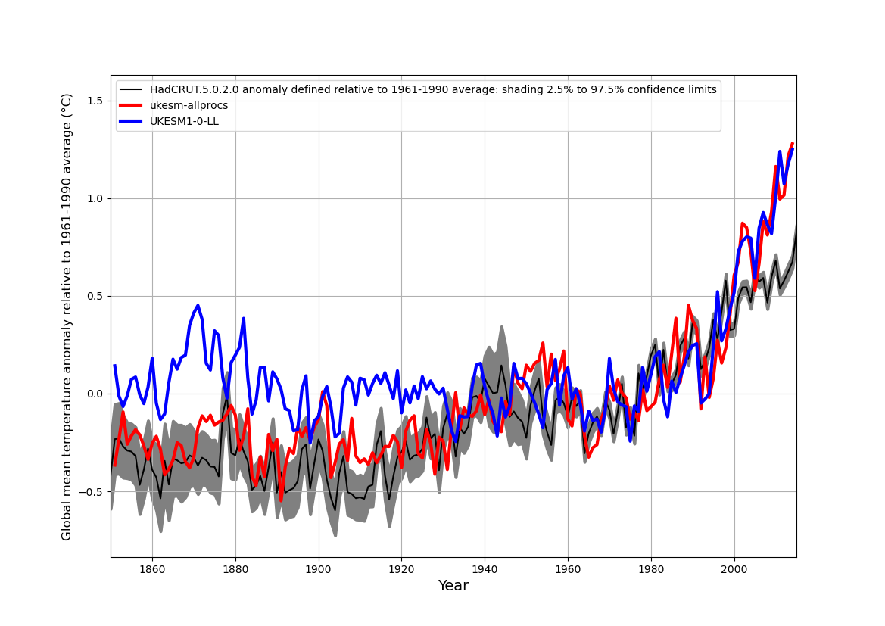
Fig. S1: Global mean temperature anomaly relative to 1961-1990 average. Emissions-driven historical simulation with ukesm-allprocs configuration (red curve) and UKESM1-0-LL (blue curve), with observations-based values from HadCRUT5.0.2.0 (black curve, 2.5% to 97.5% confidence interval is shaded).

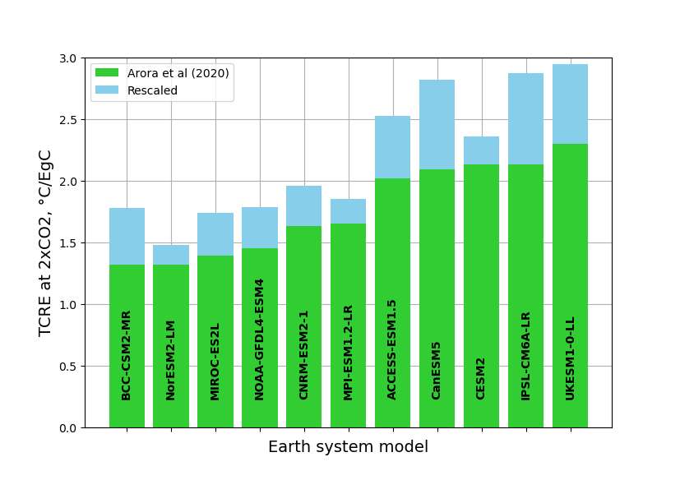

Fig. S2: Bar chart of the original TCRE (green bars) from (11), and the increase (blue bars) after rescaling to account for absent processes, for 11 CMIP6 ESMs.

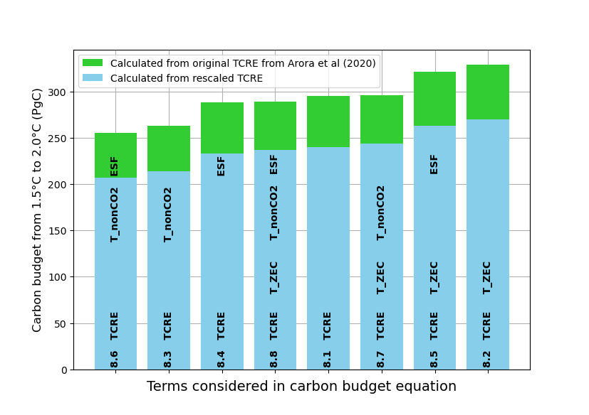

Fig. S3: Bar chart showing the average carbon budget from 1.5°C to 2°C of 11 CMIP6 ESMs. Calculated from equations 8.1 to 8.8, using the original TCRE from (11) (green bars) and the TCRE rescaled to account for missing processes (blue bars). Bar labels show equation number and the adjustment terms included in the calculation of the carbon budget: T_nonCO2 = warming due to non-CO₂ forcing, T_ZEC is zero emissions commitment (ZEC25) from (21) where available; ESF is emissions due to Earth system feedbacks not accounted for in the calculation of TCRE.

Configuration | TCRE (°C/EgC) | Cumulative Emissions (PgC)
ukesm-ctrl | 2.478 | 1077
ukesm-nonlim | 2.258 | 1180
ukesm-bvoc | 2.442 | 1085
ukesm-nodgvm | 2.516 | 1021
ukesm-wch4 | 2.603 | 1076
ukesm-df | 2.688 | 1060
ukesm-fire | 2.839 | 962
ukesm-allprocs | 3.131 | 952
UKESM1-0-LL | 2.300 | 1054

Table S1: TCRE and cumulative emissions to the point of doubling of CO₂ in the 8 UKESM configurations from this study and the CMIP6 version, UKESM1-0-LL.

 | Nitrogen limitation | Dynamic vegetation | Fire-vegetation interactions | Interactive BVOC emissions | Interactive CH₄ cycle and emissions from wetlands | Interactive diffuse fraction of PAR | Overall scaling factor for each ESM
 |  |  |  |  |  |  | TCRE | CE
ACCESS-ESM1.5 | Yes | No | No | No | No | No | 1.251 | 0.939
BCC-CSM2-MR | No | No | No | No | No | No | 1.348 | 0.853
CanESM5 | No | No | No | No | No | No | 1.348 | 0.853
CESM2 | Yes | No | Yes | No | No | No | 1.105 | 1.046
CNRM-ESM2-1 | No | No | Yes | No | No | No | 1.203 | 0.959
GFDL-ESM4 | No | Yes | Yes | Yes | No | No | 1.233 | 0.896
IPSL-CM6A-LR | No | No | No | No | No | No | 1.348 | 0.853
MIROC-ES2L | Yes | No | No | No | No | No | 1.251 | 0.939
MPI-ESM1.2-LR | Yes | Yes | Yes | No | No | No | 1.121 | 0.991
NorESM2-LM | Yes | No | Yes | Yes | No | No | 1.120 | 1.038
UKESM1-0-LL | Yes | Yes | No | Yes | No | No | 1.281 | 0.876
ukesm-ctrl | Yes | Yes | No | No | No | No | 1.267 | 0.884

Table S2: ESM-specific scaling factors and the processes included (Yes) or not (No) in each model. The final column contains the scaling factors by which the original TCRE and Cumulative Emissions from (11) are multiplied to account for the processes not represented in each model as shown in columns 2 to 7. Included are 11 CMIP6 models, and the control configuration of the ukesm process ensemble, ukesm-ctrl.

Earth System Model | TCRE (K/EgC) | Rescaled TCRE (K/EgC) | Cumulative Emissions (PgC) | Rescaled Cumulative Emissions (PgC)
BCC-CSM2-MR | 1.32 | 1.78 | 1291 | 1101
NorESM2-LM | 1.32 | 1.48 | 1075 | 1116
MIROC-ES2L | 1.39 | 1.74 | 1135 | 1066
GFDL4-ESM4 | 1.45 | 1.79 | 1066 | 955
CNRM-ESM2-1 | 1.63 | 1.96 | 1124 | 1078
MPI-ESM1.2-LR | 1.65 | 1.85 | 1127 | 1117
ACCESS-ESM1.5 | 2.02 | 2.53 | 1064 | 1000
CanESM5 | 2.09 | 2.82 | 1214 | 1035
CESM2 | 2.13 | 2.35 | 1073 | 1122
IPSL-CM6A-LR | 2.13 | 2.87 | 1107 | 944
UKESM1-0-LL | 2.30 | 2.95 | 1054 | 924
CMIP6 Mean ± Std Dev | 1.77 ± 0.36 | 2.19 ± 0.50 | 1121 ± 70 | 1042 ± 71
ukesm-allprocs, this study | 3.13 | - | 952 | -
ukesm-ctrl, this study | 2.48 | 3.14 | 1077 | 952

Table S3: Table of original and rescaled TCRE and cumulative emissions for 11 CMIP6 ESMs. The last two rows show the same figures, where applicable, for the control (ukesm-ctrl) and ‘all processes’ (ukesm-allprocs) configurations of UKESM from this study. The rescaled ukesm-ctrl values of TCRE and CE, and the TCRE and CE from ukesm-allprocs they are intended to reconstruct, are both highlighted in bold.

Equation used to calculate carbon budget from 1.5°C to 2°C | CB_{1.5_2.0} using TCRE from Arora et al (2020) (PgC) | CB_{1.5_2.0} using rescaled TCRE (PgC) | Reduction in CB on using rescaled TCRE (%)
CB_{1.5_2.0} = (2.0°C -1.5°C)/TCRE | 295 | 240 | 18.6
CB_{1.5_2.0} = (2.0°C -1.5°C - T_{ZEC})/TCRE | 329 | 270 | 17.7
CB_{1.5_2.0} = (2.0°C -1.5°C - T_{nonCO2})/TCRE | 263 | 214 | 18.6
CB_{1.5_2.0} = (2.0°C -1.5°C)/TCRE – ESF | 288 | 233 | 19.0
CB_{1.5_2.0} = (2.0°C -1.5°C -T_{ZEC})/TCRE – ESF | 321 | 263 | 18.1
CB_{1.5_2.0} = (2.0°C -1.5°C - T_{nonCO2})/TCRE – ESF | 255 | 207 | 19.1
CB_{1.5_2.0} = (2.0°C -1.5°C - T_{nonCO2} -T_{ZEC})/TCRE | 296 | 244 | 17.6
CB_{1.5_2.0} = (2.0°C -1.5°C - T_{nonCO2} -T_{ZEC})/TCRE -ESF | 289 | 237 | 18.1
Mean and standard deviation | 292±24 | 238±20 | 18.4±0.5

Table S4: Carbon emissions budget from 1.5°C to 2°C calculated from the original TCRE of the 11 CMIP6 ESMs reported in (11), before and after rescaling to account for the processes absent from each model, as calculated by the equations shown in column 1. CB_{1.5_2.0} is the carbon budget from 1.5°C to 2°C, T_{ZEC} is the committed warming evaluated 25 years after the cessation of CO₂ emissions, T_{nonCO2} is the estimated warming due to non-CO₂ forcing, and ESF is an estimate of the CO₂ released due to feedbacks unaccounted for in the calculation of TCRE. See Methods for details.

